Supplementary Information

Online survey questions

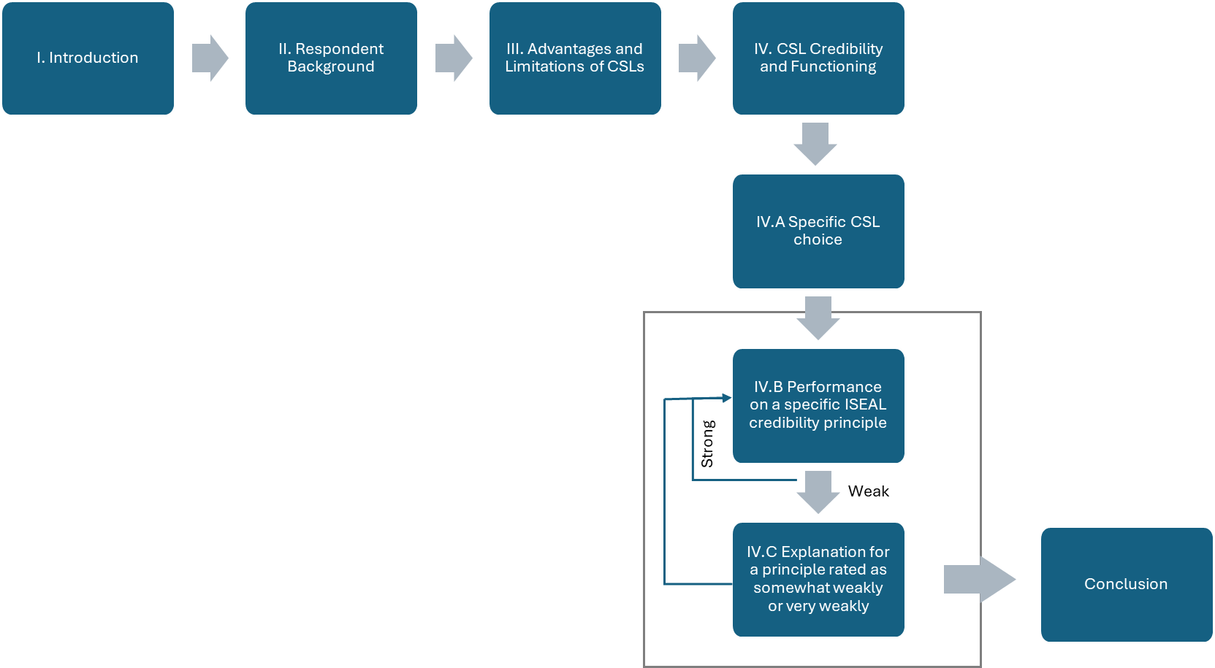

- Introduction
The HARMONITOR project, in collaboration with STAR4BBS and SUSTCERT4BIOBASED, under Horizon Europe funding, is conducting research on the perception of stakeholders concerning the effectiveness and robustness of sustainability certification schemes and labels (CSLs) for bio-based products. These CLSs can be used as a co- regulation instrument in the European Union bioeconomy.
The HARMONITOR project focuses on bio-based materials including, for example, innovative bio-based chemicals, forestry products for construction materials, and textiles. Food and energy products are excluded explicitly, although versatile upstream biomass feedstocks that can lead to both materials and energy/food are included, e.g., palm oil, wood, cotton, and wastes as feedstocks.
This survey and the results are anonymous and the only demographic data collected is the stakeholder category you belong to.
This survey should take between x and y minutes.

- Respondent Background
- Which stakeholder category most accurately describes you? Choose one.
- Sustainability certification scheme and/or label owner organization that develops standards
- Certification body that certifies/audits standards
- Bio-based product manufacturer that pursues or may pursue obtaining certification and labeling for their products
- Business or public sector purchaser of certified and/or non-certified products
- Trader of goods
- Certification support consultant
- Researcher (academic or otherwise)
- Non-governmental organization
- Policy maker
- Private consumer (general public)
- Other, please specify

- Which stakeholder category most accurately describes you? Choose one. - Other (please specify)

- Which country are you based in?

- Advantages and Limitations of CSLs
- In your opinion, what are the advantages of sustainability certification schemes and labels (CSLs) for the future development of the European Union (EU) bioeconomy? Select one or more answers.
- CSLs can provide consumers with reliable and verified information on the sustainability performance of products and services
- CSLs can encourage responsible production and consumption
- Sustainability issues and public concerns that are not yet regulated by current policy can be addressed by CSLs
- CSLs can give flexibility to industry by allowing them to choose the level of sustainability ambition they wish to achieve
- Others (please specify)
- No advantages

- (If Other was selected) In your opinion, what are the advantages of sustainability certification schemes and labels (CSLs) for the future development of the European Union (EU) bioeconomy? Please specify.

- In your opinion, what are the limitations of sustainability certification schemes and labels (CSLs) for the future development of the European (EU) bioeconomy? Select one or more answers.
- Weak system/audit rules may result in poor levels of sustainability assurance, thus damaging the overall credibility of the sustainability certification
- CSLs owners may prioritize their own business goals over sustainability goals or policy objectives
- Industry pays both the CSL and the auditor, which may cause dependencies
- A proliferation of CSLs may cause confusion for industry and consumers
- Others (please specify)
- No limitations

- (If Other was selected) In your opinion, what are the limitations of sustainability certification schemes and labels (CSLs) for the future development of the European Union (EU) bioeconomy? Please specify.

- CSL Credibility and Functioning
Introduction
The ISEAL Credibility Principles provide guidance for certification schemes and labels (CSLs) on what credible and effective sustainability systems look like. There are ten credibility principles:
- Sustainability Impacts
- Collaboration
- Value Creation
- Measurable Progress
- Stakeholder Engagement
- Transparency
- Impartiality
- Reliability
- Truthfulness
- Continual Improvement
For the next questions, the full description of each principle will be given. Think about the CSLs you are familiar with that are relevant to bio-based chemical and materials. This could include certifications for biomass feedstocks. With a particular CSL in mind, please rate how strongly you think that CSL follows that credibility principle.
- Which certification scheme and/or label (CSL) do you have in mind? (drop-down list or respondent entry)
- CSLs in general (no specific CSL)
- Specific CSL (please specify)

- (If Specific CSL was selected) Please specify which certification scheme and/or label (CSL) do you have in mind.

- With X [CSLs in general/specific CSL] in mind, how strongly do you think that X follows the Sustainability Impacts credibility principle? (1-5 + no opinion)
- If rated weak (1-2), why? (open text)

- If rated above 2, skip to next principle

- With X in mind, how strongly do you think that X follows the Collaboration credibility principle? (1-5 + no opinion)
- If rated weak (1-2), answer question 12
- If rated above 2, skip to next principle

- You have rated [QID19-ChoiceGroup-SelectedChoicesTextEntry] as weak for the COLLABORATION credibility principle. Please explain why. (open text)

- With X in mind, how strongly do you think that X follows the Value Creation credibility principle? (1-5 + no opinion)
- If rated weak (1-2), answer question 14
- If rated above 2, skip to next principle

- You have rated [QID19-ChoiceGroup-SelectedChoicesTextEntry] as weak for the VALUE CREATION credibility principle. Please explain why. (open text)

- With X in mind, how strongly do you think that X follows the Measurable Progress credibility principle? (1-5 + no opinion)
- If rated weak (1-2), answer question 16
- If rated above 2, skip to next principle

- You have rated [QID19-ChoiceGroup-SelectedChoicesTextEntry] as weak for the MEASURABLE PROGRESS credibility principle. Please explain why. (open text)

- With X in mind, how strongly do you think that X follows the Stakeholder Engagement credibility principle? (1-5 + no opinion)
- If rated weak (1-2), answer question 18
- If rated above 2, skip to next principle

- You have rated [QID19-ChoiceGroup-SelectedChoicesTextEntry] as weak for the STAKEHOLDER ENGAGEMENT credibility principle. Please explain why. (open text)

- With X in mind, how strongly do you think that X follows the Transparency credibility principle? (1-5 + no opinion)
- If rated weak (1-2), answer question 20
- If rated above 2, skip to next principle

- You have rated [QID19-ChoiceGroup-SelectedChoicesTextEntry] as weak for the TRANSPARENCY credibility principle. Please explain why. (open text)

- With X in mind, how strongly do you think that X follows the Impartiality credibility principle? (1-5 + no opinion)
- If rated weak (1-2), answer question 22
- If rated above 2, skip to next principle

- You have rated [QID19-ChoiceGroup-SelectedChoicesTextEntry] as weak for the IMPARTIALITY credibility principle. Please explain why. (open text)

- With X in mind, how strongly do you think that X follows the Reliability credibility principle? (1-5 + no opinion)
- If rated weak (1-2), answer question 24
- If rated above 2, skip to next principle

- You have rated [QID19-ChoiceGroup-SelectedChoicesTextEntry] as weak for the RELIABILITY credibility principle. Please explain why. (open text)

- With X in mind, how strongly do you think that X follows the Truthfulness credibility principle? (1-5 + no opinion)
- If rated weak (1-2), answer question 26
- If rated above 2, skip to next principle

- You have rated [QID19-ChoiceGroup-SelectedChoicesTextEntry] as weak for the TRUTHFULNESS credibility principle. Please explain why. (open text)

- With X in mind, how strongly do you think that X follows the Continual Improvement credibility principle? (1-5 + no opinion)
- If rated weak (1-2), answer question 28
- If rated above 2, skip to next principle

- You have rated [QID19-ChoiceGroup-SelectedChoicesTextEntry] as weak for the CONTINUAL IMPROVEMENT credibility principle. Please explain why. (open text)

- Thank you for evaluating how well [QID19-ChoiceGroup-SelectedChoicesTextEntry] follows the ISEAL Credibility Principles. Would you like to evaluate one more CSL?
- If yes, repeat question 8-28
- If no, skip to Conclusion

- Conclusion
Please contact Martin Junginger (h.m.junginger@uu.nl) for any questions or comments about the survey or HARMONITOR project
- Would you like to share your survey responses with us and be contacted for a follow-up interview? If you are okay with us seeing your survey responses and would like to share more of your thoughts, please leave your name and email address below. You will no longer we anonymous, but the information you provide is protected by the EU General Data Protection Regulation.

Interview guide

Follow-up interview on the effectiveness and robustness of sustainability certification schemes and labels (CSLs) for bio-based products

Date and time of interview: [date and time]
Location: Online – MS Teams

Purpose of the Interview
This study aims to obtain valuable insights into the critiques surrounding sustainability certification schemes and labels (CSLs) applicable to bio-based products and to explore potential mitigation measures. It is an integral part of HARMONITOR, an EU Horizon project that strives to enhance the effectiveness and resilience of CSLs for the EU Bioeconomy. The outcome of this research will be a peer-reviewed journal that is accessible to all. Please note that this interview will be recorded for data analysis purposes, and any information you provide will be solely used for this research project.

Interview Topics
- Background of the interviewee and familiarity with sustainability certification schemes and labels for bio-based products

- Critical issues surrounding sustainability certification schemes and labels (CSLs)
- Your views and experiences on the credibility, effectiveness and robustness of the sustainability certification schemes and labels. In particular, we would like to get your opinion on the sustainability impacts, the progress measurement of CSLs, as well as rewards and barriers in the implementation of CSLs.
- Do you share the same views as the result of the online survey? (note: the result can be found in the background information document, attached in the email)

- Views on the limitations of CSLs and the role of CSLs as a co-regulation

ISEAL Credibility Principles

Table SI-1 ISEAL Credibility Principles and its definition (ISEAL, 2021)
Credibility Principles | Definition
Sustainability Impact | A credible sustainability system has a clear purpose to drive positive social, environmental, and economic impacts and to eliminate or remediate negative impacts. It defines and clearly communicates its scope, its specific sustainability objectives, and its strategies for achieving these objectives (its theory of change). The system focuses on the significant sustainability impacts in its scope. It seeks to address the root causes of sustainability issues and deliver wider or systemic impacts. It reflects current scientific evidence and international norms when relevant. It is adapted to local or sector-specific conditions where this helps improve impact.
Collaboration | A credible sustainability system identifies governments, businesses, and civil society organisations, including other sustainability systems, that are working towards shared sustainability objectives. It actively seeks alignment and respectfully pursues collaboration with others. It establishes partnerships and shares learnings to improve its efficiency and its direct or systemic impacts.
Value creation | A credible sustainability system strives to create value that fairly rewards the effort and resources that it takes for users to participate in the system. It has a viable business model, and it operates efficiently, minimising costs for users and reaching more users by reducing other barriers to access. It supports users to implement its tools, and it empowers users by demonstrating a clear business case for participating in its system.
Measurable progress | A credible sustainability system has tools that are relevant to achieving its sustainability objectives, and these tools allow progress towards objectives to be measured over time. It collects and analyses the data it needs to measure, understand, and demonstrate the progress its users are making towards these objectives.
Stakeholder engagement | A credible sustainability system is inclusive and non-discriminatory. It empowers stakeholders to participate in decisions and hold the system to account. It involves a balanced and diverse group of stakeholders in decisions that will affect them. It strives to understand the context and perspectives of stakeholders who have been under-engaged or under-represented, and it creates opportunities to ensure their participation in decision-making. It provides clear and transparent feedback on stakeholder input and concerns. It has fair, impartial and accessible mechanisms for resolving complaints and conflicts.
Transparency | A credible sustainability system makes important information publicly available and easily accessible, while protecting confidential and private information. It enables stakeholders to understand and evaluate the system’s processes, decision-making, results, and impacts. Stakeholders have the information they need to actively participate in decisions or raise concerns.
Impartiality | A credible sustainability system identifies and avoids or mitigates conflicts of interest throughout its governance and operations, particularly when it comes to assessing its users’ performance. Transparency and stakeholder engagement help ensure the system’s integrity can be trusted.
Reliability | A credible sustainability system designs its tools so that these can be consistently implemented and assessed. It ensures assessments of users’ sustainability performance are competent and accurate, and that these assessments support any claims it allows users to make.
Truthfulness | A credible sustainability system substantiates its claims. Any claims the system or its users make are clear, relevant, and can be checked. They enable customers and other stakeholders to make informed choices. The scope and design of the system is accurately reflected in any claims, ensuring these are not misleading. Claims about sustainability impacts are backed up with data and evidence that is publicly available.
Continual improvement | A credible sustainability system regularly reviews its objectives, its strategies, and the performance of its tools and system. It evaluates the impacts and outcomes of its activities. It applies the lessons learned to improve. It responds to new evidence, stakeholder input, and external changes, adapting its strategies to improve its impacts and remain fit for purpose.

Distribution of respondents by stakeholder categories

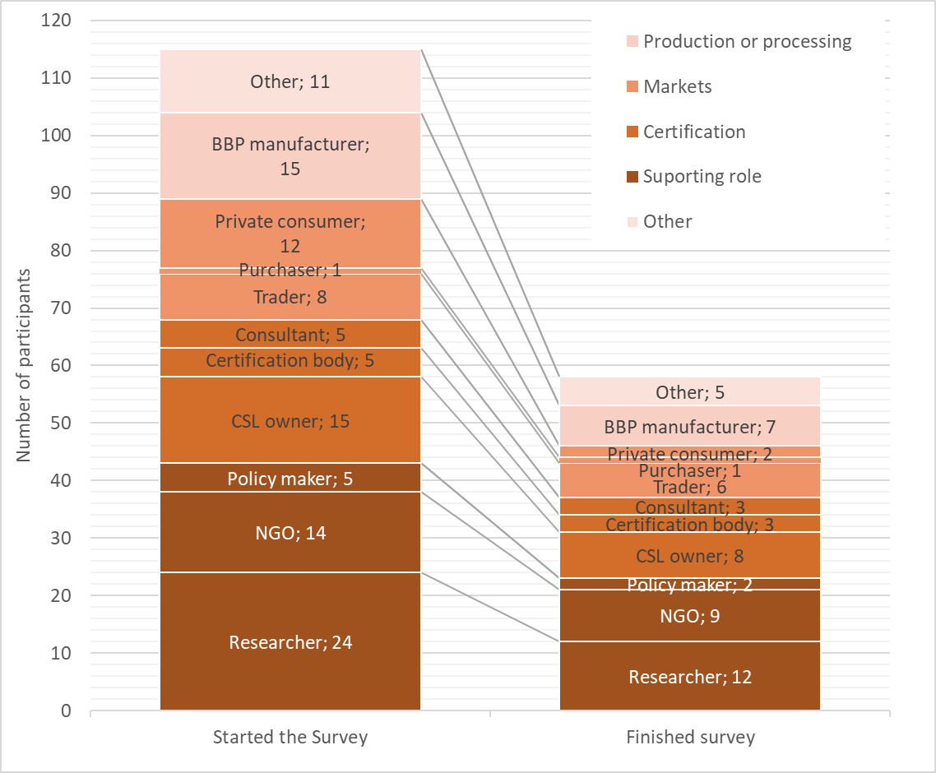
Figure SI-1 The distribution of respondents who started the survey (n = 115), and the distribution of respondents who fully completed the survey (n = 67). Other stakeholder groups that participated in this study represented the following backgrounds: Financial institutions, Industry associations, Standardization bodies, Forest and nature management organizations, Carbon project developers, Accreditation bodies for the certification schemes, International organizations, Trade organizations, Providers of bio-based feedstocks, and Government agencies

Geographical distribution of respondents

Table SI-2 Geographical distribution of respondents who started the survey
EEA-S |  | Outside EEAS
Netherlands | 37 | UK | 7
Germany | 15 | India | 4
Belgium | 8 | US | 3
Greece | 5 | Argentina | 1
France | 4 | Brazil | 1
Italy | 4 | Colombia | 1
Switzerland | 4 | Ghana | 1
Austria | 3 | Ireland | 1
Spain | 3 | Japan | 1
Estonia | 2 | Malaysia | 1
Finland | 2
Portugal | 2
Sweden | 2
Croatia | 1
Denmark | 1
Norway | 1

Descriptive statistics of the online survey results
Table SI-3 Descriptive statistics of the results for CSLs performance against ISEAL credibility principles. To evaluate the mean, median, and mode, we translated the Likert scale into a numerical scale with 1 representing "extremely weakly" and 5 representing "extremely strongly".
Specific CSLs
 | Sustainability Impacts | Measurable Progress | Collaboration | Value Creation | Stakeholder Engagement | Transparency | Impartiality | Reliability | Truthfulness | Continual Improvement
Mean | 3.9 | 3.7 | 3.9 | 4.0 | 4.0 | 4.2 | 3.8 | 4.0 | 4.0 | 4.1
Standard Error | 0.24 | 0.23 | 0.23 | 0.18 | 0.24 | 0.21 | 0.24 | 0.24 | 0.22 | 0.21
Median | 4 | 4 | 4 | 4 | 4 | 4 | 4 | 5 | 4 | 4
Mode | 5 | 5 | 5 | 5 | 5 | 5 | 4 | 5 | 4 | 4
Standard Deviation | 1.34 | 1.27 | 1.23 | 0.92 | 1.24 | 1.01 | 1.27 | 1.29 | 1.13 | 1.07
Sample Variance | 1.79 | 1.61 | 1.51 | 0.84 | 1.54 | 1.01 | 1.60 | 1.67 | 1.27 | 1.15
Range | 4 | 4 | 4 | 3 | 4 | 3 | 4 | 4 | 4 | 4
Minimum | 1 | 1 | 1 | 2 | 1 | 2 | 1 | 1 | 1 | 1
Maximum | 5 | 5 | 5 | 5 | 5 | 5 | 5 | 5 | 5 | 5
Count | 30 | 30 | 28 | 26 | 27 | 22 | 28 | 28 | 27 | 27
CSL in general
 | Sustainability Impacts | Measurable Progress | Collaboration | Value Creation | Stakeholder Engagement | Transparency | Impartiality | Reliability | Truthfulness | Continual Improvement
Mean | 3.3 | 2.9 | 3.3 | 3.2 | 3.3 | 3.4 | 3.3 | 3.3 | 3.2 | 3.3
Standard Error | 0.16 | 0.17 | 0.19 | 0.21 | 0.22 | 0.24 | 0.20 | 0.20 | 0.19 | 0.18
Median | 4 | 3 | 3 | 3 | 3 | 4 | 3 | 3 | 3.5 | 3
Mode | 4 | 3 | 3 | 4 | 4 | 4 | 3 | 4 | 4 | 4
Standard Deviation | 0.97 | 0.95 | 1.05 | 1.15 | 1.14 | 1.19 | 1.08 | 1.04 | 1.03 | 0.96
Sample Variance | 0.95 | 0.90 | 1.10 | 1.31 | 1.31 | 1.41 | 1.16 | 1.08 | 1.06 | 0.92
Range | 4 | 4 | 4 | 4 | 4 | 4 | 4 | 4 | 4 | 4
Minimum | 1 | 1 | 1 | 1 | 1 | 1 | 1 | 1 | 1 | 1
Maximum | 5 | 5 | 5 | 5 | 5 | 5 | 5 | 5 | 5 | 5
Count | 37 | 32 | 30 | 29 | 28 | 25 | 28 | 28 | 28 | 27

Number of respondents responsed to online survey questions

For Questions 20–29, the reported number of respondents covers answers referring to both specific CSLs and CSLs in general, and includes entries marked as “No opinion”. A breakdown of responses for CSLs in general and specific CSLs, excluding “No opinion” entries, is provided in Tables SI-5 and SI-6.
Table SI-4 Number of respondents responded to online survey questions
 | Question | Respondents
1 | Which stakeholder category most accurately describes you? Choose one. - Selected Choice | 115
2 | Which stakeholder category most accurately describes you? Choose one. - Other (please specify) - Text | 11
3 | Which country are you based in? | 115
4 | What are the advantages of sustainability certification schemes and labels (CSLs) for the future development of the European Union bioeconomy? Select one or more answers. - Selected Choice | 82
5 | What are the advantages of sustainability certification schemes and labels (CSLs) for the future development of the European Union bioeconomy? Select one or more answers. - Others (please specify) - Text | 12
6 | What are the limitations of sustainability certification schemes and labels (CSLs) for the future development of the European Union bioeconomy? Select one or more answers. - Selected Choice | 81
7 | What are the limitations of sustainability certification schemes and labels (CSLs) for the future development of the European Union bioeconomy? Select one or more answers. - Others (please specify) - Text | 15
8 | Which sustainability certification scheme and/or label (CSL) do you have in mind? You will have the opportunity to take this part of the survey one more time if you want to answer for another CSL. - Selected Choice | 82
9 | Which sustainability certification scheme and/or label (CSL) do you have in mind? You will have the opportunity to take this part of the survey one more time if you want to answer for another CSL. - Specific CSL (please specify) - Text | 33
10 | 1. SUSTAINABILITY IMPACTS | 68
11 | You have rated [QID19-ChoiceGroup-SelectedChoicesTextEntry] as weak for the SUSTAINABILITY IMPACTS credibility principle. Please explain why. | 13
12 | 2. MEASURABLE PROGRESS | 65
13 | You have rated [QID19-ChoiceGroup-SelectedChoicesTextEntry] as weak for the MEASURABLE PROGRESS credibility principle. Please explain why. | 10
14 | 3. COLLABORATION | 60
15 | You have rated [QID19-ChoiceGroup-SelectedChoicesTextEntry] as weak for the COLLABORATION credibility principle. Please explain why. | 10
16 | 4. VALUE CREATION | 59
17 | You have rated [QID19-ChoiceGroup-SelectedChoicesTextEntry] as weak for the VALUE CREATION credibility principle. Please explain why. | 7
18 | 5. STAKEHOLDER ENGAGEMENT | 58
19 | You have rated [QID19-ChoiceGroup-SelectedChoicesTextEntry] as weak for the STAKEHOLDER ENGAGEMENT credibility principle. Please explain why. | 10
20 | 6. TRANSPARENCY | 58
21 | You have rated [QID19-ChoiceGroup-SelectedChoicesTextEntry] as weak for the TRANSPARENCY credibility principle. Please explain why. | 10
22 | 7. IMPARTIALITY | 58
23 | You have rated [QID19-ChoiceGroup-SelectedChoicesTextEntry] as weak for the IMPARTIALITY credibility principle. Please explain why. | 11
24 | 8. RELIABILITY | 58
25 | You have rated [QID19-ChoiceGroup-SelectedChoicesTextEntry] as weak for the RELIABILITY credibility principle. Please explain why. | 9
26 | 9. TRUTHFULNESS | 58
27 | You have rated [QID19-ChoiceGroup-SelectedChoicesTextEntry] as weak for the TRUTHFULNESS credibility principle. Please explain why. | 9
28 | 10. CONTINUAL IMPROVEMENT | 58
29 | You have rated [QID19-ChoiceGroup-SelectedChoicesTextEntry] as weak for the CONTINUAL IMPROVEMENT credibility principle. Please explain why. | 7
30 | Thank you for evaluating how well [QID19-ChoiceGroup-SelectedChoicesTextEntry] follows the ISEAL Credibility Principles. Would you like to evaluate one more CSL? | 60
31 | Would you like to share your survey responses with us and be contacted for a follow-up interview? If you are okay with us seeing your survey responses and would like to share more of your thoughts, please leave your name and email address below. You will | 19

Number of responses to the section ISEAL credibility principles

Table SI-5 Number of responses to the questions “With [specific CSL] in mind, how strongly do you think [specific CSL] follows the [ISEAL credibility] principle?”
Credibility Principles | Certifier | Civil society, state, and academic | Other | Producer | Trader and consumer | Total responses
SUSTAINABILITY IMPACTS | 8 | 18 | 2 | 2 | 7 | 37
MEASURABLE PROGRESS | 8 | 15 | 1 | 2 | 6 | 32
COLLABORATION | 7 | 15 | 1 | 2 | 5 | 30
VALUE CREATION | 7 | 13 | 1 | 2 | 6 | 29
STAKEHOLDER ENGAGEMENT | 7 | 13 | 1 | 2 | 5 | 28
TRANSPARENCY | 6 | 11 | 1 | 2 | 5 | 25
IMPARTIALITY | 7 | 13 | 1 | 2 | 5 | 28
RELIABILITY | 7 | 13 | 1 | 2 | 5 | 28
TRUTHFULNESS | 4 | 8 |  | 1 | 2 | 15
CONTINUAL IMPROVEMENT | 7 | 12 | 1 | 2 | 5 | 27

Table SI-6 Number of responses to the questions “With [CSLs in general] in mind, how strongly do you think [CSLs in general] follows the [ISEAL credibility] principle?”
Credibility Principles | Certifier | Civil society, state, and academic | Other | Producer | Trader and consumer | Grand Total
SUSTAINABILITY IMPACTS | 8 | 9 | 4 | 6 | 3 | 30
MEASURABLE PROGRESS | 8 | 9 | 4 | 6 | 3 | 30
COLLABORATION | 7 | 9 | 4 | 5 | 3 | 28
VALUE CREATION | 7 | 8 | 4 | 5 | 2 | 26
STAKEHOLDER ENGAGEMENT | 7 | 9 | 4 | 5 | 2 | 27
TRANSPARENCY | 5 | 7 | 4 | 5 | 1 | 22
IMPARTIALITY | 7 | 9 | 4 | 5 | 3 | 28
RELIABILITY | 7 | 9 | 4 | 5 | 3 | 28
TRUTHFULNESS | 4 | 4 | 2 | 4 |  | 14
CONTINUAL IMPROVEMENT | 7 | 8 | 4 | 5 | 3 | 27

Distribution of feedback from online survey respondents

The 17 stakeholders who provided general feedback were primarily from the “civil society, state, and academia” and “trader and consumer ”categories (4 each), followed by “certifier” (2) and “producer” (1). One “certifier’ stakeholder consistently expressed low confidence in all ISEAL credibility principles. Feedback across ISEAL credibility principles was evenly distributed, with 4 to 7 inputs per principle.
For specific CSLs, stakeholders were evenly split between the “civil society, state, and academia” and “certifier” categories (4 each), followed by “trader and consumer” and “producer” categories (2 each), and one from Other category. Most concerns centred on Sustainability Impact (7 entries) and Impartiality (6 entries). Other principles, excluding Value Creation, received 3 to 5 inputs. The feedback for Value Creation came from a “civil society, state, and academia” category stakeholder who consistently rated all the principles poorly.

Comparison of results

Given the limited sample size, sensitivity checks were conducted by comparing results across three scenarios:
(1) all responses, regardless of completion level;
(2) responses with at least 70% completion; and
(3) fully completed (100%) responses.
The patterns and key findings were consistent across all scenarios, with no meaningful differences observed (see Figure SI-2, Figure SI-3, Table SI-7, Table SI-8, and Table SI-9 below). Restricting the analysis to fully completed responses would have reduced the richness of insights. Therefore, all responses were retained in the analysis, with the number of respondents and responses clearly reported for each sub-section.

Figure SI-2 Comparison of perceived advantages of CSLs across three response-completion scenarios

Figure SI-3 Comparison of perceived limitations of CSLs across three response-completion scenarios

Table SI-7 Perceived credibility of CSLs assessed against the ISEAL Credibility Principles (all responses)
Progress | (All)
Row Labels | Average of 1. SUSTAINABILITY IMPACTS | Average of 2. MEASURABLE PROGRESS | Average of 3. Collaboration | Average of 4. VALUE CREATION | Average of 5. STAKEHOLDER ENGAGEMENT | Average of 6. TRANSPARENCY | Average of 7. IMPARTIALITY | Average of 8. RELIABILITY | Average of 9. TRUTHFULNESS | Average of 10. CONTINUAL IMPROVEMENT
CSLs in general (no specific CSL) | 3.3 | 2.9 | 3.3 | 3.2 | 3.3 | 3.4 | 3.3 | 3.3 | 3.2 | 3.3
Certifier | 3.5 | 2.8 | 3.3 | 3.9 | 3.7 | 3.5 | 3.7 | 3.7 | 3.4 | 3.7
Civil society, state, and academic | 3.1 | 2.9 | 3.1 | 3.1 | 2.8 | 3.1 | 2.8 | 3.0 | 3.0 | 3.2
Other | 4.0 | 3.0 | 3.0 | 4.0 | 4.0 | 2.0 | 3.0 | 4.0 | 4.0 | 4.0
Producer | 3.5 | 2.5 | 3.0 | 2.5 | 3.0 | 3.5 | 3.0 | 3.0 | 3.0 | 3.0
Trader and consumer | 3.6 | 3.3 | 4.0 | 2.8 | 3.6 | 4.0 | 3.8 | 3.2 | 3.4 | 3.2
Specific CSL (please specify) | 3.9 | 3.7 | 3.9 | 4.0 | 4.0 | 4.2 | 3.8 | 4.0 | 4.0 | 4.1
Certifier | 4.5 | 3.4 | 4.3 | 4.6 | 4.3 | 4.0 | 4.4 | 4.6 | 4.6 | 4.6
Civil society, state, and academic | 3.6 | 3.7 | 3.6 | 3.5 | 3.6 | 4.3 | 3.1 | 3.3 | 3.3 | 3.6
Other | 4.5 | 4.5 | 4.8 | 4.5 | 4.3 | 4.0 | 4.3 | 4.8 | 4.5 | 4.5
Producer | 3.5 | 3.5 | 3.8 | 3.6 | 4.0 | 4.4 | 3.8 | 3.6 | 3.8 | 4.0
Trader and consumer | 3.7 | 3.7 | 3.0 | 3.5 | 4.5 | 4.0 | 3.3 | 4.7 | 4.0 | 3.7
Grand Total | 3.6 | 3.3 | 3.6 | 3.6 | 3.6 | 3.7 | 3.5 | 3.6 | 3.6 | 3.7
Table SI-8 Perceived credibility of CSLs assessed against the ISEAL Credibility Principles (based on fully completed responses)
Progress | 100
Row Labels | Average of 1. SUSTAINABILITY IMPACTS | Average of 2. MEASURABLE PROGRESS | Average of 3. Collaboration | Average of 4. VALUE CREATION | Average of 5. STAKEHOLDER ENGAGEMENT | Average of 6. TRANSPARENCY | Average of 7. IMPARTIALITY | Average of 8. RELIABILITY | Average of 9. TRUTHFULNESS | Average of 10. CONTINUAL IMPROVEMENT
CSLs in general (no specific CSL) | 3.3 | 3.0 | 3.3 | 3.3 | 3.3 | 3.4 | 3.3 | 3.3 | 3.2 | 3.3
Certifier | 3.4 | 2.9 | 3.3 | 3.9 | 3.7 | 3.5 | 3.7 | 3.7 | 3.4 | 3.7
Civil society, state, and academic | 3.1 | 2.9 | 3.1 | 3.2 | 2.8 | 3.1 | 2.8 | 3.0 | 3.0 | 3.2
Other | 4.0 | 3.0 | 3.0 | 4.0 | 4.0 | 2.0 | 3.0 | 4.0 | 4.0 | 4.0
Producer | 3.5 | 2.5 | 3.0 | 2.5 | 3.0 | 3.5 | 3.0 | 3.0 | 3.0 | 3.0
Trader and consumer | 3.5 | 3.6 | 4.0 | 2.8 | 3.6 | 4.0 | 3.8 | 3.2 | 3.4 | 3.2
Specific CSL (please specify) | 4.0 | 3.7 | 3.8 | 3.9 | 4.0 | 4.2 | 3.8 | 4.0 | 4.0 | 4.0
Certifier | 4.8 | 3.2 | 4.2 | 4.5 | 4.3 | 4.0 | 4.5 | 4.5 | 4.7 | 4.5
Civil society, state, and academic | 3.6 | 3.7 | 3.6 | 3.5 | 3.6 | 4.3 | 3.1 | 3.3 | 3.3 | 3.6
Other | 4.7 | 5.0 | 4.7 | 4.3 | 4.3 | 4.0 | 4.7 | 4.7 | 4.7 | 4.7
Producer | 3.4 | 3.4 | 3.8 | 3.6 | 4.0 | 4.4 | 3.8 | 3.6 | 3.8 | 4.0
Trader and consumer | 3.7 | 3.7 | 3.0 | 3.5 | 4.5 | 4.0 | 3.3 | 4.7 | 4.0 | 3.7
Grand Total | 3.6 | 3.3 | 3.5 | 3.5 | 3.6 | 3.7 | 3.5 | 3.6 | 3.6 | 3.7

Table SI-9 Perceived credibility of CSLs assessed against the ISEAL Credibility Principles (based on at least 70% completed responses)
Progress | 70%
Row Labels | Average of 1. SUSTAINABILITY IMPACTS | Average of 2. MEASURABLE PROGRESS | Average of 3. Collaboration | Average of 4. VALUE CREATION | Average of 5. STAKEHOLDER ENGAGEMENT | Average of 6. TRANSPARENCY | Average of 7. IMPARTIALITY | Average of 8. RELIABILITY | Average of 9. TRUTHFULNESS | Average of 10. CONTINUAL IMPROVEMENT
CSLs in general (no specific CSL) | 3.3 | 3.0 | 3.3 | 3.2 | 3.3 | 3.4 | 3.3 | 3.3 | 3.2 | 3.3
Certifier | 3.4 | 2.9 | 3.3 | 3.9 | 3.7 | 3.5 | 3.7 | 3.7 | 3.4 | 3.7
Civil society, state, and academic | 3.1 | 2.9 | 3.1 | 3.1 | 2.8 | 3.1 | 2.8 | 3.0 | 3.0 | 3.2
Other | 4.0 | 3.0 | 3.0 | 4.0 | 4.0 | 2.0 | 3.0 | 4.0 | 4.0 | 4.0
Producer | 3.5 | 2.5 | 3.0 | 2.5 | 3.0 | 3.5 | 3.0 | 3.0 | 3.0 | 3.0
Trader and consumer | 3.5 | 3.6 | 4.0 | 2.8 | 3.6 | 4.0 | 3.8 | 3.2 | 3.4 | 3.2
Specific CSL (please specify) | 4.0 | 3.7 | 3.9 | 4.0 | 4.0 | 4.2 | 3.8 | 4.0 | 4.0 | 4.1
Certifier | 4.9 | 3.4 | 4.3 | 4.6 | 4.3 | 4.0 | 4.4 | 4.6 | 4.6 | 4.6
Civil society, state, and academic | 3.6 | 3.7 | 3.6 | 3.5 | 3.6 | 4.3 | 3.1 | 3.3 | 3.3 | 3.6
Other | 4.5 | 4.5 | 4.8 | 4.5 | 4.3 | 4.0 | 4.3 | 4.8 | 4.5 | 4.5
Producer | 3.4 | 3.4 | 3.8 | 3.6 | 4.0 | 4.4 | 3.8 | 3.6 | 3.8 | 4.0
Trader and consumer | 3.7 | 3.7 | 3.0 | 3.5 | 4.5 | 4.0 | 3.3 | 4.7 | 4.0 | 3.7
Grand Total | 3.6 | 3.3 | 3.6 | 3.6 | 3.6 | 3.7 | 3.5 | 3.6 | 3.6 | 3.7

