Supplemental Material
Text S1. Overview of NCP and entities of nature classification from Twitter posts. This is a condensed version of the methodological approach but further explanation is provided in Degano et al. (2025).
- Data retrieval: Retrieved data from Twitter API between June 2011 and June 2021, targeting the Mount Kilimanjaro region using a built function query from R package academictwitteR (Barrie and Ho, 2021).
- Data cleaning: Manually filtered Twitter posts (refer as Tweets hereafter) targeting tourists and nature experiences. For instance, we discarded Tweets from tour operators, restaurants and Tweets that were talking about other than nature experiences (e.g., a new purchase of a material good).
- Inductive coding approach: A random subset of Tweets (n = 235) was independently coded by three researchers using an inductive approach, allowing non-material NCP categories and entities of nature to emerge directly from the language used by tourists rather than from predefined classifications.
  - Intercoder agreement: Coding consistency was assessed using Krippendorff’s alpha (Kalpha = 0.62), indicating acceptable agreement for exploratory qualitative analysis. Discrepancies were discussed and resolved through iterative refinement of the coding scheme to reduce bias and improve the quality of the coding process.
    - Identification of entities (e.g., “tree”, “waterfall”, “buffalo”) was more straightforward and showed minimal disagreement among coders; thus, formal reliability metrics were not calculated. Instead, classifications were harmonized through discussion.
  - Codebook development: The refined coding scheme was expanded using an additional subset of Tweets (n = 365) to develop a comprehensive codebook linking multiple terms and expressions to each NCP and entity category.
  - Validation: another two researchers were involved to verify whether the terms and phrases used to identify NCP and entities of nature were correct or some others were missing.
- Fifth teen non-material NCP and seven teen EN sub-categories were identified. Each non-material NCP was then linked back to the generalizing NCP categories according to the IPBES conceptual framework (i.e., Physical & Psychological Experiences; Learning & Inspiration; and Supporting Identities). Each entity term was linked back to sub-categories within biotic, abiotic, scale of perception or human-made features categories. For instance, biotic category encompassed different taxon such as mammal, plant, insect, reptiles or agrobiodiversity elements or biodiversity unspecified terms such as “wildlife” which cannot be placed in any of the other sub-categories.
- An automated R code was designed to identify these NCP and entities of nature in the rest of the dataset; and only Tweets that were able to be geolocated in each of the six habitat types; and presented at least one NCP and one entity were kept for further analysis. A total of 1,255 Tweets compromised the final dataset.
Table S1. Associations between non-material Nature’s Contributions to People (NCP) and entities of nature (EN) within each habitat type in Mount Kilimanjaro, Tanzania. Total perceived EN reflects the number of unique EN mentioned in Tweets for each habitat type. Non-material NCP portrays the perceived contributions within each habitat type, while frequency in Tweets reflects the number of times they were expressed by tourists in Tweets. The number of associated EN highlights the number of EN linked to each NCP, while the number of links underscores the co-occurrence of NCPs with specific EN.
Habitat Type | Total perceived EN | Non-material NCP | Frequency in Tweets | Number of associated EN | Number links
SAVANNA | 79 | Tourism | 228 | 74 | 840
SAVANNA | 79 | Recreation | 100 | 42 | 284
SAVANNA | 79 | Affective Experiences | 116 | 43 | 457
SAVANNA | 79 | Sensory Experiences | 80 | 29 | 204
SAVANNA | 79 | Aesthetic Experiences | 104 | 42 | 443
SAVANNA | 79 | Iconic Places & Charismatic Experiences | 30 | 15 | 78
SAVANNA | 79 | Challenging Experiences | 29 | 21 | 70
SAVANNA | 79 | New & Unique Experiences | 26 | 16 | 71
SAVANNA | 79 | Creativity & Inspiration | 132 | 50 | 587
SAVANNA | 79 | Restorative Experiences | 16 | 10 | 34
SAVANNA | 79 | Life Changing Perspectives | 6 | 2 | 7
SAVANNA | 79 | Learning | 6 | 5 | 12
SAVANNA | 79 | Social Cohesion & Bonding | 66 | 37 | 200
SAVANNA | 79 | Spiritual | 11 | 10 | 24
SUBMONTANE ZONE | 37 | Tourism | 52 | 27 | 108
SUBMONTANE ZONE | 37 | Recreation | 44 | 19 | 87
SUBMONTANE ZONE | 37 | Affective Experiences | 30 | 12 | 43
SUBMONTANE ZONE | 37 | Sensory Experiences | 17 | 8 | 22
SUBMONTANE ZONE | 37 | Aesthetic Experiences | 27 | 9 | 37
SUBMONTANE ZONE | 37 | Challenging Experiences | 7 | 6 | 12
SUBMONTANE ZONE | 37 | New & Unique Experiences | 13 | 12 | 30
SUBMONTANE ZONE | 37 | Creativity & Inspiration | 15 | 7 | 22
SUBMONTANE ZONE | 37 | Restorative Experiences | 7 | 2 | 6
SUBMONTANE ZONE | 37 | Social Cohesion & Bonding | 22 | 10 | 30
SUBMONTANE ZONE | 37 | Spiritual | 6 | 2 | 6
MONTANE FOREST | 24 | Tourism | 36 | 18 | 98
MONTANE FOREST | 24 | Recreation | 58 | 22 | 163
MONTANE FOREST | 24 | Affective Experiences | 21 | 16 | 63
MONTANE FOREST | 24 | Sensory Experiences | 12 | 13 | 41
MONTANE FOREST | 24 | Aesthetic Experiences | 20 | 15 | 59
MONTANE FOREST | 24 | Iconic Places & Charismatic Experiences | 9 | 9 | 24
MONTANE FOREST | 24 | Challenging Experiences | 13 | 9 | 30
MONTANE FOREST | 24 | Creativity & Inspiration | 11 | 10 | 35
MONTANE FOREST | 24 | Life Changing Perspectives | 5 | 6 | 15
MONTANE FOREST | 24 | Social Cohesion & Bonding | 18 | 9 | 42
SUBALPINE ERICA FOREST & BUSHLAND | 16 | Tourism | 16 | 9 | 38
SUBALPINE ERICA FOREST & BUSHLAND | 16 | Recreation | 31 | 15 | 67
SUBALPINE ERICA FOREST & BUSHLAND | 16 | Affective Experiences | 12 | 8 | 26
SUBALPINE ERICA FOREST & BUSHLAND | 16 | Sensory Experiences | 9 | 7 | 18
SUBALPINE ERICA FOREST & BUSHLAND | 16 | Aesthetic Experiences | 6 | 5 | 12
SUBALPINE ERICA FOREST & BUSHLAND | 16 | Iconic Places & Charismatic Experiences | 6 | 5 | 10
SUBALPINE ERICA FOREST & BUSHLAND | 16 | Challenging Experiences | 5 | 3 | 8
SUBALPINE ERICA FOREST & BUSHLAND | 16 | Creativity & Inspiration | 7 | 6 | 17
SUBALPINE ERICA FOREST & BUSHLAND | 16 | Social Cohesion & Bonding | 7 | 3 | 8
ALPINE ZONE | 28 | Tourism | 53 | 25 | 124
ALPINE ZONE | 28 | Recreation | 73 | 25 | 173
ALPINE ZONE | 28 | Affective Experiences | 23 | 11 | 38
ALPINE ZONE | 28 | Sensory Experiences | 24 | 13 | 53
ALPINE ZONE | 28 | Aesthetic Experiences | 16 | 10 | 36
ALPINE ZONE | 28 | Iconic Places & Charismatic Experiences | 8 | 7 | 16
ALPINE ZONE | 28 | Sense of Achievement | 7 | 4 | 10
ALPINE ZONE | 28 | Challenging Experiences | 22 | 13 | 52
ALPINE ZONE | 28 | New & Unique Experiences | 8 | 8 | 20
ALPINE ZONE | 28 | Creativity & Inspiration | 15 | 9 | 29
ALPINE ZONE | 28 | Social Cohesion & Bonding | 16 | 10 | 34
BARE ROCK & SPARSE VEGETATION | 57 | Tourism | 273 | 50 | 868
BARE ROCK & SPARSE VEGETATION | 57 | Recreation | 310 | 51 | 949
BARE ROCK & SPARSE VEGETATION | 57 | Affective Experiences | 207 | 44 | 595
BARE ROCK & SPARSE VEGETATION | 57 | Sensory Experiences | 197 | 45 | 596
BARE ROCK & SPARSE VEGETATION | 57 | Aesthetic Experiences | 127 | 34 | 369
BARE ROCK & SPARSE VEGETATION | 57 | Iconic Places & Charismatic Experiences | 181 | 36 | 567
BARE ROCK & SPARSE VEGETATION | 57 | Sense of Achievement | 130 | 25 | 338
BARE ROCK & SPARSE VEGETATION | 57 | Challenging Experiences | 139 | 39 | 448
BARE ROCK & SPARSE VEGETATION | 57 | New & Unique Experiences | 68 | 27 | 226
BARE ROCK & SPARSE VEGETATION | 57 | Restorative Experiences | 27 | 18 | 91
BARE ROCK & SPARSE VEGETATION | 57 | Creativity & Inspiration | 93 | 31 | 303
BARE ROCK & SPARSE VEGETATION | 57 | Life Changing Perspectives | 20 | 13 | 56
BARE ROCK & SPARSE VEGETATION | 57 | Learning | 20 | 7 | 36
BARE ROCK & SPARSE VEGETATION | 57 | Social Cohesion & Bonding | 148 | 43 | 411
BARE ROCK & SPARSE VEGETATION | 57 | Spiritual | 30 | 15 | 71

Table S2. Raw values for effective partners (e^{H}) and degree of complementary specailization (‘d) at both regional (entire mountain) and local (each habitat type) scale of analysis for each non-material nature’s contributions to people at Mount Kilimanjaro. Non-material NCP were grouped by their IPBES generalizing category (see Degano et al., under review), last column represent the total number of entities of nature (EN) mentioned in each habitat type.
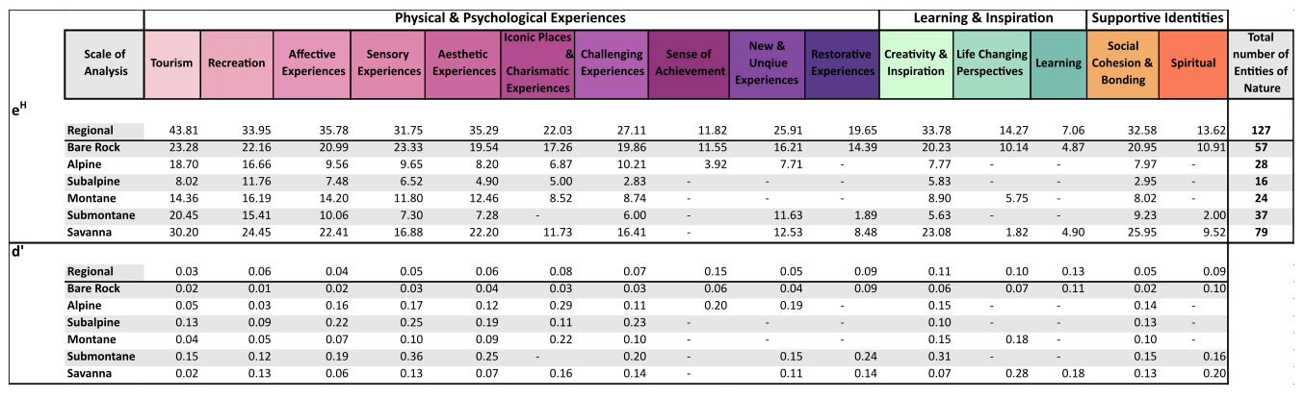

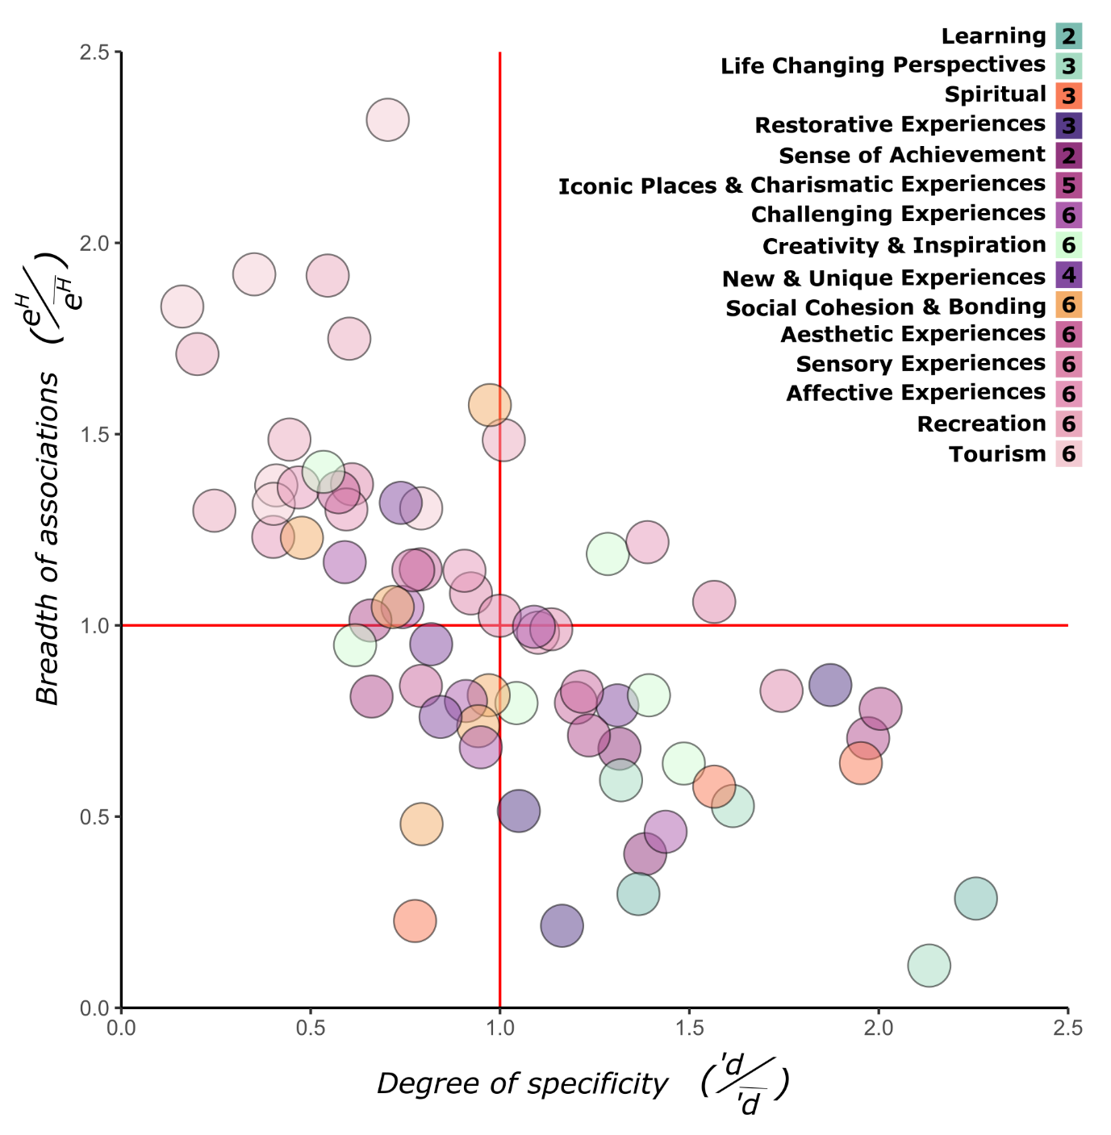
Figure S1. Non-material Nature’s Contribution to People characterization based on their associations with entities of nature (EN) in each habitat type. Local scale of analysis representing the NCP typology for each non-material NCP in each habitat type it occurs based on the breath of association (x-axis) and degree of specificity (y-axis). Number of circles represent the total habitats in which an NCP occur. Breadth of association and degree of specificity are calculated as the standardized values for effectives partners (e^{H}) and degree of complementary specialization (d’), respectively.
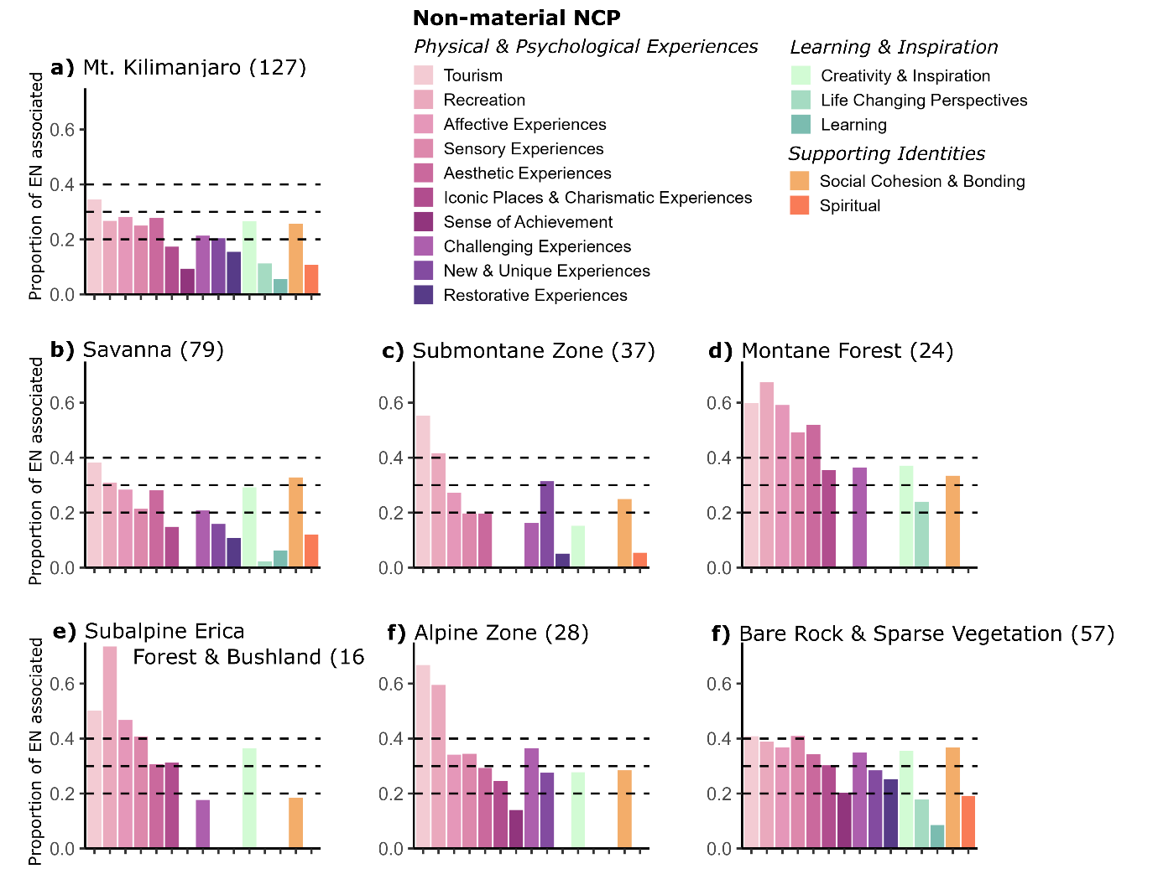
Figure S2. Proportion of available entities of nature (EN) associated with each non-material NCP across Mount Kilimanjaro. (a) meta-network pooling Tweets from the entire dataset to create one bipartite network depicting the regional scale of analysis. (b-f) habitats networks geo-locating Tweets across the six main habitat types to create six bipartite networks, depicting the local scale of analysis. Values in brackets represent the total number of available EN in each network. Dashed lines represent three different levels depicting which NCP are associated with at least 20%, 30% or 40% of the available EN. At a threshold of 30% most NCP will be comparable with Figure 2 from the main text. Those habitat types with a low number of EN mentioned by people (e.g., erica forest, alpine zone and montane forest) tend to be associated with all NCP, that’s why percentages are high despite being relatively associated with few EN.
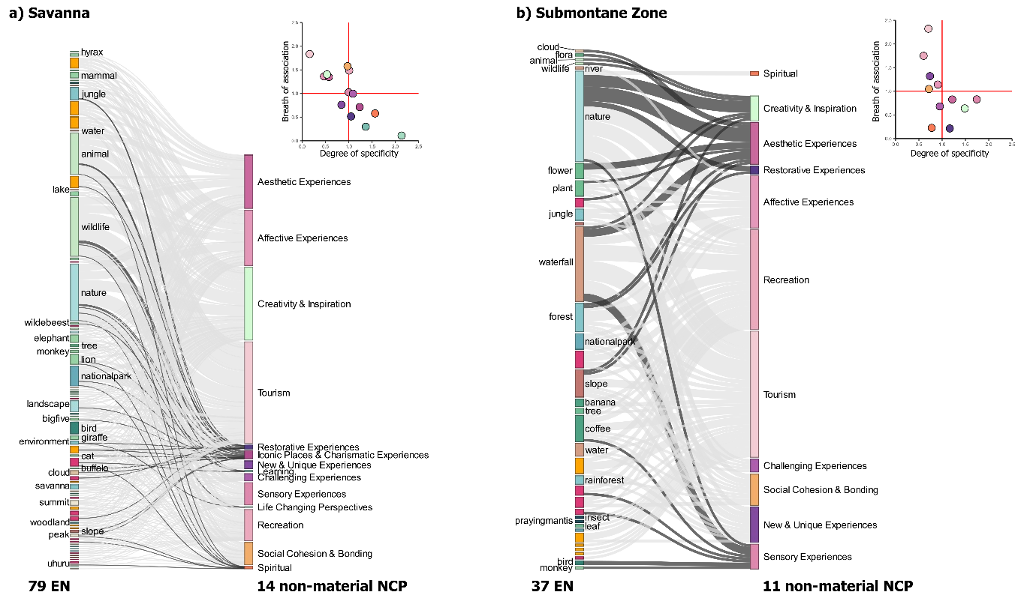
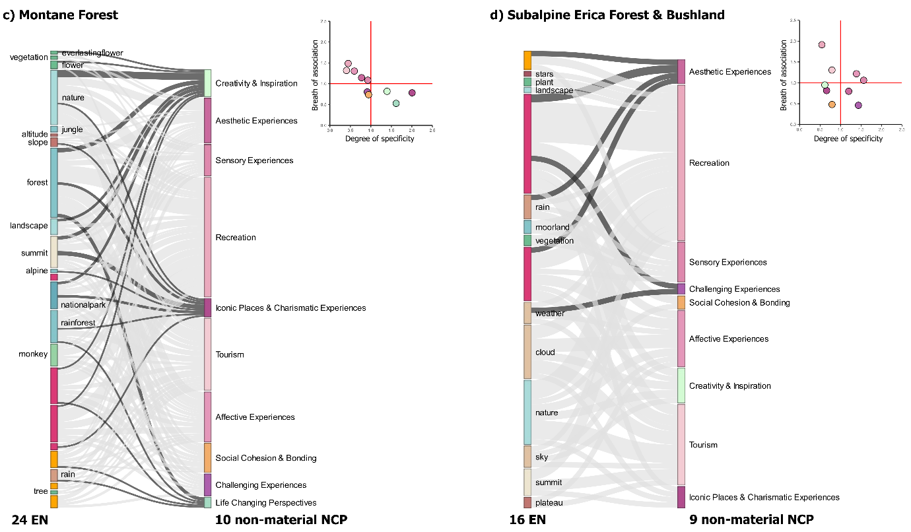
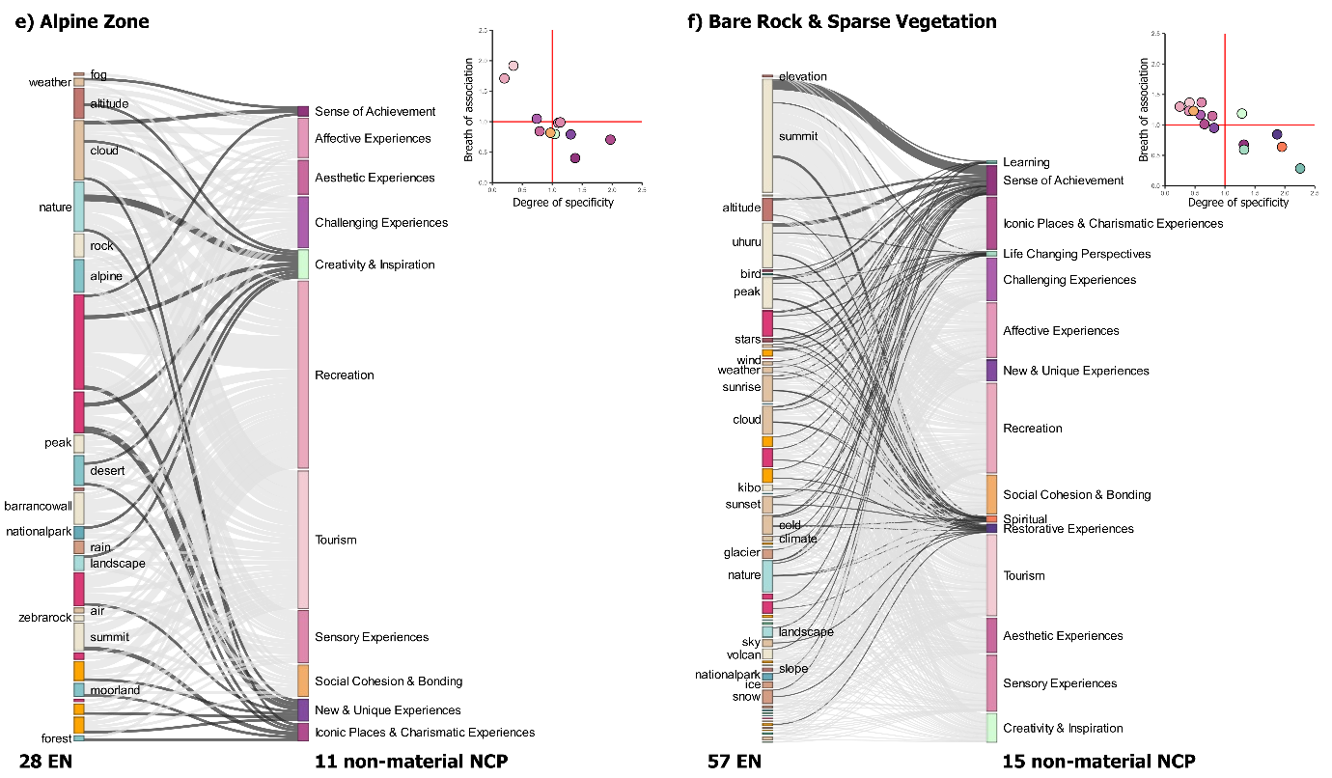
Figure S3. NCP-EN network per habitat type (a-f). Each panel represents a different habitat type (a-f), the first column represents the corresponding perceived entities of nature (EN) and its quantity, and the second column represents the derived non-material NCP and its quantity. The width of the links represents the strength of association, and the highlighted links are specialized associations within each habitat type based on each matrix inset, which considers the bread and specificity of NCP associations with EN. The nodes color palette represents the type of category for EN (abiotic: brown; biotic: green; scale of perception: blue; and human-made: dark orange) and non-material NCP (Physical & Psychological Experiences: pink; Learning & Inspiration: lighter green; Supporting Identities: lighter orange). Mountain EN was removed to facilitate viewing other associations, this entity was associated with all non-material NCP, and it was perceived in all habitat types.
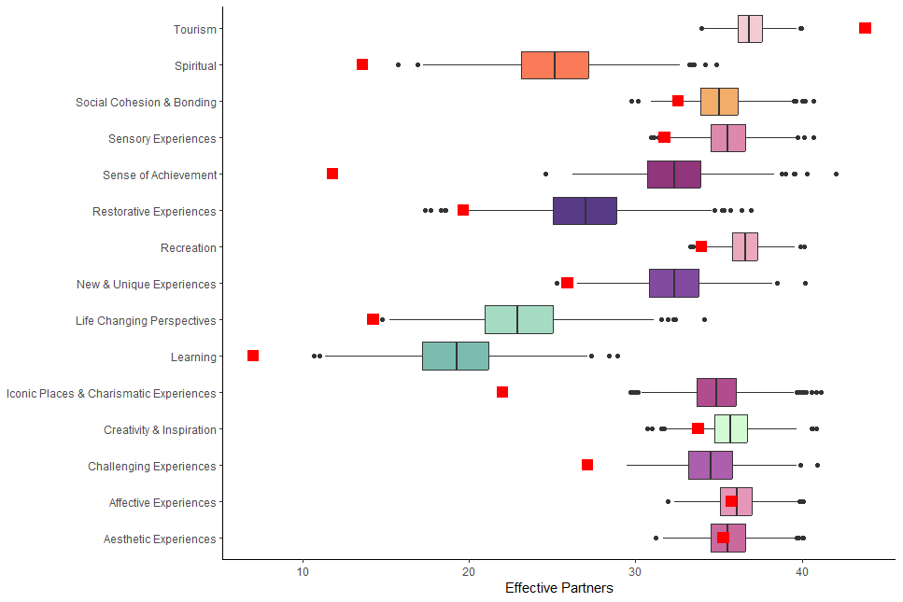
Figure S4. Null models for effective partners. Compared observed values (red squares) against the mean of 1000 independent null models (boxplot). Observed values that do not overlap the null model values, represent those consistently NCP characterized as specialized and generalized. To perform this analysis, we utilized the 'nullmodel' function (from the '‘bipartite'’ package), and applied the “r2dtable” to constrain the network size while randomizing the distribution of links among rows and columns, thereby maintaining constant marginal totals (Dormann et al., 2009).
References
- Barrie, C., & Ho, J. 2021. academictwitteR: an R package to access the Twitter Academic Research Product Track v2 API endpoint. Journal of Open-Source Software 6(62): 3272.
- Degano, M. E., Augustino Kwaslema, S., Böhning-Gaese, K., Hemp, A., Lehnen, L., Martín-López, B., Pearson, J., Mueller, T., and Arbieu, U. 2025. Perceptions of nature and its non-material contributions to people at Mount Kilimanjaro. People and Nature 7: 1697-1712. https://doi.org/10.1002/pan3.70079
- Dormann, C. F., Fründ, J., Blüthgen, N., and Gruber, B. 2009. Indices, Graphs and Null Models: Analyzing Bipartite Ecological Networks. The Open Ecology Journal 2.

