Supplementary Data

Figure S1. Change detection workflow. Classes excluded from the temporal consistency filter: 0 = Unclassified, 3 = Shadow, 5 = No data.

Figure S2. Sampling points for ground-based determination along the pasture-forest transition in the study area of Malga Telvagola. P: pasture; MF: mature spruce forest; YFB: young spruce forest belt.

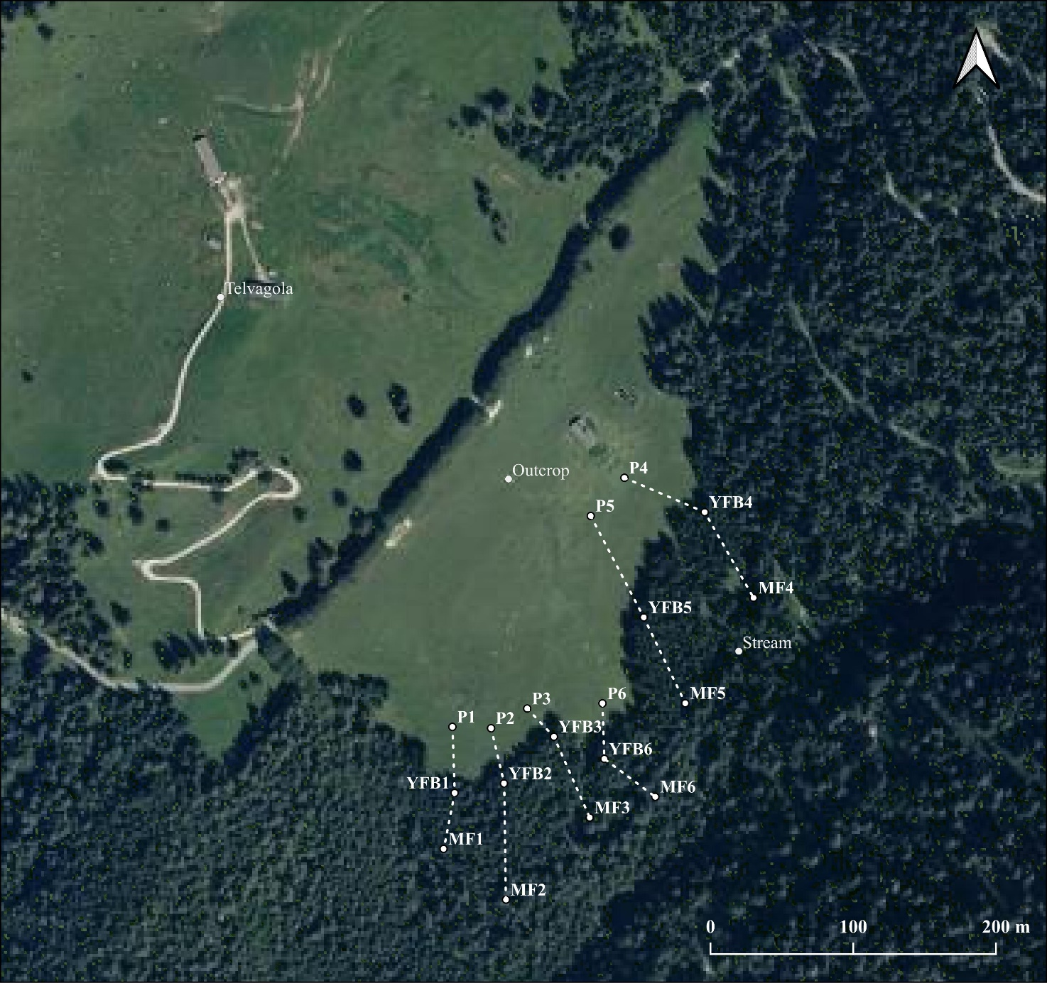

Figure S3. Time series of resident population in Tesino municipalities (Castello Tesino, Cinte Tesino, Pieve Tesino), 1921-2021. Source: ISTAT database.

Table S1. Anonymized details of stakeholders interviewed during the field visit conducted on April 22-24, 2024, in accordance with European data protection and privacy regulations (GDPR).

Interview Number | Stakeholder description | Place and date
1 | Director of the Valsugana Tourist Office | Online, 23/04/2024
2 | Rector of the Castello Tesino Hunters’ ReserveManager of the Garny Canterbury Hotel | Castello Tesino, 22-23/04/2024
3 | Deputy Mayor of Pieve Tesino | Pieve Tesino, 23/04/2024
4 | Former Municipal Forester of Pieve Tesino | Pieve Tesino, 23/04/2024
5 | Current Municipal Forester of Pieve Tesino | Pieve Tesino, 23/04/2024
6 | Castello Tesino Municipal Library officer | Castello Tesino, 23/04/2024
7 | Vice-president of the Woodland Work Documentation Centre | Castello Tesino, 23/04/2024
8 | Deputy Mayor of Castello Tesino  Director of the Tesino Ecomuseum | Castello Tesino, 23/04/2024
9 | Caretaker of the Alpine Study Center | Pieve Tesino, 24/04/2024
10 | Owner of Naturalmente Lagorai, Maso Franz Agrifarm | Pieve Tesino, 24/04/2024
11 | Director of the Territorial Promotion Office of the Chamber of Commerce, Industry and Handicrafts of the Autonomous Province of Trento | Trento, 24/04/2024
12 | Director of the Research and Study Center of the Chamber of Commerce, Industry and Handicrafts of the Autonomous Province of Trento | Trento, 24/04/2024
13 | Keeper, farmer, and cheesemaker at Malga Telvagola | Cognola (TN), 24/04/2024

Table S2. List of the species, botanical family, and biological forms of the main plants living along the pasture-forest transition in the Malga Telvagola site. P: pasture; MF: mature forest of Picea abies; YFB: young forest belt of Picea abies.

Species | Plot | Botanical  Family | Biological  form
Carum carvi L. | P | Apiaceae | H scap
Polygonatum verticillatum (L.) All. | P | Asparagaceae | G rhiz
Achillea millefolium L. | P | Asteraceae | H scap
Arctium sp. | P | Asteraceae | H bienn
Cardus defloratus L. s.l. | P | Asteraceae | H scap
Carlina acaulis L. | P | Asteraceae | H ros
Centaurea montana L. | P | Asteraceae | H scap
Cirsium eriophorum (L.) Scop. | P | Asteraceae | H bienn
Leontodon hispidus L. s.l. | P | Asteraceae | H ros
Leucanthemum ircutianum DC. subsp. ircutianum | P | Asteraceae | H scap
Lophiolepis eriophora (L.) Del Guacchio, Bureš, Iamonico & P.Caputo | P | Asteraceae | H bienn
Taraxacum sect. Taraxacum F. H. Wigg. | P | Asteraceae | H ros
Tragopogon pratensis/orientalis | P | Asteraceae | H scap
Myosotis alpestris F.W. Schmidt | P | Boraginaceae | H scap
Biscutella laevigata L. | P | Brassicaceae | H scap
Phyteuma sp. | P | Campanulaceae | H scap
Knautia drymeja Heuff. s.l. | P | Caprifoliaceae | H scap
Valeriana "gruppo officinalis" | P | Caprifoliaceae | H scap
Cerastium arvense L. subsp. arvense | P | Cariophyllaceae | H scap
Cerastium holosteoides Fr. | P | Cariophyllaceae | H scap
Silene dioica (L.) Clairv. | P | Cariophyllaceae | H scap
Colchicum autumnale L. | P | Colchicaceae | G bulb
Juniperus communis L. | P | Cupressaceae | P caesp
Euphorbia cyparissias L. | P | Euphorbiaceae | H scap
Anthyllis vulneraria L. subsp. alpicola (Brügger) Gutermann | P | Fabaceae | H scap
Lathyrus pratensis L. s.l. | P | Fabaceae | H scap
Lotus corniculatus L. subsp. Alpinus (DC.) Rothm. | P | Fabaceae | H scap
Trifolium pratense L. subsp. pratense | P | Fabaceae | H scap
Trifolium montanum L. subsp. montanum | P | Fabaceae | H scap
Vicia sepium L. | P | Fabaceae | H scap
Vicia cfr. incana Gouan | P | Fabaceae | H scap
Gentiana acaulis L. | P | Gentianaceae | H ros
Hypericum cfr. maculatum Crantz subsp. maculatum | P | Hypericaceae | H scap
Crocus vernus (L.) Hill | P | Iridaceae | G bulb
Luzula multiflora (Ehrh.) Lej. subsp. multiflora | P | Juncaceae | H caesp
Ajuga reptans L. | P | Lamiaceae | Ch rept
Thymus sp. | P | Lamiaceae | Ch frut
Ziziphora granatensis (Boiss. & Reut.) Melnikov subsp. alpina (L.) Bräuchler & Gutermann | P | Lamiaceae | Ch suffr
Veratrum lobelianum Bernh. | P | Melanthiaceae | G rhiz
Dactylorhiza sambucina (L.) Soó | P | Orchidaceae | G bulb
Platanthera bifolia (L.) Rich. | P | Orchidaceae | G bulb
Plantago argentea Chaix subsp. liburnica Ravnik | P | Plantaginaceae | H ros
Plantago media L. subsp. media | P | Plantaginaceae | H ros
Veronica chamaedrys L. s.l. | P | Plantaginaceae | H scap
Anthoxanthum odoratum L. | P | Poaceae | H caesp
Avenula pubescens (Huds.) Dumort. | P | Poaceae | H caesp
Avenula versicolor (Vill.) Lainz | P | Poaceae | H caesp
Agrostis tenuis Sibth. (Agrostis sp.) | P | Poaceae | H caesp
Dactylis glomerata L. s.l. | P | Poaceae | H caesp
Deschampsia caespitosa (L.) P. Beauv. | P | Poaceae | H caesp
Festuca rubra L. (Festuca sp.) | P | Poaceae | H caesp
Phleum rhaeticus (Humphries) Rauschert | P | Poaceae | H caesp
Poa pratensis L. subsp. pratensis | P | Poaceae | H caesp
Poa annua L. | P | Poaceae | T caesp
Polygala alpestris Rchb. subsp. alpestris | P | Polygalaceae | H scap
Rumex arifolius All. | P | Polygonaceae | H scap
Rumex alpinus L. | P | Polygonaceae | H scap
Ranunculus acris L. s.l. | P | Ranunculaceae | H scap
Ranunculus montanus Willd. | P | Ranunculaceae | H scap
Trollius europeaus L. | P | Ranunculaceae | H scap
Alchemilla vulgaris L. | P | Rosaceae | H ros
Geum rivale L. | P | Rosaceae | H scap
Potentilla erecta (L.) Raeusch. | P | Rosaceae | H scap
Potentilla aurea subsp. aurea | P | Rosaceae | H scap
Poterium sanguisorba L. s.l. | P | Rosaceae | H scap
Cruciata glabra (L.) C.Bauhin ex Opiz | P | Rubiaceae | H scap
Cruciata laevips Opiz | P | Rubiaceae | H scap
Galium album Mill. s.l. | P | Rubiaceae | H scap
Galium lucidum All. subsp. lucidum | P | Rubiaceae | H scap
Galium verum L. subsp. verum | P | Rubiaceae | H scap
Verbascum cfr. alpinum Turra | P | Scrophulariaceae | H scap
Urtica dioica L. | P | Urticaceae | H scap
Viola tricolor L. | P | Violaceae | H bienn
Picea abies (L.) H. Karst | P/YFB/MF | Pinaceae | P scap
Petasites albus (L.) Gaertn. | MF | Asteraceae | G rhiz
Oxalis acetosella L. | MF | Oxalidaceae | G rhiz

Table S3. Methodological details on determination of plant and soil functional traits in the Malga Telvagola site.

Leaf pigment determination | Leaf pigments of the main plant species of the pasture-forest transition were determined using a portable MPM-100 multi-pigment meter. This involved measuring the leaf fluorescence (F) ratio to evaluate anthocyanin (Anth, F660nm / F525nm) and flavanol (Flav, F660nm / F325nm) content, as well as assessing leaf transmission in the far red and near infrared to evaluate chlorophyll content (Chl, T850nm / T720nm). The nitrogen-balance index (NBI) was calculated as (T850nm/T720nm) / (F660nm/F325nm), which represents the Chl/Flav ratio.
Leaf mass per area (LMA) determination | Leaf samples were washed with deionized water, and a sub-sample of known areas was obtained using a cork borer of varying diameters, depending on the leaf shape and area. For Picea abies, the projected leaf area of small twigs was measured using a scanner and ImageJ software. Subsequently, leaf samples of known areas were oven-dried at 45°C until they reached a constant weight, which was used to determine the Leaf Mass per Area (LMA) as the ratio of dry leaf mass to leaf area (g m⁻²).
Aggregate and particle size distribution | A laser granulometer, the Mastersizer 2000 (Malvern Panalytical Ltd., UK), was employed to assess the size distribution of soil aggregates ranging from 0.02 to 2000 μm. Subsequently, the samples were sonicated while still in the recirculation system of the granulometer and measured every minute until the size distribution of the dispersed particles stabilized (~10 minutes). The median diameter of soil aggregates (d50) was determined at each measurement interval. The results of the particle size distribution at the end of the sonication period were used to evaluate the textural class. The granulometric curve of the aggregates prior to sonication was compared with that obtained at the conclusion of the ultrasound treatment, and the difference in d50 between the samples before and after sonication was utilized as an index of aggregate stability (ASI) according to Rawlins et al. (2013).
Substrate-induced respiration (SIR) method | Sieved to 2 mm and air-dried soil (1 g) was placed in a vial (volume 12 ml), conditioned to 60% of water holding capacity determined for each soil separately and kept for 7 days at incubation temperatures (22°C) and constant soil humidity. On the 7th day, glucose solution (0.1 ml g⁻¹, 10 mg g⁻¹) was added, and the vials were immediately sealed and flushed with zero air. The glucose-enriched soil was incubated for 3 hours, the CO₂ concentration in the vials was determined from the peak height measured with IRMS (Isoprime Cheadle, UK) coupled to multiflow and calibrated against standard gas concentrations and the SIR rate was expressed in µL CO₂ g⁻¹ soil h⁻¹.
Soil enzymatic activities | To determine the soil enzymatic activities, re-wetted soil samples were treated with 25 ml Na-acetate buffer (pH 5.5) and homogenized with UltraTurrax (IKA) for 1 min at 9600 g. Then an aliquot of suspension (100 μL) was withdrawn and dispensed into a 96-well microplate where 100 μL of substrate solution 1 mM was added to obtain a final substrate concentration of 500 μM. An automated fluorometric plate-reader (Infinite F200 pro TECAN) was used to measure fluorescence (excitation 360 nm; emission 450 nm) after 0, 30, 60, 120, and 180 min of incubation and enzyme activities were calculated as μmol MUB g⁻¹ C h⁻¹.
Carbon and nitrogen concentration and stable isotope analyses in the soil-plant system | Leaf samples were washed with deionized water, oven-dried at 45°C until they achieved a constant weight and then grounded into a fine powder. An aliquot of each dried leaf sample was analyzed to determine the concentration and isotope composition of carbon (δ¹³C) and nitrogen (δ¹⁵N) using an IRMS (Isoprime, Cheadle, UK) coupled to an elemental analyser (NA1500, Carlo Erba, Milan, Italy) at the CNR-IRET laboratory.  The concentrations of total carbon and total nitrogen of soils were measured on air-dried soil samples sieved with 2 mm mesh using a FlashEA 1112 elemental analyser at the CNR-IGG laboratory, with measurements calibrated against Acetanilide and Urea standards. The carbonate content of the samples expressed as Total Inorganic Carbon (TIC) was determined through gasometry (with calibration to pure calcite) as described by Leone et al. (1988). Soil Organic Carbon (SOC) was quantified from the difference between TC and TIC.  For the isotopic analysis, an aliquot of the soil sample was treated with 10% HCl to remove carbonate, washed several times with deionized water to neutral pH, and then dried again at 40 °C. Isotopic composition of bulk organic matter was obtained by evolving CO₂ by combustion using a FlashEA 1112 elemental analyser, interfaced to a DeltaQ mass spectrometer (ThermoFisher) via the Conflo IV interface. Samples for stable isotopes on total nitrogen were analyzed for ¹⁵N/¹⁴N ratios without further pre-treatment by continuous flow elemental analysis isotope ratio mass spectrometry (CF-EA-IRMS), as well as for δ¹³C determination.  International standards USGS-40 (δ¹³C = - 26.39 ‰ and δ¹⁵N = - 4.52 ‰), IAEA-N1 (δ¹⁵N = + 0.4 ‰), IAEA-CH₆ (δ¹³C = - 10.45 ‰) and IAEA-CH7 (δ¹³C = - 32.15%) were analysed during each run for calibrating the results and within-run standards (graphite and ammonium chloride) measured in order to check the instrument functioning and possible drift deviations. The results of carbon (δ¹³C) and nitrogen (δ¹⁵N) isotope ratio analyses were reported in per mill (‰) on the relative δ-scale and referred to the following international standards: V-PDB (Vienna Pee Dee Belemnite) for the carbon isotope ratio and atmospheric air for the nitrogen isotope ratio. Average analytical reproducibility was about ± 0.15‰ for δ¹³C and ± 0.2‰ for δ¹⁵N.
Leone G, Leoni L, Sartori F (1988) Revisione di un metodo gasometrico per la determinazione di calcite e dolomite. Atti Soc Tosc Sc Nat, Mem, Serie A, 95: 7-20.
Rawlins BG, Wragg J, Lark RM (2013) Application of a novel method for soil aggregate stability measurement by laser granulometry with sonication. Eur J Soil Sci 64(1): 92-103. https://doi.org/10.1111/ejss.12017

Table S4. Leaf functional traits of plant species collected along the pasture-forest transition in the Malga Telvagola site. LMA: leaf mass per area; Chl: chlorophyll index; Flav: flavanol index; Anth: anthocyanin index; NBI: nitrogen balance index; C: carbon concentration; N: nitrogen concentration; C/N: carbon to nitrogen ratio; δ¹³C: carbon isotope composition; δ¹⁵N: nitrogen isotope composition. Values are means ± standard error (nd: not determined).
Species | Plot | Family | LMA  (g m⁻²) | Chl  (r.u.) | Flav  (r.u.) | Anth  (r.u.) | NBI  (r.u.) | C  (%) | N  (%) | C/N | δ¹³C  (‰) | δ¹⁵N  (‰)
Anthoxanthum odoratum | Pasture | Poaceae | 91.5±2.0 | nd | nd | nd | nd | 44.41±0.04 | 1.73±0.05 | 25.74±0.80 | -28.52±0.06 | -1.87±0.02
Avenula pubescens | Pasture | Poaceae | 89.0±0.6 | nd | nd | nd | nd | 43.32±0.68 | 1.83±0.27 | 25.16±3.36 | -28.88±0.18 | -0.82±0.02
Dactylis glomerata | Pasture | Poaceae | 106.8±5.5 | 0.38±0.08 | 1.04±0.10 | 0.25±0.05 | 0.37±0.05 | 43.83±0.38 | 2.23±0.19 | 20.38±1.78 | -27.95±0.18 | -0.14±0.34
Deschampsia caespitosa | Pasture | Poaceae | 132.3±10.2 | 0.58±0.08 | 0.98±0.03 | 0.26±0.04 | 0.64±0.10 | 45.37±2.44 | 2.12±0.24 | 22.65±2.00 | -27.73±0.17 | -0.26±0.38
Festuca rubra | Pasture | Poaceae | 90.1±10.9 | 0.43±0.06 | 0.94±0.06 | 0.21±0.03 | 0.48±0.06 | 42.97±0.66 | 1.80±0.24 | 26.72±3.67 | -28.42±0.31 | -0.76±0.64
Phleum rhaeticus | Pasture | Poaceae | 88.8±5.1 | 0.48±0.05 | 1.07±0.05 | 0.30±0.07 | 0.44±0.04 | 43.81±0.25 | 2.37±0.06 | 18.57±0.53 | -27.34±0.17 | 0.47±0.40
Poa pratensis | Pasture | Poaceae | 94.7±4.9 | 0.51±0.03 | 0.98±0.06 | 0.25±0.03 | 0.62±0.06 | 43.96±0.32 | 2.11±0.27 | 22.73±3.00 | -27.51±0.18 | -0.95±0.22
Lathyrus pratensis | Pasture | Fabaceae | 40.8±3.3 | 0.65±0.06 | 0.97±0.09 | 0.17±0.04 | 0.75±0.08 | 44.22±0.58 | 3.65±0.26 | 12.41±0.80 | -28.63±0.12 | 0.01±0.52
Trifolium pratense | Pasture | Fabaceae | 35.5±1.0 | 1.01±0.08 | 1.03±0.07 | 0.23±0.02 | 1.04±0.12 | 42.61±0.74 | 3.72±0.25 | 11.67±0.65 | -29.02±0.30 | -1.40±0.07
Trifolium montanum | Pasture | Fabaceae | 36.2±3.6 | 0.97±0.09 | 0.91±0.07 | 0.18±0.03 | 1.17±0.10 | 42.44±0.25 | 3.69±0.33 | 11.98±1.07 | -29.36±0.24 | -0.84±0.24
Vicia sepium | Pasture | Fabaceae | 47.7±0.3 | 0.83±0.11 | 1.43±0.09 | 0.13±0.01 | 0.58±0.07 | 43.30±0.61 | 3.41±0.50 | 13.13±1.52 | -28.72±0.29 | -0.88±0.24
Plantago media | Pasture | Plantaginaceae | 93.1±0.7 | 0.63±0.06 | 0.60±0.05 | 0.01±0.01 | 0.98±0.05 | 44.12±0.04 | 2.46±0.02 | 17.92±0.18 | -28.81±0.73 | -0.54±0.04
Veronica chamaedrys | Pasture | Plantaginaceae | 48.4±0.7 | 0.64±0.07 | 1.14±0.05 | 0.21±0.04 | 0.60±0.07 | 43.79±0.21 | 2.68±0.26 | 16.63±1.47 | -30.43±0.61 | -1.24±0.19
Ranunculus acris | Pasture | Ranunculaceae | 91.8±1.8 | 0.86±0.08 | 1.41±0.07 | 0.12±0.01 | 0.62±0.07 | 41.55±0.45 | 2.55±0.05 | 16.31±0.15 | -27.91±0.02 | 1.40±0.10
Trollius europeaus | Pasture | Ranunculaceae | 84.9±9.9 | 0.35±0.10 | 0.93±0.10 | 0.02±0.01 | 0.38±0.07 | 41.62±0.55 | 2.53±0.34 | 17.04±2.24 | -26.47±0.16 | -1.09±0.37
Achillea millefolium | Pasture | Asteraceae | 47.5±3.5 | 0.40±0.05 | 0.94±0.06 | 0.12±0.03 | 0.45±0.06 | 42.31±0.35 | 2.88±0.27 | 15.33±1.14 | -29.64±0.16 | -0.79±0.44
Taraxacum officinale | Pasture | Asteraceae | 41.9±5.1 | 0.62±0.03 | 0.97±0.08 | 0.07±0.02 | 0.82±0.18 | 40.96±0.38 | 3.22±0.35 | 14.34±1.90 | -29.45±0.20 | -0.50±0.32
Alchemilla vulgaris | Pasture | Rosaceae | 74.7±4.8 | 0.70±0.03 | 1.21±0.04 | 0.04±0.01 | 0.60±0.04 | 42.98±0.34 | 2.81±0.11 | 15.46±0.43 | -27.80±0.14 | -1.17±0.35
Cruciata laevips | Pasture | Rubiaceae | 63.8±4.4 | 0.64±0.06 | 1.23±0.09 | 0.27±0.04 | 0.59±0.08 | 42.03±0.73 | 2.64±0.33 | 17.42±3.01 | -28.68±0.36 | -1.29±0.36
Rumex arifolius | Pasture | Polygonaceae | 44.2±0.8 | 0.52±0.06 | 0.82±0.05 | 0.11±0.03 | 0.65±0.08 | 40.63±0.13 | 3.96±0.06 | 10.27±0.11 | -28.20±0.10 | 4.49±1.49
Crocus vernus | Pasture | Iridaceae | 60.0±3.0 | 1.13±0.24 | 1.31±0.14 | 0.08±0.01 | 0.85±0.09 | 43.75±0.67 | 3.20±0.17 | 13.74±0.54 | -28.03±0.12 | 2.77±0.02
Picea abies | Young forest | Pinaceae | 225.2±14.9 | 0.51±0.02 | 1.50±0.02 | 0.17±0.02 | 0.34±0.02 | 46.88±0.58 | 1.04±0.08 | 47.09±3.67 | -28.17±0.09 | -1.21±0.17
Picea abies | Old forest | Pinaceae | 194.0±11.7 | 0.42±0.02 | 1.42±0.02 | 0.15±0.02 | 0.30±0.02 | 46.65±0.44 | 1.21±0.06 | 39.49±1.97 | -27.58±0.19 | -2.91±0.36

