Supplementary Information
Identification of a Cowden syndrome patient with a novel PTEN mutation and establishment of patient-derived induced pluripotent stem cells
Fumitaka Obayashi¹, Atsuko Hamada¹, Sachiko Yamasaki¹, Taku Kanda³, Shigeaki Toratani², Tetsuji Okamoto^{2,4}
¹ Oral and Maxillofacial Surgery, Hiroshima University Hospital, Hiroshima, Japan
² Department of Molecular Oral Medicine and Maxillofacial Surgery, Graduate School of Biomedical and Health Science, Hiroshima University, Hiroshima, Japan
³ Oral and maxillofacial Surgery, Hiroshima Prefectural Hospital, Hiroshima, Japan
⁴ School of Medical Sciences, The University of East Asia, Shimonoseki 751-8503, Yamaguchi, Japan

Journal name: In Vitro Cellular & Developmental Biology - Animal
Correspondence: Tetsuji Okamoto Email address: tetsuok@hiroshima-u.ac.jp
Correspondence: Atsuko Hamada E-mail: hamaco@hiroshima-u.ac.jp
Department of Molecular Oral Medicine and Maxillofacial Surgery, Division of Applied Life Science, Graduate Institute of Biomedical and Health Science, Hiroshima University,
1-2-3, Kasumi, Minami-ku, Hiroshima-city, Hiroshima 734-8553, Japan

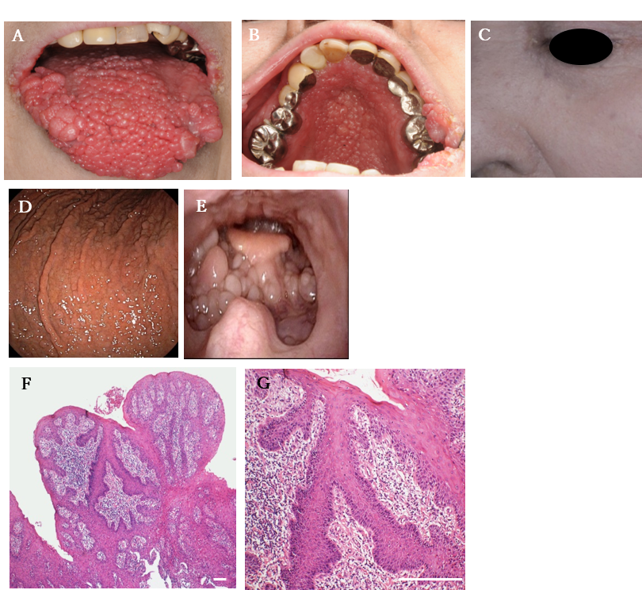
Supplementary data 1. (A, B): Cobblestone-like lesions over the tongue (A) and palate (B). (C) Keratotic papules on facial skin. (D, E): Fiber scope showing multiple polyps in the pharynx (D) and gastrointestinal tract (E). (F, G): Histological findings reveal verrucous mucosal hyperplasia in the buccal mucosa. (Scale bar,100µm)

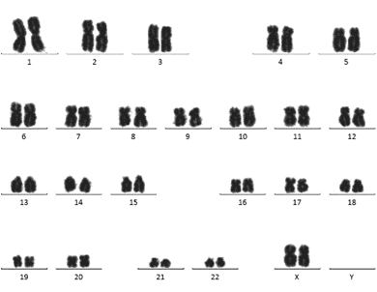
【A】 CS-iPSC passage 48

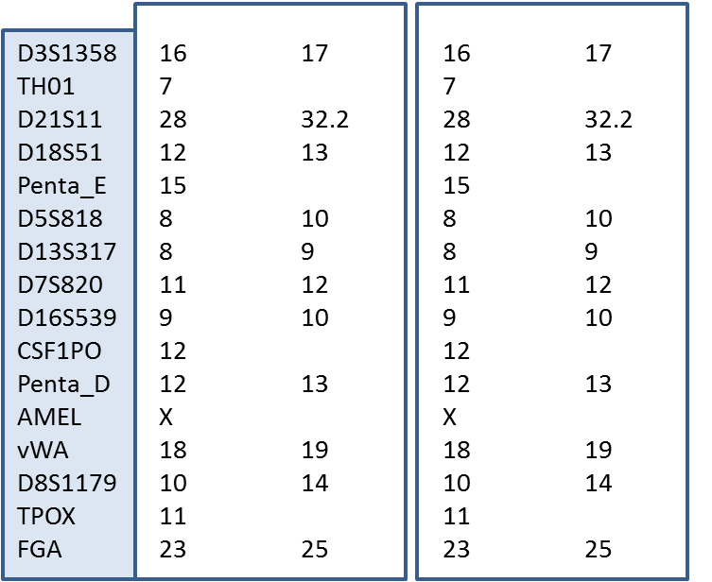
【B】
CS-iPSC passage48
CS-PBMC

Supplementary data 2. Karyotype analysis of CS-iPSCs passage 48 (A). STR analysis of CS-iPSCs (B).

