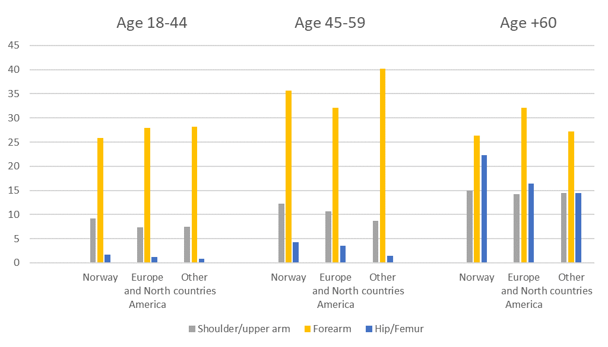
Proportion of subsequent fractures (%)
Supplementary Fig 1 Distribution of major subsequent fractures in patients with an index forearm fracture 2008–2019 divided into three regions of origin and by age

