Supporting Information
Table S1. Film thickness d_{LLZO} used for the evaluation of the data gathered during electrochemical characterization of the samples utilized in this study. The data presented were obtained from representative substrates that were included in each fabrication batch and not used during electrochemical characterization but. d_{LLZO} was measured at six distinct locations, and the average value was used for the evaluation of the data.
figure | characterization method | d_{LLZO} / µm
3 | As-deposited PAD-LLZO film:  - Hebb-Wagner Polarization | 33.0  29.3  32.3  37.3  34.8  34.7 | 33.4
3, 4 | As-deposited PAD-LLZO film:  - determination of activation energy (Arrhenius plot)  - CCD determination | 29.6  31.0  33.5  31.7  29.9  31.0 | 31.1
6 | PAD-LLZO film annealed at 400 °C for 1 h:  - Hebb-Wagner Polarization | 41.8  45.0  39.5  43.5  47.8  35.5 | 42.1
6, 7 | PAD-LLZO film annealed at 400 °C for 1 h:  - determination of activation energy (Arrhenius plot)  - CCD determination | 27.1  27.1  40.0  25.7  29.1  42.9 | 32.0
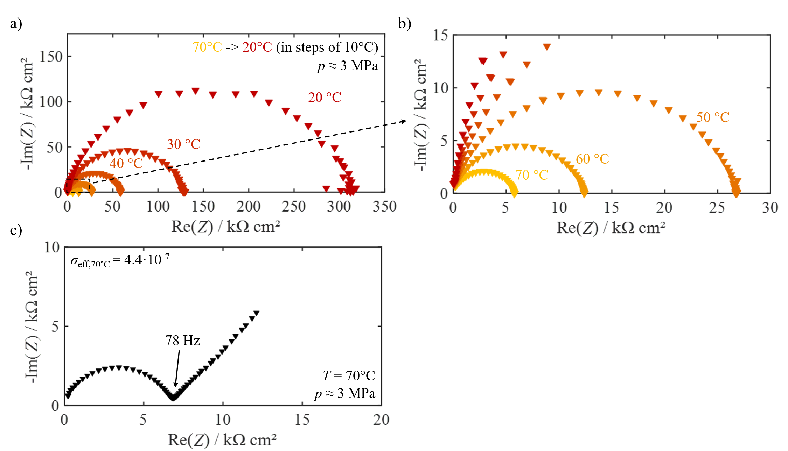
Figure S1: a), b) Temperature-dependent EIS spectra of an as-deposited PAD-LLZO film in the temperature range 70°C (yellow) to 20°C (red). c) EIS spectrum measured at 70°C of an as-deposited PAD-LLZO film during Hebb-Wagner polarization to determine σ_{eff}. The applied external pressure was ~ 3MPa.

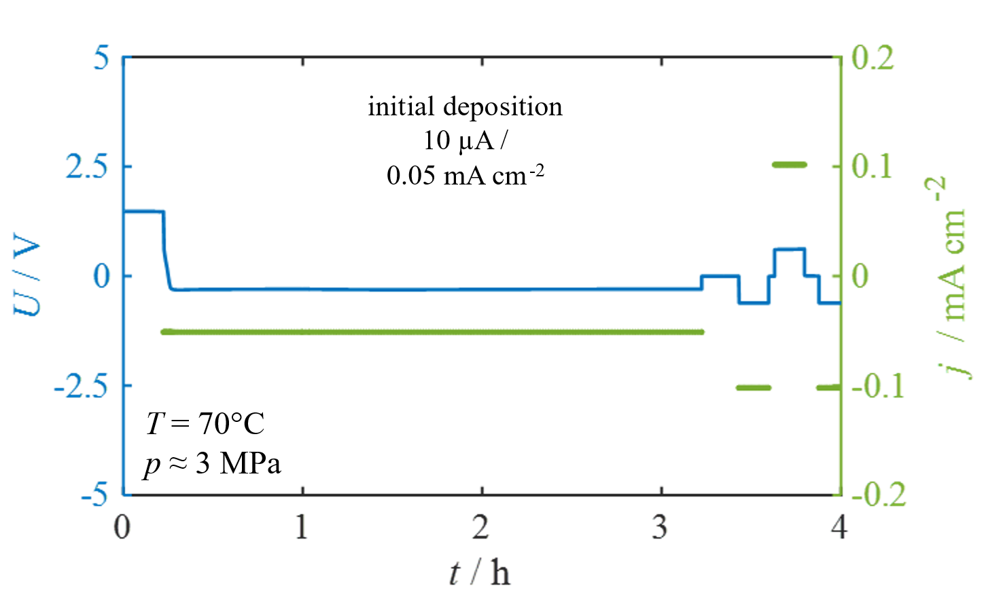
Figure S2. Initial lithium electrodeposition for the PAD-LLZO electrochemically characterized in the as-deposited state (Figure 3). The applied external pressure was ~ 3MPa at a temperature of 70°C.

Table S2. Results of the equivalent circuit fitting of the EIS measurements displayed in Figure 3 c). The applied model structure is R₁Q₁.
R₁ / Ω cm² | Q₁ / F | α ₁
5.8·10³ | 5.4·10⁻⁹ | 0.82
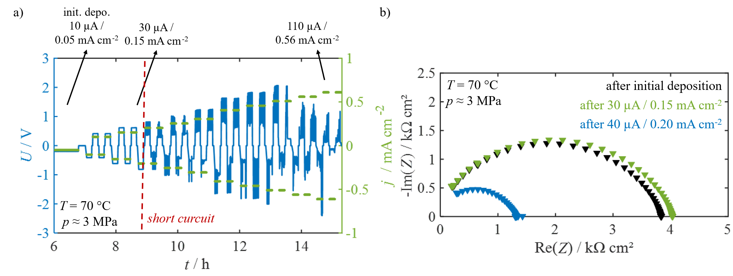
Figure S3: Determination of the CCD of an as-deposited PAD-LLZO film in a Cu|Li|LLZO|Li cell setup: a) Stripping and plating of lithium (the duration of the initial deposition was extended to approximately 7 h, c) EIS spectra measured during the CCD determination. The applied external pressure throughout all characterizations steps was ~ 3 MPa at 70°C.

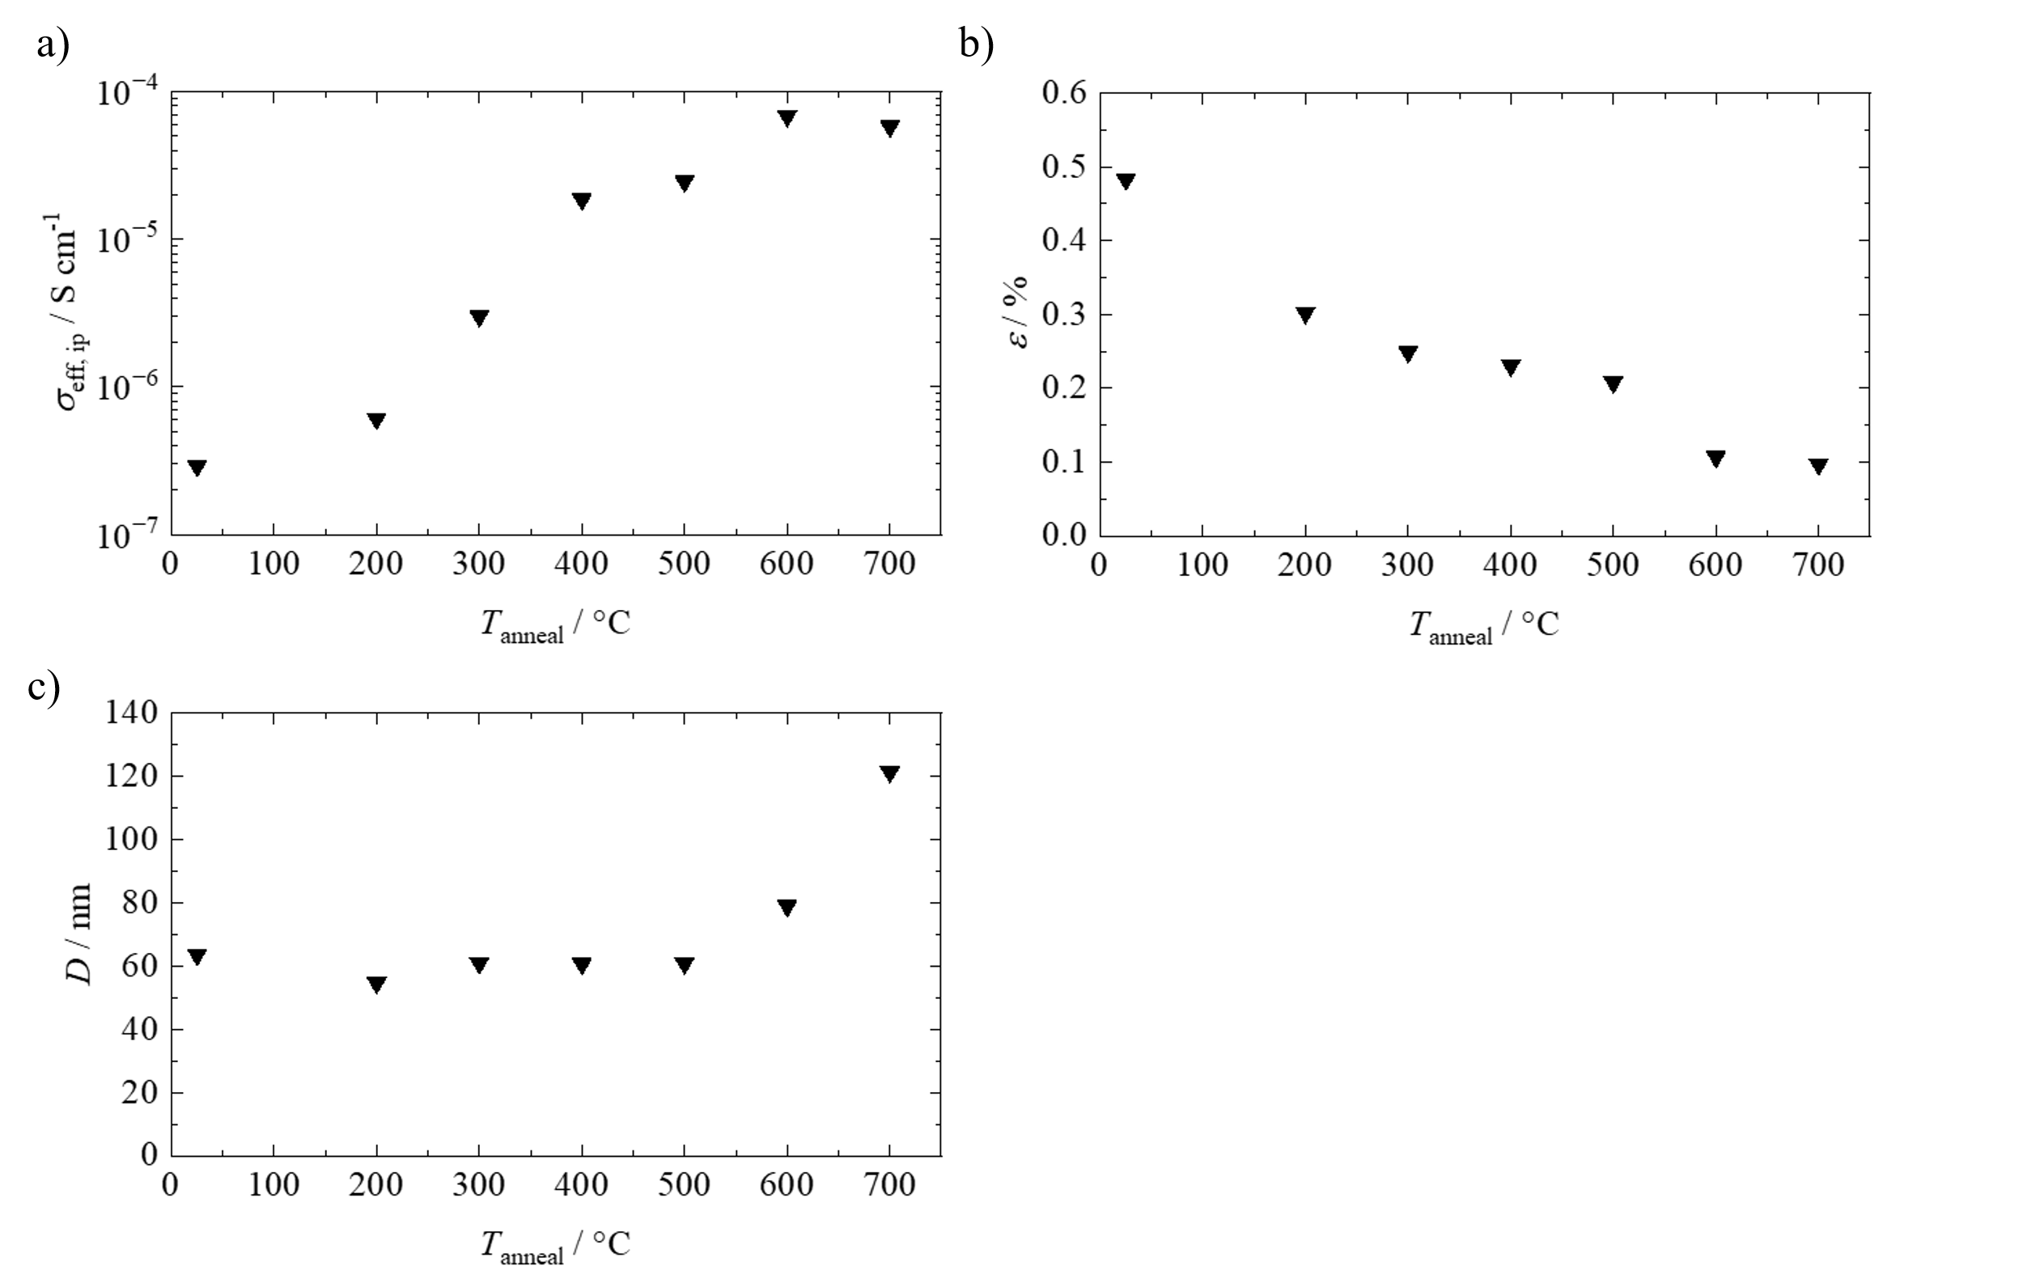
Figure S4. Graphical representation of the study by Hanft et al. on the effect of thermal annealing on various properties of PAD-LLZO films. a) In-plane conductivity (σ_{eff, ip}) measured at room temperature, b) microstrain ε₀, and c) crystallite size D of PAD-LLZO films as a function of the annealing temperature (T_{anneal}) in the range from 25°C to 700°C. The graphical representation presented herein is created based on data from Hanft et al.(Ref. 14).

In Figure S4 the in-plane conductivity σ_{eff, ip}, the microstrain ε₀, and the crystallize size D as a function of the annealing temperature, ranging from 25°C to 700°C with dwell times of 1 h as obtained in a study by Hanft et al. are given (Ref. 14). The values for σ_{eff, ip}, were measured at room temperature on screen-printed gold interdigital electrodes and are assigned to the ionic conductivity of the film. The ε₀ and D were determined by a Rietveld refinement of XRD data acquired on PAD-LLZO films deposited on silicon wafers.
Figure S4 a) shows that the conductivity σ_{eff, ip} can be increased up to two orders of magnitude from approximately 10⁻⁷ S cm⁻¹ to approximately 10⁻⁵ S cm⁻¹ by annealing the samples at 400°C. At higher temperatures, there is a further, but less pronounced increase in σ_{eff, ip}. For the microstrain ε₀, a continuous decrease is observed over the entire range of T_{anneal}. The microstrain decreases from 0.48 % in the as-deposited state to 0.23 % at 400°C and 0.10 % at 700°C, respectively (c.f. Figure S4 b)). The crystallite size D (Figure S4 c)) is not affected by annealing up to 500°C. At T_{anneal} = 600°C and 700°C, D increases from approximately 60 nm to 80 nm and 120 nm, respectively (green markers).

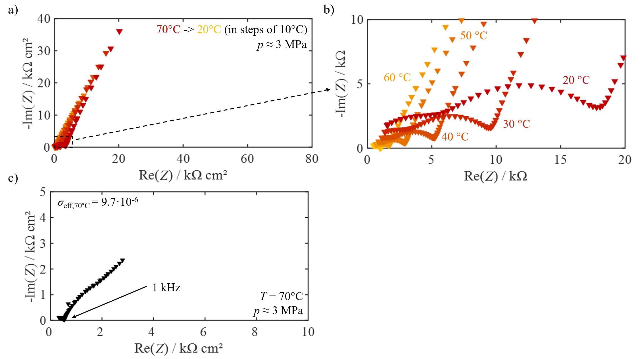
Figure S5: a), b) Temperature-dependent EIS spectra of a PAD-LLZO film annealed at 400°C for 1 h in the temperature range 70°C (yellow) to 20°C (red). c) EIS spectrum measured at 70°C of a PAD-LLZO film annealed at 400°C for 1 h during Hebb-Wagner polarization to determine σ_{eff}. The applied external pressure was ~ 3 MPa.

Table S3. Results of the equivalent circuit fit of the EIS measurement before the initial lithium electrodeposition displayed in Figure 5 c) and d). The applied model structure is R₁Q₁-R₂Q₂-Q_{Int}.
R₁ / Ω cm² | Q₁ / F | α₁ | R₂ / Ω cm² | Q₂ / F | α₂ | Q_{Int} / F | α_{Int}
114 | 5.6·10⁻⁹ | 0.88 | 4.6·10² | 7.6·10⁻⁸ | 0.88 | 2.8·10⁻⁵ | 0.56

Table S4. Overview on the result of the cycling experiment conducted on PAD-LLZO films annealed at 400°C for 1 h in a Cu|LLZO|Li cell setup.
Cell Nr. | d_{LLZO}/ µm | observation
1 | 32.0 | - intact cell BOL  - potential drop after approx. 1 h during initial lithium electrodeposition  - after initial lithium electrodeposition only real part of impedance to be observed
2 | 32.0 | - intact cell BOL  - potential drop after approx. 0.25 h during initial lithium electrodeposition  - after initial lithium electrodeposition only real part of impedance to be observed
3 | 35.0 | - intact cell BOL  - potential drop after approx. 0.75 h during initial lithium electrodeposition  - after initial lithium electrodeposition only real part of impedance to be observed
4 | 19.8 | - intact cell BOL  - potential drop after approx. 1.5 h during initial lithium electrodeposition
5 | 16.5 | - intact cell BOL  - constant decrease in potential during initial lithium electrodeposition  - potential drop after approx. 8.5 h during initial lithium electrodeposition  - after initial lithium electrodeposition only real part of impedance to be observed
6 | 16.5 | - intact cell BOL  - potential drop after approx. 0.7 h during initial lithium electrodeposition

