Supplemental materials

Table 2a Descriptive statistics of consent with retrospective use of interventional radiology data
 | All respondents  (n=2409) |  |  | Respondents with reading time > 12.3 seconds (n=769)
 | Never permission | Permission with explicit patient consent | Permission without explicit patient consent | Never permission | Permission with explicit patient consent | Permission without explicit patient consent
By the hospital | 73 (3.0%) | 1574 (65.4%) | 760 (31.6%) | 13 (1.7%) | 438 (56.9%) | 318 (41.3%)
By a university | 263 (10.9%) | 1745 (72.5%) | 399 (16.6%) | 59 (7.7%) | 510 (66.2%) | 200 (26.0%)
By other non-commercial institutions | 451 (18.7%) | 1629 (67.7%) | 327 (13.6%) | 114 (14.8%) | 488 (63.4%) | 167 (21.7%)
By commercial firms | 1521 (63.2%) | 829 (34.4%) | 57 (2.4%) | 509 (66.1%) | 235 (30.5%) | 25 (3.2%)
By government agencies | 506 (21.0%) | 1541 (64.0%) | 360 (15.0%) | 152 (19.7%) | 464 (60.3%) | 153 (19.9%)

Figures 1a-2e

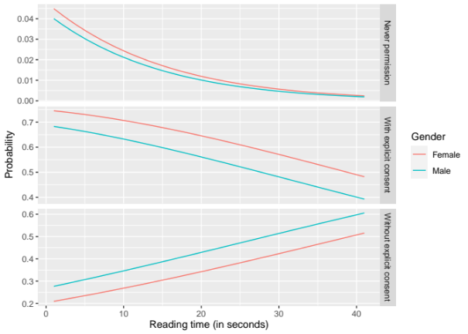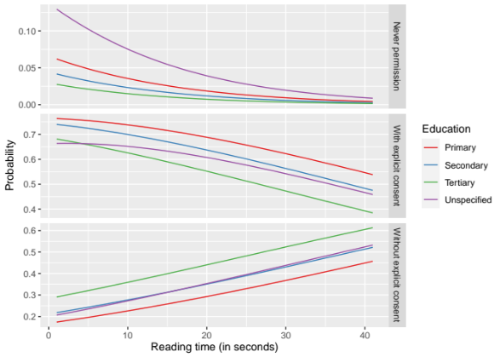
Figure 2a Should patients approve use of retrospective data by a hospital?
Specified for level of education and reading time of an explanation of retrospective radiology research

Figure 1a Should patients approve use of retrospective data by a hospital?
Specified for gender and reading time of an explanation of retrospective radiology research

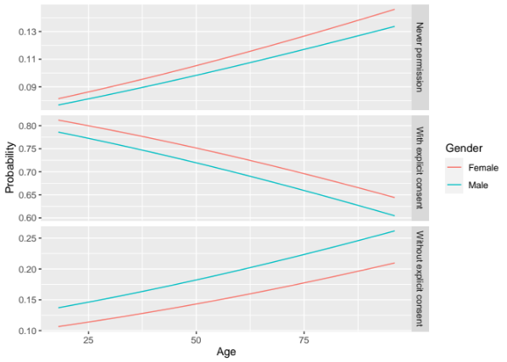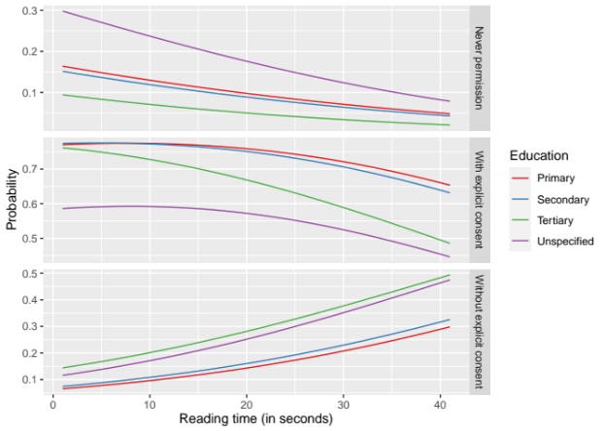
Figure 2b Should patients approve use of retrospective data by a university?
Specified for level of education and reading time of an explanation of retrospective radiology research

Figure 1b Should patients approve use of retrospective data by a university?
Specified for gender and reading time of an explanation of retrospective radiology research

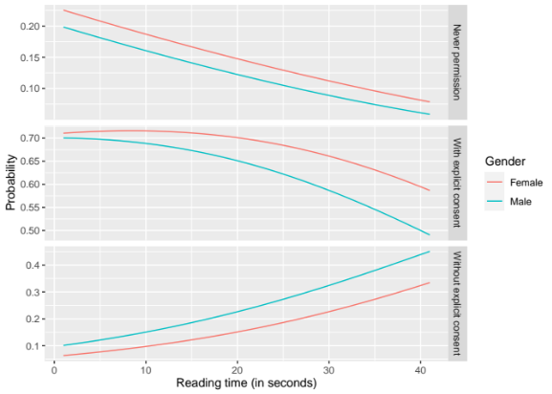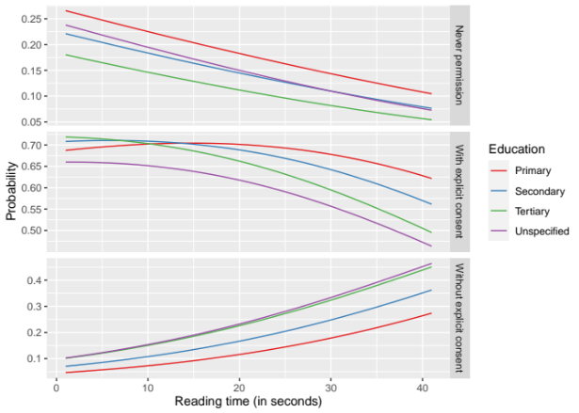
Figure 1c Should patients approve use of retrospective data by a non-commercial organization?
Specified for gender and reading time of an explanation of retrospective radiology

Figure 2c Should patients approve use of retrospective data by a non-commercial organization?
Specified for level of education and reading time of an explanation of retrospective radiology

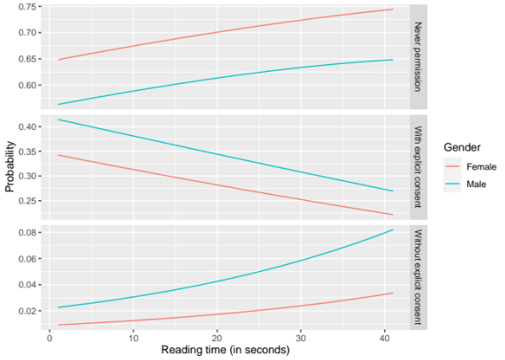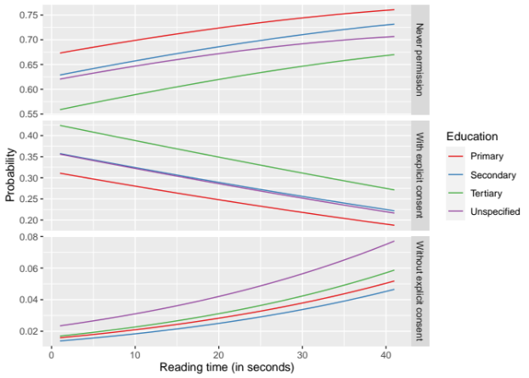
Figure 2d Should patients approve use of retrospective data by a commercial organization?
Specified for level of education and reading time of an explanation of retrospective radiology

Figure 1d Should patients approve use of retrospective data by a commercial organization?
Specified for gender and reading time of an explanation of retrospective radiology

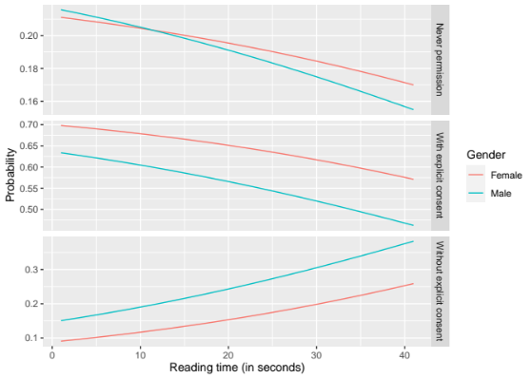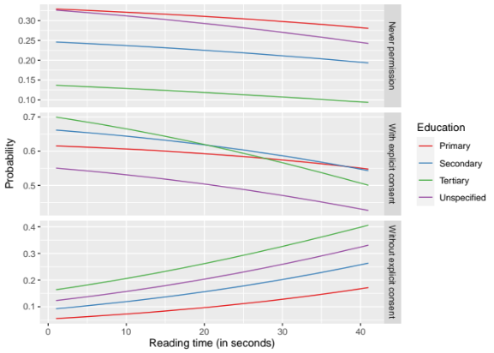
Figure 2e Should patients approve use of retrospective data by a governmental organization?
Specified for level of education and reading time of an explanation of retrospective radiology

Figure 1e Should patients approve use of retrospective data by a governmental organization?
Specified for gender and reading time of an explanation of retrospective radiology

