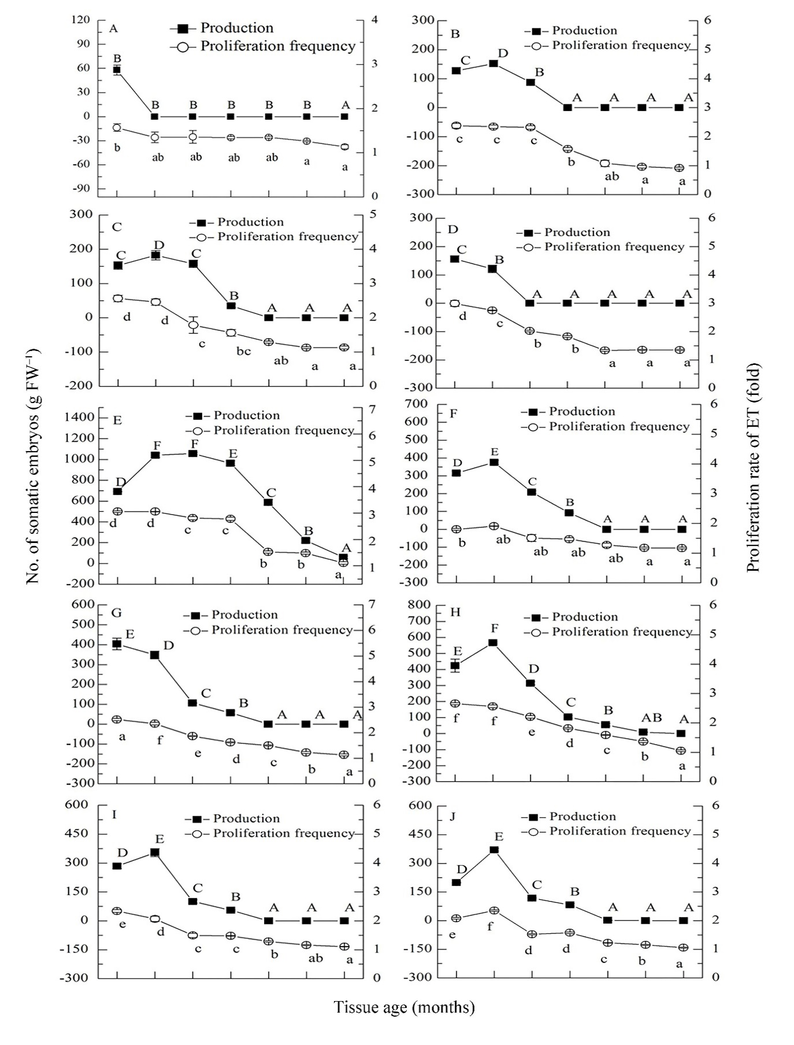
Fig. S1 Mean number (±SE) of somatic embryos produced and proliferation rate of embryonic tissue (ET) with tissue age of Pinus thunbergii. Cell lines: (A) 1536-1. (B) 1536-2. (C) 1536-3. (D)1536-4. (E)1539-1. (F)1637-1. (G)1637-4. (H)1637-5. (I)1637-8. (J) 1637-9. Different lower case letters indicate a significant difference at a tissue age, different upper case letters indicate a significant difference in production at a tissue age (Duncan’s test). Three replicates were prepared per cell lines.

