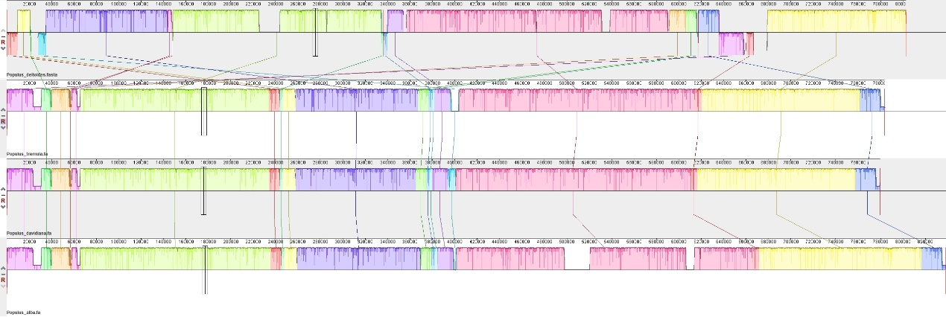
Fig. S1 Collinearity relationship of four poplar mitogenomes.

