Appendix

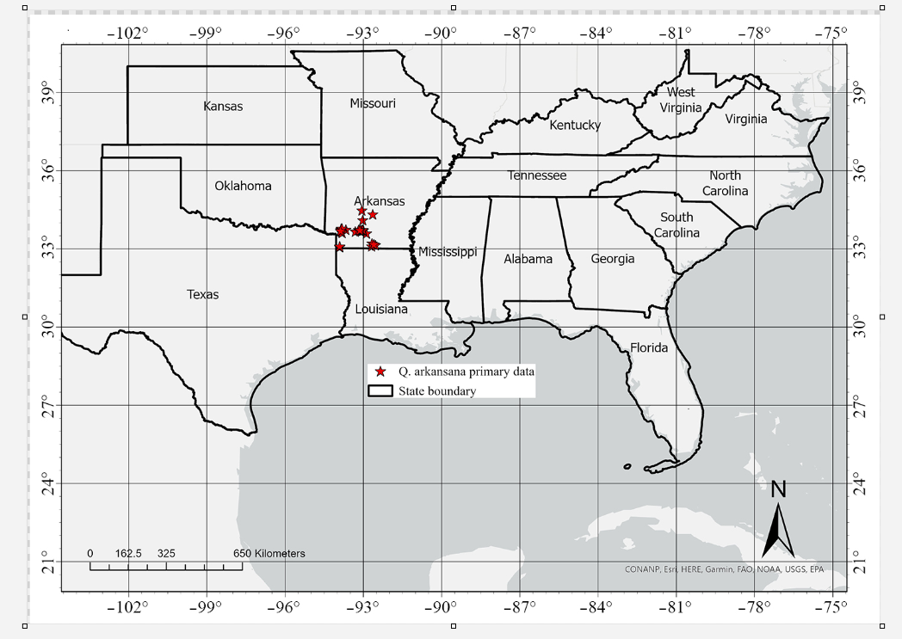
Fig. S1 Current populations sampled across areas in Arkansas, 89 locations.

Fig. S2 Variance Inflation Factors (VIFs) for environmental variables. Environmental variables were selected with variance inflation factors (VIF) < 5.

Table S1 Bioclimatic and topographic variables considered for the habitat attributes of Q. arkansana.
Variables | Code | Unit
Annual Mean Temperature | BIO 1 | °C
Mean Diurnal Range [Mean of monthly (Max Temperature - Min Temperature)] | BIO 2 | °C
Isothermality (BIO 2/BIO 7) (*100) | BIO 3 | %
Temperature Seasonality (Standard Deviation*100) | BIO 4 | °C
Max Temperature of Warmest Month | BIO 5 | °C
Min Temperature of Coldest Month | BIO 6 | °C
Temperature Annual Range (BIO 5-BIO 6) | BIO 7 | °C
Mean Temperature of Wettest Quarter | BIO 8 | °C
Mean Temperature of Driest Quarter | BIO 9 | °C
Mean Temperature of Warmest Quarter | BIO 10 | °C
Mean Temperature of Coldest Quarter | BIO 11 | °C
Annual Precipitation | BIO 12 | mm
Precipitation of Wettest Month | BIO 13 | mm
Precipitation of Driest Month | BIO 14 | mm
Precipitation Seasonality (Coefficient of Variation) | BIO15 | mm
Precipitation of Wettest Quarter | BIO 16 | Millimeter
Precipitation of Driest Quarter | BIO 17 | Millimeter
Precipitation of Warmest Quarter | BIO 18 | Millimeter
Precipitation of Coldest Quarter | BIO 19 | Millimeter
Elevation | Elevation | m
Slope | Slope | Degree
Aspect | Aspect

Table S2 Pearson correlations among selected environmental variables used for species distribution modelling. Environmental variables were checked for multi-collinearity, those with correlation coefficients > 0.7 were excluded.
Variables | Elevation | Slope | Aspect | Bio2 | Bio3 | Bio8 | Bio9 | Bio10 | Bio13 | Bio15
Slope | 0.5
Aspect | 0 | 0.04
Bio2 | 0.28 | 0.03 | -0.04
Bio3 | -0.34 | –0.04 | –0.02 | 0.26
Bio8 | –0.11 | –0.21 | –0.06 | –0.07 | 0.15
Bio9 | –0.53 | –0.12 | 0 | 0.02 | 0.63 | –0.22
Bio10 | –0.56 | –0.44 | –0.07 | 0.18 | 0.55 | 0.3 | 0.53
Bio13 | –0.45 | –0.06 | 0.03 | –0.26 | 0.54 | –0.08 | 0.53 | 0.27
Bio15 | 0.12 | –0.24 | –0.08 | 0.19 | 0.1 | 0.52 | –0.26 | 0.39 | –0.05
Bio18 | –0.31 | –0.02 | 0.04 | –0.34 | 0.39 | 0.1 | 0.2 | –0.08 | 0.67 | –0.09

Table S3 Predicted current suitable habitat of Quercus arkansana inside the protected area system in federal (FED), state (STAT), and total (km²) across different state. Protected area shapefile was downloaded from PAD-US database, managed in part by the United States Geological Survey and Gap Analysis Project (Gergley and McKerrow 2013; USGS 2022).
State | Protected Area Designation Type |  | Protected area
State | FED | STAT | Total (km²)
Alabama | 1814 | 395 | 2209
Arkansas | 739 | 509 | 1248
Florida | 1695 | 476 | 2171
Georgia | 868 | 148 | 1016
Kansas |  |  | 0
Kentucky |  |  | 0
Louisiana | 834 | 80 | 914
Missouri |  |  | 0
Mississippi | 2376 | 664 | 3040
North Carolina |  |  | 0
Oklahoma | 263 | 30 | 293
South Carolina |  |  | 0
Tennessee |  |  | 0
Texas | 1256 |  | 1256
Virginia |  |  | 0
West Virginia |  |  | 0
Total | 9845 | 2302 | 12147

Table S4 Predicted future (2050, 2070, and 2090) suitable habitat of Quercus arkansana inside the protected area system in federal (FED), state (STAT), and total (km²) across different states under three climate change scenarios (SSP126, SSP245, and SSP585). Protected area shapefile was downloaded from PAD-US database, managed in part by the United States Geological Survey and Gap Analysis Project (Gergley and McKerrow 2013; USGS2022).
State | Year | SSP126 |  |  | SSP245 |  |  | SSP585
State | Year | FED | STAT | Total (km²) | FED | STAT | Total (km²) | FED | STAT | Total (km²)
Alabama
 | 2050 | 4443 | 911 | 5354 | 760 | 184 | 944 | 365 | 373 | 738
 | 2070 | 3537 | 532 | 4069 | 407 | 460 | 867 | 5 | 11 | 16
 | 2090 | 4054 | 790 | 4844 |  | 45 | 45 |  |  | 0
Arkansas |  |  |  | 0 |  |  | 0 |  |  | 0
 | 2050 | 1244 | 216 | 1460 | 25 |  | 25 | 2 |  | 2
 | 2070 | 400 |  | 400 |  |  | 0 |  |  | 0
 | 2090 | 989 | 1 | 990 |  |  | 0 |  |  | 0
Florida |  |  |  | 0 |  |  | 0 |  |  | 0
 | 2050 | 3 | 79 | 82 |  |  | 0 | 22 | 112 | 134
 | 2070 | 196 | 612 | 808 | 257 | 624 | 881 |  |  | 0
 | 2090 | 15 | 183 | 198 |  |  | 0 |  |  | 0
Georgia |  |  |  | 0 |  |  | 0 |  |  | 0
 | 2050 | 2160 | 779 | 2939 | 1155 | 451 | 1606 | 1352 | 446 | 1798
 | 2070 | 2504 | 966 | 3470 | 2552 | 779 | 3331 | 2868 | 512 | 3380
 | 2090 | 2447 | 957 | 3404 | 390 | 252 | 642 | 3 |  | 3
Kansas
 | 2050 |  |  | 0 |  |  | 0 |  |  | 0
 | 2070 |  |  | 0 |  |  | 0 |  |  | 0
 | 2090 |  |  | 0 |  |  | 0 |  |  | 0
Kentucky
 | 2050 | 1565 | 159 | 1724 | 1243 | 101 | 1344 | 2996 | 215 | 3211
 | 2070 | 2262 | 107 | 2369 | 6235 | 337 | 6572 | 831 | 384 | 1215
 | 2090 | 3178 | 186 | 3364 | 5524 | 516 | 6040 |  |  | 0
Louisiana
 | 2050 |  |  | 0 |  |  | 0 | 1 |  | 1
 | 2070 |  |  | 0 |  |  | 0 | 9 |  | 9
 | 2090 |  |  | 0 |  |  | 0 |  |  | 0
Missouri
 | 2050 | 27 |  | 27 |  |  | 0 |  |  | 0
 | 2070 |  |  | 0 |  |  | 0 |  |  | 0
 | 2090 |  |  | 0 |  |  | 0 |  |  | 0
Mississippi
 | 2050 | 11 | 1 | 12 |  |  | 0 |  |  | 0
 | 2070 |  |  | 0 |  |  | 0 |  |  | 0
 | 2090 | 98 |  | 98 |  |  | 0 |  |  | 0
North Carolina |  |  |  | 0 |  |  | 0 |  |  | 0
 | 2050
 | 2070 | 6 | 37 | 43 | 12 | 43 | 55 |  |  | 0
 | 2090 |  |  | 0 |  | 1 | 1 |  |  | 0
Oklahoma |  |  |  | 0 |  |  | 0 |  |  | 0
 | 2050
 | 2070 | 32 |  | 32 |  |  | 0 |  |  | 0
 | 2090 | 88 |  | 88 |  |  | 0 |  |  | 0
South Carolina
 | 2050 | 99 | 89 | 188 |  |  | 0 | 324 | 134 | 458
 | 2070 | 153 | 133 | 286 | 559 | 153 | 712 | 205 | 147 | 352
 | 2090 | 134 | 114 | 248 |  |  | 0 |  |  | 0
Tennessee
 | 2050 | 2535 | 2009 | 4544 | 1352 | 598 | 1950 | 1054 | 1253 | 2307
 | 2070 | 2532 | 1535 | 4067 | 2472 | 2187 | 4659 | 1541 | 1180 | 2721
 | 2090 | 2409 | 2119 | 4528 | 696 | 1802 | 2498 |  |  | 0
Texas
 | 2050 |  |  | 0 |  |  | 0 |  |  | 0
 | 2070 |  |  | 0 |  |  | 0 | 1 |  | 1
 | 2090 |  |  | 0 |  |  | 0 |  |  | 0
Virginia
 | 2050 |  |  | 0 |  |  | 0 |  |  | 0
 | 2070 |  |  | 0 |  |  | 0 | 243 | 17 | 260
 | 2090 |  |  | 0 |  |  | 0 | 104 | 28 | 132
West Virginia
 | 2050 |  |  | 0 |  |  | 0 |  |  | 0
 | 2070 |  |  | 0 |  |  | 0 | 35 | 102 | 137
 | 2090 |  |  | 0 |  |  | 0 | 4 |  | 4
Total |  |  |  |  |  |  |  |  |  | 0
 | 2050 | 12087 | 4243 | 16330 | 4535 | 1334 | 5869 | 6116 | 2533 | 8649
 | 2070 | 11622 | 3922 | 15544 | 12494 | 4583 | 17077 | 7903 | 2184 | 10087
 | 2090 | 13412 | 4350 | 17762 | 6610 | 2616 | 9226 | 111 | 28 | 139

