Supplementary Figures
Fig. S1 Artificial stem bending for tension wood induction in P. alba ‘berolinensis’. Trunk sections with the same height and length (red frames in figure) were removed from the treatment and normal groups. The upper side of the leaning trunks was collected as TW, the lower side was collected as OW, and the developing xylem from the straight trunks was collected as NW.

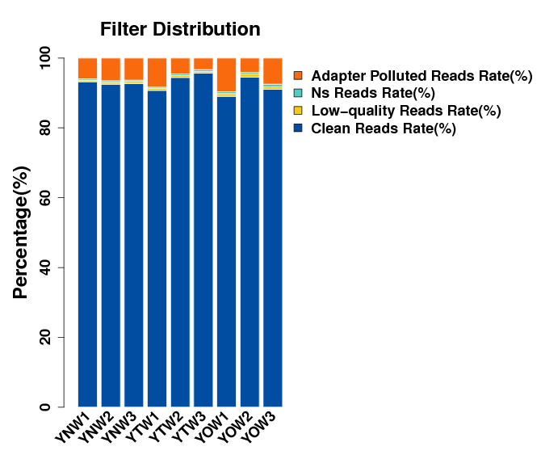
Fig. S2 Histogram of data filtering. Histogram can directly reflect the quality of sequencing data. The higher the proportion of Clean Reads, the better the data quality. The abscissa represents the name of the sample, and the ordinate represents the proportion of the four sequences.

Fig. S3 UpSetR plot depicting the number of unique and shared unigenes between NT, NR, BLASTP, and BLASTX databases. NT represents comparison data between transcripts and the NT database; NR represents comparison data between transcripts and the NR database; BLASTX represents comparison data between transcripts and the UniProt database; BLASTP represents comparison data between ORFs and the UniProt database. Points connected by lines represent the intersection of multiple sets. The bottom left (bar chart) in the figure is the size of each set; The lower right is the intersection of various sets, where black dots indicate yes and gray dots indicate no. The number above each bar represents total number of unigenes in that category.

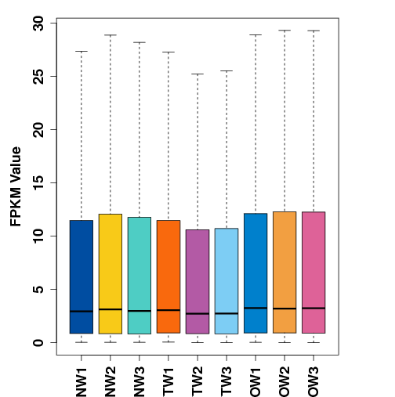
Fig. S4 FPKM value distribution of unigenes in the TW, OW and NW transcriptomes of P. alba ‘Berolinensis’. The abscissa represents 9 samples, and the ordinate represents the FPKM value.

Fig. S5 DEG analysis in the TW, OW and NW transcriptomes of P. alba ‘Berolinensis’ A Statistics on the number of DEGs. B UpSetR plot of DEGs.

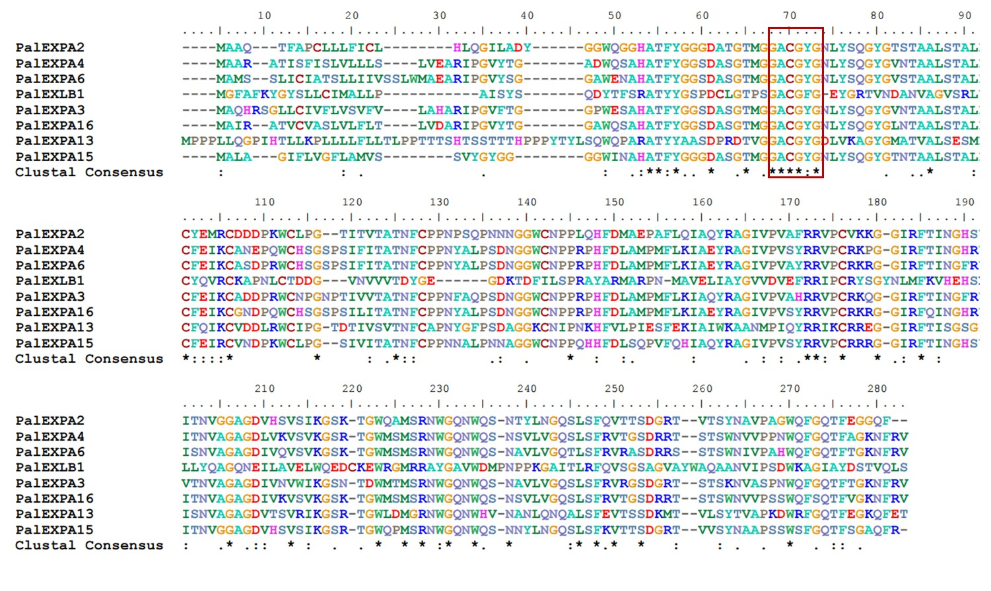
Fig. S6 Multiple sequence alignment of the EXP proteins in P. alba ‘Berolinensis’. The red box indicates a conserved domain.

