Supplementary materials
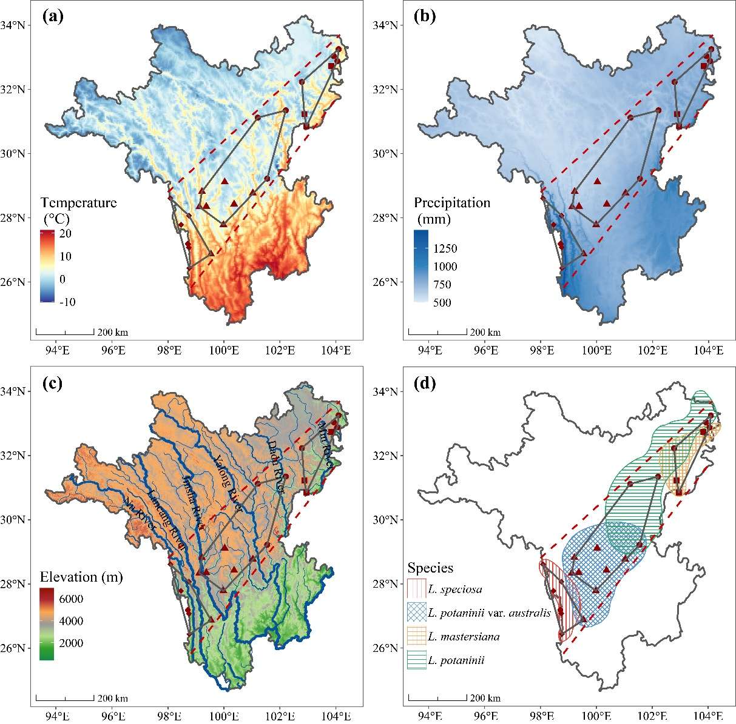
Fig S1. Climatic, geographical, and biogeographical context of the study area in the Hengduan Mountains. (a) Spatial pattern of mean annual temperature for the period 1960–2022. (b) Spatial pattern of total annual precipitation for the period 1960–2022. (c) Major river watersheds. (d) Distribution of the studied Larix species.

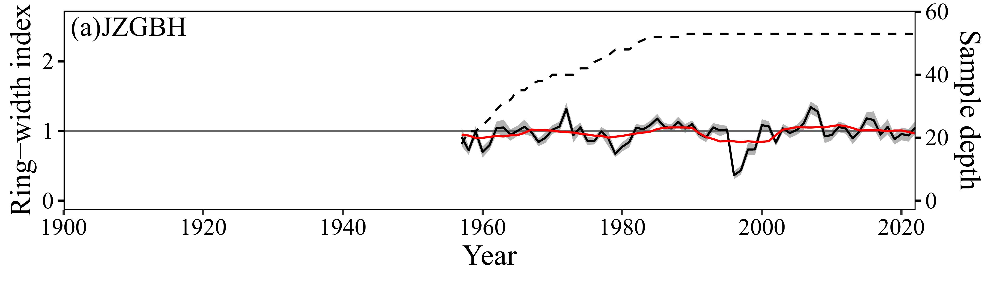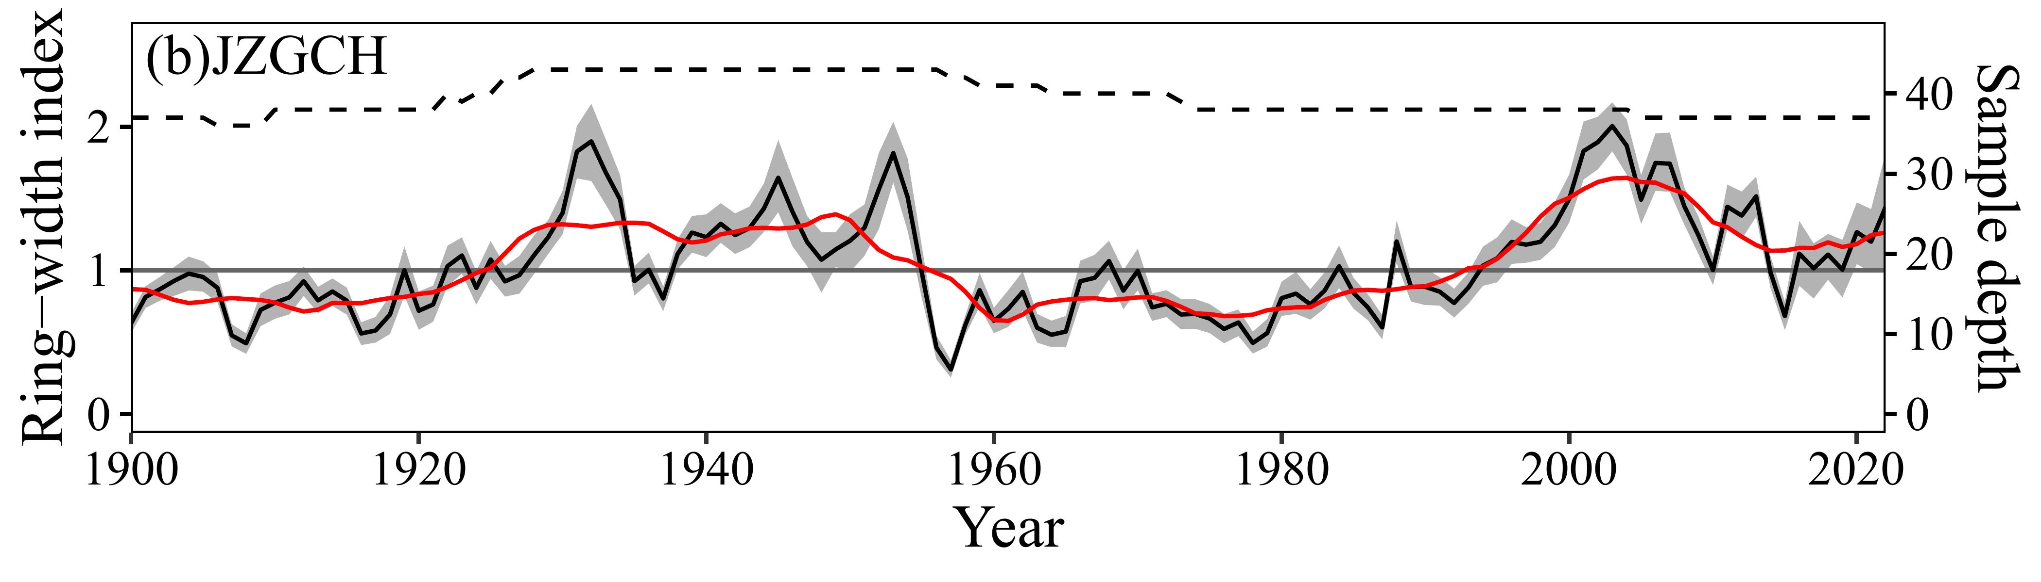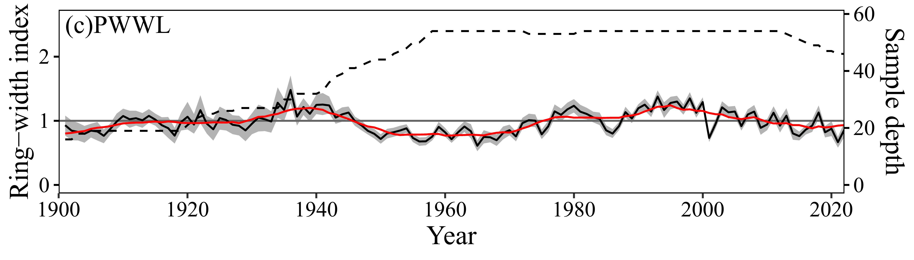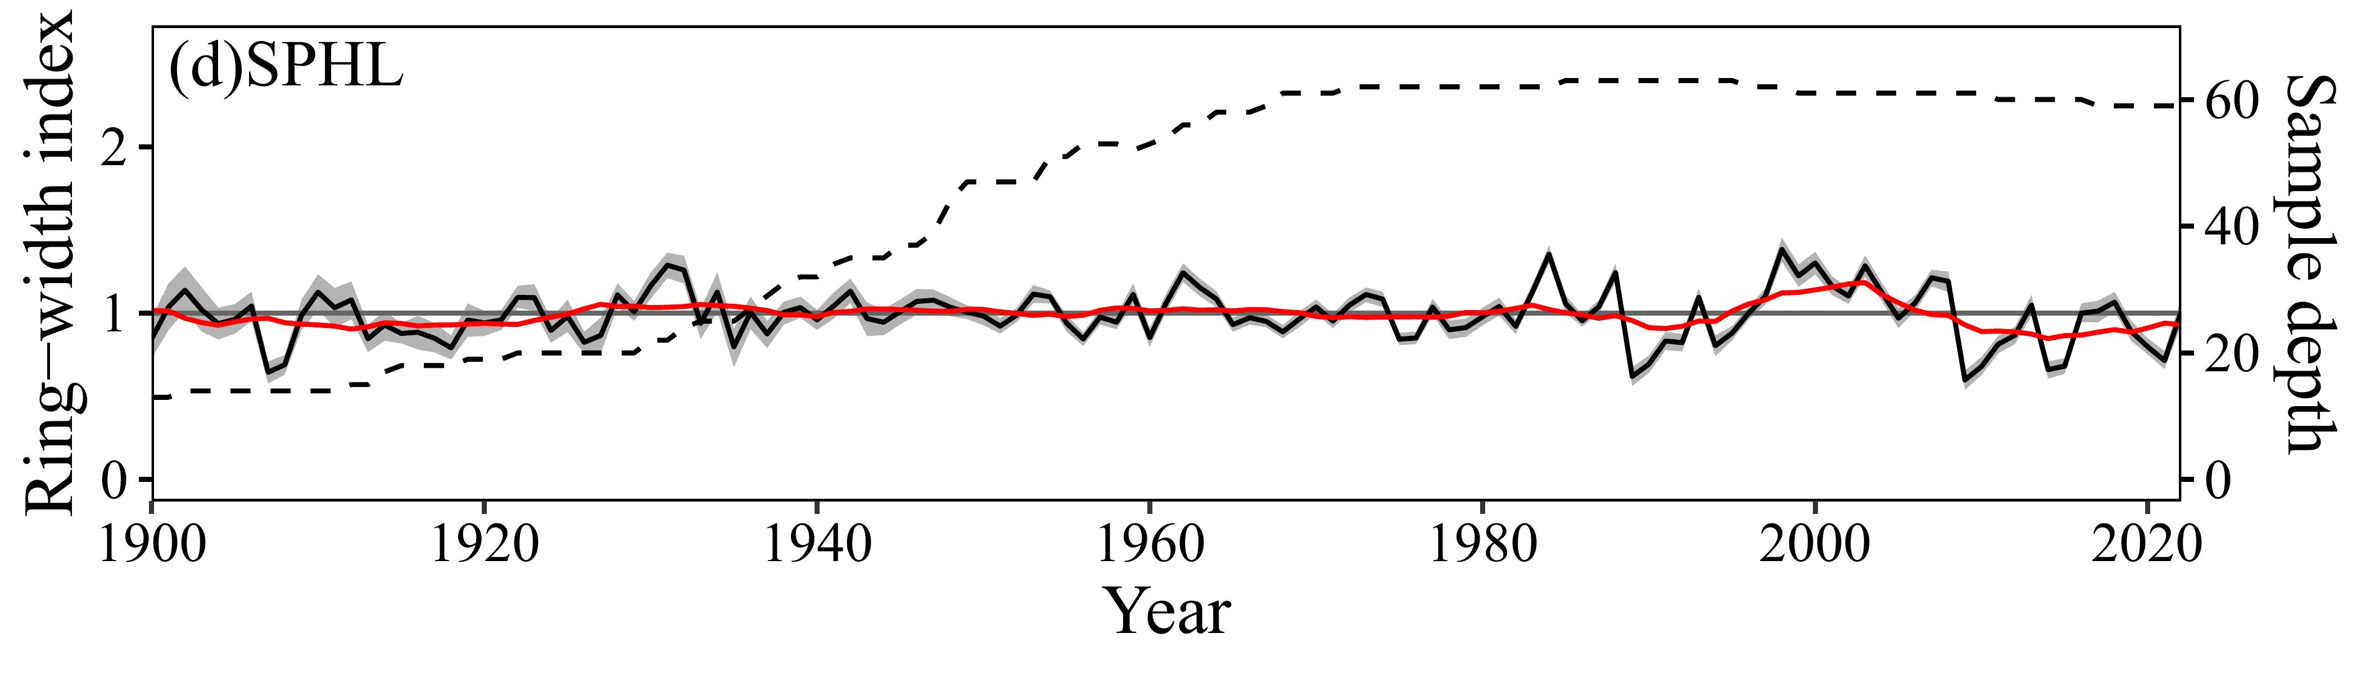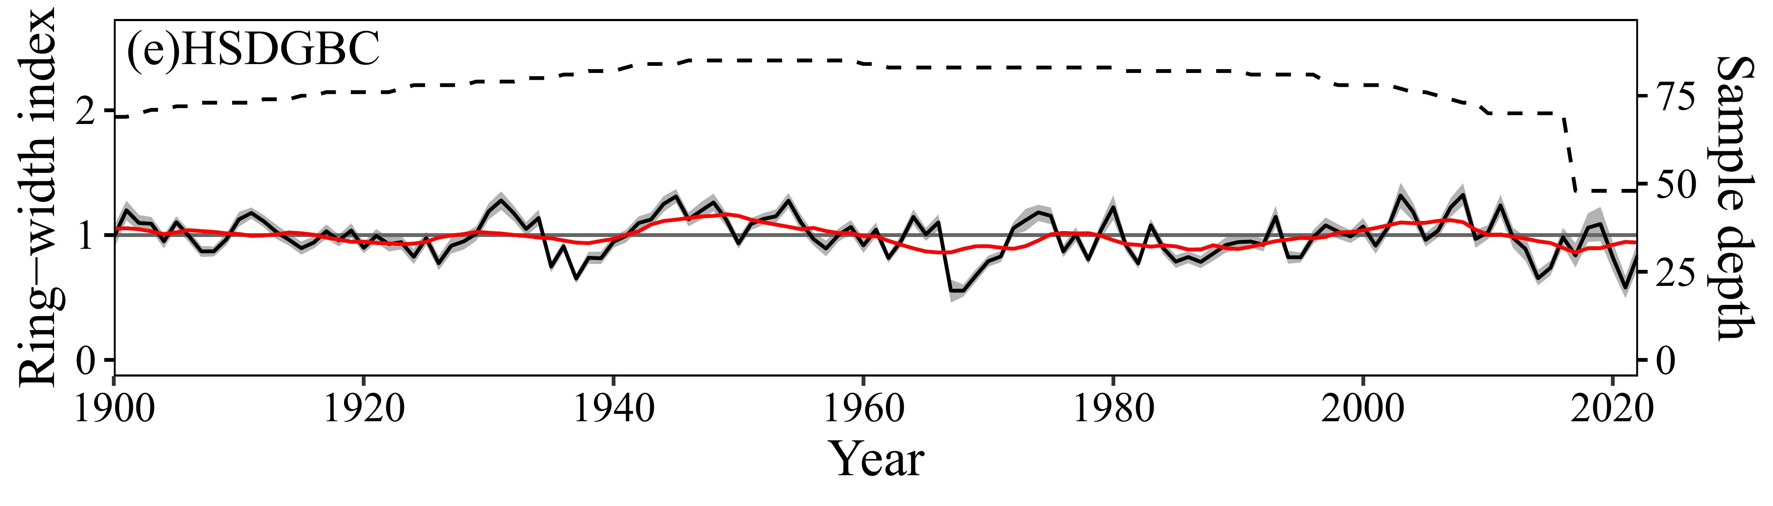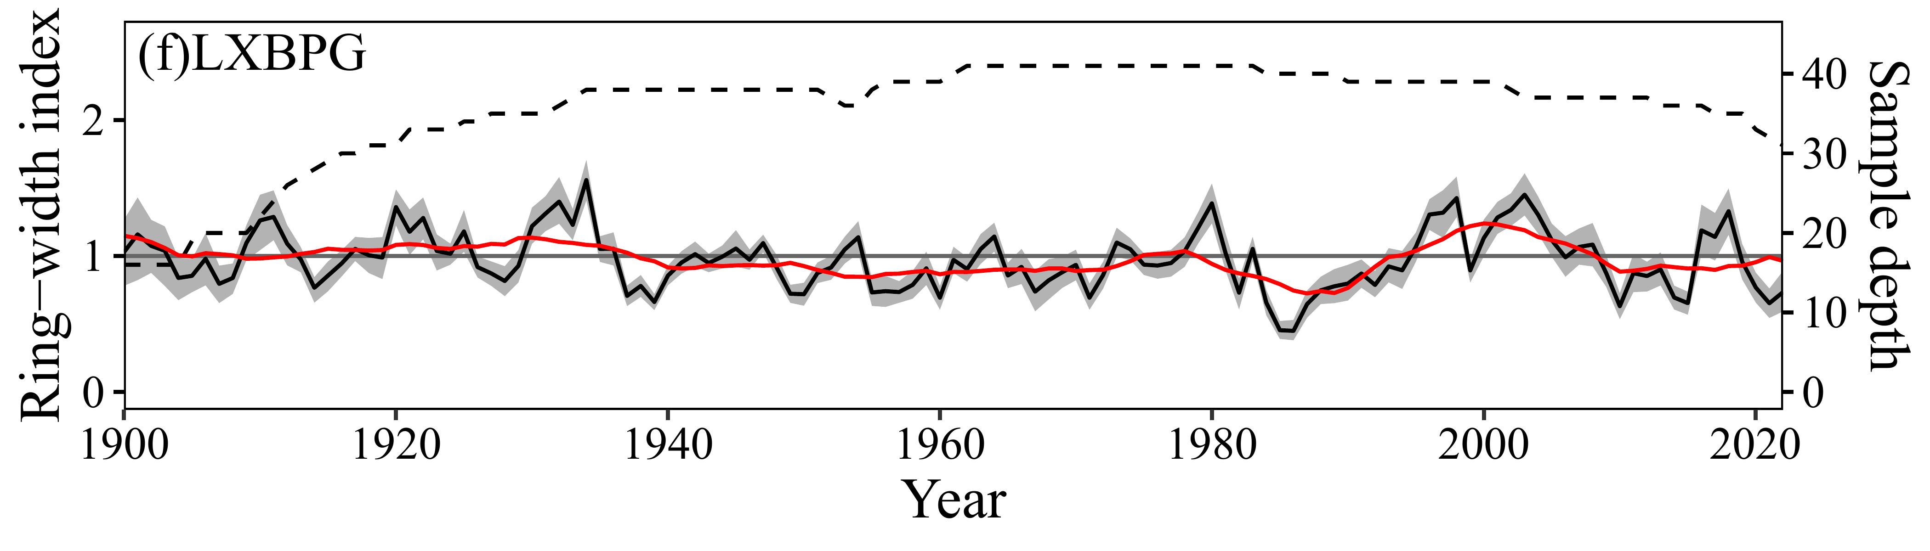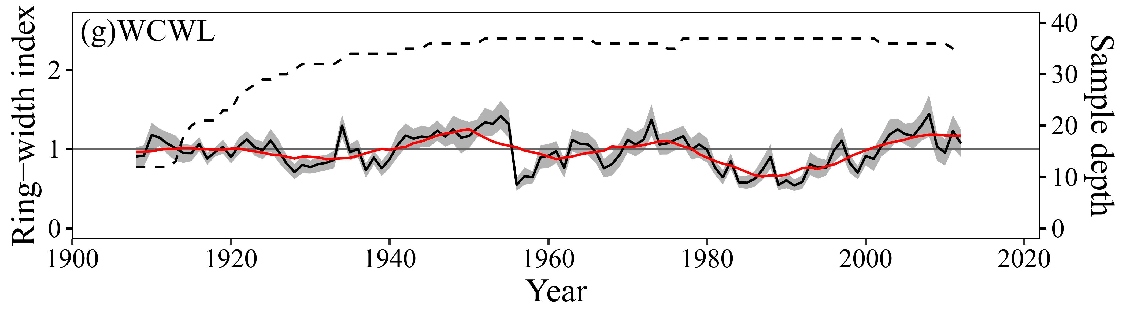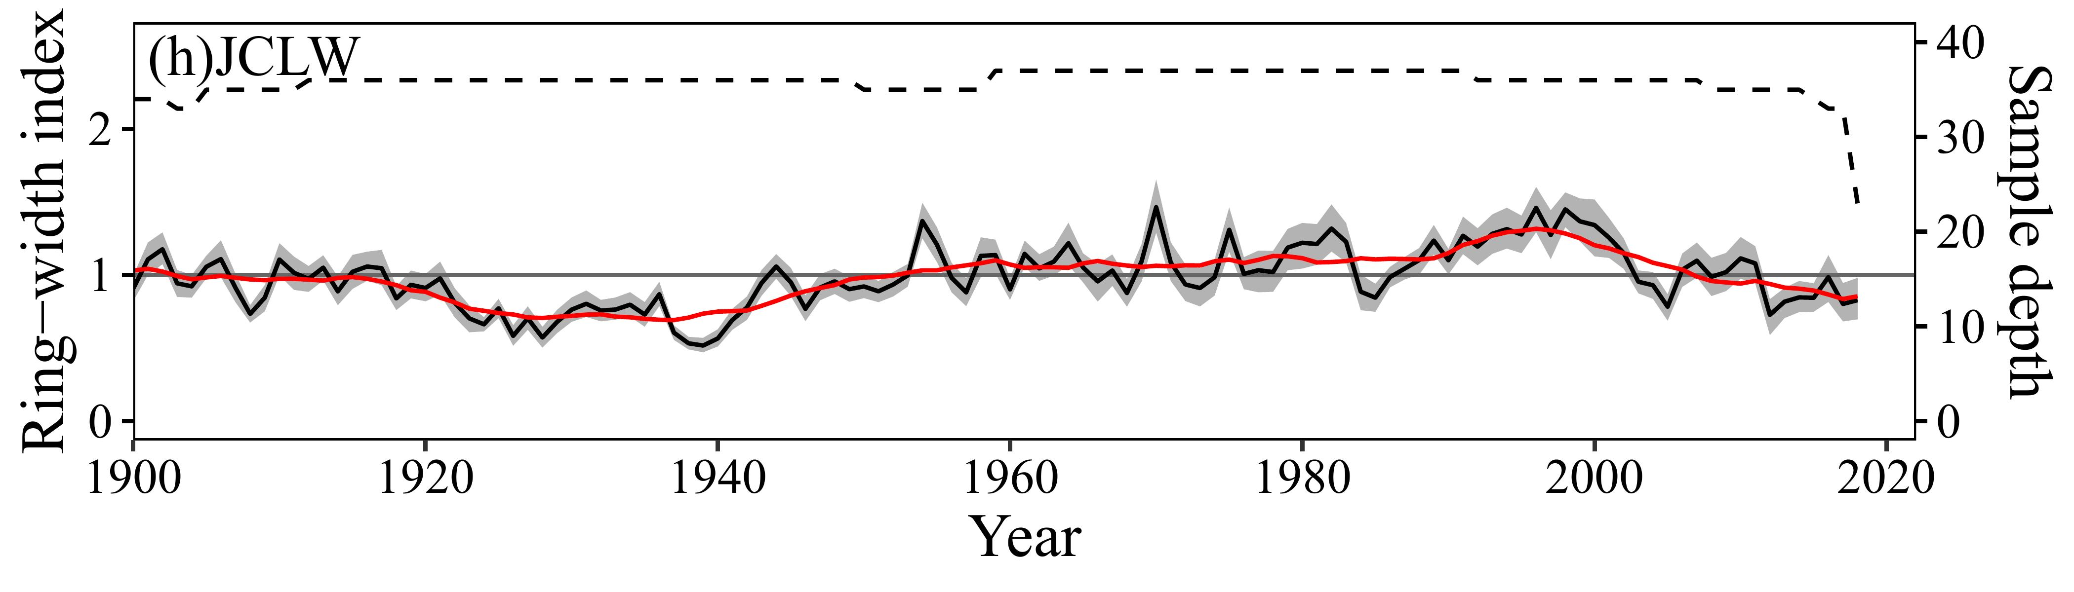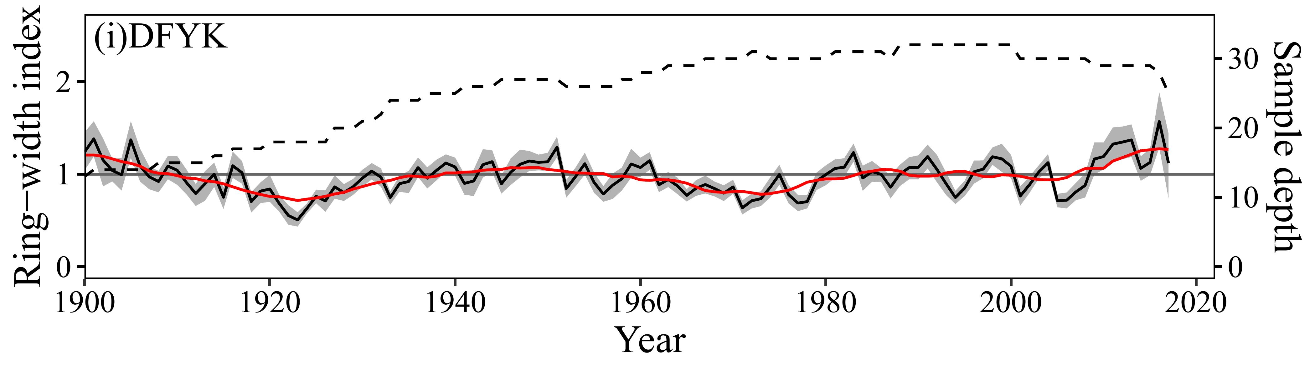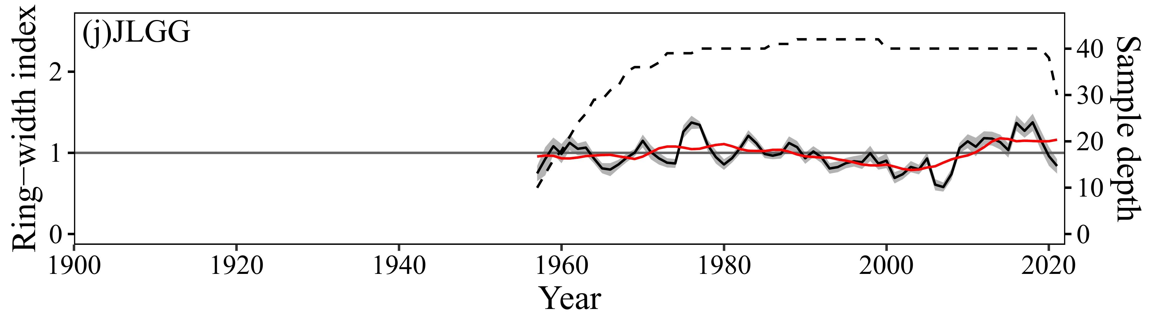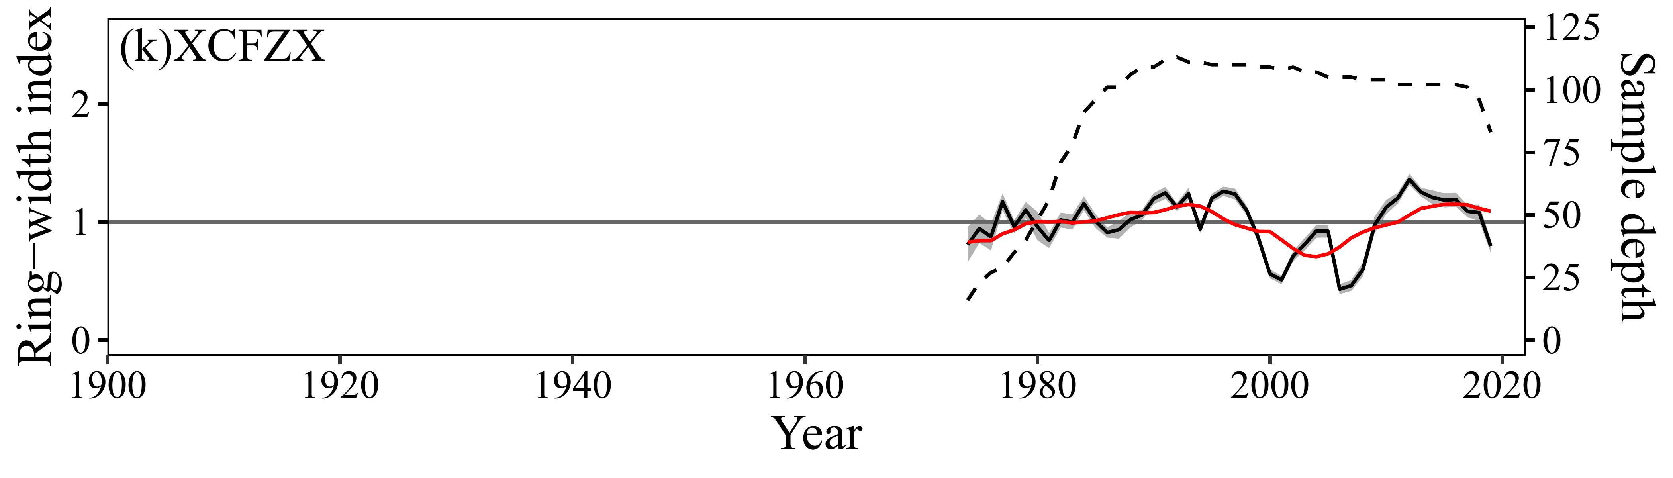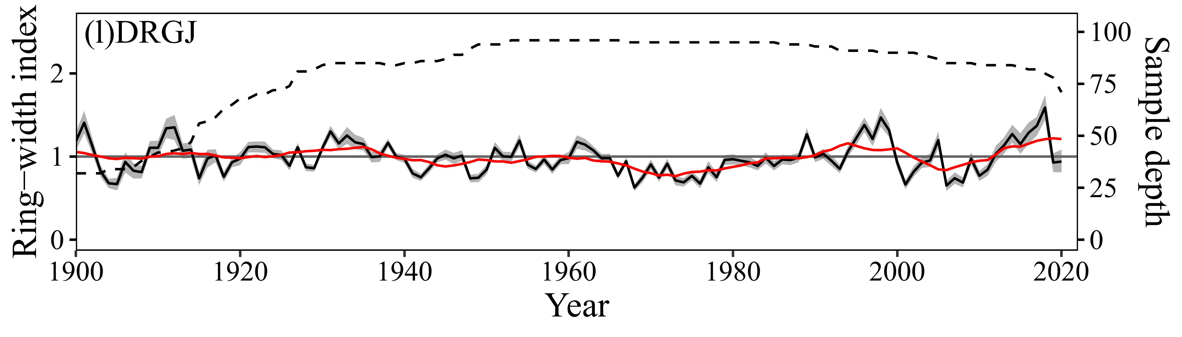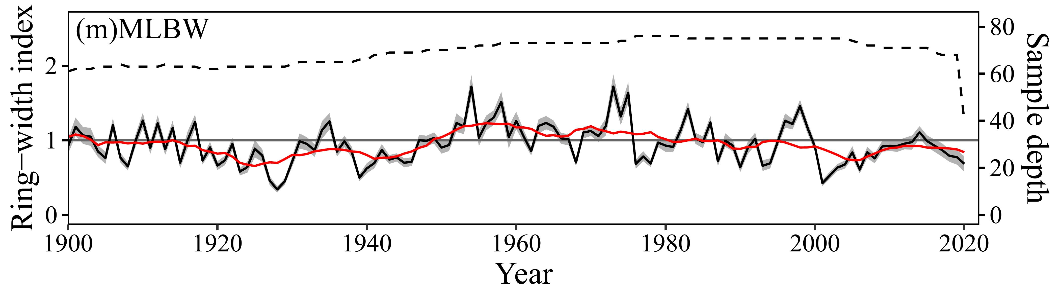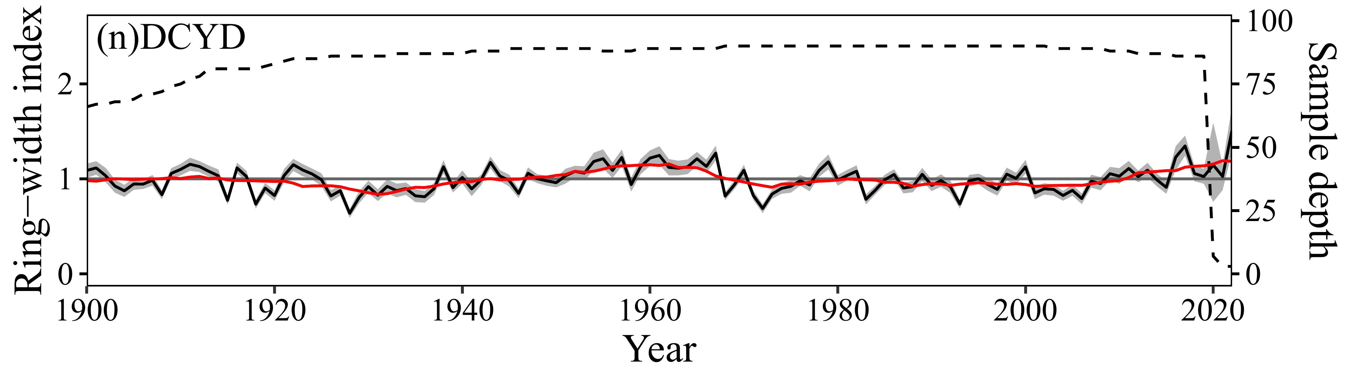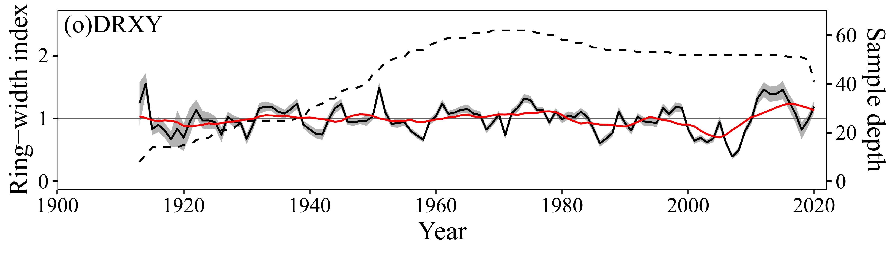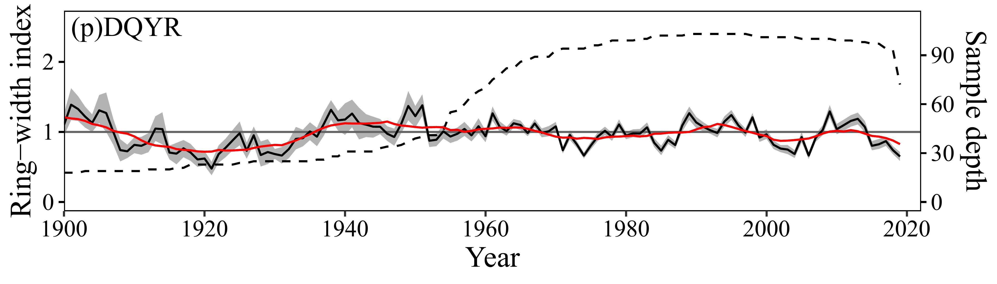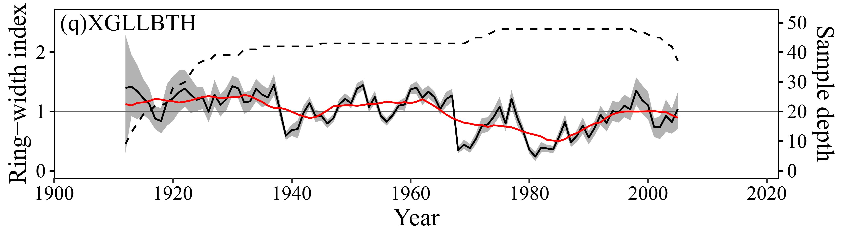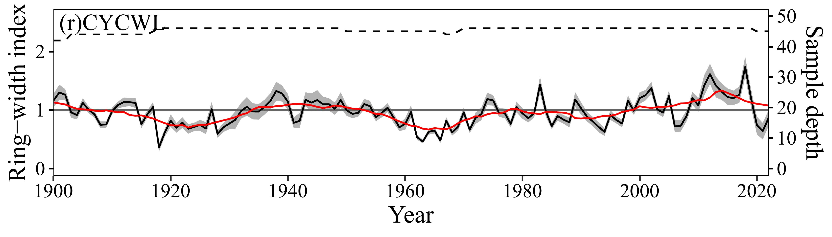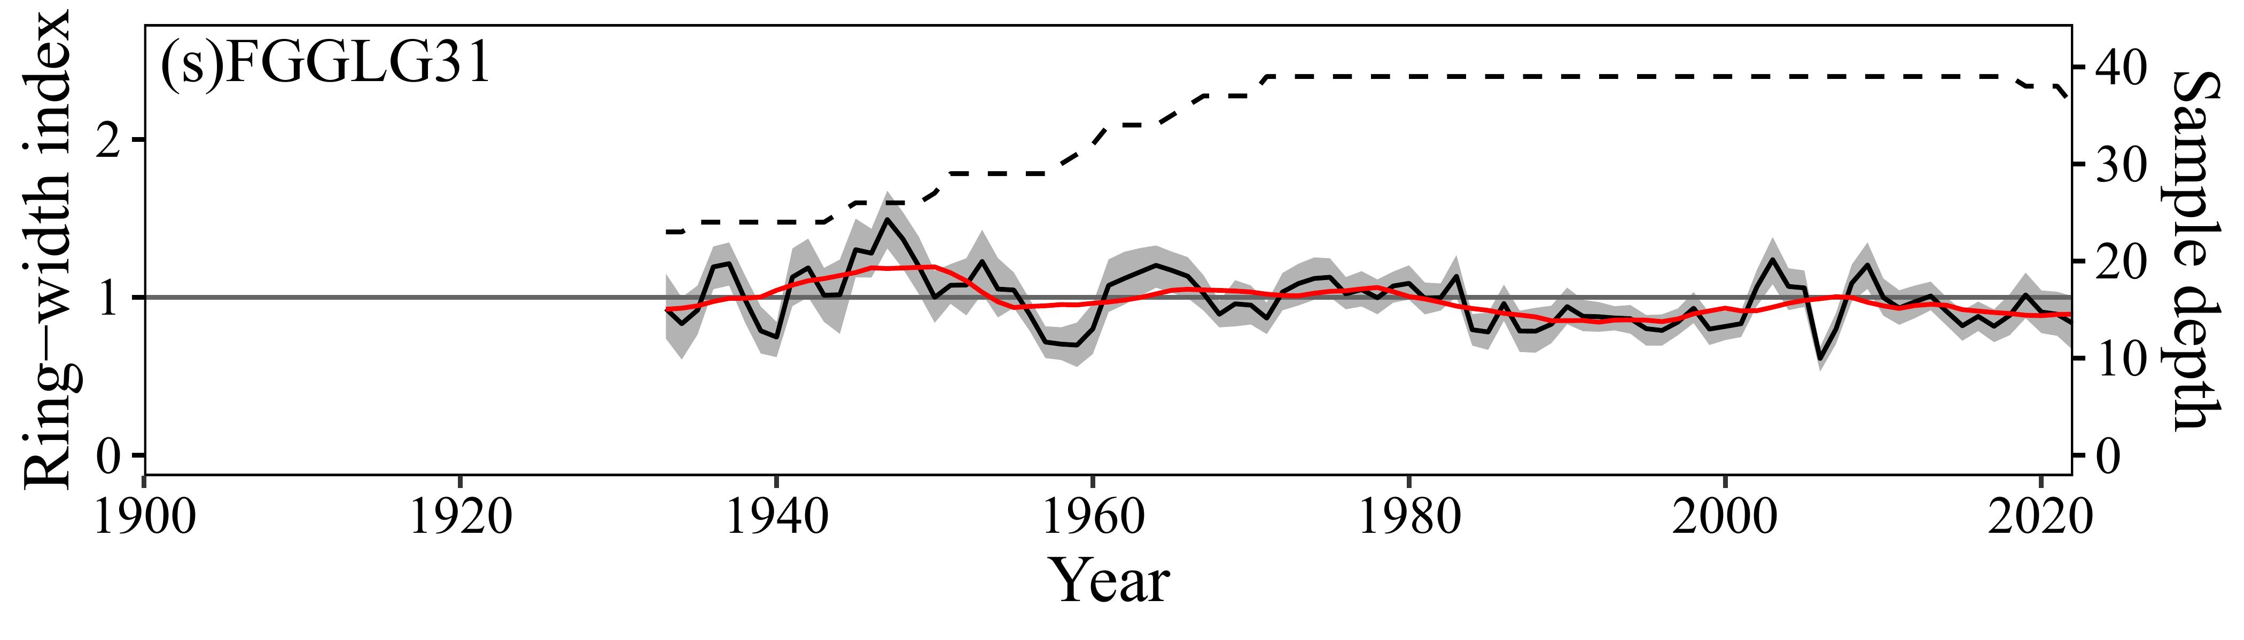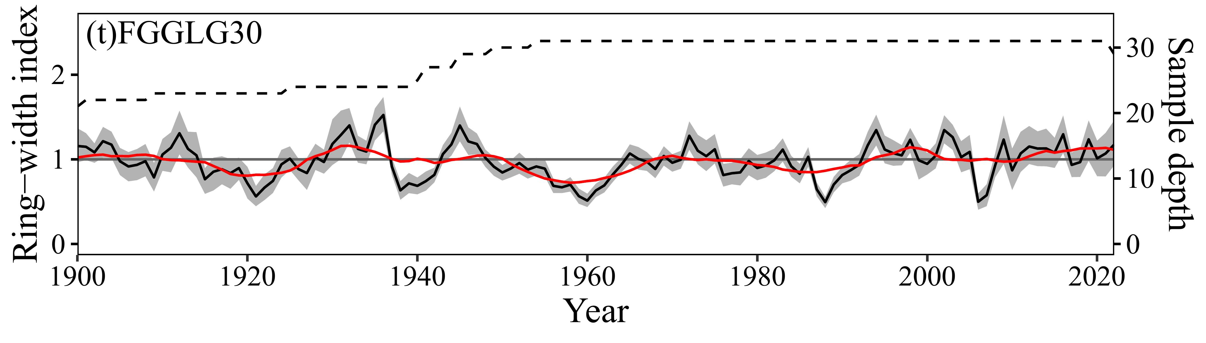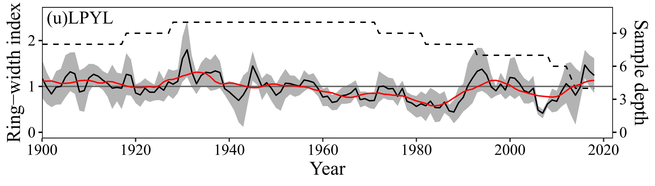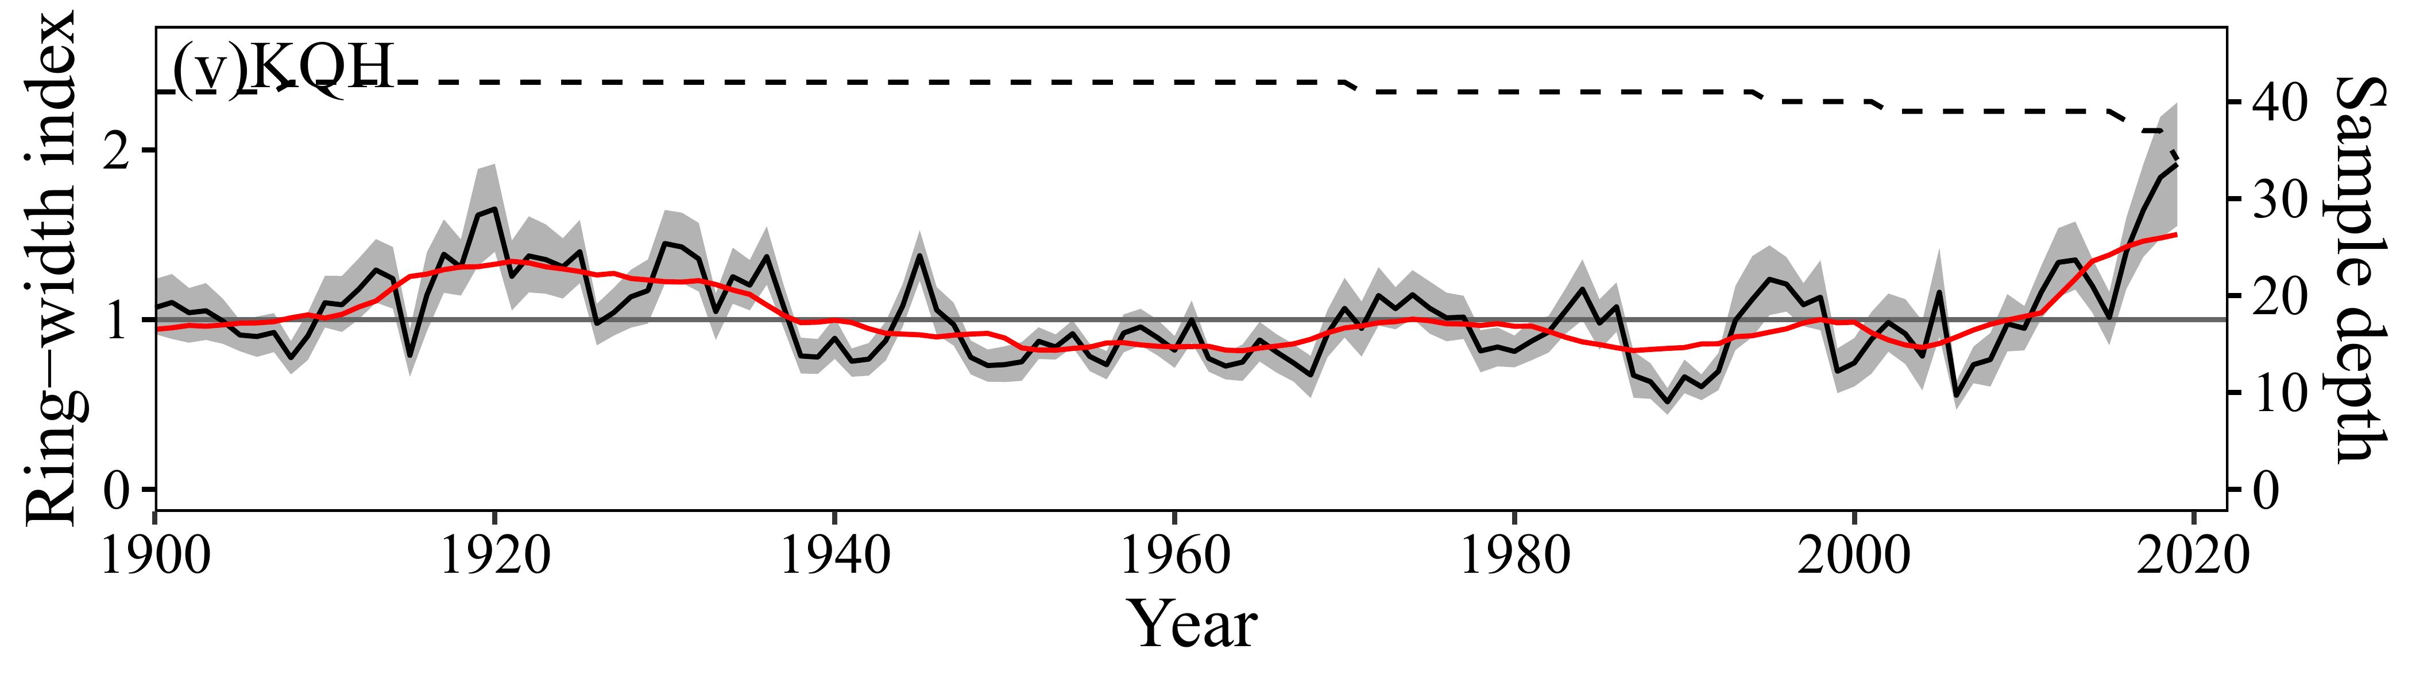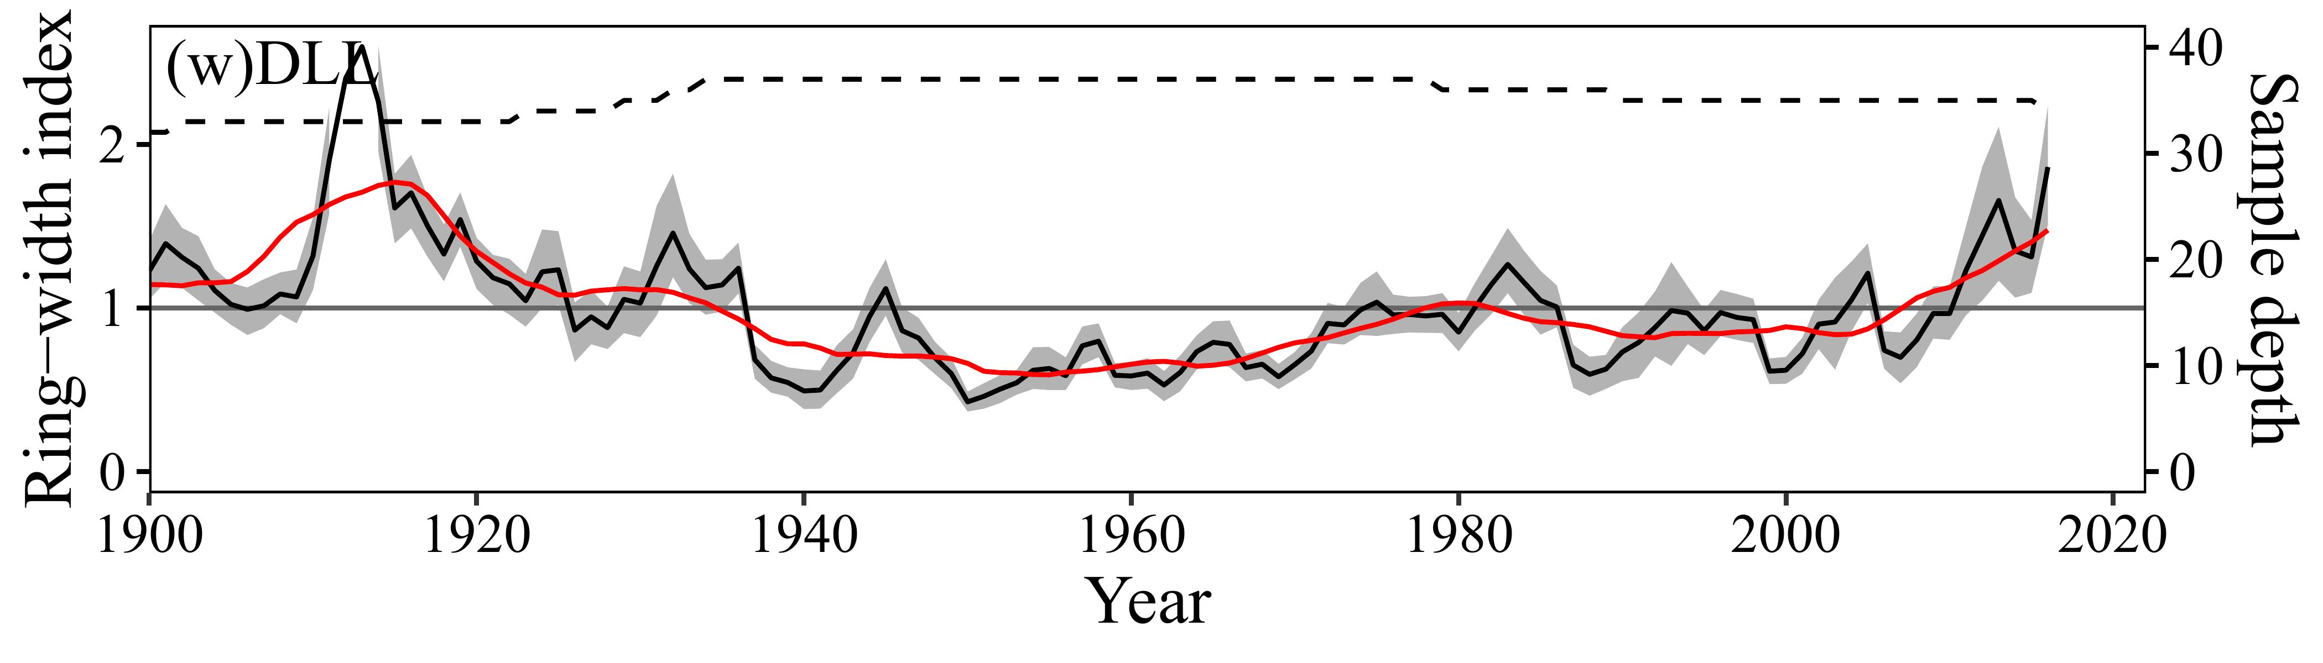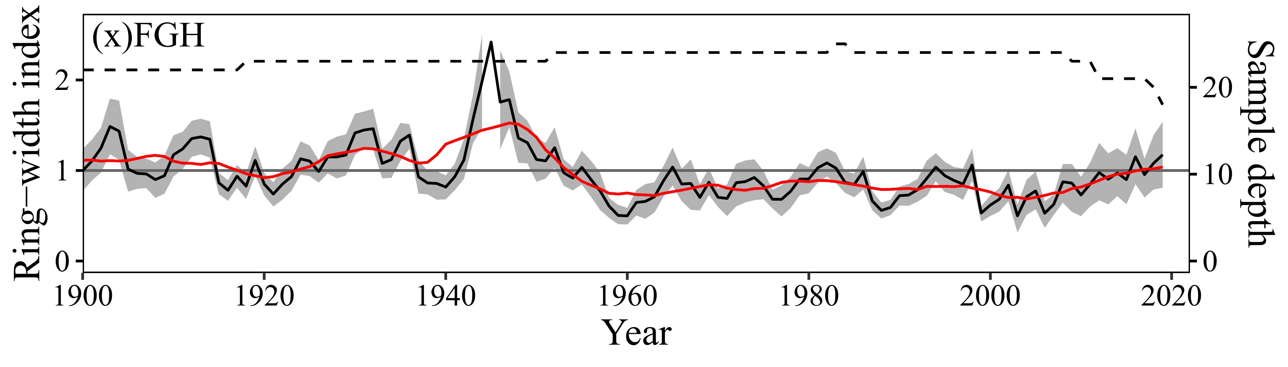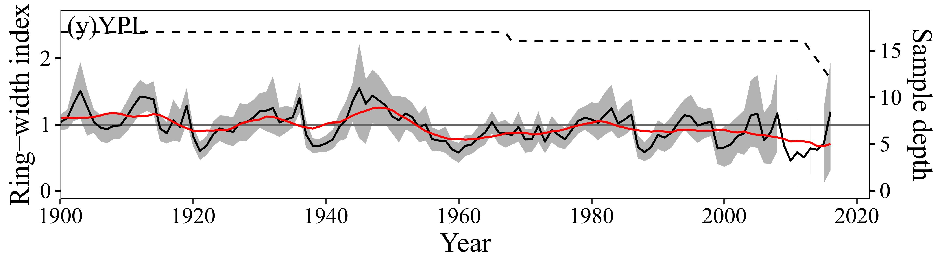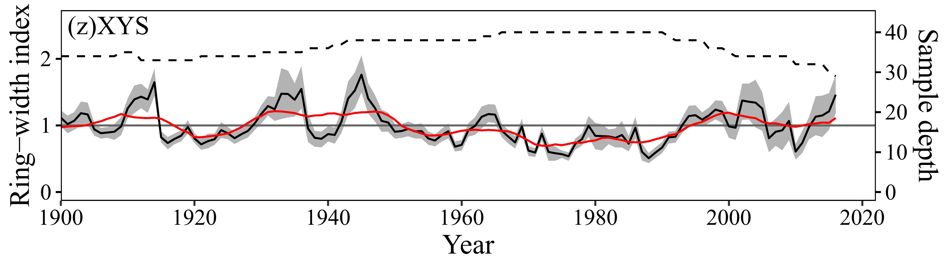Fig. S2. 26 standardized chronologies of Larix. Only years with SSS > 0.85 are shown. The grey area represents the 95% confidence interval based on 1000 bootstrap resamplings. The dashed line indicates sample depth, and the red line represents the 11-year moving average.
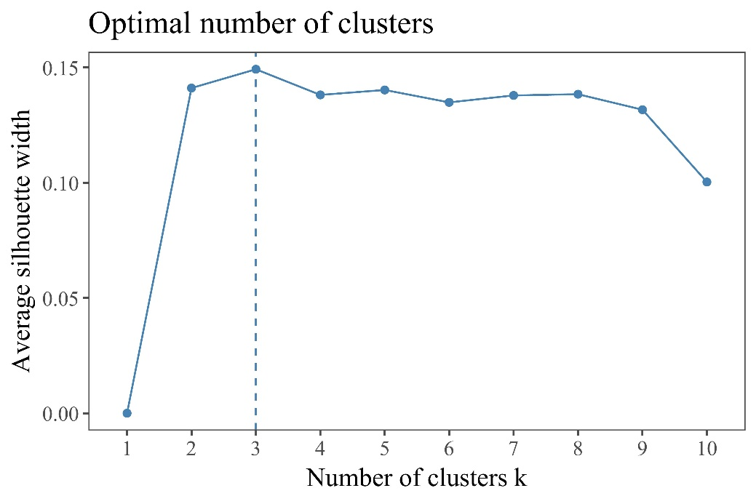
Fig. S3. Optimal number of clusters determined by the silhouette width method.
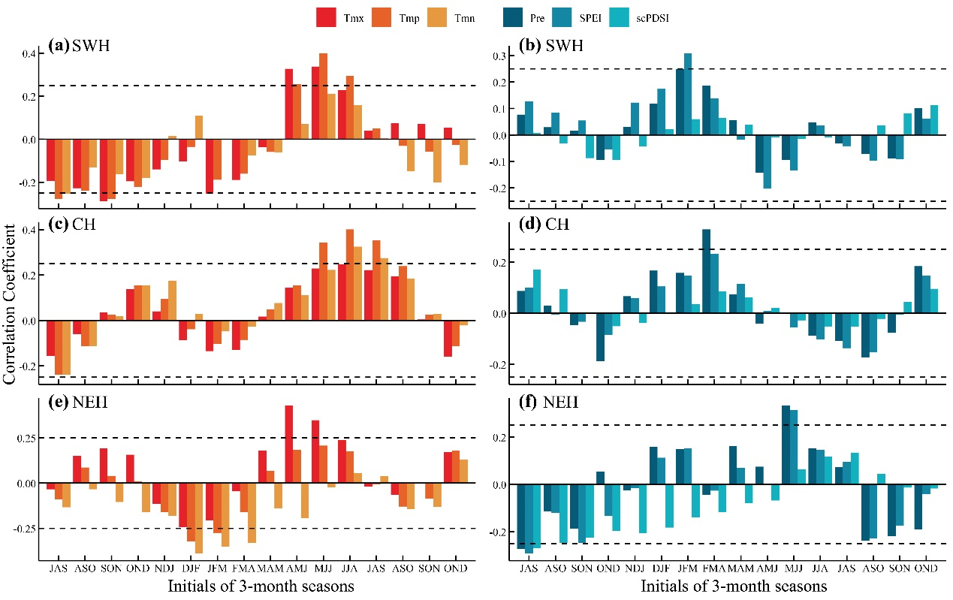
Fig. S4. First-difference correlation analysis between regional chronologies and climate factors on a 3-month scale from 1960 to 2022. (a), (c), (e) show temperature-related climate factors, including maximum temperature (Tmx), mean temperature (Tmp), and minimum temperature (Tmn). (b), (d), (f) represent moisture-related climate factors, including precipitation (Pre), self-calibrated Palmer Drought Severity Index (scPDSI), and Standardized Precipitation Evapotranspiration Index (SPEI). The x-axis covers an 18-month period with a 3-month sliding window, spanning from July of the previous year to December of the current year. Seasons are labeled by the uppercase initials of the constituent months (e.g., JFM for January-February-March). The horizontal dashed line indicates the significance threshold at p < 0.05.

