Supplementary materials
Figs: S1-S11
Tables: S1

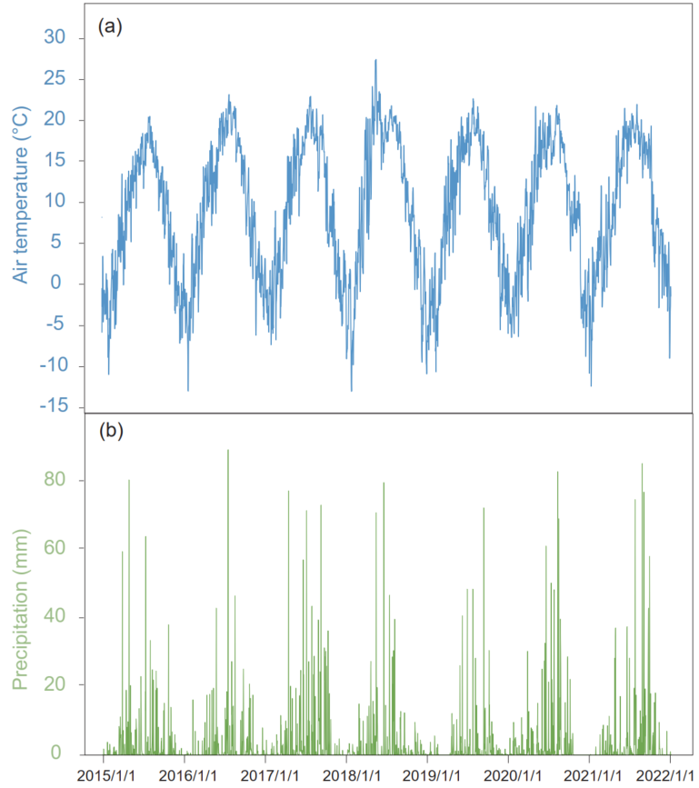
Fig. S1 The mean daily temperature (a) and precipitation (b) across the experimental observation period
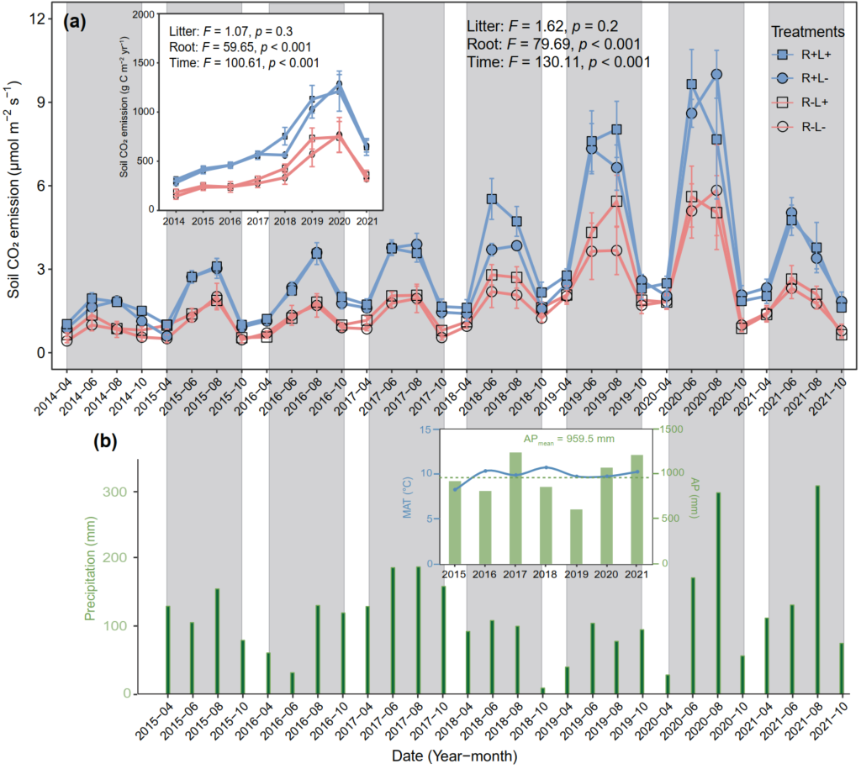
Fig. S2 Soil carbon emission (a) per treatment, as well as the air temperature and precipitation in this study site (b) across the observation period. MAT, the mean annual air temperature; AP, annual precipitation (AP)
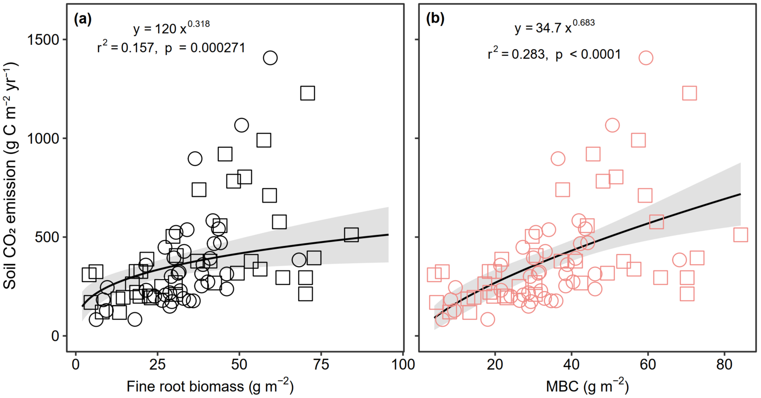
Fig. S3 Relationships between fine root biomass in plots with roots (a), soil microbial biomass carbon in plots without roots (b) and soil carbon emission.

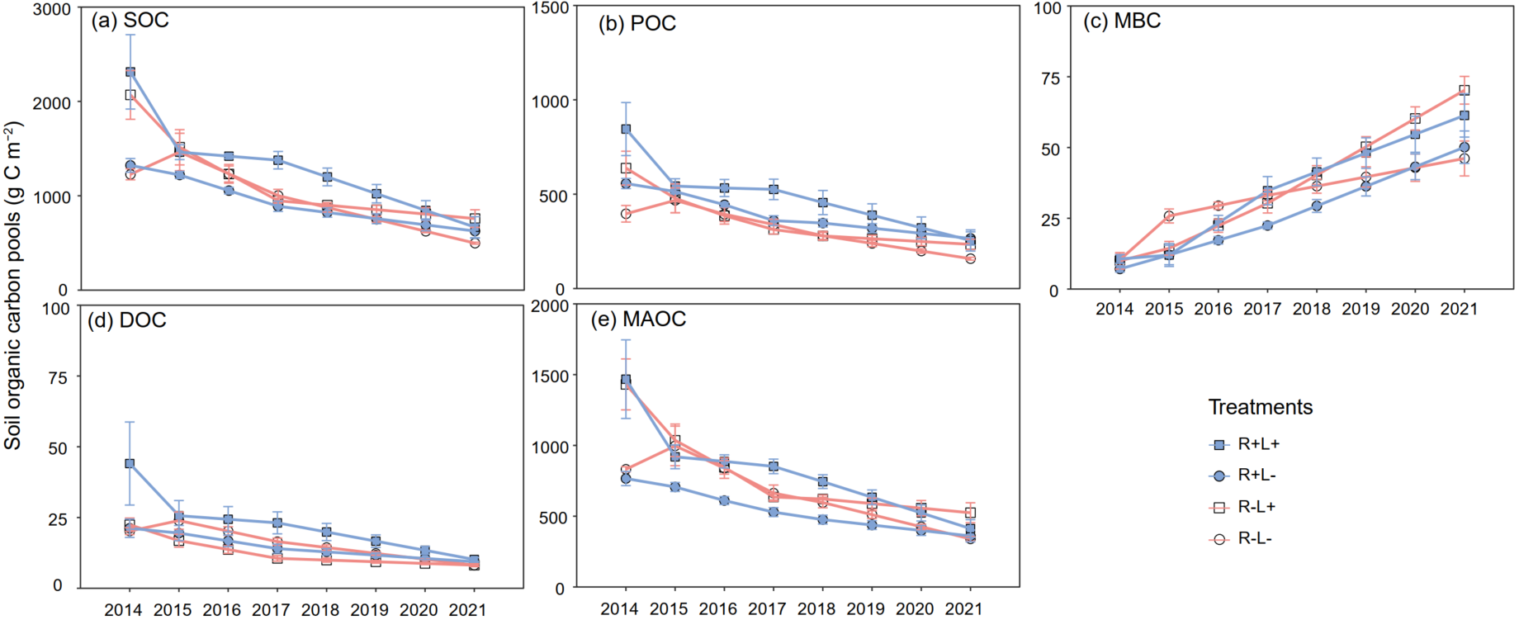
Fig. S4 Density of soil organic carbon and its fractions at 0-40 cm depth per treatment across the observation period.
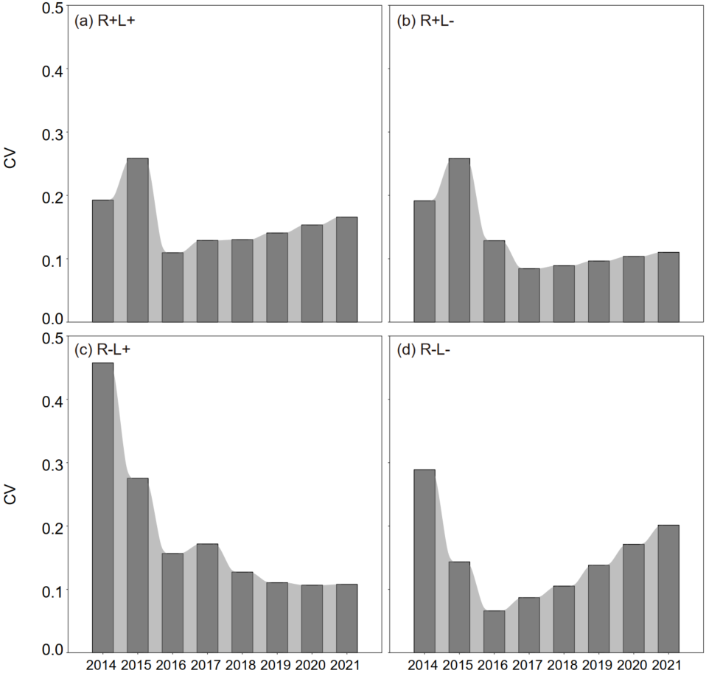
Fig. S5 Coefficients of variation (CV) of theoretical estimates of soil carbon emission per treatment over the observation period.
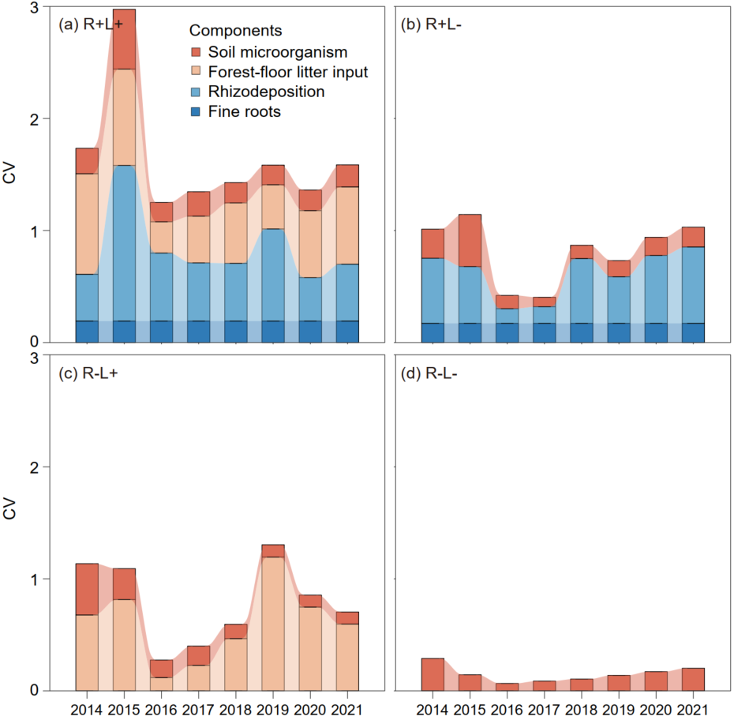
Fig. S6 Coefficients of variation (CV) of theoretical estimates of soil carbon emission components per treatment across the observation period.
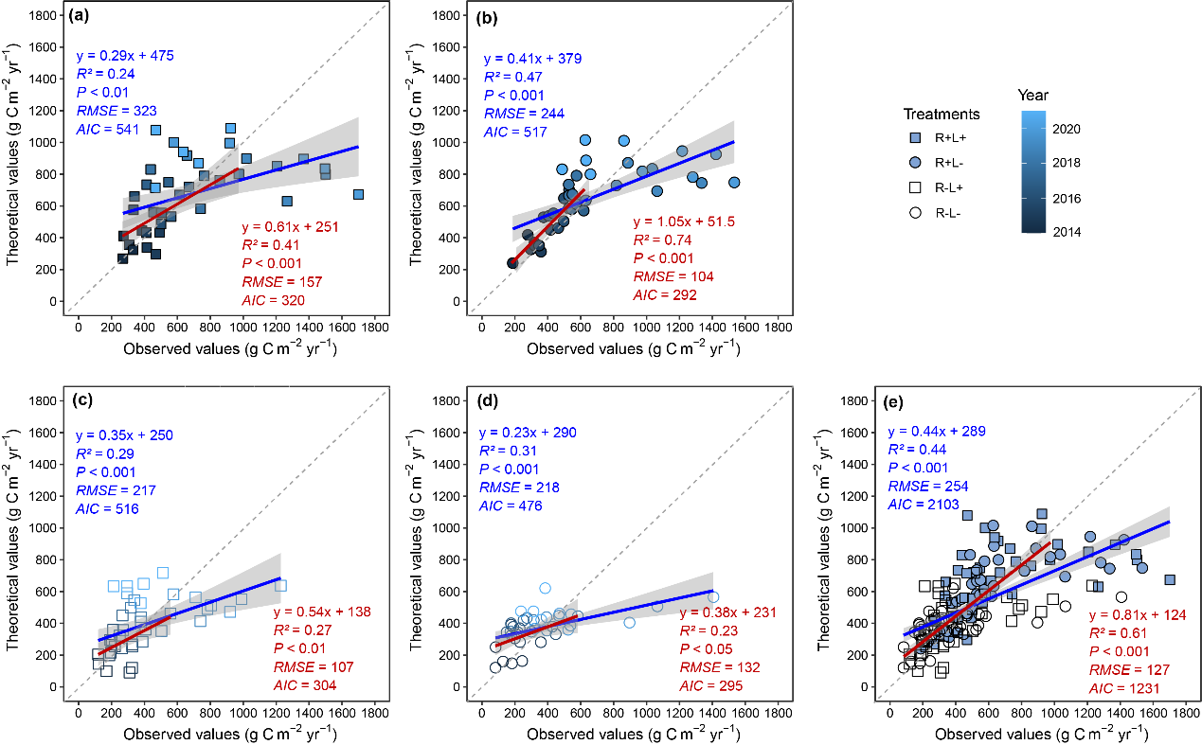
Fig. S7 Comparison between the theoretical and observed soil carbon emissions from our experiment. R+L+, treatment with litter and roots; R+L-, treatment with roots alone; R-L+, treatment with litter alone; R-L-, treatment with no litter. The blue lines indicate the regression between theoretical and observed soil carbon emissions from 2014 to 2021; the red lines represent the regression between theoretical and observed soil carbon emissions from 2014 to 2018.

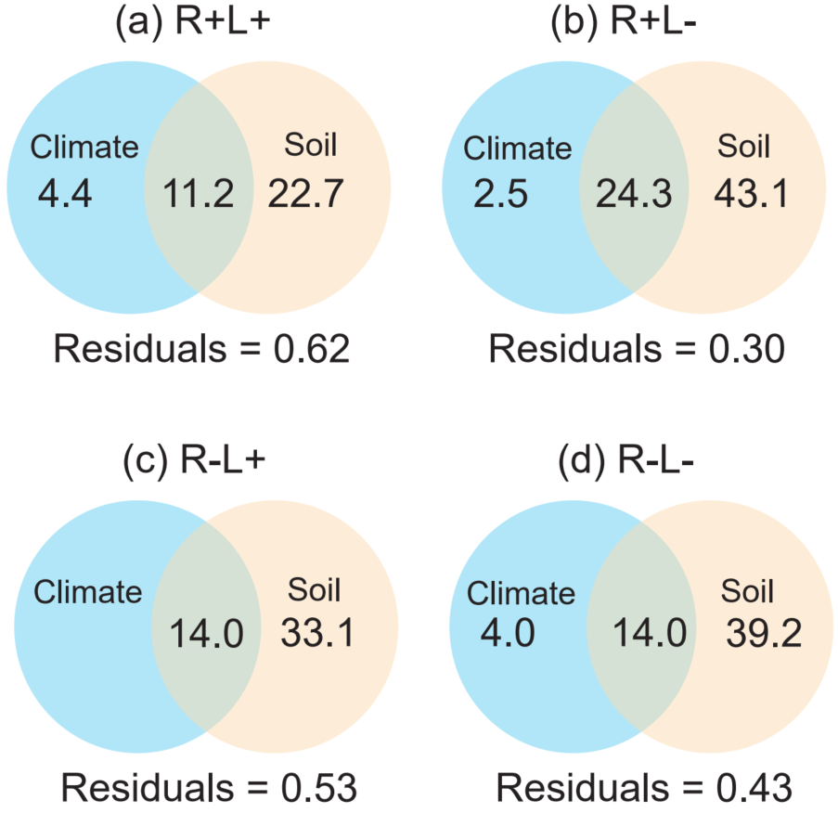
Fig. S8 The independent and interactive effects of climate and soil factors on soil C emission per treatment across the observation period by variance partitioning analysis.
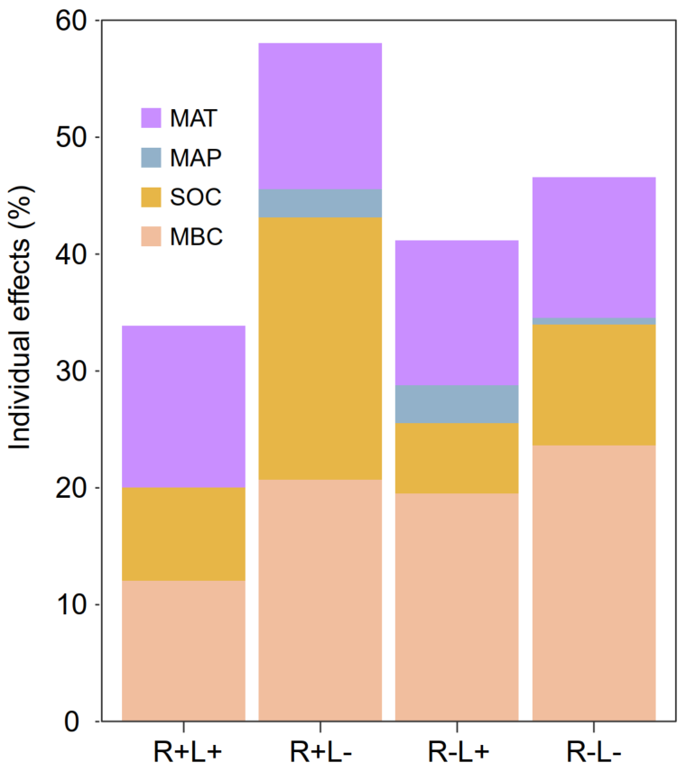
Fig. S9 The individual effects of climatic, edaphic, and litter factors on soil C emission by hierarchical partitioning analysis.
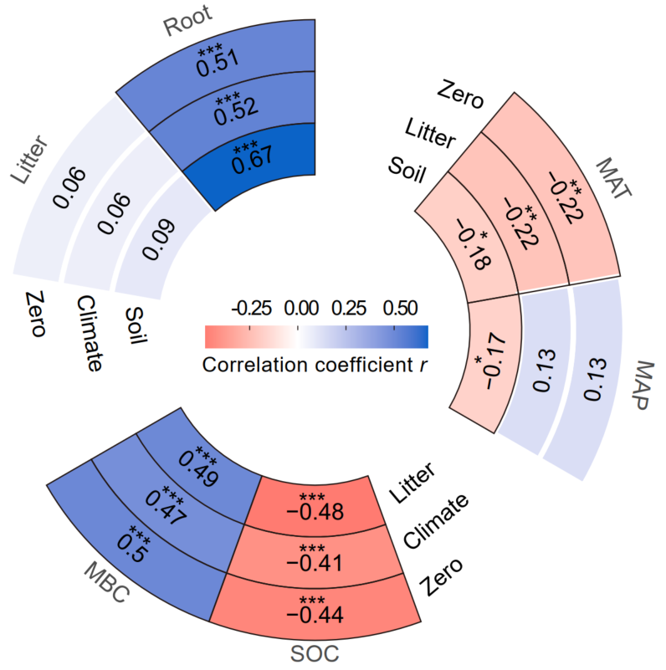
Fig. S10 Relationships between the soil carbon emission and climate, soil as well as litter types by partial correlation analysis.
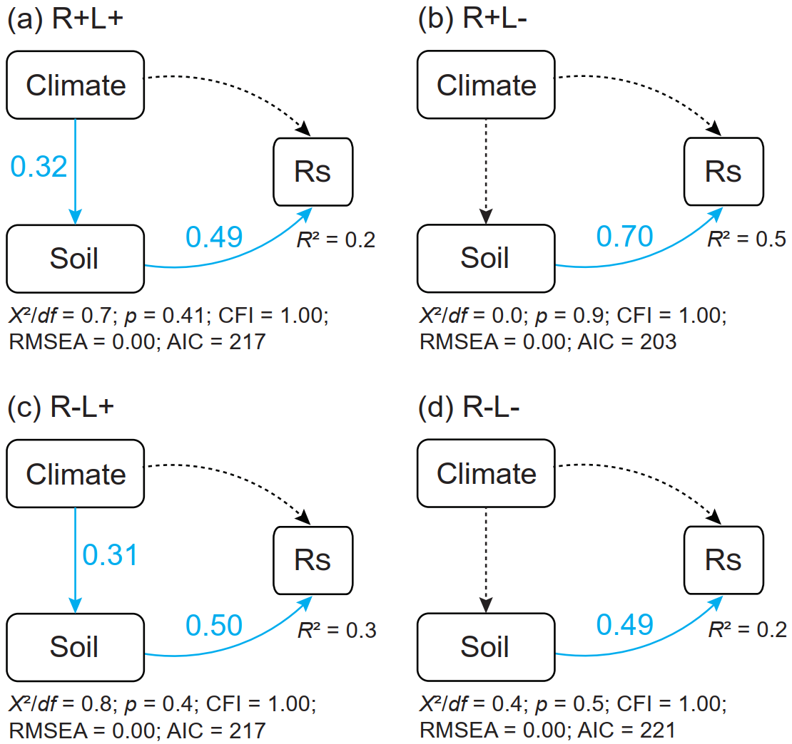
Fig. S11 The direct and indirect effects of climate, and soil factors (SOC content and MBC content) on soil carbon emission per treatment across the observation period.

Table S1 Experimental design and soil carbon emission components per treatment in this study
Treatments | MBC | Litter-C | Root-C | Fine root biomass
R+L+ | √ | √ | √ | √
R+L- | √ |  | √ | √
R-L+ | √ | √
R-L- | √
Note: MBC, soil microbial biomass carbon; Litter-C, soil C derived from forest-floor litter; Root-C, soil C derived from rhizodeposition.

