Appendix

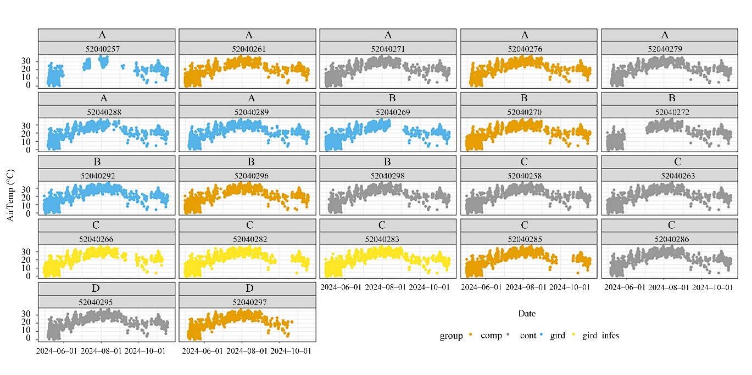

Fig. S1 Hourly air temperature measured at the tree-level at breast height during the study period (May–November 2024). Colours indicate the respective treatment group (compression = comp, control = cont, girdling = gird, girdled bark beetle-infested = gird_infes), while letters refer to the respective plot (A, B, C, D).

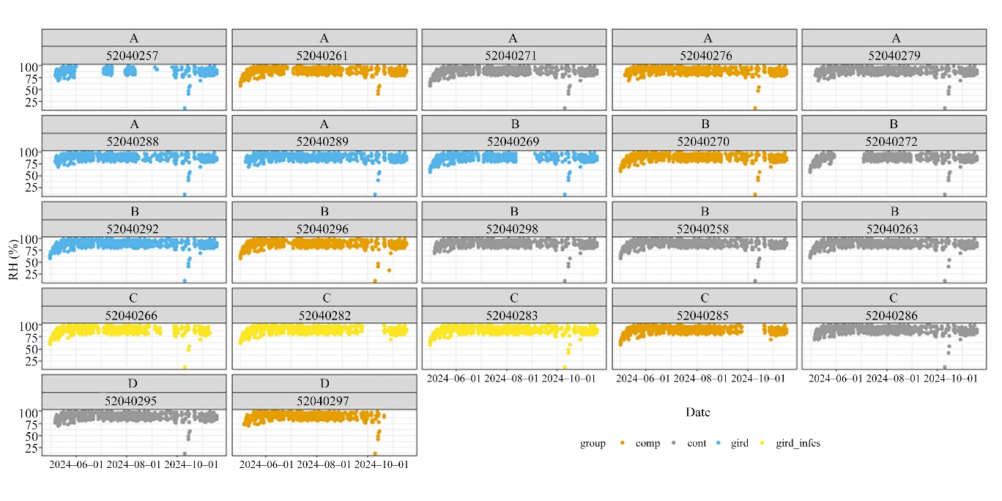

Fig. S2 Hourly relative humidity measured at the tree-level at breast height during the study period (May–November 2024). Colours indicate the respective treatment group (compression = comp, control = cont, girdling = gird, girdled bark beetle-infested = gird_infes), while letters refer to the respective plot (A, B, C, D).

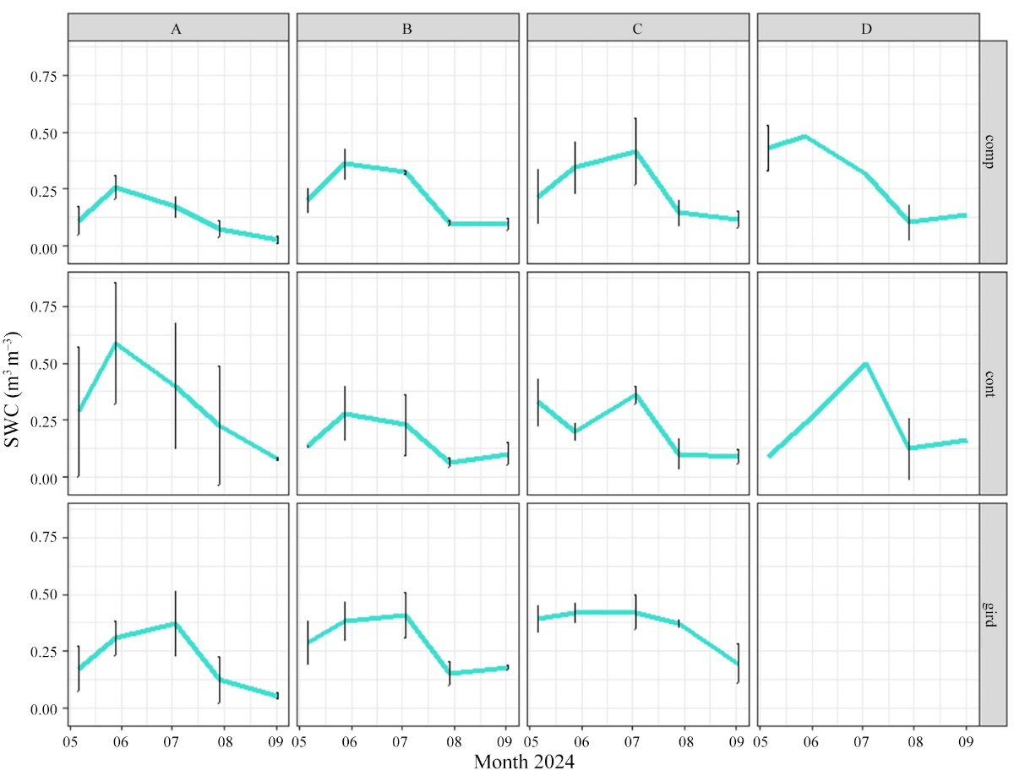

Fig. S3 Mean hourly soil water content (m³ m^{–3}) measured at each treatment class (compression = comp, control = cont, girdling = gird) at each plot (A, B, C, D). Means and standard deviations refer to measurements that were taken at three marked locations at each treatment class at each plot. The measurements were repeated five times during the study period (May–November 2024).

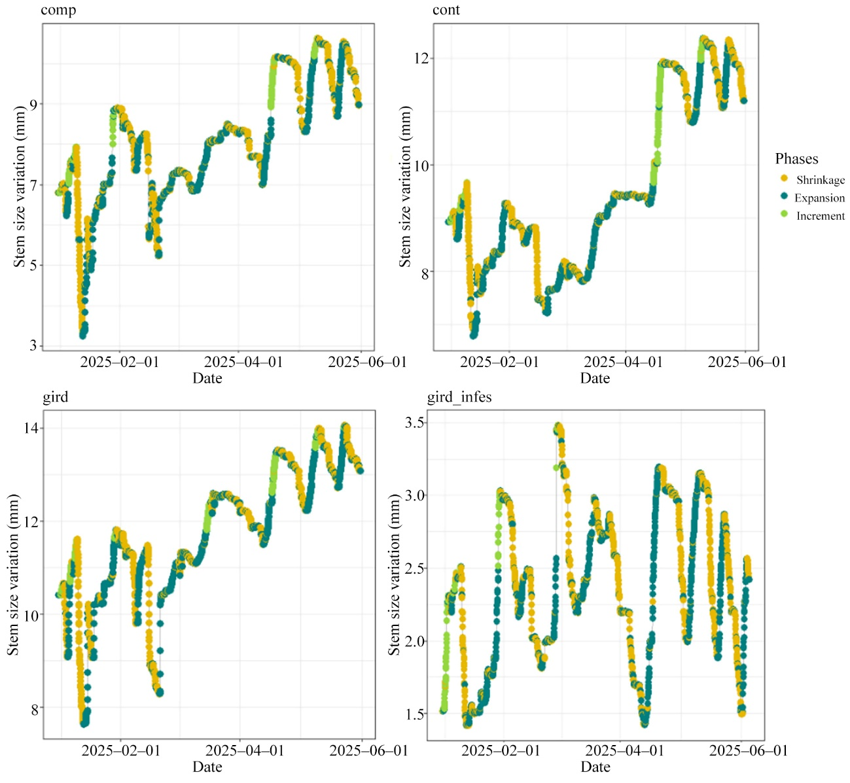

Fig. S4 Stem size variation (mm) expressed as shrinkage (yellow), expansion (dark green) and increment (light green) of a compressed tree (a), a control tree (b), a girdled tree (c) and a girdled bark beetle infested tree (d) for the year 2025 (January–June).

