Genetic Analysis of Quantitative Phenotypes in AD and MCI: Imaging, Cognition and Biomarkers
Journal: Brain Imaging and Behavior
Li Shen*, Paul M. Thompson, Steven G. Potkin, Lars Bertram, Lindsay A. Farrer, Tatiana M. Foroud, Robert C. Green, Xiaolan Hu, Matthew J. Huentelman, Sungeun Kim, John S.K. Kauwe, Qingqin Li, Enchi Liu, Fabio Macciardi, Jason H. Moore, Leanne Munsie, Kwangsik Nho, Vijay K. Ramanan, Shannon L. Risacher, David J. Stone, Shanker Swaminathan, Arthur W. Toga, Michael W. Weiner, Andrew J. Saykin*, and for the Alzheimer’s Disease Neuroimaging Initiative
*Please address correspondence to:
Li Shen, Ph.D., or Andrew J. Saykin, Psy.D.
Center for Neuroimaging, Department of Radiology and Imaging Sciences,
IU School of Medicine, 355 W 16th Street, Suite 4100, Indianapolis, IN 46202, USA
Phone: (317) 963-7504 or (317) 963-7501, Fax: (317) 963-7547
E-mail: shenli@iu.edu or asaykin@iupui.edu

Supplemental Fig. 1 Example Metacore pathway enrichment results of 101 unique genes listed in Supplemental Table 1. This figure shows significantly enriched results (FDR p≤0.05) by canonical pathway maps, which represent a comprehensive set of signaling and metabolic maps for humans. All maps are created by Thomson Reuters scientists by a high quality manual curation process based on published peer reviewed literature. The top 5 scored maps (maps with the 5 lowest p values) are shown in (a-e) and figure legend is shown in (f). Experimental data from all files is linked to and visualized on the maps as thermometer like figures.
(a) Cell adhesion_Ephrin signaling: FDR p=0.018, 45 genes in total, and 4 hit genes (Ephrin-A, Ephrin-A5, Ephrin-A receptors, GRB2).
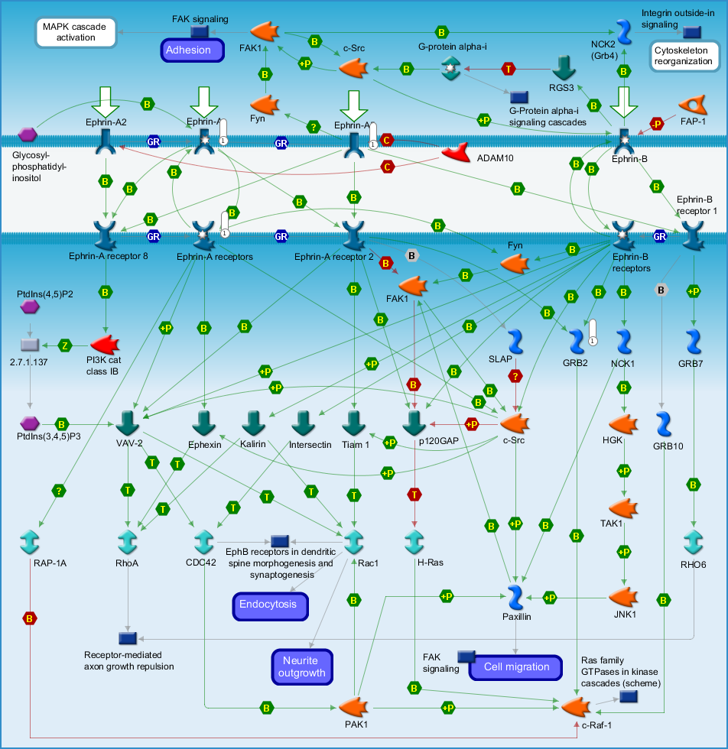

(b) Neurophysiological process_nNOS signaling in neuronal synapses (TOC): FDR p=0.048, 29 genes in total, 3 hit genes (NR2B, nNOS, NR2).
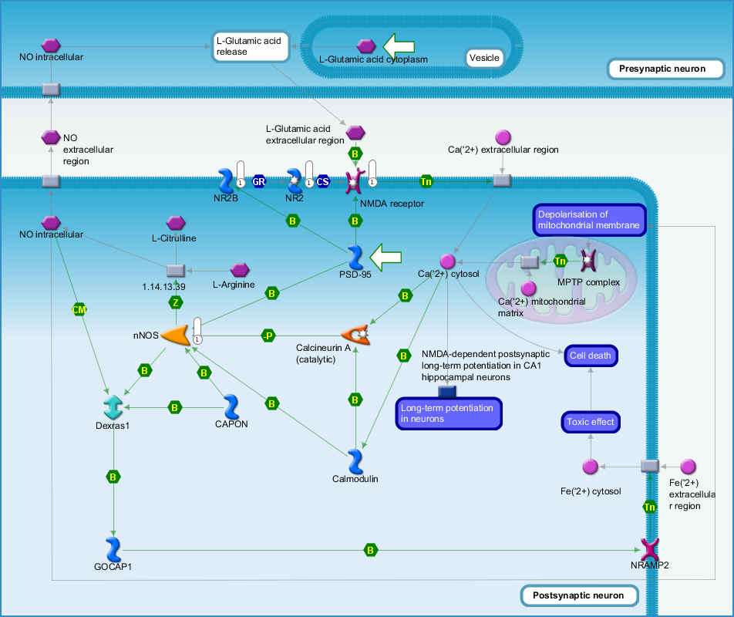

(c) Neurophysiological process_NMDA dependent postsynaptic long term potentiation in CA1 hippocampal neurons: FDR p=0.050, 80 genes in total, 4 hit genes (BDNF, GRB2, NR2B, NR2).
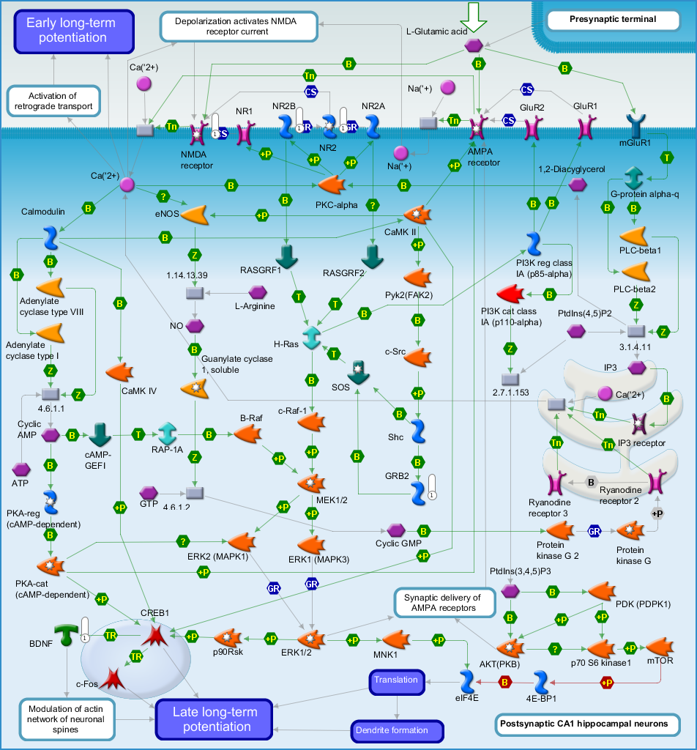

(d) Immune response_Alternative complement pathway: FDR p=0.050, 39 genes in total, 3 hit genes (CD21, CR1, Clusterin).
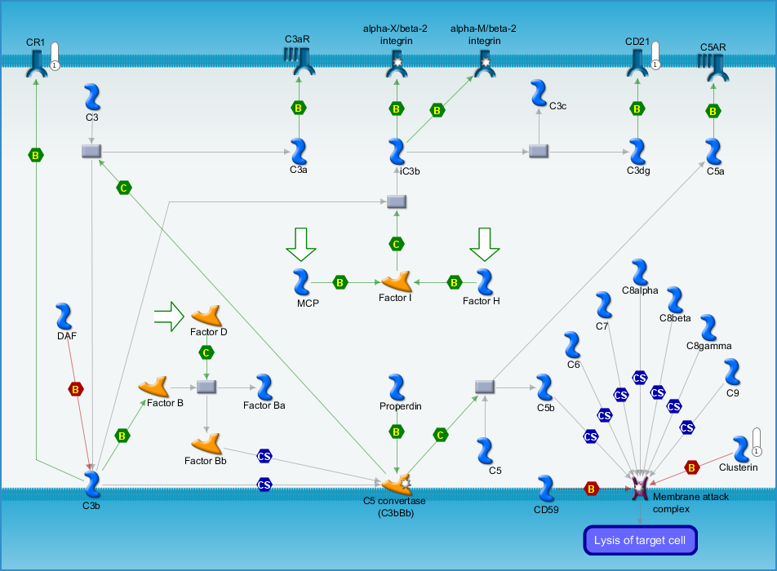

(e) Development_Neurotrophin family signaling: FDR p=0.050, 40 genes in total, 3 hit genes (BDNF, GAB2, GRB2).
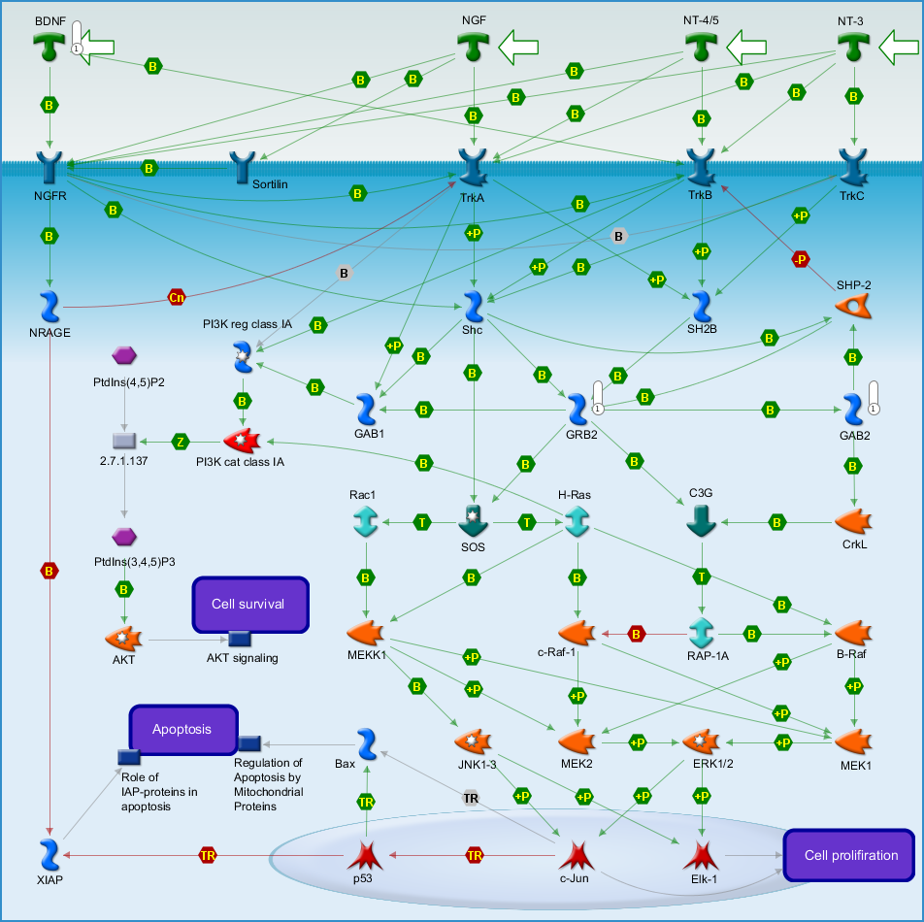

(f) Figure legend.
