Supplementary Materials
Table S1 – MNI coordinates of results. Synthetic account of surviving voxels at FDR-corrected-p 0.05
% of voxels accounted for | Overlapping Anatomical Structure | Atlas code
4.8% | Left Peri-Calcarine Cortex | 43
4.4% | Right Lingual Gyrus | 48
4.3% | Right Cerebellum (VIII) | 104
4.0% | Right Cerebellum (Crus 1) | 92
3.9% | Right Peri-Calcarine Cortex | 44
3.8% | Left Lingual Gyrus | 47
3.2% | Right Cerebellum (Crus 2) | 94
3.2% | Right Middle Occipital Gyrus | 52
2.6% | Right Cerebellum (VI) | 100
2.5% | Left Cerebellum (VIII) | 103
2.5% | Right Middle Temporal Gyrus | 86
2.4% | Left Cerebellum (VI) | 99
2.3% | Left Cuneus | 45
2.2% | Left Cerebellum (Crus 2) | 93
2.1% | Left Cerebellum (Crus 1) | 91
1.9% | Right Inferior Occipital Gyrus | 54
1.8% | Right Cuneus | 46
1.7% | Right Fusiform Gyrus | 56
1.6% | Right Precuneus | 68
1.4% | Left Superior Occipital Gyrus | 49
1.3% | Left Middle Occipital Gyrus | 51
1.2% | Left Precuneus | 67
1.2% | Right Superior Occipital Gyrus | 50
1.0% | Left Fusiform Gyrus | 55
Note: intersection with atlas CA_ML_18_MNI; 75.8% of voxels accounted for. Regions < 1% not reported

Figure S2 - Violin Plot, distribution differences per group, mean FD value
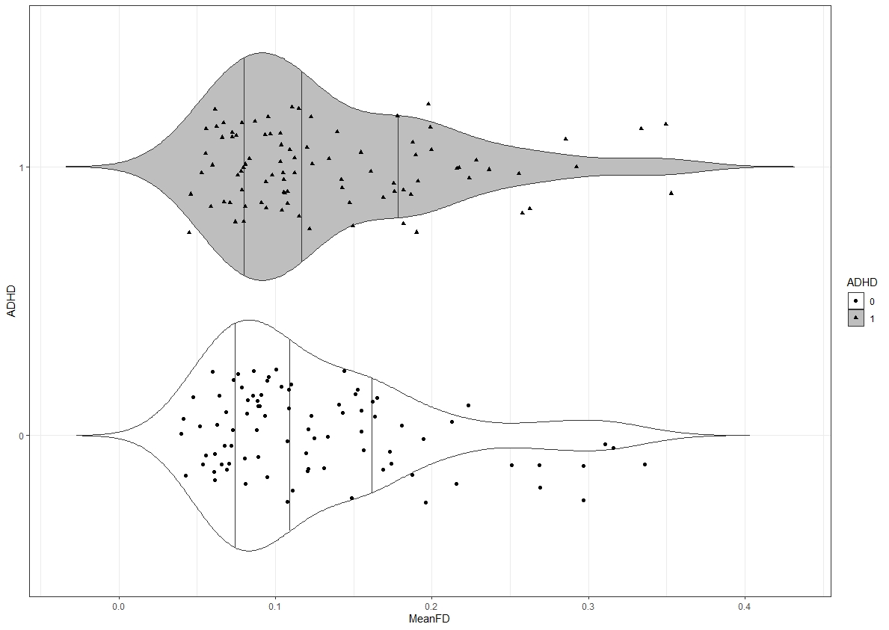
Note: Violin plot divided per quartile of distribution (25, 50, 75 percentiles).
0 neurotypicals
1 ADHD participants

