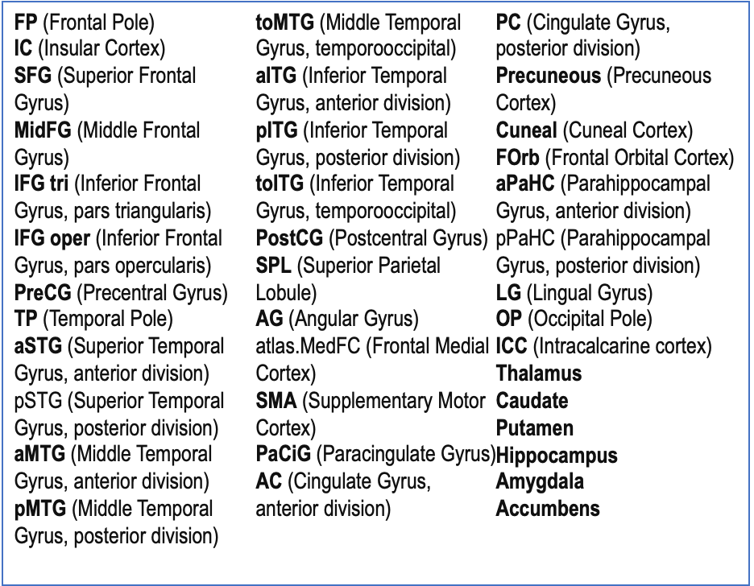

Supplementary Table 1: Target Regions were selected to exclude cerebellar and other brain stem regions and include regions that play a role in both executive function and memory largely in the frontal and middle temporal lobe areas.

