Figure S1. Diagnostic plots for the binomial model predicting the presence/absence of Eimeria spp.
Figure S2. Diagnostic plots for the binomial model predicting the presence/absence of Metastrongylus spp.

Figure S3. Diagnostic plots for the binomial model predicting the presence/absence of GIS.

Figure S4. Diagnostic plots for the model predicting Eimeria spp. abundance.

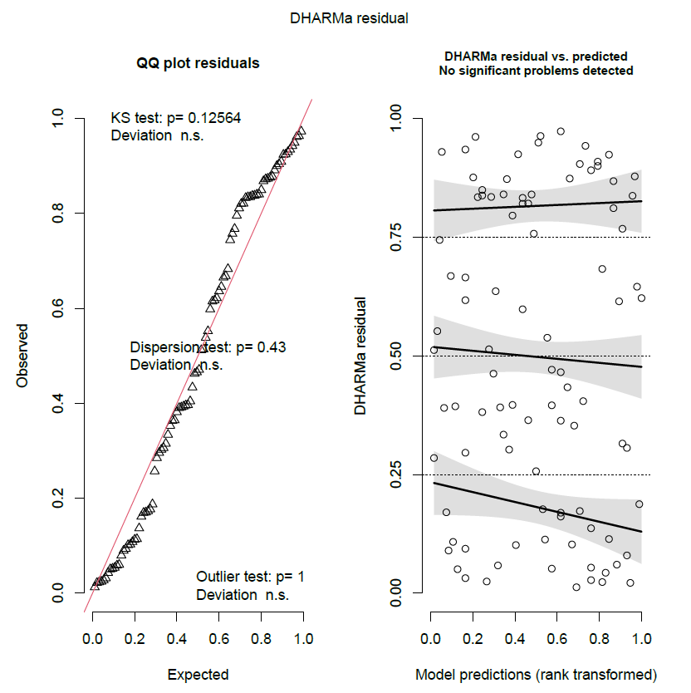
Figure S5. Diagnostic plots for the model predicting Metastrongylus spp. abundance.

Figure S6. Diagnostic plots for the model predicting GIS abundance.

