SUPPLEMENTARY MATERIAL
SM1. Crossing design
Table S1. Crossing desgin with number of individuals and included in final analyses per family and time point.
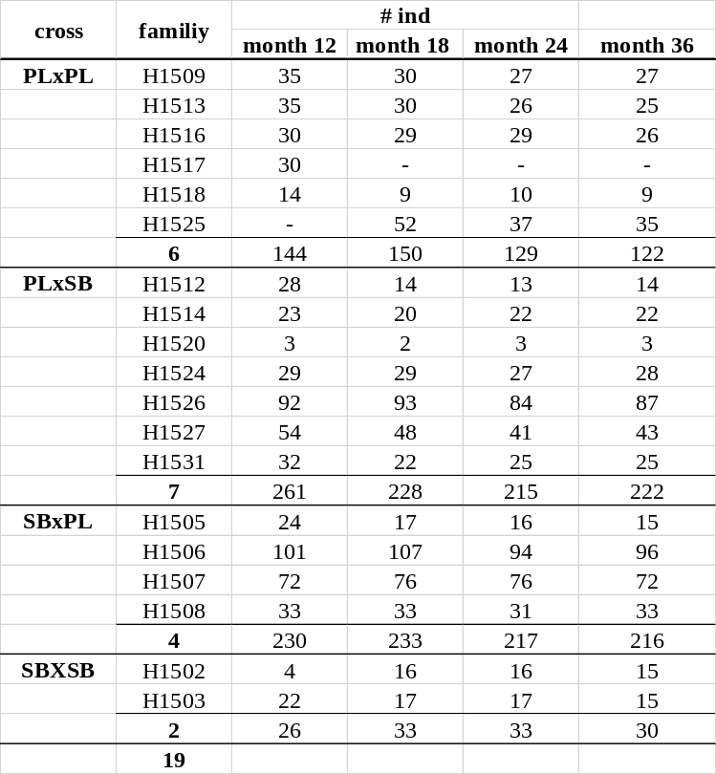

Table 2. Significant terms affecting shape of sexed individuals phenotyped at 18, 24 and 36 months after fertilization in a mixed-model MANOVA using residual randomization. Error terms updated to account for nested families within cross types. (**)
 | d.f. | SS | MS | Rsq | F | Z | Pr (>F)
log(Csize) | 1 | 0.078 | 0.0776 | 0.069 | 229.595 | 10.562 | 0.001 **
month | 2 | 0.085 | 0.0427 | 0.076 | 126.196 | 12.387 | 0.001 **
sex | 1 | 0.049 | 0.0489 | 0.044 | 144.58 | 9.644 | 0.001 **
cross | 3 | 0.055 | 0.0183 | 0.049 | 4.061 | 4.484 | 0.001 **
cross:family | 14 | 0.063 | 0.0045 | 0.056 | 13.352 | 17.552 | 0.001 **
log(Csize):month | 2 | 0.009 | 0.0046 | 0.008 | 13.609 | 7.748 | 0.001 **
log(Csize):sex | 1 | 0.025 | 0.0246 | 0.022 | 72.617 | 9.004 | 0.001 **
log(Csize):month:sex | 2 | 0.010 | 0.0049 | 0.009 | 14.612 | 8.224 | 0.001 **
log(Csize):month:sex:cross:family | 99 | 0.103 | 0.0010 | 0.092 | 3.086 | 18.015 | 0.001 **
Residuals | 1231 | 0.416 | 0.0003 | 0.371
Total | 1356 | 1.121

SM 2. Pairwise comparisons in means and variances between cross types at each time point, using 1000 permutations
Table S2.1. Month 12 – Mean pairwise differences by cross type
Pairwise distances between means, plus statistics
 | d | UCL(95%) | Z | Pr>d
PLxPL:PLxSB | 0.0093 | 0.0047 | 7.493 | 0.001
PLxPL:SBxPL | 0.0145 | 0.0048 | 13.191 | 0.001
PLxPL:SBxSB | 0.0214 | 0.0115 | 7.017 | 0.001
PLxSB:SBxPL | 0.0096 | 0.0033 | 12.815 | 0.001
PLxSB:SBxSB | 0.0174 | 0.0109 | 5.456 | 0.001
SBxPL:SBxSB | 0.0101 | 0.0111 | 1.191 | 0.113

Table S2.2. Month 12 – Observed variances by cross type
Observed variances by group
PLxPL | 0.000251
PLxSB | 0.000278
SBxPL | 0.000273
SBxSB | 0.000238

Table S2.3. Month 12 – Variance pairwise differences by cross type
Pairwise distances between variances, plus statistics
 | d | UCL(95%) | Z | Pr>d
PLxPL:PLxSB | 2.74E-05 | 3.055E-05 | 1.581 | 0.088
PLxPL:SBxPL | 2.23E-05 | 3.103E-05 | 1.056 | 0.165
PLxPL:SBxSB | 1.25E-05 | 5.938E-05 | -0.636 | 0.691
PLxSB:SBxPL | 5.12E-06 | 2.476E-05 | -0.639 | 0.673
PLxSB:SBxSB | 3.99E-05 | 5.744E-05 | 0.973 | 0.159
SBxPL:SBxSB | 3.48E-05 | 5.664E-05 | 0.650 | 0.23

Table S2.4. Month 18 - Mean pairwise differences by cross type
Pairwise distances between means, plus statistics
 | d | UCL(95%) | Z | Pr>d
PLxPL:PLxSB | 0.0140 | 0.0039 | 15.4466 | 0.001
PLxPL:SBxPL | 0.0179 | 0.0037 | 20.2788 | 0.001
PLxPL:SBxSB | 0.0253 | 0.0077 | 13.7834 | 0.001
PLxSB:SBxPL | 0.0101 | 0.0037 | 11.6984 | 0.001
PLxSB:SBxSB | 0.0203 | 0.0079 | 10.6856 | 0.001
SBxPL:SBxSB | 0.0174 | 0.0078 | 9.0448 | 0.001

Table S2.5. Month 18 – Observed variances by cross type
Observed variances by group
PLxPL | 0.000251
PLxSB | 0.000257
SBxPL | 0.000279
SBxSB | 0.000236

Table S2.6. Month 18 – Variance pairwise differences by cross type
Pairwise distances between variances, plus statistics
 | d | UCL(95%) | Z | Pr>d
PLxPL:PLxSB | 6.37E-06 | 2.87E-05 | -0.556 | 0.644
PLxPL:SBxPL | 2.82E-05 | 2.78E-05 | 1.929 | 0.043
PLxPL:SBxSB | 1.49E-05 | 5.11E-05 | -0.392 | 0.575
PLxSB:SBxPL | 2.19E-05 | 2.41E-05 | 1.548 | 0.082
PLxSB:SBxSB | 2.12E-05 | 4.96E-05 | 0.079 | 0.399
SBxPL:SBxSB | 4.31E-05 | 4.99E-05 | 1.515 | 0.089

Table S2.7. Month 24 - Mean pairwise differences by cross type
Pairwise distances between means, plus statistics
 | d | UCL(95%) | Z | Pr>d
PLxPL:PLxSB | 0.0120 | 0.0042 | 11.4171 | 0.001
PLxPL:SBxPL | 0.0212 | 0.0039 | 20.3373 | 0.001
PLxPL:SBxSB | 0.0302 | 0.0076 | 15.8586 | 0.001
PLxSB:SBxPL | 0.0153 | 0.0037 | 17.1499 | 0.001
PLxSB:SBxSB | 0.0219 | 0.0074 | 12.1959 | 0.001
SBxPL:SBxSB | 0.0151 | 0.0072 | 7.6740 | 0.001

Table S2.8. Month 24 – Observed variances by cross type
Observed variances by group
PLxPL | 0.000370
PLxSB | 0.000307
SBxPL | 0.000241
SBxSB | 0.000322

Table S2.9. Month 24 – Variance pairwise differences by cross type
Pairwise distances between variances, plus statistics
 | d | UCL(95%) | Z | Pr>d
PLxPL:PLxSB | 6.35E-05 | 3.78E-05 | 4.121 | 0.001
PLxPL:SBxPL | 1.29E-04 | 3.92E-05 | 8.890 | 0.001
PLxPL:SBxSB | 4.78E-05 | 7.20E-05 | 0.923 | 0.166
PLxSB:SBxPL | 6.52E-05 | 3.54E-05 | 4.723 | 0.001
PLxSB:SBxSB | 1.57E-05 | 6.92E-05 | -0.553 | 0.641
SBxPL:SBxSB | 8.09E-05 | 6.82E-05 | 2.600 | 0.020

Table S2.10. Month 36 - Mean pairwise differences by cross type
Pairwise distances between means, plus statistics
 | d | UCL(95%) | Z | Pr>d
PLxPL:PLxSB | 0.0100 | 0.0056 | 6.0334 | 0.001
PLxPL:SBxPL | 0.0104 | 0.0055 | 6.6022 | 0.001
PLxPL:SBxSB | 0.0166 | 0.0109 | 4.5607 | 0.002
PLxSB:SBxPL | 0.0105 | 0.0044 | 9.1559 | 0.001
PLxSB:SBxSB | 0.0121 | 0.0105 | 2.7498 | 0.018
SBxPL:SBxSB | 0.0124 | 0.0104 | 3.0227 | 0.010

Table S2.11. Month 36 – Observed variances by cross type
Observed variances by group
PLxPL | 0.000583
PLxSB | 0.000614
SBxPL | 0.000538
SBxSB | 0.000548

Table S2.12. Month 36 – Variance pairwise differences by cross type
Pairwise distances between variances, plus statistics
 | d | UCL(95%) | Z | Pr>d
PLxPL:PLxSB | 3.15E-05 | 7.84E-05 | -0.013 | 0.443
PLxPL:SBxPL | 4.47E-05 | 7.68E-05 | 0.625 | 0.244
PLxPL:SBxSB | 3.44E-05 | 1.45E-04 | -0.531 | 0.64
PLxSB:SBxPL | 7.62E-05 | 6.34E-05 | 2.552 | 0.017
PLxSB:SBxSB | 6.59E-05 | 1.38E-04 | 0.233 | 0.346
SBxPL:SBxSB | 1.03E-05 | 1.38E-04 | -1.054 | 0.873

SM3. MANCOVA with the full dataset
Table S3. Table 2. Final mixed-model MANOVA using residual randomization on shape of the full dataset of individuals phenotyped at 12, 18, 24 and 36 months after hatching. Error terms updated to account for nested families within cross types.

SM4. PCAs at month 36
Figure S5. Two first principal components of month 36, showing that either pure crosses or reciprocal hybrids did not cluster towards the “most male or female” area of the morphospace. Each point represents one individual and shaded areas depict 95% confidence ellipses.

SM5. Centroid size
Table S5.1. Centroid size summary by month:cross.
month | cross | Csize mean (cm) | std. dev (cm)
12 | PLxPL | 8.94 | ± | 0.94
 | PLxSB | 8.86 | ± | 0.67
 | SBxPL | 9.33 | ± | 0.84
 | SBxSB | 9.35 | ± | 0.84
18 | PLxPL | 13.15 | ± | 1.49
 | PLxSB | 11.82 | ± | 1.47
 | SBxPL | 11.88 | ± | 1.47
 | SBxSB | 13.71 | ± | 1.84
24 | PLxPL | 18.81 | ± | 2.45
 | PLxSB | 18.52 | ± | 2.16
 | SBxPL | 18.58 | ± | 2.13
 | SBxSB | 19.62 | ± | 2.72
36 | PLxPL | 25.46 | ± | 4.75
 | PLxSB | 24.90 | ± | 4.53
 | SBxPL | 25.57 | ± | 3.31
 | SBxSB | 23.35 | ± | 3.50

Table S5.2. Centroid size summary by month:sex.
month | sex | Csize mean (cm) | std. dev (cm)
12 | NA | 9.07 | ± | 0.82
18 | F | 12.08 | ± | 1.58
 | M | 12.57 | ± | 1.68
 | NA | 11.95 | ± | 1.51
24 | F | 18.7 | ± | 2.19
 | M | 19.19 | ± | 2.05
 | NA | 17.69 | ± | 2.39
36 | F | 25.87 | ± | 3.58
 | M | 25.41 | ± | 4.29
 | NA | 23.83 | ± | 4.30

SM6. Morphological disparity
Table SM6. Morphological disparity from Phenotypic Trajectory Analysis per sex and cross type at different time points.
time point (month) | morphological disparity within time point | sex | morphological disparity within month:sex | cross type | morphological disparity within month:cross
12 | 2.747x10⁻⁴ | f | - | PLxPL | 2.507x10⁻⁴
 |  |  |  | PLxSB | 2.781x10⁻⁴
12 | 2.747x10⁻⁴ | m | - | SBxPL | 2.730x10⁻⁴
 |  |  |  | SBxSB | 2.382x10⁻⁴
18 | 2.722x10⁻⁴ | f | 2.965x10⁻⁴ | PLxPL | 3.240x10⁻⁴
 |  |  |  | PLxSB | 3.091x10⁻⁴
18 | 2.722x10⁻⁴ | m | 2.995x10⁻⁴ | SBxPL | 3.212x10⁻⁴
 |  |  |  | SBxSB | 3.002x10⁻⁴
24 | 3.179x10⁻⁴ | f | 2.878x10⁻⁴ | PLxPL | 3.700x10⁻⁴
 |  |  |  | PLxSB | 3.066x10⁻⁴
24 | 3.179x10⁻⁴ | m | 3.993x10⁻⁴ | SBxPL | 2.414x10⁻⁴
 |  |  |  | SBxSB | 3.222x10⁻⁴
36 | 5.974x10⁻⁴ | f | 4.342x10⁻⁴ | PLxPL | 5.830x10⁻⁴
 |  |  |  | PLxSB | 6.136x10⁻⁴
36 | 5.974x10⁻⁴ | m | 5.374x10⁻⁴ | SBxPL | 5.377x10⁻⁴
 |  |  |  | SBxSB | 5.488x10⁻⁴

Table 3. Covariates effects from independent MANOVAs at for months 12, 18, 24 and 36, using residual randomization. Error terms updated to account for nested families within cross types.
 | Month 12 |  |  |  |  | Month 18
 | Rsq | Z | pr (>F) |  |  | Rsq | Z | pr (>F)
log(Csize) | 0.037 | 8.136 | 0.001 | ** |  | 0.080 | 10.191 | 0.001 | **
cross | 0.106 | 4.374 | 0.001 | ** |  | 0.131 | 5.310 | 0.001 | **
cross:family | 0.110 | 13.774 | 0.001 | ** |  | 0.097 | 14.776 | 0.001 | **
log(Csize):cross | 0.020 | -0.831 | 0.788 |  |  | 0.023 | 0.360 | 0.037
log(Csize):cross:family | 0.016 | 0.596 | 0.283 |  |  | 0.016 | 1.872 | 0.036 | *
Residuals | 0.675 |  |  |  |  | 0.542
 | Month 24 |  |  |  |  | Month 36
 | Rsq | Z | pr (>F) |  |  | Rsq | Z | pr (>F)
log(Csize) | 0.042 | 8.229 | 0.001 | ** |  | 0.082 | 7.091 | 0.001 | **
cross | 0.197 | 4.737 | 0.001 | ** |  | 0.044 | 2.618 | 0.008 | **
cross:family | 0.006 | 14.375 | 0.001 | ** |  | 0.071 | 7.495 | 0.001 | **
log(Csize):cross | 0.139 | -4.823 | 1.000 |  |  | 0.009 | -1.241 | 0.899
log(Csize):cross:family | 0.023 | 3.331 | 0.002 | ** |  | 0.037 | 4.172 | 0.001 | **
Residuals | 0.574 |  |  |  |  | 0.727

Fig. S4.1. Morphological disparity across time in males (blue) and females (red).
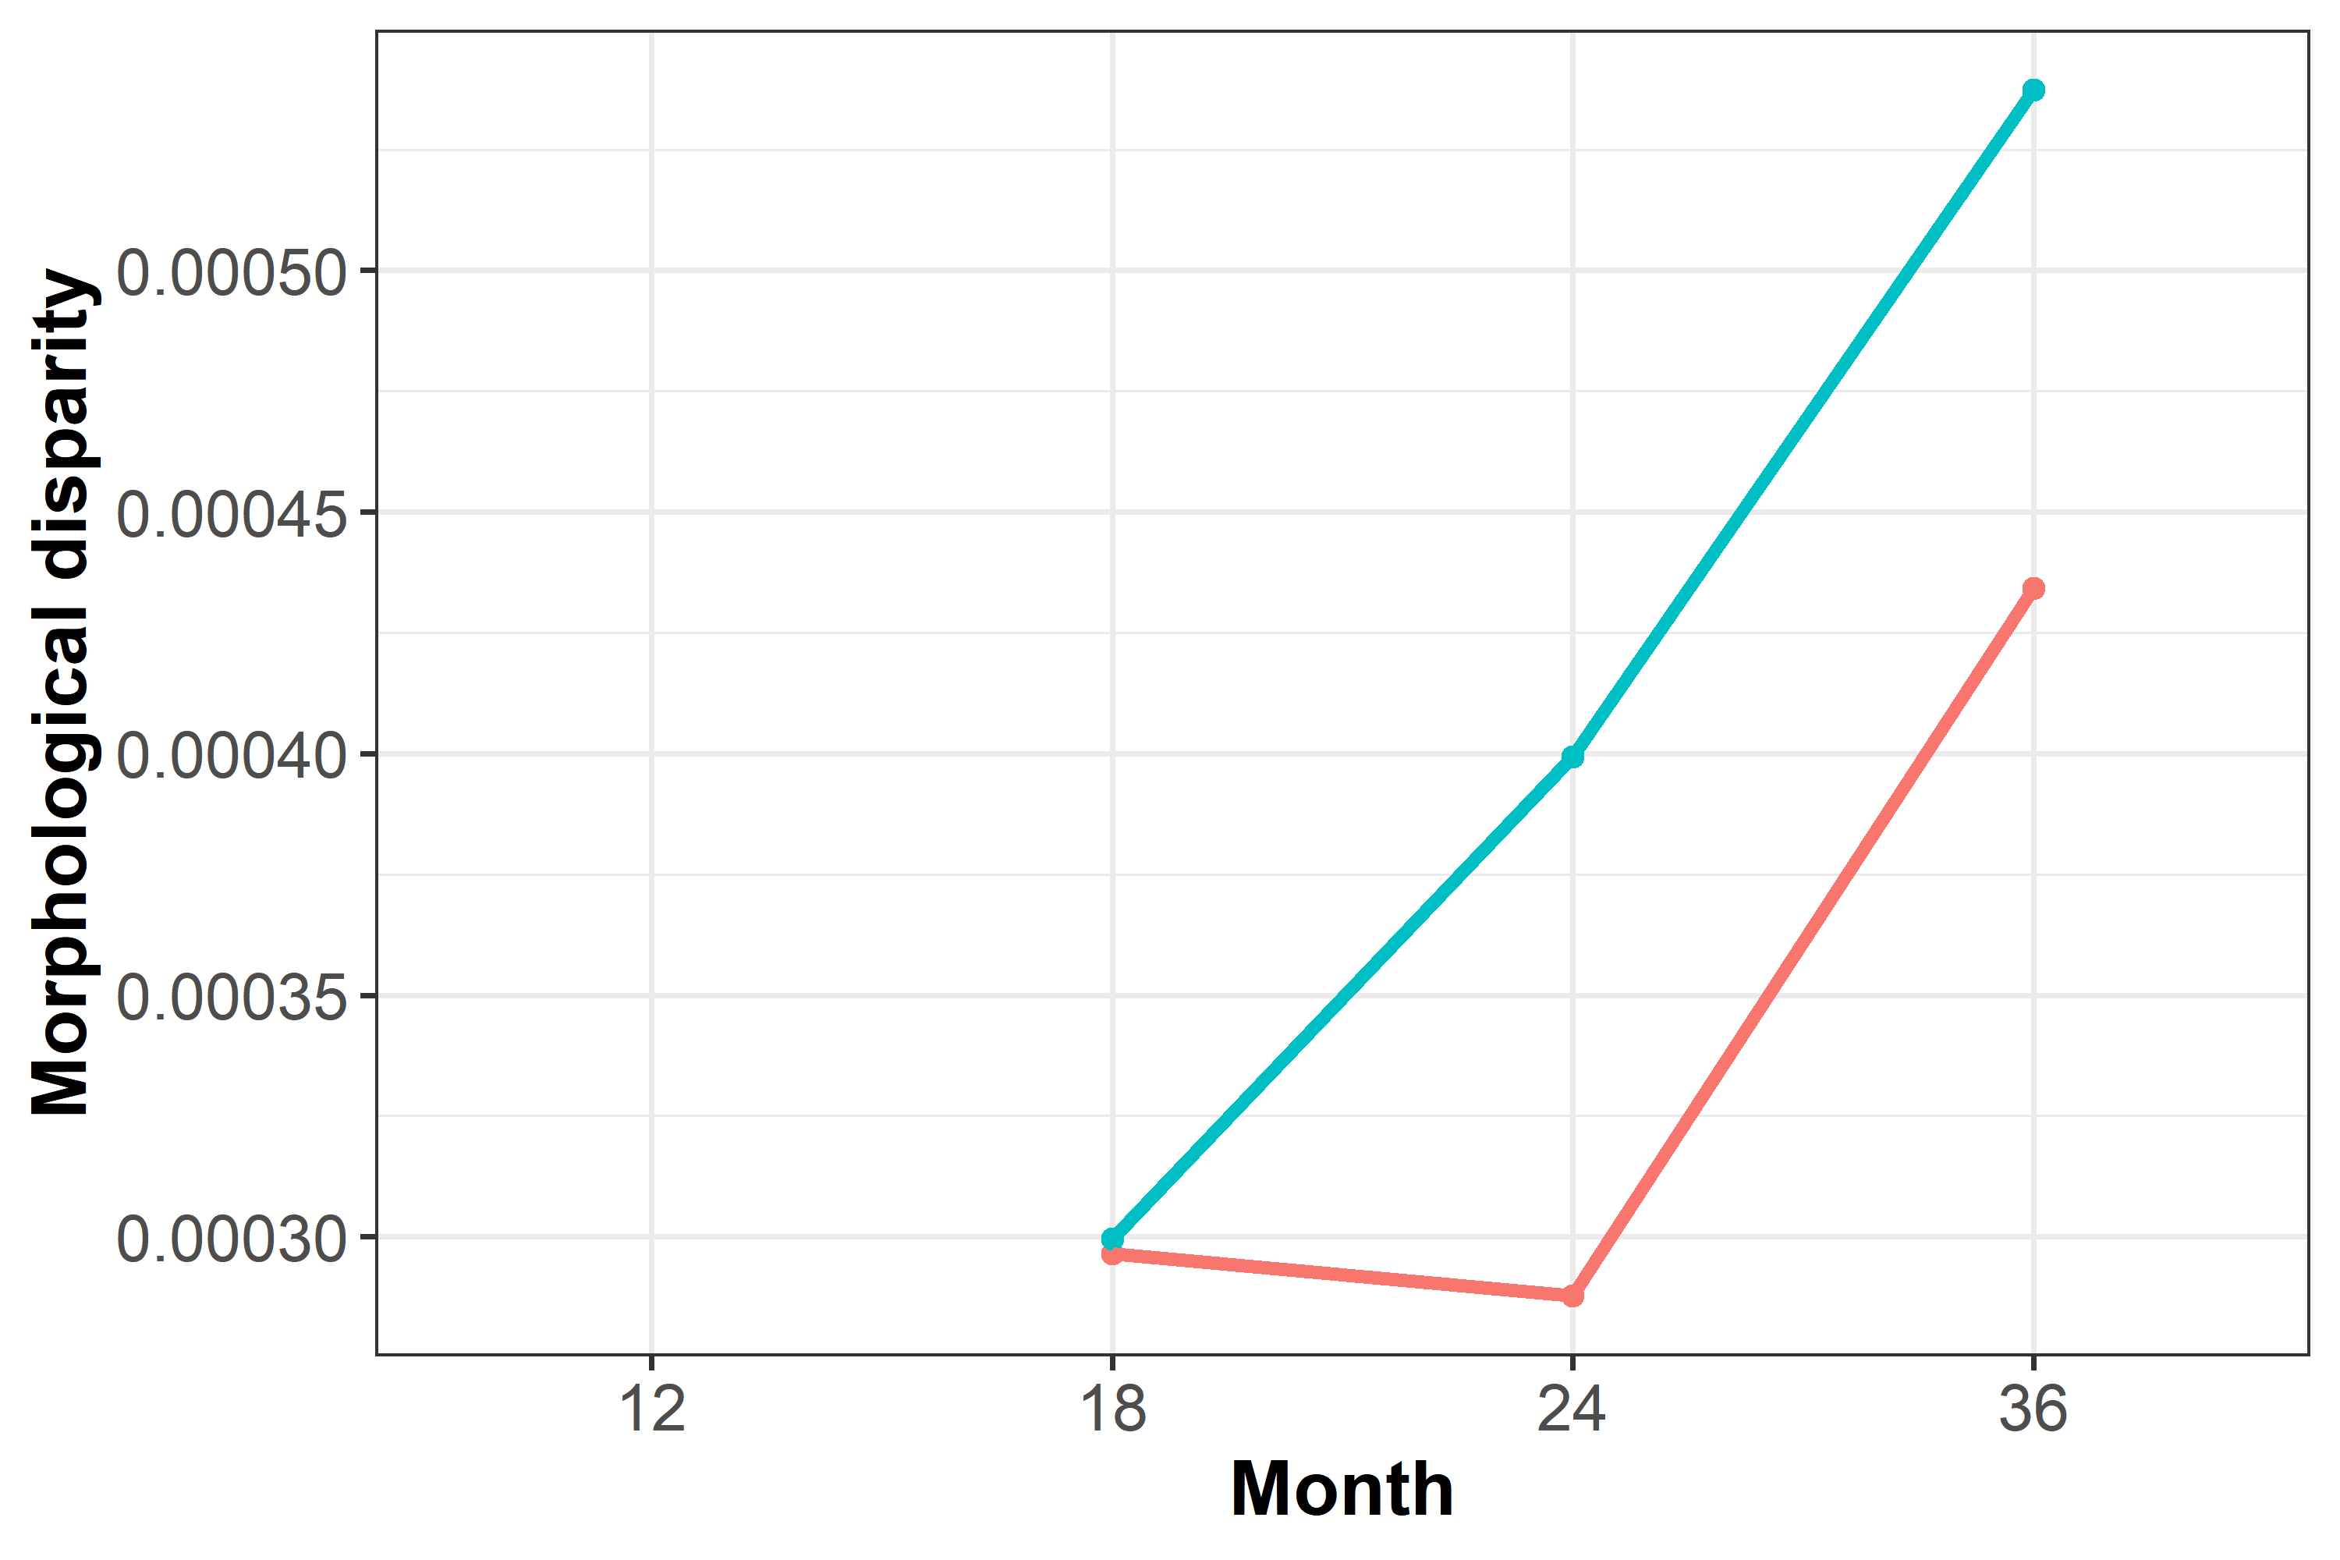

Fig S4.2. Morphological disparity across time in the different morphs

SM7. Wireframes corresponding to Fig 7. Wireframes represent predicted shapes at each extreme of the two first principal components per time point. Low values of each principal component are represented by blue wireframes and high values by red wireframes.
Mo

