Supplementary Material 2 to Mizerovská et al. (2023) "Parallel evolution of skull form in three rodent genera inhabiting steep elevation gradients of Ethiopian highlands."
Fig S1 Geographical location of samples used in this study and a simplified map of the potential natural vegetation of Ethiopia (based on Friis et al., 2010, https://vegetationmap4africa.org)
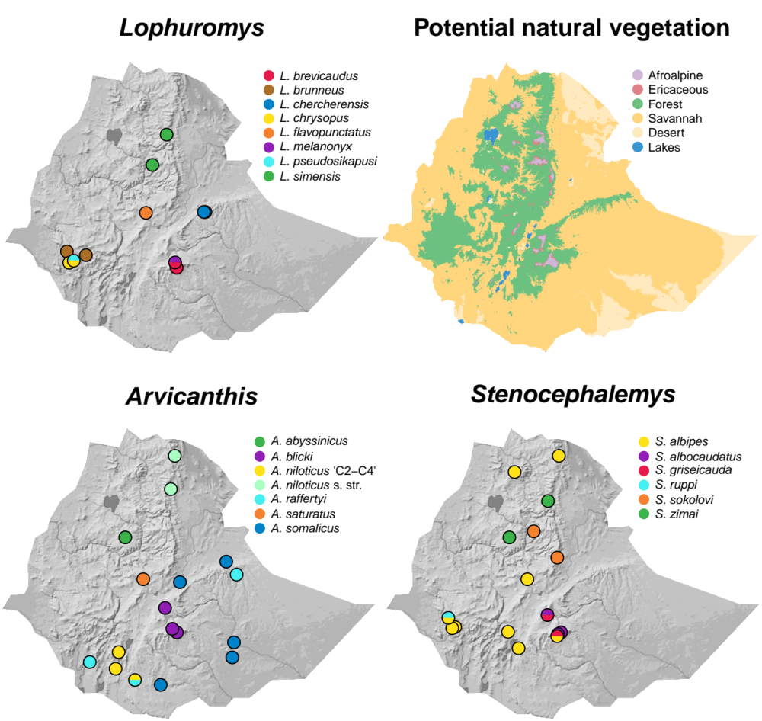

Fig. S2 Symmetric and asymmetric part of skull shape variation. On the left, the wireframe plots show the mean symmetric shape (in green) completely hiding the mean asymmetric shape (in red) beneath it, which demonstrates the directional asymmetry of the skull is negligible. On the right, the lines show proportions of symmetric and asymmetric variation attributable to principal components calculated separately on each of them. It can be seen that distribution of asymmetric variation is much closer to isotropy (=evenness in all directions). Finally, the pie plot shows the shares of symmetric and asymmetric part on the total shape variation (95.2% and 4.8%, respectively). Overall, the comparison indicates asymmetric variation is of minor importance and largely stochastic. The results were similar for mandible shape variation, although the share of asymmetric part was larger (9.6%)
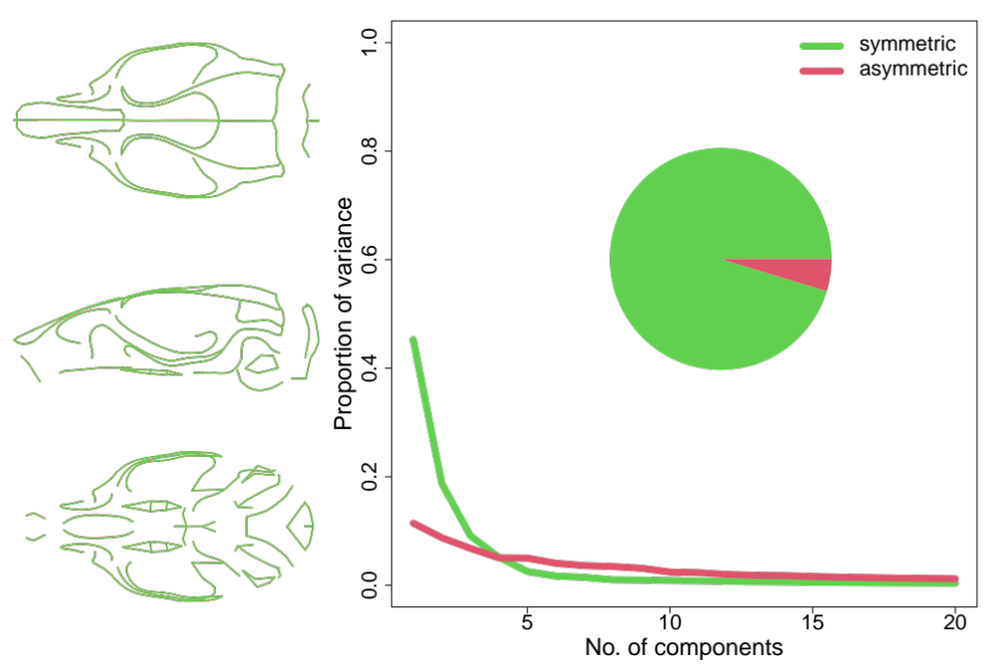

Fig. S3 Ordination of species means in the space of the first two PLS components of shape variation, which were estimated exactly as in the main analysis (cf. Fig. 4) but based on the fixed landmarks only. The comparison with Fig. 4 shows the main observed trend was not driven by presence of a large number of semilandmarks.
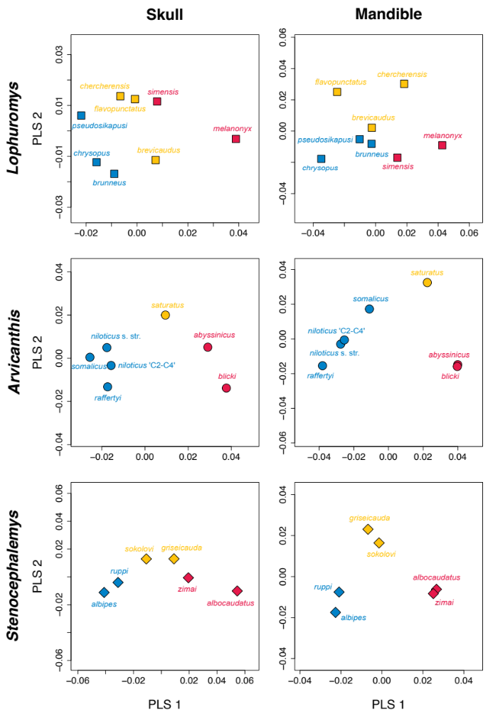

Fig. S4 Direct comparison of the main skull shape elevational trend in the three genera. Wireframe plots compared shapes corresponding to unit shifts along PLS1 from the same starting point, which was the grand mean shape from the Generalized Procrustes analysis (in grey). The other colours indicate the genus (yellow = Lophuromys, green = Arvicanthis, brown = Stenocephalemys). The same predicted shapes are shown in the dorsal, lateral, and ventral view
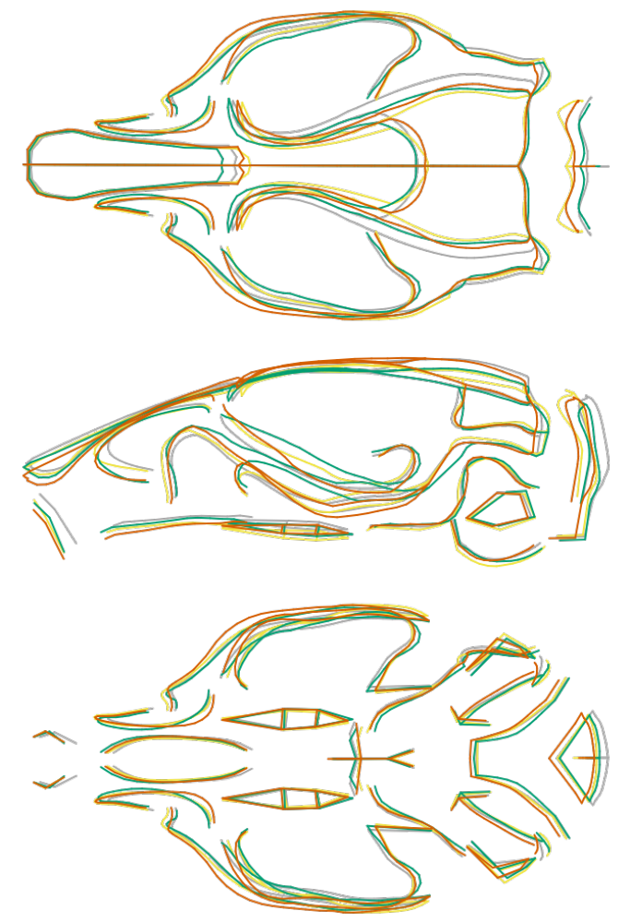
Fig. S5 Direct comparison of the main mandible shape elevational trend in the three genera. Wireframe plots are arranged as in Fig. S4
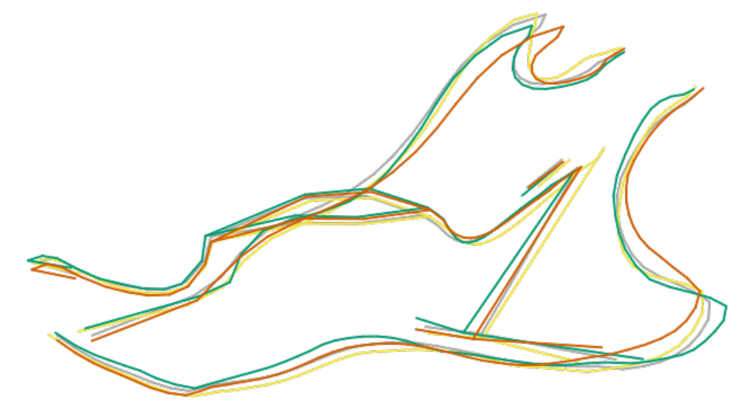

Fig. S6 Skull shape differences accounted for by PLS2, i.e., the additional elevational trend. Wireframe plots contrast shapes corresponding to the minimum and maximum species mean PLS2 scores. PLS2 generally distinguishes mid-elevation species (yellow outline) from the rest (grey outline). The same predicted shapes are shown in three views (dorsal, lateral, and ventral)
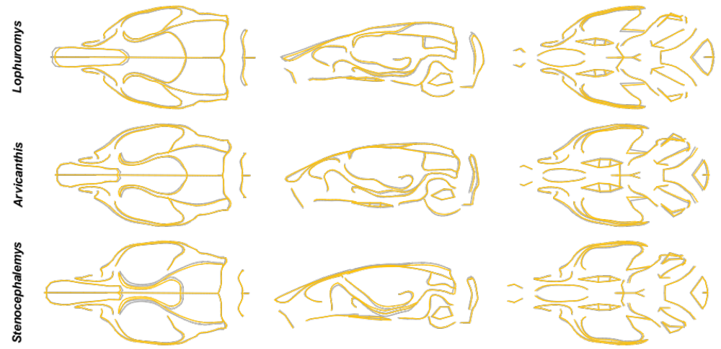

Fig. S7 Mandible shape differences accounted for by PLS2, i.e., the additional elevational trend. Wireframe plots are arranged as in Fig. S4, but only a single (lingual) view is given
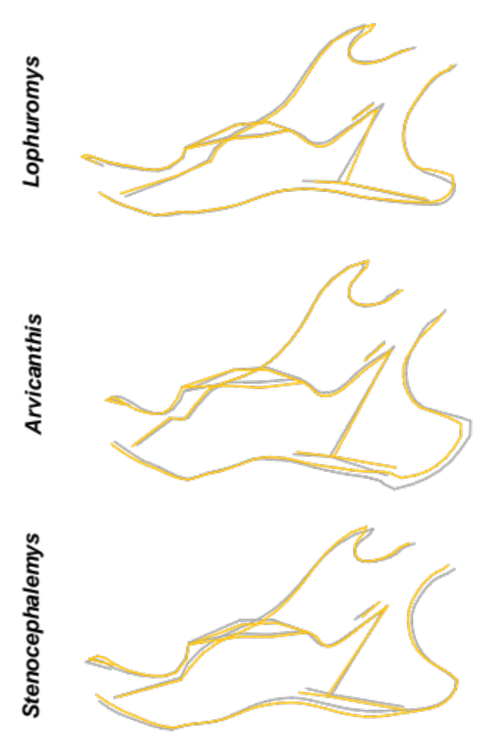

Fig. S8 Intra- and interspecific variation in mandible centroid size. Within each genus the species are ordered according to the elevation range of their occurrence, the dots are coloured according to the elevation zones as in Fig. 4
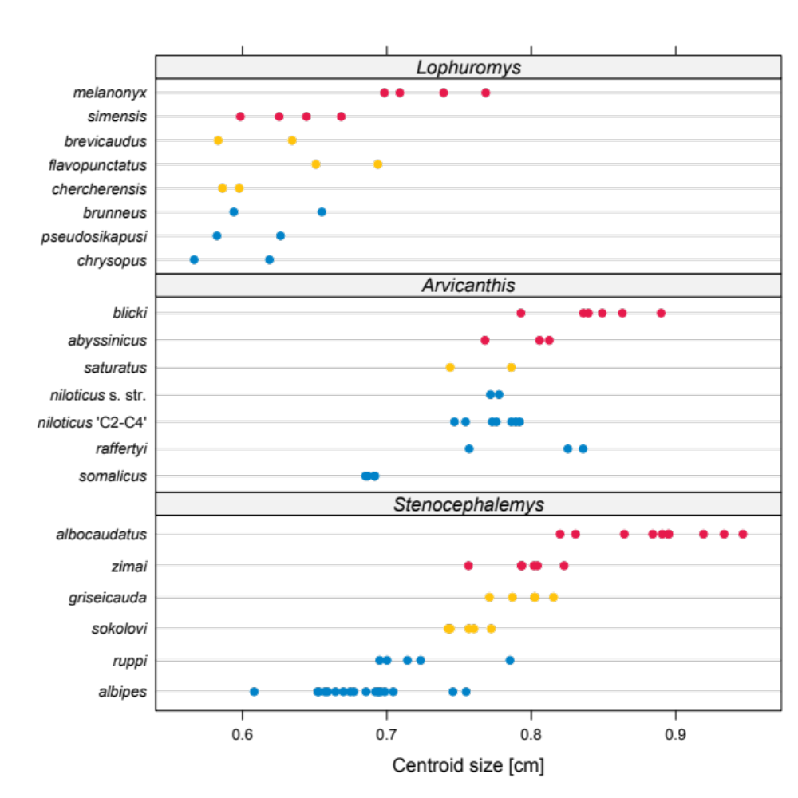

Table S1 Anatomical definitions of fixed landmarks on the skull and mandible. The numbers correspond to those in Fig. 2 of the main text
Landmark no. | Anatomical definition
SKULL
1 | anterior tip of the nasal bone
2 | intersection of the naso-frontal suture and the midline
3 | intersection of the coronal and sagittal suture
4 | intersection of the sagittal and parietal-interparietal suture
5 | the uppermost point of the occipital crest
6, 7 | the left / right extreme of the interparietal bone
8, 9 | posterior end of the squamosal suture on the roof of the braincase
10, 11 | the lowermost point of the infraorbital canal
12, 38 | the center of the alveolar ridge over the upper incisor
13, 39 | the left / right extreme of the upper incisor at the ventral edge of the alveolus
14, 40 | the lower end of the zygomatic plate
15, 41 | the uppermost point of the infraorbital canal
16, 42 | the upper end of the zygomatic plate
17, 43 | the left / right extreme of zygomaticomaxillary suture on the ventral edge of zygomatic arch
18, 44 | the left / right extreme of temporozygomatic suture on the ventral edge of zygomatic arch
19, 45 | intersection of parietal, temporal and occipital bones
20, 46 | posterior tip of the posttympanic process of squamosal
21, 47 | contact of the squamosal and pterygoid
22, 48 | intersection of the frontal process of maxilla with frontal and lacrimal bones
23, 49 | intersection of the frontal and zygomatic process of the maxilla
24, 50 | intersection of the maxilla and zygomatic bone at the upper edge of zygomatic arch
25, 51 | intersection of the temporal and zygomatic bone at the upper edge of zygomatic arch
26, 52 | maxilla at the posterior edge of the third upper molar
27, 53 | maxilla at the anterior edge of the first upper molar
28, 54 | base of the zygomatic process of the maxilla from inside of the orbit
29, 55 | anterior end of the palatal foramen
30, 56 | anterior end of the palatal foramen
31 | posterior end of the palatines at the midline
32 | midpoint of the basisphenoid-basioccipital suture on the ventral side of the skull
33 | the ventral extreme of foramen magnum at the midline
34, 57 | the dorsal extreme of the anterior crus of ectotympanic
35, 58 | base of the styliform process of auditory bulla at the side adjacent to midplane
36, 59 | posterior crus of ectotympanic
37, 60 | base of the styliform process of auditory bulla in its most concave shaped part
61 | the dorsal extreme of foramen magnum at the midline
62, 63 | lateral extremes of the occipital bone
64, 65 | anterior tip of intersection of the parietal and squamosal bones on the dorsal side of the skull
66, 67 | anterior tip of premaxillae
68, 70 | posterior point of fissura orbitalis
69, 71 | upper point of fissura orbitalis
72 | anterior edge of canalis opticus
73 | posterior edge of canalis opticus
74 | anterior edge of mesopterygoid fossa
75 | midpoint of suture between the presphenoid and basiphenoid
76, 77 | posterior point of sphenopalatine vacuities
78, 81 | anterior point of parapterygoid fossa
79, 82 | posterior point of foramen ovale accessorius
80, 83 | the lowermost point of the sphenofrontal suture on the lateral surface
84, 90 | lateral extremes of the basisphenoid-basioccipital suture on the ventral side of the skull
85, 91 | notch at the contact of the basioccipital and exoccipital
86, 92 | posterior edge of the paroccipital process
87, 93 | the outermost point of the occipital condyle
88, 94 | intersection of the occipital condyle and the edge of foramen magnum
89, 95 | notch on the occipital condyle
96, 101 | stylomastoid foramen
97, 102 | between anterior and posterior crus of ectotympanic
98, 103 | the ventral extreme of the anterior crus of ectotympanic
99, 104 | rostral process of malleus fused to ectotympanic
100, 105 | base of the styliform process of auditory bulla at the side distant from midplane
106, 110 | contact of the first and second molars on the labial side of maxilla
107, 111 | contact of the second and third molars on the labial side of maxilla
108, 112 | contact of the first and second molars on the lingual side of maxilla
109, 113 | contact of the second and third molars on the lingual side of maxilla
114, 115 | anterior tip of the intersection of coronal and squamosal suture
MANDIBLE
1 | symphysis
2 | the uppermost point on the incisor alveolar rim
3 | the lowermost point on the incisor alveolar rim
4 | mental foramen
5 | intersection of the superior and inferior masseteric ridge
6 | anterior edge of lower molar row
7 | tip of the coronoid process
8 | anterior edge of mandibular condyle
9 | tip of the post-condylar process
10 | tip of the angular process
11 | the maximum curvature of the lower edge of the angular process
12 | upper point of mandibular foramen
13 | posterior edge of lower molar row
14 | the lowermost point between the ramus and the alveolar region
15 | anterior end of horizontal crest in masseteric fossa
16 | the most prominent point on the horizontal crest in masseteric fossa
17 | posterior end of horizontal crest in masseteric fossa
18 | contact of the first and second molar on the labial side of mandible
19 | contact of the second and third molars on the labial side of mandible
20 | contact of the first and second molars on the lingual side of mandible
21 | contact of the second and third molars on the lingual side of mandible
22 | origin of the angular process on the lower ramus
23 | lower point of mandibular foramen
24 | the deepest concavity of the pterygoid fossa
25 | the lowermost point of the incisor
26 | most dorsal and most posterior point of the pterygoid fossa

