Appendix A – Geometric morphometrics pilot study

Methods
A pilot study to test two variables was conducted. The first variable tested the number of replicates necessary to reduce operational error to a tolerable amount. For this, three adult females are used from three species: S. brevipalpis, S. rufidens and Undescribed species 3. The second variable is allometry within species to determine if juveniles can be included in the study. For this, three adult female and three juveniles of S. maraisi were also included. Each specimen was reset and photographed in a random order five times to ensure that there was no operational bias in the photography process (Bakkes, 2017). A Leica M 165C stereomicroscope attached to Leica camera (DMC-2900) was used for the photography and the specimens were set in a petri dish of glass beads for ease of adjustment, to ensure similar angles in each photograph.
Once photographed all the images were compiled using tpsUtil v1.79 (Rohlf, 2015) and were imported to tpsDig v.2.31 (Rohlf, 2015) for digitisation. The photographs were selected at random when digitising to ensure that there was no operational bias. The photography and landmarking were performed by the same operator for the entire process to ensure that no additional error was introduced (Bakkes, 2017).
The statics used to complete the pilot study were performed in MorphoJ v.1.06d (Klingenberg, 2011). A general procrustes analyses (GPA) was performed to standardise the data. Thereafter, a principal component analyses (PCA) was done to determine if the between species differences are greater than the within species. A regression was performed to test for allometry for the different female life stages. Lastly, a procrustes ANOVA was performed to test if there is a significant influence of maturity, species and replication. Procrustes ANOVA was also used to determine the percentage error due to orientation (error introduced during photography) and digitisation for the different numbers of replications. This was calculated using the mean sum of squares (Bakkes 2017, Fruciano 2016). For further information on each statistical analysis, please see the method in the manuscript.

Results & Discussion
The results of the PCA shows clear separation between species. The clustering is tighter between species than within species (Figure P1). This indicates that this character may be useful for separating species, but is not too fine scale to detect within species differences. The tightness of each individual cluster also indicates that the replications were very similar and not mistaken for within species variation. The distinct separating between the juveniles and adults of S. maraisi shows that the differences in the relative positions and sizes of the eyes are highly variable between the two life stages. The two life stages can thus not be compared with in a species and juveniles should not be included in downstream analyses.

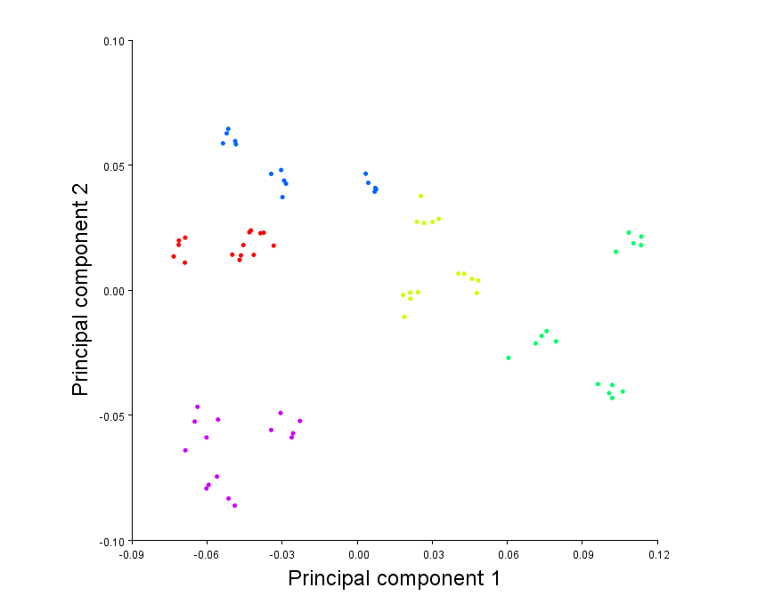
PC2 (23.24%)
PC1 (48.71%)

S. brevipalpis
Undescribed species 3
S. rufidens
S. maraisi (adults)
S. maraisi (juveniles)

Figure P1. Morphospace plots of the first two PCs for the female pilot dataset. A. The morphospace plot coloured by species. S. maraisi is shown for juveniles (green) and adults (yellow) of the species.

The regressions of shape and centroid size show that there is a significant relationship between the two variables. When juveniles are included with the other species, the amount of variation explained by size is 40.32%, this is reduced to 12.11% when the juveniles are removed and species are accounted for (Figure P2). When only the S. maraisi specimens are tested, 46.58% of the variation is due to size. This shows that the variation in allometry within a species between two life stages is too great to be included with the species variation, as these relationships would be obscured. The species pooled regression displays evolutionary allometry, this is expected as size is used as an identifying feature between Stasimopus species (Figure P2C).

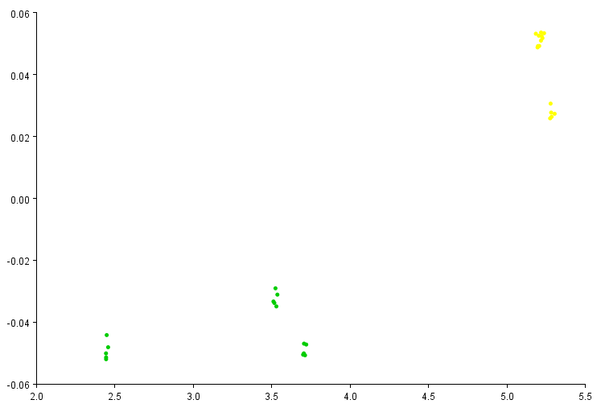
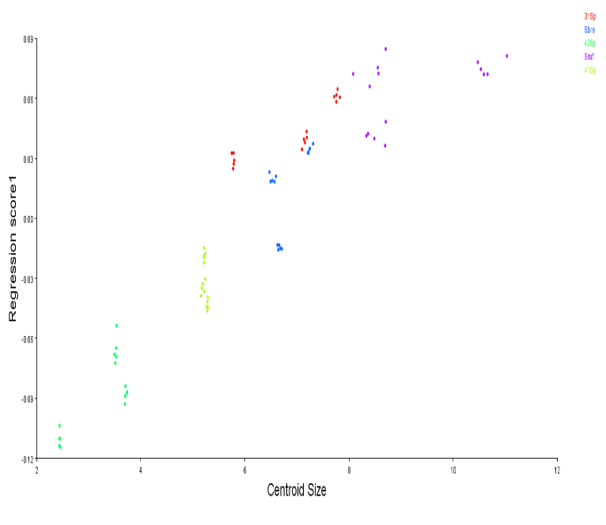
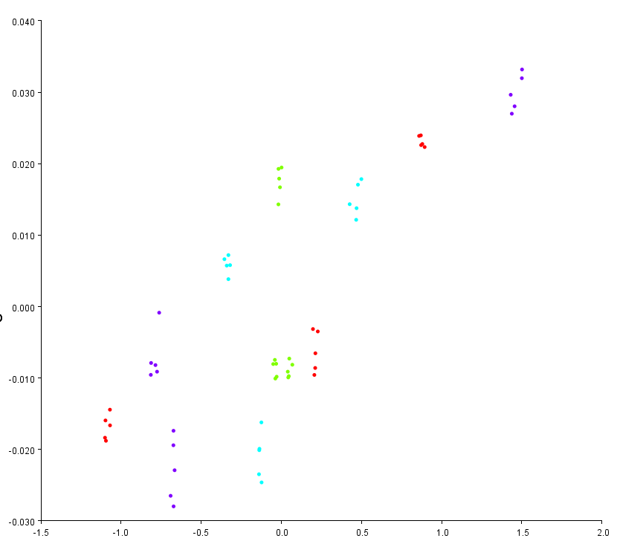
Centroid size
Regression scores
A
B
C
D



Effect | P | % Predicted
- Shape vs size | <0.0001 | 40.32%
B. Species allometry | <0.0001 | 46.58%
C. Evolutionary allometry | <0.0001 | 12.11%

S. brevipalpis
Undescribed species 3
S. rufidens
S. maraisi (adults)
S. maraisi (juveniles)

Figure P2. Various regressions of procrustes distances against centroid size. A. Regression of all four species (including the S. maraisi juveniles – yellow). B. Regression of the S. maraisi specimens to test allometry within the species. C. Regression pooled by species (not including juveniles) to test evolutionary allometry. D. Table showing the significance of the regressions and the percentage variation in the dataset which is predicted by centroid size.

The Procrustes ANOVA of various variables and shape shows that there is a significant relationship between species as well as maturity and shape (Table P1). There are differences between the various species relative eye positions and sizes, indicating that this character could be used to separate species. The same pattern is true for the juveniles and adults of S. maraisi, indicating again that the juveniles cannot be included in the analyses. There is no significance between shape and replications, indicating that each replication was similar enough and that multiple replications may not be necessary.

Effect | SS | MS | Df | F | P
Species | 0.20681 | 0.001149 | 180 | 180 | <0.0001
Maturity | 0.18172 | 0.003029 | 60 | 40.53 | <0.0001
Replications | 0.00257 | 0.000011 | 240 | 0.12 | 1.000
Table P1. Procrustes ANOVA of the various variable relationship with shape of Stasimopus ocular patterns.

The testing for error between replications is shown in Table P2. The error which contributed the most to total error in each replication was orientation error. This is the placement and photography of the specimens. This is likely due to the specimen not facing the camera lens at exactly the same angle in every photograph. This however, still contributes to a small amount of the total variation in the dataset (3.287% at most). The total variation is also at a manageably low level (<5%) even with only two replications.

Reps | Effect | SS | MS | Df | F | P | % Error | Total error
5 | Individual | 0.95867 | 0.001141 | 840 | 95.06 | <.0001 |  | 1.583%
 | Orientation | 0.05403 | 0.000012 | 4500 | 1.98 | <.0001 | 1.052% | 1.583%
 | Digitisation | 0.02180 | 0.000006 | 3600 |  |  | 0.531% | 1.583%
4 | Individual | 0.76671 | 0.000913 | 840 | 72.08 | <.0001 |  | 2.049%
 | Orientation | 0.04559 | 0.000013 | 3600 | 2.10 | <.0001 | 1.387% | 2.049%
 | Digitisation | 0.01630 | 0.000006 | 2700 |  |  | 0.662% | 2.049%
3 | Individual | 0.57726 | 0.000687 | 840 | 51.20 | <.0001 |  | 2.885%
 | Orientation | 0.03624 | 0.000013 | 2700 | 2.09 | <.0001 | 1.953% | 2.885%
 | Digitisation | 0.01153 | 0.000006 | 1800 |  |  | 0.932% | 2.885%
2 | Individual | 0.38862 | 0.000463 | 840 | 30.42 | <.0001 |  | 4.751%
 | Orientation | 0.02738 | 0.000015 | 1800 | 2.24 | <.0001 | 3.287% | 4.751%
 | Digitisation | 0.00650 | 0.000007 | 960 |  |  | 1.464% | 4.751%
Table P2. Procrustes ANOVA of the digitisation and orientation error associated with different numbers of replication. The percentage error is calculated based on the mean sum of squares (MS).

Conclusion
The results of the pilot study that there are significant and quantifiable differences in the relative position and size between Stasimopus species. The differences between eye patterns of juveniles and adults within the same species is too great and will likely confound the between species results. For this reason, juveniles will not be included in the study. The error testing showed that there is more error introduced from the photography process than digitisation. The total error with only two replicates is still below 5%. The decision was made to only use on replication for the study.

References
Bakkes, D. K. (2017). Evaluation of measurement error in rotational mounting of larval Rhipicephalus (Acari: Ixodida: Ixodidae) species in geometric morphometrics. Zoomorphology, 136(3), 403–410. https://doi.org/10.1007/s00435-017-0357-8
Fruciano, C. (2016). Measurement error in geometric morphometrics. Development Genes and Evolution, 226(3), 139–158. https://doi.org/10.1007/s00427-016-0537-4
Klingenberg, C. P. (2011). MorphoJ: an integrated software package for geometric morphometrics. Molecular Ecology Resources, 11, 353–357. https://doi.org/10.1111/j.1755-0998.2010.02924.x
Rohlf, F. J. (2015). The tps series of software. Hystrix, the Italian Journal of Mammalogy, 26, 1–4. https://doi.org/10.4404/hystrix-26.1-11264

