Supplementary Information for:

Climate Change Predictive of Body Size and Proportionality in Humans

This file includes:

Supplementary Results
Figures S1 to S12
Table S1

Other supplementary materials for this manuscript include the following:

Supplementary Data 1

Supplementary Results

Prior research comparing climate records to body size changes have relied exclusively on regression analysis without an ability to control for the numerous co-variates associated with changing physiology over time. As a result, none of the climate models have been able to account for more than a small amount of the variation in Homo body size. Nevertheless, regression analysis provides additional information to determine high-level correlations between climate and body size changes. While the present study relies principally on group differences in the Homo sample without regression modeling, regression analyses have been provided as Supplemental Information to isolate specific trends.

Because there were numerous cooling and warming cycles across the last 700,000 years, changes in body mass were tested against these fluctuations to determine whether the changes directly correlated with global warming and cooling trends. Modeling both cooler and warmer than average periods separately demonstrated clear quadratic trends in both cases (Fig. S1). Within cooler periods, there is an increase in body mass as temperatures decline, then an apparent decrease at the most extreme temperatures. Conversely, during warmer than average periods, body mass decreases as temperatures rise, reaches a low point, and then appears to increase slightly across the hottest average temperatures. These results are consistent with cubic models that found similar generalizable trends between climate and body mass (Figs. S2-S4). Inclusion of sex and geography as co-variates in a cubic polynomial model increases the correlations significantly and can account for roughly half (r² = 0.50) of the variability (Figs. S3-S4). Eliminating potential data outliers as discussed in the manuscript further increases the explanatory power of the model and reduces the differences between the linear and polynomial fit (see Fig. S10).

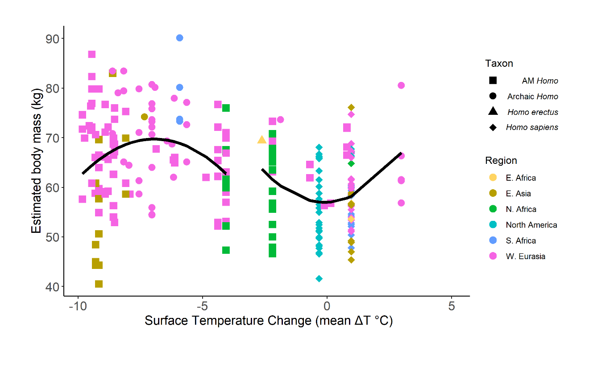

Fig. S1. Body mass (kg) changes during warming and cooling cycles (changes in Antarctic surface temperature (°C) relative to the mean for the last millennium) over the past 700,000 years. Within periods of global warming and cooling, body mass changes largely correspond to changing temperatures. A quadratic trend was identified in both cases (p < 0.01) and while each is significant, the combined linear and quadratic effect of temperature only explains roughly 10% of the variability in body mass during periods of global warming (r² = 0.07) and cooling (r² = 0.09), owing in large part to negative to neutral effects at extreme temperatures (Fig. S12).

Several other non-linear regression models were considered in an attempt to find other generalizable trends between temperature and body mass across the past 700 kyr. Across each model, the effect of temperature was considered first in isolation before including the effects of sex and latitude as covariates. A cubic model appears to provide the best balance between explaining the variability in the data and generalizing to unseen observations.

The table below summarizes the relevant statistics for each of the models, including a standard linear model as presented in the main manuscript (Fig. 2). All effects in these models are highly significant (P < 0.02).

Table S1. Regression Models
Model | Adjusted r² | AIC | RMSE | RMSPE
Linear | 0.13 | 1788.33 | 8.93 | 8.98
Cubic | 0.19 | 1773.97 | 8.6 | 8.74
Cubic+Sex+Latitude | 0.49 | 1452.69 | 6.56 | 6.77
Cubic+Sex+Latitude+Temp:Sex | 0.5 | 1448.7 | 6.47 | 6.71

To test the predictability of each model, estimated r², AIC, Root Mean Squared Error (RMSE) and Root Mean Squared Prediction Error (RMSPE) were calculated, and the results demonstrated greater strength as the models increased in complexity, suggesting that adding sex, latitude, and the interaction effects provided incremental explanatory power. The results indicate that the model which includes temperature (linear, quadratic and cubic effects), sex and latitude explains a sufficient amount of the variability in the data without overfitting, indicating that each of these three factors are key drivers of the change in body mass and together can account for upwards of 50% of the variability in body mass over the past 700,000 years.

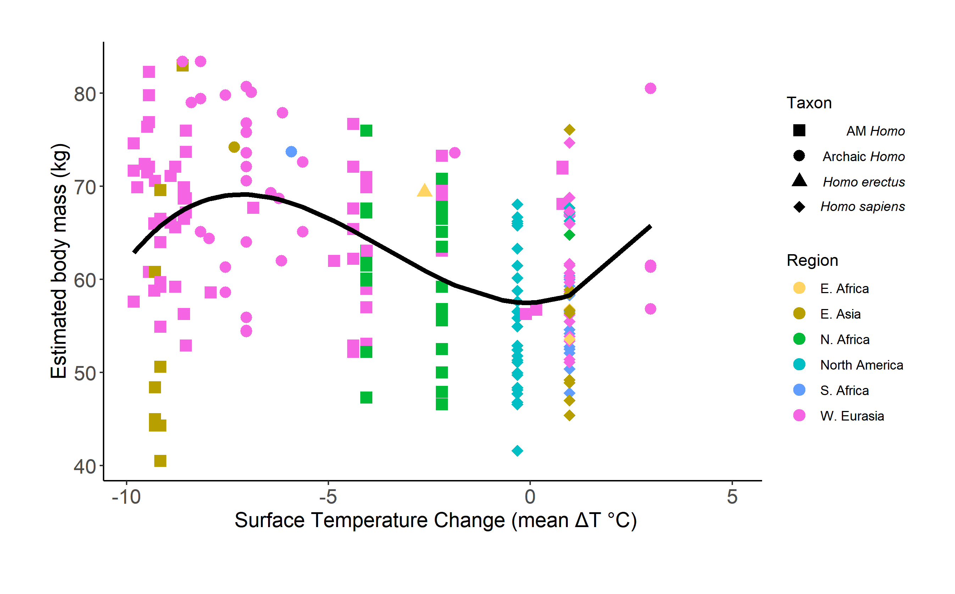
Fig. S2. Cubic Model. A cubic model increases the fit relative to a simple LSR but outliers could be effecting the results at extreme temperatures (see, for instance, Fig. S9).

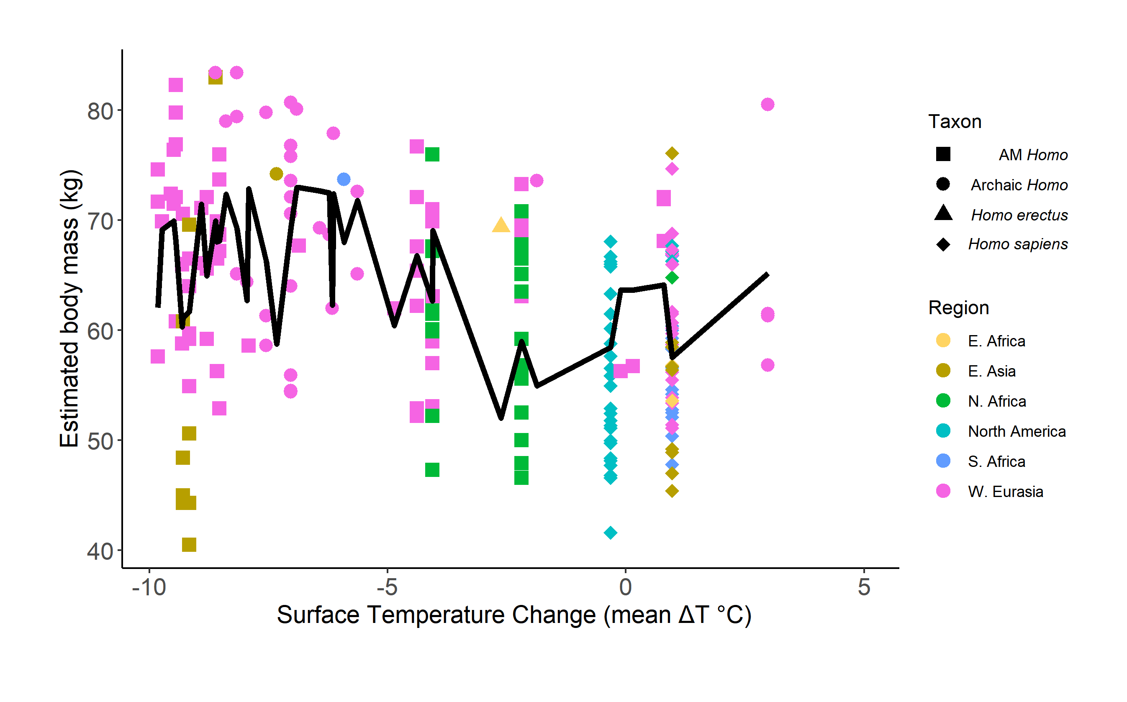
Fig. S3. Cubic model with additional covariates of sex and latitude. Including sex and latitude as covariates significantly improves the fit and demonstrates the combined effect of each of these variables alongside climate on body mass changes. Black line represents a time series of the data including sex and latitude as covariates.

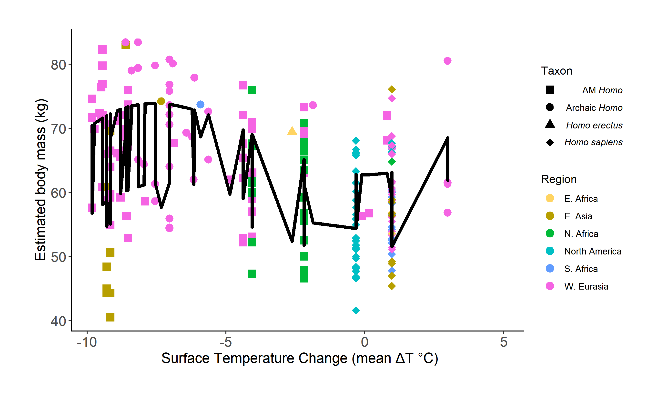
Fig. S4. Cubic model with additional covariates and interaction between sex and temperature. Inclusion of the interaction effect between sex and temperature marginally increases the fit, suggesting that the combined effect has increased explanatory power. Black line represents a time series of the data including the interaction effect.

Analysis of results across 10,000-year periods. A linear model of the results using 10,000-year increments (Fig. S5) shows a similar pattern as the 100-year analysis presented in the manuscript (Fig. 2).
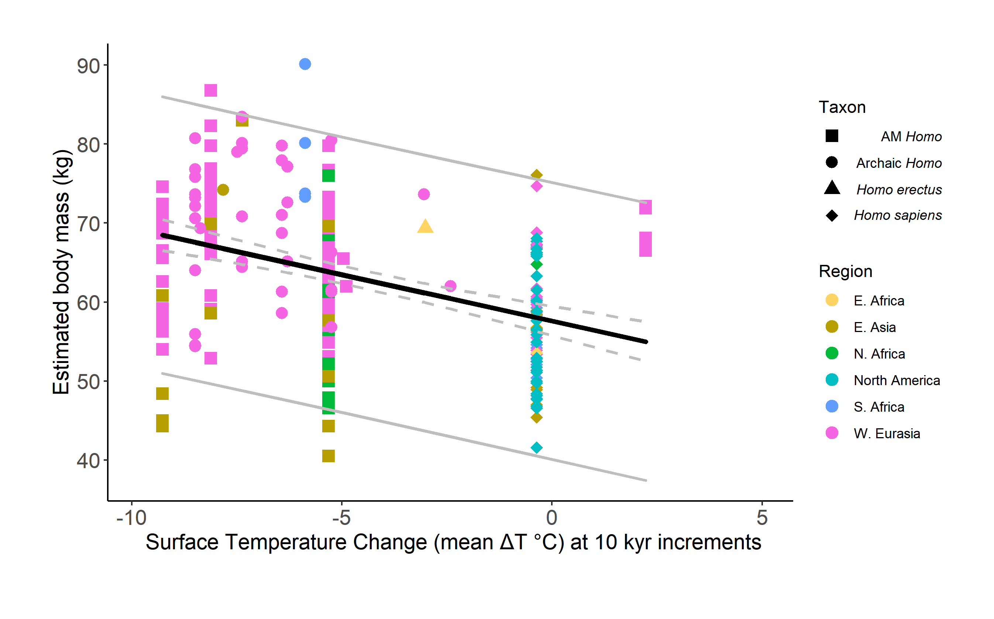
Fig. S5. Relationship between body mass (kg) and global climate change (changes in Antarctic surface temperature (°C) relative to the mean for the last millennium) across 10,000-year periods. Body mass estimates demonstrate an inverse relationship with climate change across 10,000-year mean averages over the past 700,000 years (LSR, r = -.4030; P < 0.0001; Durbin-Watson, 1.438). Homo body mass in cooler periods (∆Ts below -4.44°C) averaged 65.43 + 0.75 (n = 160) as compared to 57.98 + 0.84 (n = 87) during warmer periods across 10 kyr periods, or a roughly 12.06% difference. Gray lines indicate 95% confidence intervals around the observations; dotted gray lines represent the confidence intervals surrounding the regression line.

Body mass and climate change over time. Looking at the changes to body mass and temperature independently over time shows that both have similar temporal trends (Figs. S6-S7). If considered linearly, body mass generally trends lower over the past 700kyr BP and temperature trends warmer over that same period. The cubic models also reflect similar patterns over time and can explain the significant correlations found between the two variables (Fig. 2).

Fig. S6. Body mass changes over the last 700 kyr. (blue = temperature measures; orange = linear model (r = 0.3254, P < 0.0001); black line = cubic model (r² = 0.2334).

Fig. S7. Temperature changes relative to the mean for the last millennium over the last 700 kyr. (blue = temperature measures; orange = linear model (r = -0.2413, P < 0.0001); black line = cubic model (r² = 0.153).

Independence of temperature’s effect on body size. A two-way ANOVA with interaction between temperature (changes in Antarctic surface temperature (°C)) and sex shows that there is a significant interaction between the two factors (P < 0.02), indicating that the combined effect of temperature and sex plays an important role in the determination of body mass. This interaction was considered in the non-linear modeling (Fig. S4) but did not provide a sizable increase in model performance. Exploring the interaction further reveals a synergistic relationship, where both male and female observations in warmer periods tend to have lower body mass. This effect is stronger for males than females (Fig. S8).

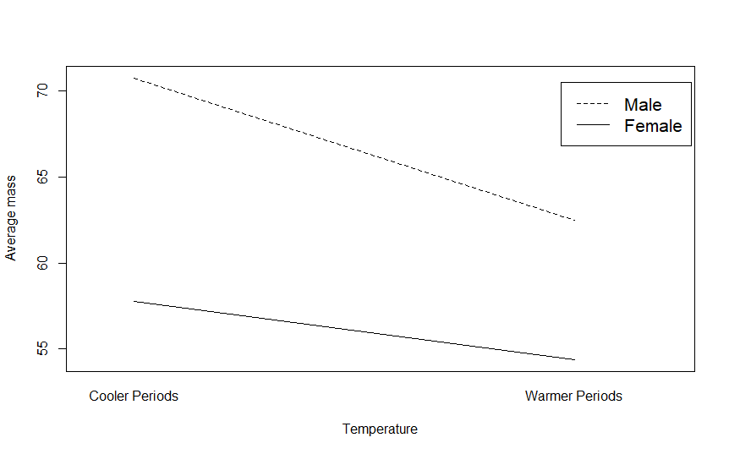
Fig. S8. Interaction effect between temperature and sex over the past 700,000 years.

A similar analysis including the effect of temperature, latitude, and their interaction displays no significant interaction (P = 0.30) between the two factors, indicating independence of temperature and latitude with respect to their effect on body mass.

Considering only the last 50kyr, with respect to sex, the relationship is consistent with the general trends observed across all 700kyr (P < 0.04). There is clear evidence of a synergistic interaction effect of sex and temperature on body mass. There is also a significant interaction effect between temperature and latitude (P < 0.04) over the last 50kyr (Fig. S9). This interaction indicates that temperature changes in high latitudes are associated with steeper declines in body mass size.
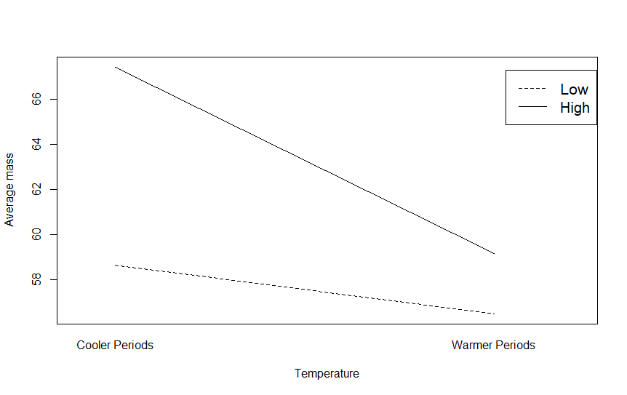
Fig. S9. Interaction effect between temperature and latitude over the past 50,000 years.

Tests excluding potential outliers and confounds. The non-linear models generally present a pattern of changing body mass that is in line with changing temperatures up to very high and low temperatures but detect trend reversals at the extremes. Two outliers in the data could account for much of this effect. The analysis in Fig. S10 removes ten E. Asia fossils from Tam Hang and Minatogawa due to their below normal body mass and five Neanderthals from Kaprina which coincided with the warmest period tested. Removal of those two groups of fossils eliminates much of the effect at the two tales and increases the linear fit significantly (Fig. S10). More data are ultimately needed to determine whether the non-linear trends are being driven by these fossils as outliers or whether there is a generalizable inverse effect at extreme temperatures.

Fig. S10. Linear and cubic models without potential outliers. Removing the two potential outlier groups at the temperature extremes materially increases the effect of the linear model (LSR, r = -.51, P < 0.0001) while reducing the overall difference between the explained variance between the linear model (orange, r² = .26) and the cubic model (black, r² = .28).

Possibly as a result of the outliers, the regional data in East Asia appear to show a pattern inconsistent with the general trends presented in the manuscript (Figs. 2, S1-4). However, on closer inspection, no discernable trend is apparent in the subsample (LSR, r = -.05, P < 0.81). Including the outliers, there is a slight albeit non-significant tendency toward smaller bodies in warmer average climates (difference of 4.18%, P < 0.32, t-test). If the outliers are excluded, the results for the East Asia sample are highly significant and consistent with the overall trends of the study (difference of 26.65%, P < 0.01, t-test).

The body mass data included three estimates of body mass (San Teodoro 1, San Teodoro 3, and Arene Candide 1) from stature/bi-iliac breadth measurements. Although these measurements also correlate with estimated stature, a decision was made to include those fossils as they are representative of a time period where little body mass data is currently available. The results from estimated body mass were also tested excluding those three estimates and there were no changes to the directionality or significance of any results (where significant, all results P < 0.05).

The proportionality data included three estimates of body mass (OH 28, Zhoukoudian Femur 1, and Zhoukoudian Femur 4) that relied on multivariate formulas. While these formulas have been considered acceptable practice generally, estimates of body mass using multivariate formulas have been questioned (1). The results were tested excluding these three estimates and there were no changes to the direction or significance of the results presented in the manuscript for body mass (P < 0.05, t-test) or when utilized in respect to proportionality (see “Additional formulas for proportionality” below for statistics).

Additional tests of moderate and extreme climatic periods. Comparing body mass differences during more temperate periods over the past 700 kyr BP (interquartile range against the mean ∆T of -3.74°C) did not change the direction or materiality of the results (Fig. S11). Homo averaged 66.64 kg + 1.14 (n = 57) in cooler than average periods as compared to 58.51 kg + 1.09 (n = 59) for warmer periods, or a roughly 13% difference (P < 0.0001, t-test).

Fig. S11. Relationship between body mass (kg) and global climate change (changes in Antarctic surface temperature (°C) relative to the mean for the last millennium) across 100-year periods during more moderate temperature changes. Significant changes to Homo body mass across the past 700 kyr BP took place during more moderate temperature cycles (LSR, r = -.55, P < 0.0001).

This is in contrast to tests at more extreme temperatures, where no significant changes were found (all tests, P > 0.09, t-tests) (Fig. 4). Limiting the sample to the colder half (1st and 2nd quartile, mean ∆T of -7.26), Homo averaged 66.2 kg (n = 70) during cooler average temperatures as compared to 66.6 kg (n = 57) for warmer periods (P = 0.40, t-test). Limiting the sample to the warmer half (3rd and 4th quartile, mean ∆T of -0.02), Homo averaged 58.5 kg (n = 59) during cooler average temperatures as compared to 59.5 kg (n = 61) for warmer periods (P = 0.25, t-test). Excluding outliers did not change the significance or direction of the results: no outliers within the moderate periods; across the colder half (mean ∆T of -7.10 at the 25th percentile), Homo averaged 68.7 kg (n = 60) during cooler average temperatures as compared to 66.6 kg (n = 57) for warmer periods (P = 0.097, t-test); across the warmer half (mean ∆T of -0.15 at the 75th percentile), Homo averaged 58.5 kg (n = 59) during cooler average temperatures as compared to 59 kg (n = 56) for warmer periods (P = 0.40, t-test).

Considering only AM humans during more temperate periods (interquartile range against the mean ∆T of -2.40°C), body mass averaged 63.12 kg (n = 33) during cooler average temperatures as compared to 58.08 kg (n = 56) for warmer periods (P < 0.001, t-test). Limiting the sample to the colder half (1st and 2nd quartile, mean ∆T of -7.36), Homo averaged 64.90 kg (n = 58) during cooler average temperatures as compared to 63.12 kg (n = 33) for warmer periods (P = 0.19, t-test). Limiting the sample to the warmer half (3rd and 4th quartile, mean ∆T of -0.11), Homo averaged 58.08 kg (n = 56) during cooler average temperatures as compared to 58.91 kg (n = 57) for warmer periods (P = 0.29, t-test).

Tests of different climate records. Regression analyses of both East African and North Atlantic climate records (Fig. S12) showed similar patterns to the EPICA Dome C results with respect to changing body mass.

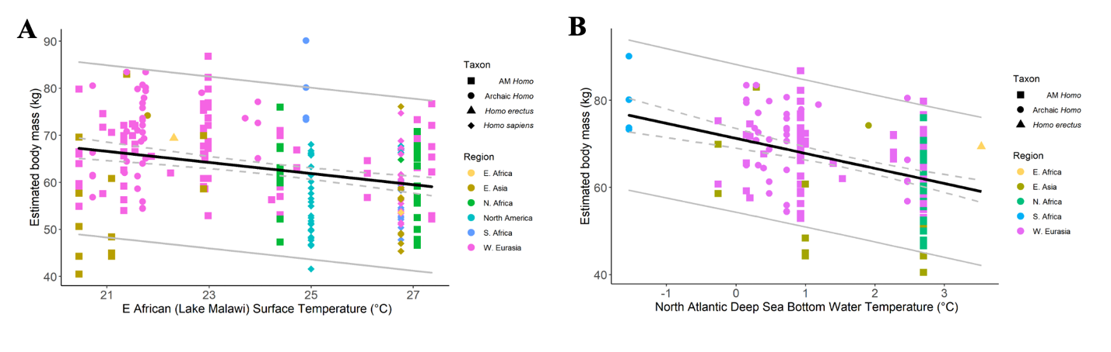
Fig. S12. Relationship between Homo body mass (kg) and regional climate change in East Africa (Lake Malawi sedimentary core, °C) and the North Atlantic (deep sea core, °C). (A) Consistent with the global climate results, body mass estimates display an inverse relationship with East African regional temperature records (LSR, r = -.2880; P < 0.0001; Durbin-Watson, 1.346). (B) Body mass estimates were also inversely correlated with Northern Atlantic regional temperature changes (LSR, r = -.4230, P < 0.0001; Durbin-Watson, 1.600). Gray lines indicate 95% confidence intervals around the observations; dotted gray lines represent the confidence intervals surrounding the regression line.

In addition to the three paleotemperature records, estimated body mass was also compared against four pollen sequences and a marine sediment sample derived from grain-size analyses. The pollen sequences were derived from two sources dating back to 40 kyr BP: three samples were derived from the equatorial mountains in the Burundi highlands at 1850 to 2240 meters of elevation; a fourth sample came from the South Tanganyika basin at 770 meters of elevation (the fourth sample was derived from a prior record provided by the same researcher and reconstructed with a new synthesis in agreement with updated methodology) (2). Six additional sequences were available but not utilized as there were no records with matching time periods to available fossil remains in Africa. Pollen sequences were used to derive a time-series of annual mean precipitation level estimates in millimeters by calculating the difference between the reconstructed absolute value of the pollen counts and the modern precipitation value (2). Pollen records have been shown to be predictive of precipitation levels as well as estimated rainfall and water availability (2). No correlations were found testing the annual precipitation levels against estimated body mass (LSR, r = .05, P = 0.72, n = 48) for the African Homo sample.

Estimates of paleo-humidity levels were also compared against Homo estimated body mass. Grain-size analyses of siliciclastic marine sediments from the coast of Mauritania (core GeoB7920; 2,278-meter water depth) were utilized to derive humidity estimates for Northwest Africa over the past 120,000 years (3). To derive relative changes in humidity, the log ratio of three core endmembers from the marine sediment was utilized [log(hemi-pelagic mud) / (coarse aeolian dust + fine aeolian dust)], where hemi-pelagic mud provided a measure of river runoff and aeolian dust records provided measures of subaerial erosion and continental vegetation cover (3). The marine sediment analysis was also shown to be predictive of continental humidity and vegetation cover (3). No relationship was found between estimated humidity levels and estimated body mass across the entire African Homo sample (LSR, r = -.16, P = 0.29, n = 48). Limiting the sample to regional body mass estimates in North Africa also did not produce significant correlations with humidity levels (LSR, r = .26, P = 0.15, n = 31).

Additional formulas for body proportionality. In addition to the formula for proportionality that tested stature as a function of body mass which was presented in the main manuscript, formulas for body mass index (BMI) and surface to volume ratio (SA:V) were also considered. The formula for SA:V utilized modern norms (4-5) and compared body surface area to body volume ([[√ (height (cm) x weight (kg))] / 3600] / [(1.015 x weight) – 4.937]; the results were significant and demonstrated a 4.33% (P < 0.01, t-test) increase in body proportionality during warming periods when tested across 100-year temperature increments and a 6.35% (P < 0.0001, t-test) increase during warming periods across 10,000-year increments. Body mass index (BMI) was also calculated using a standard formula for modern populations (body mass (kg) / stature² (m)) (6); the results were directionally consistent but significant only for the 10,000-year temperature increments (5.30% larger during cooler periods, P < 0.03, t-test (10,000-year); 3.35% larger during cooler periods, P = 0.13, t-test (100-year)). Each test of body proportionality was performed against the complete dataset as well as the dataset excluding three samples (OH 28, Zhoukoudian Femur 1, and Zhoukoudian Femur 4) that utilized multivariate formulas for estimating body mass (see Methods) and there were no changes to the direction or significance of the results (P < 0.05 for all results except BMI at 100-year increments, P = 0.17). Formulas and the derivative data, including the four multivariate estimates, can be found in Dataset S1B.

Body mass changes over the past 1,000 years. Between 1,000 years ago to present, global temperatures in the sample increased from ∆T = -0.32°C to ∆T = 0.97°C (P = 0.0001, t-test) and body mass increased from 54.99 (+ 1.42) to 58.16 (+ 0.98) (P = 0.03, t-test).

