A Supplementary Material for
The Impact of Guest Compounds and Complexation Techniques on The Encapsulation of β-cyclodextrin for Active Packaging Applications
Nafeesa Mohamad Jilani¹ · Hayati Samsudin¹ · Mohd Firdaus Yhaya² ·

¹ Food Technology Division, School of Industrial Technology, Universiti Sains Malaysia, 11800 Penang, Malaysia.
² Biomaterial and #D Imaging (BioM3D) Laboratory, School of Dental Sciences, Universiti Sains Malaysia, 16150 Kubang Kerian, Kelantan, Malaysia.

Corresponding authors:
Hayati Samsudin | Food Technology Division, School of Industrial Technology, Universiti Sains Malaysia, 11800, Penang, Malaysia; E-mail: hayatis@usm.my
Mohd Firdaus Yhaya | Biomaterial and #D Imaging (BioM3D) Laboratory, School of Dental Sciences, Universiti Sains Malaysia, 16150 Kubang Kerian, Kelantan, Malaysia; Email: firdausya@usm.my

This supplementary file contains one Figure and two Tables: Figures S1, and Tables S1, and S2.

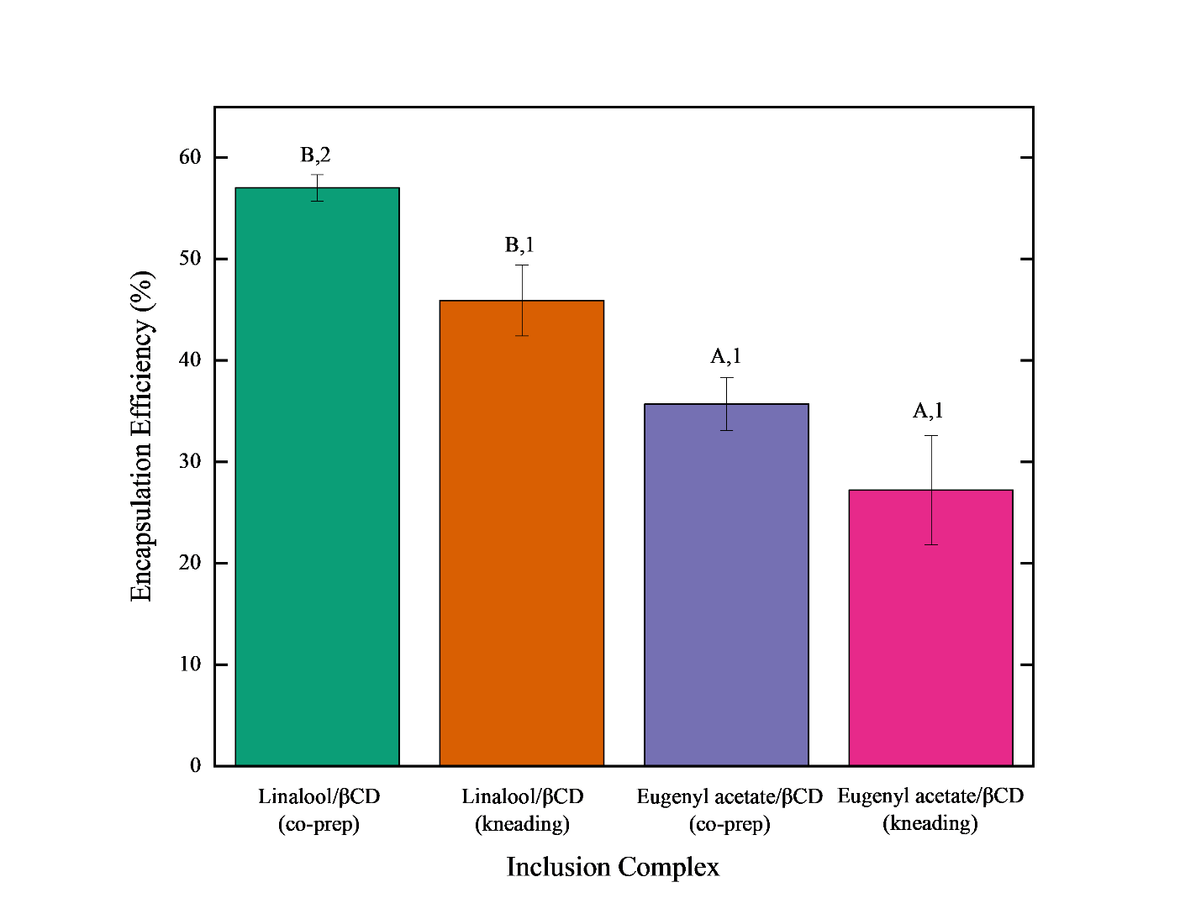
Fig. S1: Encapsulation efficiency (%) of inclusion complex. Values given are averages ± SD. from four replicates. Different letter (^{A, B}) indicates significant differences significant differences between compound (p < 0.05). Different number (^{1,2}) indicates significant difference between preparation method (p <0.05).

Table S1: Differential scanning calorimetry (DSC) data for inclusion complex and starting materials. Inclusion complex values in average ± SD.
Peak | Onset temp (°C) | Heat fusion (J/g) | Heat flow (m/W)
Linalool/βCD (co-prep)
1 | 98.81 ± 11.22 | 4.28 ± 1.13 | -0.61 ± 0.15
2 | 137.75 ± 9.77 | 20.28 ± 9.77 | -0.64 ± 0.92
3 | 312.27 ± 2.43 | 174.60 ± 95.88 | -3.97 ±0.86
Linalool/ βCD (kneading)
1 | 97.77 ± 8.73 | 10.43 ± 0.76 | -0.38 ± 0.31
2 | 151.61 ± 88.28 | 42.12 ± 24.56 | -1.25 ± 0.74
3 | 316.77 ± 1.04 | 183.30 ± 12.68 | -5.32 ± 0.69
Eugenyl acetate/ βCD (co-prep)
1 | 89.09 ± 9.08 | 450.60 ± 33.58 | -9.38 ± 1.69
2 | 321.84 ± 5.92 | 210.50 ± 12.51 | -9.40 ± 0.35
Eugenyl acetate/ βCD (kneading)
1 | 85.23 ± 3.17 | 29.37 ± 7.38 | -1.27 ± 0.45
2 | 145.67 ± 4.46 | 29.27 ± 11.28 | -1.23 ± 0.38
3 | 213.44 ± 4.62 | 17.11 ± 4.89 | -0.51 ± 0.06
4 | 320.45 ± 8.62 | 208.90 ± 15.59 | -7.97 ± 2.02

Table S2: Thermogravimetric analysis (TGA) data for inclusion complex and starting materials. Inclusion complex values presented in average ± SD.
Peak | Onset (°C) | Midpoint (°C) | Residue (%)
Linalool/βCD (co-prep)
1 | 67.68 ± 11.26 | 86.92 ± 28.61 | 87.38 ± 4.48
2 | 99.60 ± 3.06 | 127.51 ± 10.69 | 82.35 ± 7.13
3 | 309.03 ± 1.16 | 325.90 ± 2.30 | 4.99 ± 0.01
Linalool/ βCD (kneading)
1 | 108.29 ± 0.98 | 113.05 ± 0.92 | 90.03 ± 1.22
2 | 152.43 ± 3.54 | 160.31 ± 8.11 | 72.97 ± 4.78
3 | 308.12 ± 1.40 | 325.51 ± 1.49 | 6.34 ± 0.54
Eugenyl acetate/ βCD (co-prep)
1 | 52.23 ± 0.27 | 61.88 ± 0.56 | 84.22 ± 8.53
2 | 96.75 ± 0.82 | 122.53 ± 2.05 | 74.65 ± 5.62
3 | 318.07 ± 1.12 | 327.05 ± 1.52 | 3.59 ± 2.97
Eugenyl acetate/ βCD (kneading)
1 | 107.75 ± 0.47 | 113.05 ± 0.92 | 90.03 ± 1.22
2 | 151.44 ± 8.67 | 160.32 ± 8.14 | 72.97 ± 4.78
3 | 308.30 ± 6.65 | 325.51 ± 1.49 | 6.34 ± 0.54

