Article title: Processing- and fermentation-associated changes in chemical and volatile profiles of coffee cherry pulp tea
Journal name: Journal of Food Measurement and Characterization
Author names: Wen-Shiun Chang¹, Tsung-Yen Wu², and Chih-Min Yang^{1,*}
Affiliation: National Chung Hsing University, Taichung, Taiwan
e-mail address of the corresponding author: cmyang@nchu.edu.tw

Supplementary Table 1. Putatively identified metabolites with significant fold changes in coffee cherry pulp tea and its Lactiplantibacillus plantarum-fermented beverage in positive ion mode
Spot No. | RT (min) | m/z | Metabolite name | CAS No. | Formula | Log₂ Fold Change | Precursor Intensity
 |  |  |  |  |  |  | Fermentation | Non-fermentation
Phenolics / Phenolic acids
1 | 4.93 | 142.0 | 5-Hydroxymethyl-2-furancarboxylic acid | 6338-41-6 | C₆H₆O₄ | 10.01 | 49929100 | 48506
2 | 5.71 | 165.1 | trans-Cinnamic acid | 140-10-3 | C₉H₈O₂ | 8.98 | 33968580 | 67415
3 | 4.44 | 170 | Gallic acid | 149-91-7 | C₇H₆O₅ | -2.33 | 22678240 | 113993700
4 | 5.71 | 368.1 | Chlorogenic acid | 327-97-9 | C₁₇H₂₀O₉ | -3.18 | 393061 | 3568882
5 | 4.40 | 121.1 | 4-Vinylphenol | 2628-17-3 | C₈H₈O | -3.39 | 200698 | 2107186
6 | 2.17 | 308 | Resveratrol-3-O-sulfate | 553662-69-4 | C₁₄H₁₂O₆S | -6.27 | 515191 | 39838820
Flavonoids
7 | 1.46 | 302 | Morin | 480-16-0 | C₁₅H₁₀O₇ | 2.22 | 4935994 | 1057015
8 | 6.00 | 342.1 | 5,7,3',4'-Tetramethoxyisoflavone | 40316-84-5 | C₁₉H₁₈O₆ | 2.59 | 8670146 | 1440314
9 | 1.74 | 427.1 | Diosmetine triacetate | 3162-05-8 | C₂₂H₁₈O₉ | -1.4 | 1803600 | 4775874
10 | 9.11 | 300.1 | Luteolin 7-methyl ether | 20243-59-8 | C₁₆H₁₂O₆ | -2.11 | 1057375 | 4552929
11 | 7.85 | 300.1 | Naringenin 4',7-dimethylether | 29424-96-2 | C₁₇H₁₆O₅ | -2.53 | 12631580 | 72839610
12 | 1.70 | 275.1 | Phloretin | 60-82-2 | C₁₅H₁₄O₅ | -2.80 | 431607 | 3010808
13 | 1.60 | 306.1 | Epigallocatechin | 13425-13-3 | C₁₅H₁₄O₇ | -3.08 | 1528376 | 12956,740
14 | 7.98 | 303 | Quercetin | 117-39-5 | C₁₅H₁₀O₇ | -3.32 | 46850 | 466611
15 | 7.16 | 358.1 | Quercetin 3,5,7,3',4'-pentamethyl ether | 1247-97-8 | C₁₉H₁₈O₇ | -3.77 | 13066450 | 11781960
16 | 8.64 | 286 | Kaempferol | 520-18-3 | C₁₅H₁₀O₆ | -3.87 | 61676 | 900560
17 | 8.13 | 464.1 | Quercetin 3-glucoside | 482-35-9 | C₂₁H₂₀O₁₂ | -3.99 | 38010 | 603777
Alkaloids and N-containing heterocycles
18 | 7.26 | 376.1 | Riboflavin | 83-88-5 | C₁₇H₂₀N₄O₆ | 1.83 | 2644385 | 743792
19 | 1.71 | 138 | Trigonelline | 535-83-1 | C₇H₇NO₂ | -1.52 | 11176420 | 32019670
20 | 1.63 | 194.1 | Caffeine | 58-08-2 | C₈H₁₀N₄O₂ | -3.37 | 3201967 | 33217510
21 | 5.98 | 219.1 | trans-Zeatin | 1637-39-4 | C₁₀H₁₃N₅O | -3.79 | 28333 | 393219
22 | 5.51 | 252.1 | 2,2-Diphenylcyclopropanecarbohydrazide | 63070-28-0 | C₁₆H₁₆N₂O | -4.23 | 115961 | 2171556
Amino acids
23 | 1.53 | 147.1 | L-Glutamic acid | 56-86-0 | C₅H₉NO₄ | 1.74 | 44420020 | 13338640
24 | 5.39 | 214.1 | Val-Pro | 20488-27-1 | C₁₀H₁₈N₂O₃ | 5.23 | 6155181 | 164513
Fatty acids / Lipid derivatives
25 | 7.64 | 316.2 | Cafestol | 469-83-0 | C₂₀H₂₈O₃ | -3.52 | 672317 | 7718725
26 | 12.32 | 310.2 | 9-Hydroperoxy-10E,12Z,15Z-octadecatrienoic acid | 64265-94-7 | C₁₈H₃₀O₄ | -6.39 | 162777 | 13692690
27 | 5.26 | 356.2 | Kahweol acetate | 81760-47-6 | C₂₂H₂₈O₄ | 7.38 | 36429550 | 219066
Others
28 | 1.37 | 389.9 | (5-Chloro-2-iodophenyl)(2-fluoro-6-methoxyphenyl)methanone | 1233025-91-6 | C₁₄H₉ClFIO₂ | 4.48 | 38175460 | 1708127
29 | 5.36 | 250.1 | 2,8-Dimethyl-2-(.beta.-carboxyethyl)-6-hydroxychroman | 1221504-67-1 | C₁₄H₁₈O₄ | 5.48 | 13005750 | 290986
30 | 2.44 | 261.1 | 2-Isopentyl-1,3-dioxo-5-isoindolinecarboxylic acid | 496913-99-6 | C₁₄H₁₅NO₄ | 7.21 | 5172963 | 35020
All metabolites were tentatively annotated based on accurate mass and, when available, MS/MS spectral matching against public databases; identifications may include isomers/adducts and should be interpreted cautiously.
Supplementary Table 2. Putatively identified metabolites with significant fold changes in coffee cherry pulp tea and its Lactiplantibacillus plantarum-fermented beverage in negative ion mode
Spot No. | RT (min) | m/z | Metabolite name | CAS No. | Formula | Log₂ Fold Change | Precursor Intensity
 |  |  |  |  |  |  | Fermentation | Non-fermentation
Phenolics / Phenolic acids
1 | 5.08 | 633.1 | Corilagin | 23094-69-1 | C₂₇H₂₂O₁₈ | 2.03 | 25247050 | 6183194
2 | 5.64 | 170 | Gallic acid | 149-91-7 | C₇H₆O₅ | 2.65 | 39231600 | 6256225
3 | 5.27 | 955.1 | Chebulinic acid | 18942-26-2 | C₄₁H₃₂O₂₇ | 4.29 | 113363900 | 5811471
4 | 6.77 | 243.1 | Oxyresveratrol | 29700-22-9 | C₁₄H₁₂O₄ | 8.02 | 12064240 | 42039
5 | 7.84 | 367.1 | 3-O-Feruloylquinic acid | 62969-69-5 | C₁₇H₂₀O₉ | -2.37 | 67498660 | 347897600
6 | 6.50 | 533.2 | Arctiin | 20362-31-6 | C₂₇H₃₄O₁₁ | -2.58 | 3030584 | 18104490
7 | 2.19 | 305 | 2,2'-Dithiodibenzoic acid | 119-80-2 | C₁₄H₁₀O₄S₂ | -2.61 | 4294944 | 26279940
8 | 1.57 | 209 | Glucaric acid | 25525-21-7 | C₆H₁₀O₈ | -3.16 | 53369790 | 476267300
9 | 9.35 | 337.1 | 3-O-p-Coumaroylquinic acid | 5746-55-4 | C₁₆H₁₈O₈ | -3.30 | 124760 | 1230915
10 | 7.7 | 313.1 | Glucovanillin | 494-08-6 | C₁₄H₁₈O₈ | -7.16 | 11248 | 1612644
Flavonoids
11 | 4.98 | 621.2 | Pectolinarin | 28978-02-1 | C₂₉H₃₄O₁₅ | 8.64 | 46741540 | 116934
12 | 5.57 | 497.1 | Verproside | 50932-20-2 | C₂₂H₂₆O₁₃ | 6.88 | 74814990 | 634820
13 | 3.37 | 280.1 | 8-Carboxy-3-methylflavone | 3468-01-7 | C₁₇H₁₂O₄ | 2.64 | 43307380 | 6953037
14 | 11.12 | 272.1 | Naringenin | 480-41-1 | C₁₅H₁₂O₅ | 3.47 | 115260 | 10408
15 | 8.01 | 609.2 | Rutin | 153-18-4 | C₂₇H₃₀O₁₆ | -1.07 | 6830232 | 14300290
16 | 7.91 | 449.1 | Marein | 535-96-6 | C₂₁H₂₂O₁₁ | -3.59 | 22426 | 269269
17 | 5.61 | 395.2 | Gartanin | 33390-42-0 | C₂₃H₂₄O₆ | -5.27 | 45247 | 1741365
Alkaloids and N-containing heterocycles
18 | 3.15 | 160.1 | 3-(2-Hydroxyethyl)indole | 526-55-6 | C₁₀H₁₁NO | 7.12 | 1399251 | 10064
19 | 4.80 | 324 | 1-.beta.-D-Arabinofuranosyluracil 5'-monophosphate | 18354-06-8 | C₉H₁₃N₂O₉P | 4.30 | 23168190 | 1177769
20 | 2.56 | 323.1 | Cytidine 3'-monophosphate | 84-52-6 | C₉H₁₄N₃O₈P | 3.94 | 9773869 | 636774
21 | 4.44 | 169 | Theophylline | 58-55-9 | C₇H₈N₄O₂ | -2.78 | 22678240 | 113993700
22 | 1.70 | 387.1 | Secologanin | 19351-63-4 | C₁₇H₂₄O₁₀ | -3.10 | 2185448 | 18712420
Amino acids
23 | 4.96 | 611.2 | Glutathione, oxidized | 27025-41-8 | C₂₀H₃₂N₆O₁ | 2.54 | 6496027 | 1117972
24 | 6.53 | 203.1 | L-Tryptophan | 73-22-3 | C₁₁H₁₂N₂O₂ | 3.98 | 54232140 | 3425299
Fatty acids / Lipid derivatives
25 | 9.24 | 319.2 | 17-Hydroxyeicosatetraenoic acid | 128914-47-6 | C₂₀H₃₂O₃ | -7.07 | 12190 | 1642955
26 | 1.32 | 329.2 | 15-Hydroxy-7-oxoabieta-8,11,13-trien-18-oic acid | 95416-25-4 | C₂₀H₂₆O₄ | 4.40 | 14415720 | 683292
27 | 9.92 | 302.2 | Abietic acid | 514-10-3 | C₂₀H₃₀O₂ | -2.5 | 698950 | 3947408
28 | 11.73 | 239 | 5-[(1E,3E)-Hepta-1,3-dienyl]-2,3-dihydroxycyclopentane-1-carboxylic acid | 1217876-27-1 | C₁₃H₂₀O₄ | -4.11 | 204620 | 3535687
29 | 14.73 | 275.2 | 9,12-Octadecadiynoic acid | 2012-14-8 | C₁₈H₂₈O₂ | -4.21 | 149693 | 2776242
30 | 13.43 | 325.2 | 2-[5-[(3Z,6Z)-2,12-Dihydroxydodeca-3,6-dienyl]oxolan-2-yl]acetic acid | 1217868-40-0 | C₁₈H₃₀O₅ | -11.95 | 6799 | 26853530
Organic acid
31 | 3.98 | 218.1 | Piperic acid | 136-76-1 | C₁₂H₁₀O₄ | 7.55 | 10913870 | 58175
32 | 5.27 | 955.1 | Chebulinic acid | 18942-26-2 | C₄₁H₃₂O₂₇ | 4.29 | 113363900 | 5811471
33 | 5.39 | 191.1 | (-)-Quinic acid- | 77-95-2 | C₇H₁₂O₆ | 4.90 | 41271130 | 1380601
34 | 2.49 | 173 | DL-Isocitric acid lactone | 4702-32-3 | C₆H₆O₆ | 2.02 | 33965410 | 8388478
35 | 2.22 | 175 | Vitamin C | 50-81-7 | C₆H₈O₆ | 2.78 | 3198843 | 466737
36 | 1.58 | 165 | D-Arabinonic acid | 488-30-2 | C₅H₁₀O₆ | 2.91 | 70907440 | 9445594
37 | 2.07 | 133 | DL-Malic acid | 6915-15-7 | C₄H₆O₅ | -5.99 | 1157608 | 73654930
38 | 3.36 | 191 | Citric acid | 77-92-9 | C₆H₈O₇ | -8.02 | 1191687 | 309643400
Others
39 | 8.66 | 166.1 | Pyridoxal | 66-72-8 | C₈H₉NO₃ | 8.25 | 1062757 | 3502
40 | 3.32 | 243.1 | N-(2-Methoxyphenyl)-2-pyridinecarbimidothioic acid | 13225-86-0 | C₁₃H₁₂N₂OS | 5.60 | 5400860 | 111311
41 | 7.09 | 305.1 | 2-(3,4-Dimethoxybenzamido)thiophene-3-carboxamide | 864969-71-6 | C₁₄H₁₄N₂O₄ | -2.23 | 19301 | 90440
42 | 8.67 | 627.2 | Uhdoside A | 150044-19-8 | C₃₂H₃₆O₁₃ | -6.14 | 43376 | 3,064029
All metabolites were tentatively annotated based on accurate mass and, when available, MS/MS spectral matching against public databases; identifications may include isomers/adducts and should be interpreted cautiously.

Supplementary Table 3. Volatile compounds and odor description in coffee cherry pulp tea and its Lactiplantibacillus plantarum-fermented beverage
Volatile compounds | Odor description | CAS No. | KIC¹ | KIL² | Non-fermentation |  | Fermentation
 |  |  |  |  | Area | Area (%) | Area | Area (%)
Aldehydes
3-Methylbutanal | malt | 590-86-3 | 711 | 676 | 52021 | 0.33 | 327082 | 0.54
2-Methylbutyraldehyde | cocoa, almond | 96-17-3 | 714 | 662 | 157942 | 1.00 | ND | ND
Valeraldehyde | almond, malt, pungent | 110-62-3 | 729 | 696 | 9413 | 0.06 | ND | ND
Hexanal | grass, tallow, fat | 66-25-1 | 801 | 801 | 558345 | 3.52 | 203966 | 0.33
Benzaldehyde | almond, burnt sugar | 100-52-7 | 960 | 960 | 473216 | 2.98 | 1219359 | 1.99
2-Octenal | green | 2363-89-5 | 1059 | 1059 | 45697 | 0.29 | ND | ND
β-Cyclocitral | mint | 432-25-7 | 1219 | 1204 | 38650 | 0.24 | ND | ND
5-Ethyl-2-thiophene carbaldehyde | fruity, cherry, woody, tropical fruit | 36880-33-8 | 1230 | 1172 | 44154 | 0.28 | ND | ND
Tridecanal | flower, sweet, must | 10486-19-8 | 1510 | 1502 | 171523 | 1.08 | 122145 | 0.20
Pentadecanal | fresh | 2765-11-9 | 1714 | 1701 | 29291 | 0.18 | ND | ND
Nonanal | fat, citrus, green | 124-19-6 | 1104 | 1107 | 424291 | 2.67 | 516626 | 0.85
3-(Methylthio)propionaldehyde | cooked potato | 3268-49-3 | 906 | 909 | ND | ND | 97411 | 0.16
Phenylacetaldehyde | hawthorne, honey, sweet | 122-78-1 | 1042 | 1081 | ND | ND | 1136938 | 1.86
Octanal | fat, soap, lemon, green | 124-13-0 | 1003 | 1006 | ND | ND | 107657 | 0.18
Alcohols
1-Penten-3-ol | butter, pungent | 616-25-1 | 722 | 680 | 118847 | 0.75 | ND | ND
1-Octen-3-ol | mushroom | 3391-86-4 | 980 | 978 | 109000 | 0.69 | ND | ND
2-Ethyl-1-hexanol | rose, green | 104-76-7 | 1029 | 1030 | 2264760 | 14.28 | 2164603 | 3.54
Benzyl alcohol | sweet, flower | 100-51-6 | 1034 | 1040 | 356949 | 2.25 | 2739434 | 4.48
1-Nonanol | fat, green | 143-08-8 | 1133 | 1176 | 66646 | 0.42 | ND | ND
1-Butanol | fruit | 71-36-3 | 714 | 617 | ND | ND | 2795854 | 4.57
3-Methylbutan-1-ol | whiskey, malt, burnt | 123-51-3 | 751 | 697 | ND | ND | 1384743 | 2.27
2-Methyl-1-butanol | wine, onion | 137-32-6 | 754 | 731 | ND | ND | 951007 | 1.56
1-Pentanol | balsamic | 71-41-0 | 776 | 759 | ND | ND | 104334 | 0.17
3-Methyl-2-buten-1-ol | herb | 556-82-1 | 781 | 772 | ND | ND | 148072 | 0.24
Hexan-1-ol | resin, flower, green | 111-27-3 | 869 | 867 | ND | ND | 683597 | 1.12
1-Heptanol | green | 111-70-6 | 971 | 970 | ND | ND | 233100 | 0.38
3-Octanol | moss, nut, mushroom | 589-98-0 | 997 | 999 | ND | ND | 257102 | 0.42
(E)-oct-2-en-1-ol | soap | 18409-17-1 | 1068 | 1067 | ND | ND | 64565 | 0.11
2-Phenylpropan-2-ol | green, sweet, earthy | 617-94-7 | 1085 | 1107 | ND | ND | 41966 | 0.07
Laevo-borneol | earthy, minty, woody, musty | 464-45-9 | 1172 | 1138 | ND | ND | 77926 | 0.13
3-Methyl-3-buten-1-ol | sweet, fruity | 763-32-6 | 748 | 724 | ND | ND | 128515 | 0.21
2-Phenylethanol | honey, spice, rose, lilac | 60-12-8 | 1111 | 1136 | ND | ND | 1401807 | 2.29
Monoterpene Alcohols
α-Terpineol | oil, anise, mint | 98-55-5 | 1195 | 1195 | 96671 | 0.61 | 71395 | 0.12
DL-Menthol | cooling, mentholic minty | 1490-04-6 | 1178 | 1184 | 1100237 | 6.94 | ND | ND
Geraniol | rose, geranium | 106-24-1 | 1250 | 1255 | ND | ND | 326754 | 0.53
Monoterpenes
Cineole | mint, sweet | 470-82-6 | 1032 | 1059 | 351685 | 2.22 | ND | ND
Camphor | camphor | 76-22-2 | 1147 | 1149 | 168615 | 1.06 | 118976 | 0.19
p-Cymene | citrus | 99-87-6 | 1082 | 1025 | 346609 | 2.18 | ND | ND
D-Longifolene | sweet, woody, rose | 475-20-7 | 1411 | 1412 | 56837 | 0.36 | ND | ND
Isophorone | sweet, green, citrus | 78-59-1 | 1121 | 1123 | ND | ND | 2472346 | 4.04
Nerol | sweet | 106-25-2 | 1224 | 1228 | ND | ND | 274150 | 0.45
Phenols
Methyl salicylate | peppermint | 119-36-8 | 1191 | 1192 | 867038 | 5.47 | 19443831 | 31.81
Ketones
Cyclohexanone | minty | 108-94-1 | 895 | 891 | 518489 | 3.27 | 190060 | 0.31
Propiophenone | fruity | 93-55-0 | 1064 | 1128 | 106850 | 0.67 | ND | ND
Isophorone | sweet, green, fruity, citrus | 78-59-1 | 1121 | 1123 | 2977809 | 18.77 | ND | ND
Benzophenone | rose, herbal | 119-61-9 | 1626 | 1626 | 27144 | 0.17 | ND | ND
Acetophenone | must, flower, almond | 98-86-2 | 1064 | 1029 | ND | ND | 156058 | 0.26
Esters
Dimethyl adipate | mild nutty | 627-93-0 | 1242 | 1151 | 63993 | 0.40 | 176169 | 0.29
Dibutyl phthalate | faint | 84-74-2 | 1954 | 2037 | 40631 | 0.26 | 89595 | 0.15
Ethyl propionate | fruity | 105-37-3 | 736 | 708 | ND | ND | 34690 | 0.06
n-Butyl acetate | pear | 123-86-4 | 814 | 813 | ND | ND | 511701 | 0.84
Linalyl anthranilate | citrus, orange flower, petitgrain | 7149-26-0 | 1099 | 1104 | ND | ND | 4753429 | 7.78
Organic acids
Octanoic acid | sweat, cheese | 124-07-2 | 1167 | 1192 | 18964 | 0.12 | 901449 | 1.47
Nonanoic acid | green, fat | 112-05-0 | 1266 | 1289 | ND | ND | 636555 | 1.04
Decanoic acid | sour, citrus | 334-48-5 | 1361 | 1372 | ND | ND | 330908 | 0.54
Norisoprenoids
β-Damascenone | apple. rose, honey | 23726-93-4 | 1379 | 1379 | 198088 | 1.25 | 106191 | 0.17
β-Ionone | fruity, berry, green | 14901-07-6 | 1478 | 1457 | 30870 | 0.19 | ND | ND
Furans
Furfuryl alcohol | burnt | 98-00-0 | 853 | 849 | ND | ND | 62678 | 0.10
(Z)-linalool oxide (furanoid) | flower | 5989-33-3 | 1071 | 1069 | ND | ND | 4412340 | 7.22
(E)-linalool oxide | flower | 34995-77-2 | 1087 | 1086 | ND | ND | 2120824 | 3.47
(Z)-linalool oxide (pyranoid) | citrus, green | 14009-71-3 | 1174 | 1169 | ND | ND | 183859 | 0.30
Others
Toluene | paint | 108-88-3 | 772 | 794 | 513902 | 3.24 | 738497 | 1.21
o-Xylene | geranium | 95-47-6 | 866 | 907 | 177716 | 1.12 | 343332 | 0.56
2-Ethyltoluene | peppermint, fruity, sweet | 611-14-3 | 976 | 1006 | 1259704 | 7.94 | 1122321 | 1.84
1,4-Diethylbenzene | rose, balsamic | 105-05-5 | 1046 | 1106 | 60160 | 0.38 | ND | ND
Naphthalene | tar | 91-20-3 | 1183 | 1231 | 170611 | 1.08 | 371932 | 0.61
Tetradecane | alkane | 629-59-4 | 1400 | 1413 | 59407 | 0.37 | 89097 | 0.15
Pentadecane | alkane | 629-62-9 | 1500 | 1500 | 39175 | 0.25 | ND | ND
Several detected volatile compounds (e.g., phthalates, aromatic hydrocarbons, and alkanes) are commonly reported as background contaminants associated with SPME fibers, laboratory materials, or environmental sources. These compounds were retained for completeness but were not emphasized in the interpretation.
¹KIC: Kovats indices calculated against n-alkanes.
²KIL: Kovats retention indexes in the literature (ADAMS, 2007).

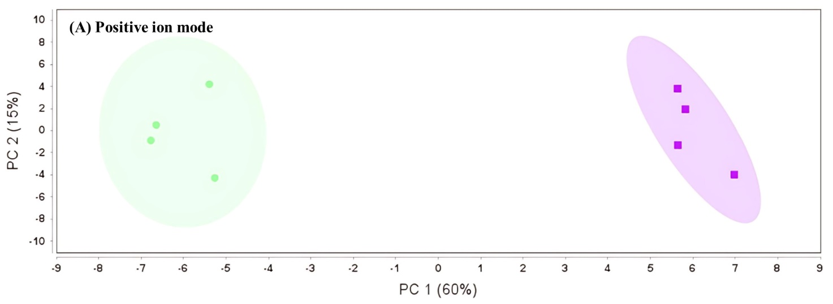
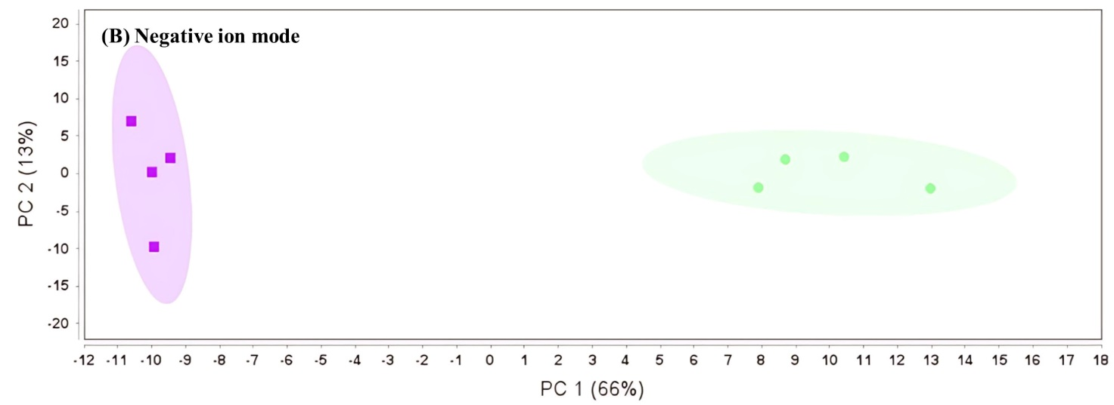
Supplementary Figure 1. Principal component analysis plots of metabolite distribution in coffee cherry pulp tea (green) and its L. plantarum-fermented beverage (purple). (A) Positive ion mode. (B) Negative ion mode. Each point represents one sample. The percentages in parentheses indicate the variance explained by each principal component. Each point represents an individual sample, and the shaded ellipses denote group clustering for visualization purposes.

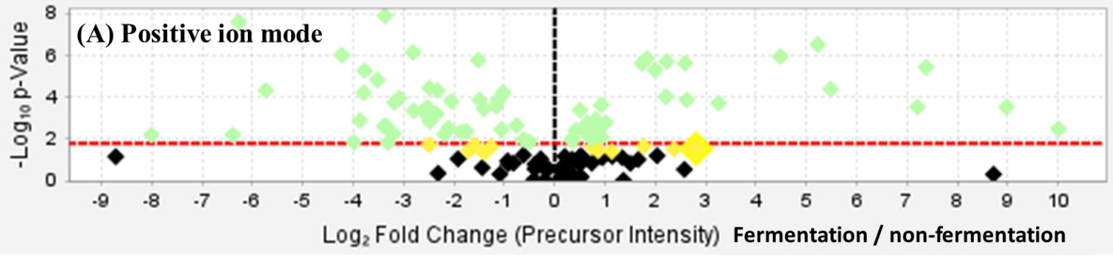
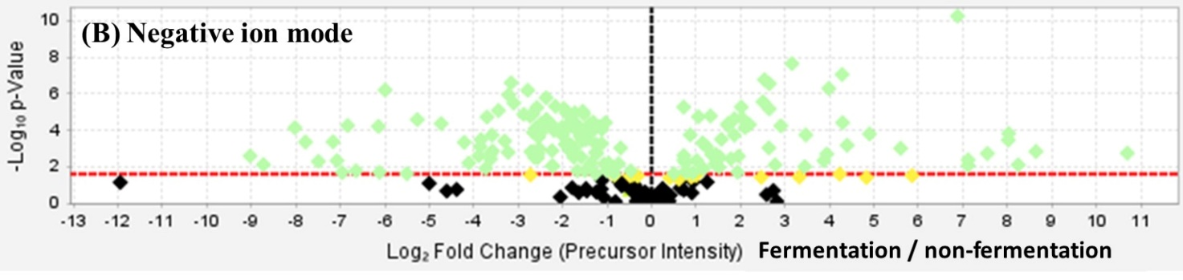
Supplementary Figure 2. Volcano plots illustrating differential metabolite features between coffee cherry pulp tea and its Lactiplantibacillus plantarum-fermented beverage in (A) positive and (B) negative ion modes. The x-axis represents the log₂ fold change in precursor ion intensity (fermentation/non-fermentation), and the y-axis represents the -log₁₀ p-value. Metabolite features showing statistically significant changes (p < 0.05) are highlighted, whereas non-significant features are shown in black. The red dashed line indicates the significance threshold.

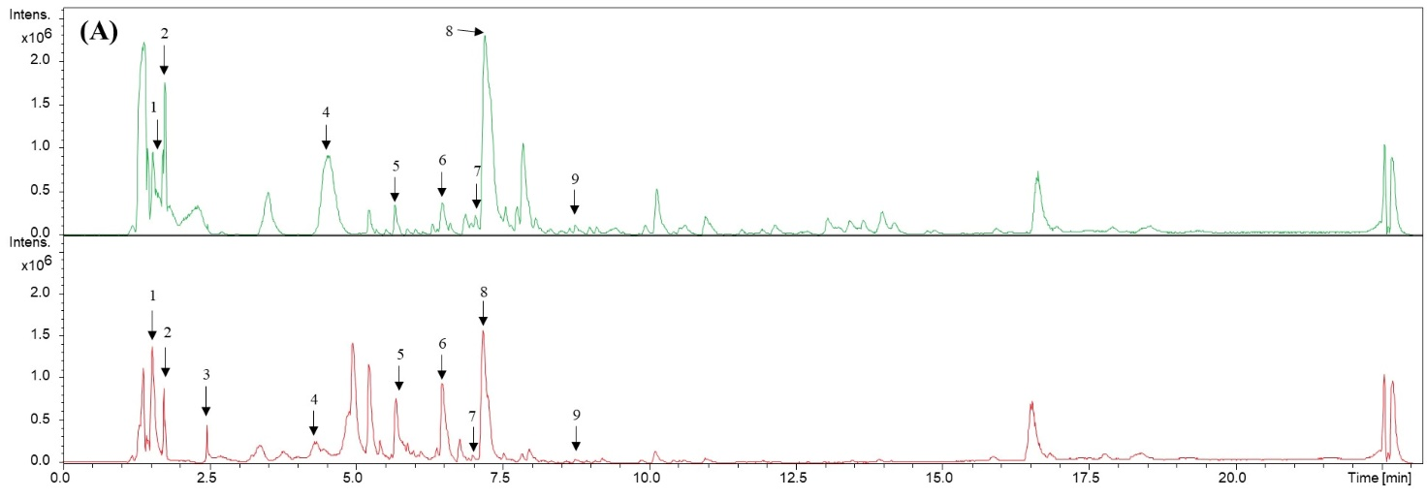
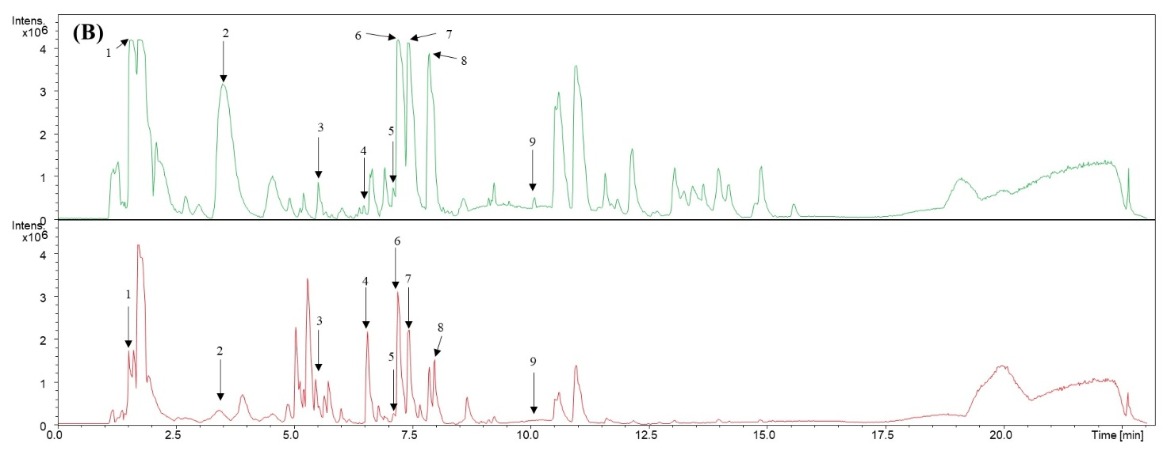
Supplementary Figure 3. Base peak chromatograms (BPCs) of coffee cherry pulp (CCP) tea and its Lactiplantibacillus plantarum-fermented beverage acquired in (A) positive and (B) negative ion modes. In each panel, the upper trace represents CCP tea, and the lower trace represents the fermented beverage.

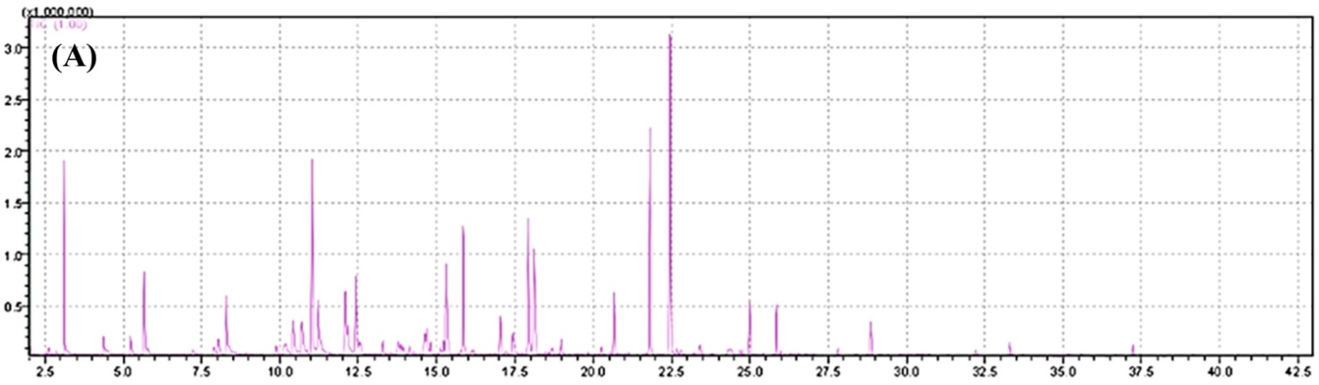
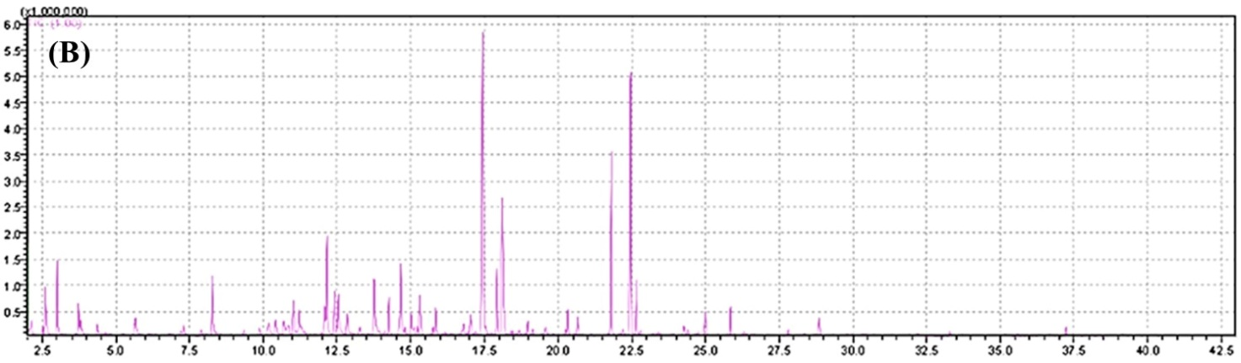
Supplementary Figure 4. Total ion chromatogram of volatile compounds from (A) coffee cherry pulp tea and (B) its Lactiplantibacillus plantarum-fermented beverage. The x-axis represents the retention time (minutes). The y-axis represents the ion intensity (arbitrary units).

