SUPPLEMENTARY MATERIAL

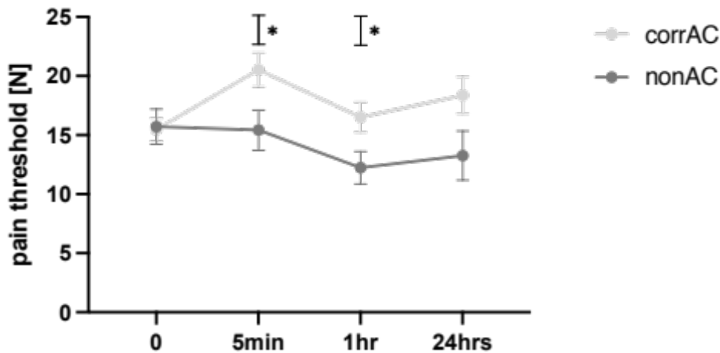

Figure 1a Development of the pain threshold before (p=0.9624) and 5 min (p=0.0284), 1 h (p=0.0303) and 24 h (p=0.0673) after AC. Comparing both groups: corrAC vs nonAC. P values were calculated by using Satterthwaite t- test.

Figure 1b corrAC: Development of the pain threshold before and 5 min, 1 h and 24 h after AC. A significant pain threshold increase was seen 5 min after AC (p < 0.0001). Also, the difference between baseline and 24 h was significant (p = 0.0028). Other differences were not significant.

Figure 1c nonAC: Development of the pain threshold before and 5 min, 1 h and 24 h after AC. No significant changes were seen (p = 0.1138).

Table 1a Skin temperatures for corresponding AC.
Area | baseline | 5 min | 1 hour | 24 hours | p value ANOVA | p value  Scheffé  0 – 24h
G1 | 36.9 ± 0.4 | 36.8 ± 0.3 | 37.0 ± 0.4 | 37.2 ± 0.6 | 0.0070 | 0.0320
G2 | 36.8 ± 0.3 | 36.8 ± 0.3 | 37.0 ± 0.4 | 37.0 ± 0.6 | 0.1060 | ---
G3 | 36.8 ± 0.3 | 36.8 ± 0.3 | 36.9 ± 0.3 | 37.0 ± 0.4 | 0.0084 | 0.0224
G4 | 36.9 ± 0.3 | 36.8 ± 0.2 | 36.9 ± 0.3 | 37.2 ± 0.5 | 0.0002 | 0.0005
G5 | 36.9 ± 0.4 | 36.8 ± 0.3 | 36.9 ± 0.3 | 37.2 ± 0.5 | 0.0009 | 0.0063

Table 1b Skin temperatures for non-corresponding AC
Area | baseline | 5 min | 1 hour | 24 hours | P value ANOVA | p value  Scheffé  0 – 24h
G1 | 36.9 ± 0.2 | 37.0 ± 0.4 | 36.7 ± 0.4 | 36.9 ± 0.2 | 0.2813 | ---
G2 | 36.9 ± 0.2 | 36.9 ± 0.4 | 36.7 ± 0.5 | 36.9 ± 0.2 | 0.5263 | ---
G3 | 36.9 ± 0.2 | 36.8 ± 0.1 | 36.8 ± 0.1 | 36.8 ± 0.1 | 0.6209 | ---
G4 | 36.8 ± 0.2 | 36.9 ± 0.3 | 36.8 ± 0.2 | 37.2 ± 0.7 | 0.1953 | ---
G5 | 36.9 ± 0.2 | 36.8 ± 0.2 | 36.8 ± 0.3 | 37.3 ± 0.4 | 0.0115 | 0.0378

