Patient data

Perioperative anticoagulation in elective surgery

Risk stratification |  | thromboembolic risk
Indication of OAK |  | low | medium | high
Atrial fibrillation |  | 0-2 | 3-4 | 5-6  stroke  <3 months
  CHADS₂ | Score
  previus stroke | 2
  age >75 years | 1
  hypertension | 1
  diabetes | 1
  heart insufficieny | 1
  sum of points | _____
Venous thromboembolism (e.g. deep vein thrombosis)  Pulmonary embolism |  |  | >3 months | ≤3 months
Heart valve prothesis | bileaflet mechanical aortic valve | sinus rhythm & CHADS₂ =0 | CHADS₂ >0
 | biological aortic valve |  | sinus rhythm | AF
 | older aortic mechanical valve |  |  | always
 | tricuspid valve replacement |  |  | always
Thrombophilia | antithrombin III deficiency  antiphospholipid syndrome  antiphospholipid antibodies  Factor V Leiden |  | always  always | always  always
Perioperative bridging |  | prophylactic LMWH | half-dose LMWH | full-dose LMWH  Heparin i.v.*
* in CKD with eGFR <30mL/min with high bleeding and high thromboembolic risk

Individual dosing of LMWH (Enoxaparin) s.c.
Age: ____ years |  |  |  | Weight: _____ kg | eGFR: _____ mL/min
Prophylactic LMWH |  |  | 40mg g.d
half-dose / full-dose LMWH |  | weight-adjusted dose 0.8 – 1.0 mg/kg BW  in morbid obesity half-dose split dose e.g. 140kg in 60-70mg b.i.d)  in elderly (>75 years) better 0.8 mg/kg BW  if CKD with eGFR <50mL/min 50% dose reduction  check anti–factor Xa level 3-5 days postoperatively |  |  |  | (max. 100mg single dose)  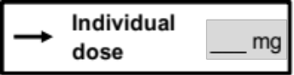
Timing of LMWH bridging

for warfarin pre- and postoperative briding, for DOAK preoperative interruption and postoperative bridging
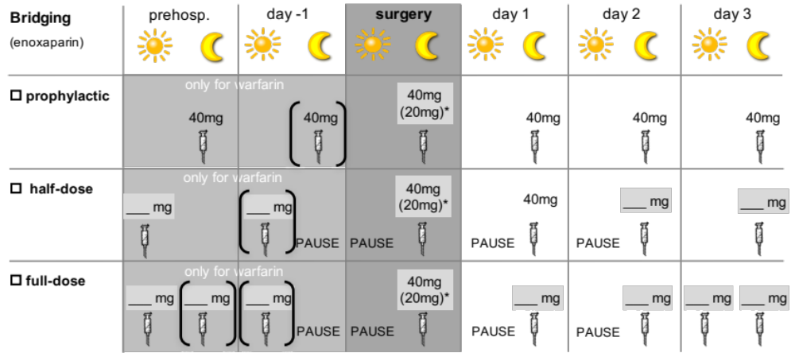
( ) if additional platelet inhibation * if CKD with eGFR <50mL/min
Preoperative interruption of OAK

Warfarin | minumum 7 days interruption prior surgery  INR check every 2 days off INR <2 beginn of briding (as stated above)  check INR the day before surgery  target INR <1,3 (no i.v. substitution of vitamin K)
Apixaban  Rivaroxaban  Edoxaban
   | eGFR | ≥80 | 50-80 | 30-50 | 15-30 | mL/min
  Bleeding risk*: | low | ≥24h | ≥24h | ≥24h | ≥36h
  Bleeding risk*: | medium/ high | ≥ 48h | 48-72h | 72-96h | ≥96h
Dabigatran
   | eGFR | ≥80 | 50-80 | 30-50 | mL/min
  Bleeding risk*: | low | ≥24h | ≥36h | ≥48h
  Bleeding risk*: | medium/ high | ≥48h | ≥60h | ≥96h

Abbreviations: OAK: oral anticoagulation; AF: atrial fibrillation; LWMH: low molecule weight heparine; CKD: chronic kidney disease; GFR: glomerulary filtration rate; s.c.: subcutaneous; BW: body weight; DOAK: dual oral anticoagulation; INR: international normalized ratio; i.v. intravenous.

