Supplemental Figure 2. Distribution of individual health-related quality of life measures by race and ethnicity
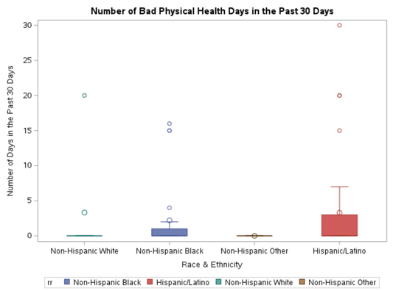
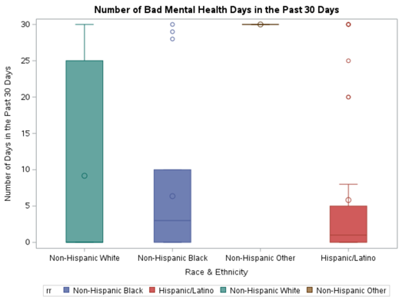
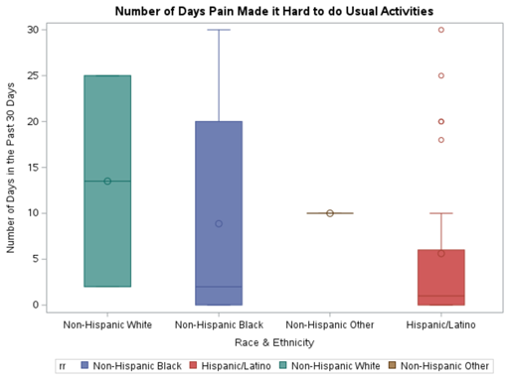
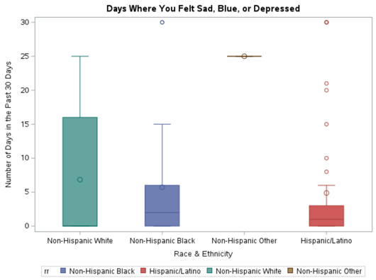
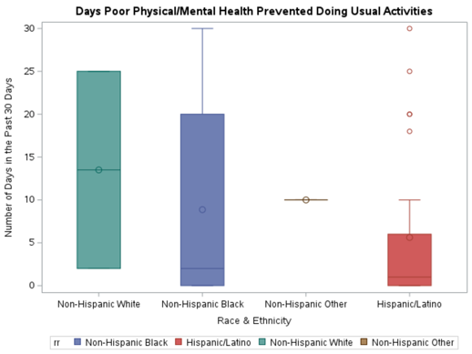
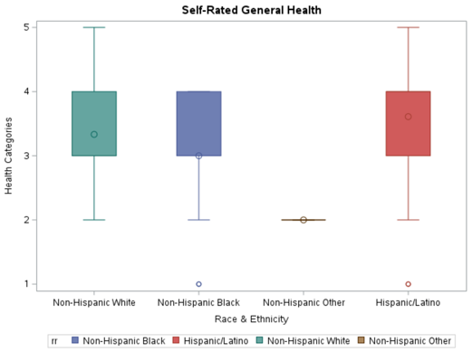
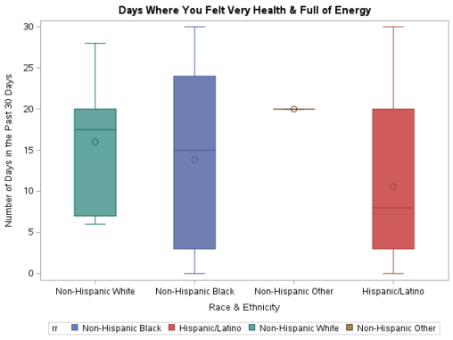
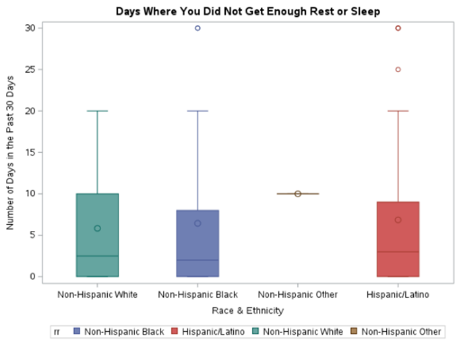
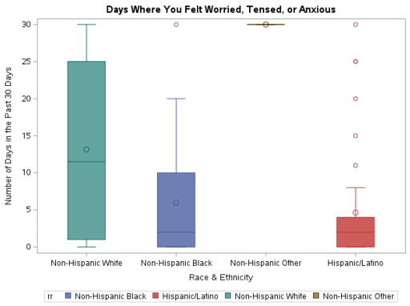
(a) The number of bad health days experienced in the last 30 days

(b) The number of bad mental health days experienced in the last 30 days

(c) The number of days pain made it hard to do usual activities

(d) The number of days poor mental or physical health prevented doing usual activities
(e) Self-rated general health
(f) Days where participants felt sad, blue, or depressed
(g) Days where participants did not get enough rest or sleep
(g) Days where participants felt worried, tensed or anxious
(g) Days where participants felt very healthy and full of energy

