Supplementary File 1
Search strategy
Ovid MEDLINE(R) ALL <1946 to June 01, 2024>
1 exp Diabetes Mellitus, Type 2/
2 (non insulin$ depend$ or noninsulin$ depend$ or non-insulin$ depend$).tw,ot.
3 (NIDD or T2D or T2DM).tw,ot.
4 ((late or adult$ or mature$ or slow or stable$) adj3 onset).mp. and diabet$.tw,ot.
5 1 or 2 or 3 or 4
6 exp Bariatric Surgery/
7 (bariatric surger* or gastric surger* or metabolic surger* or bariatric surgical procedur*).tw,ot.
8 6 or 7
9 5 and 8
10 limit 9 to randomised controlled trial

Assessment of consistency (global and local)
Remission
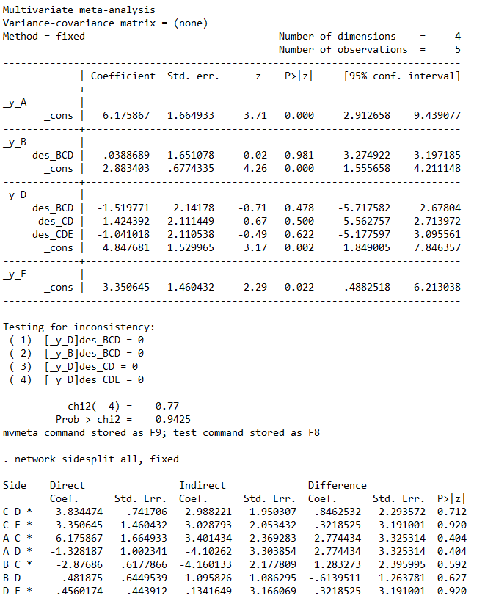
HbA1c
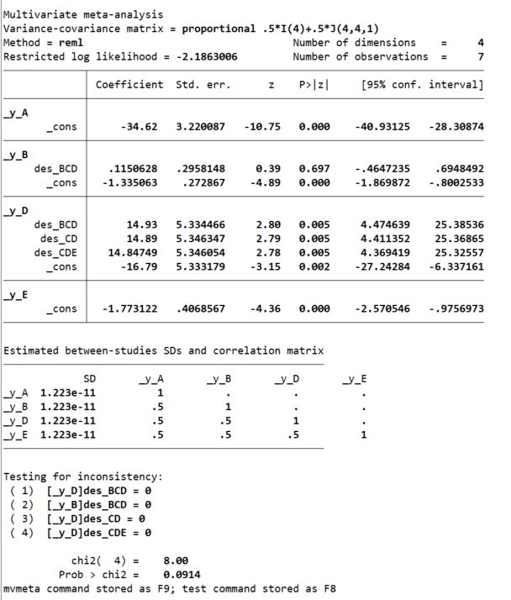
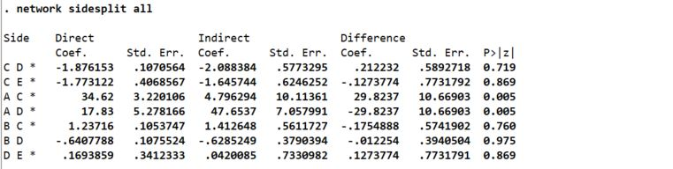
BMI
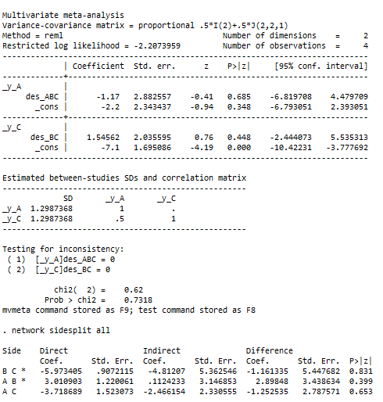
TG
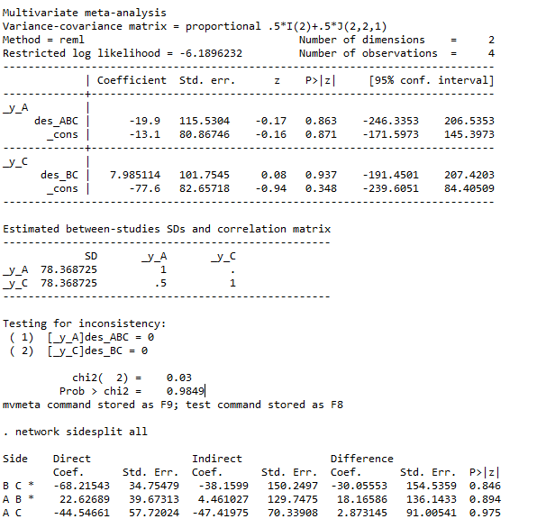
TC
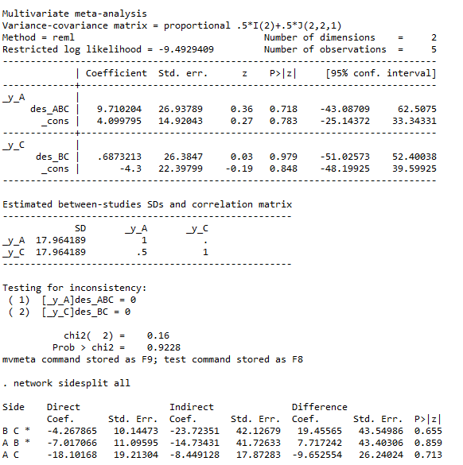
LDL
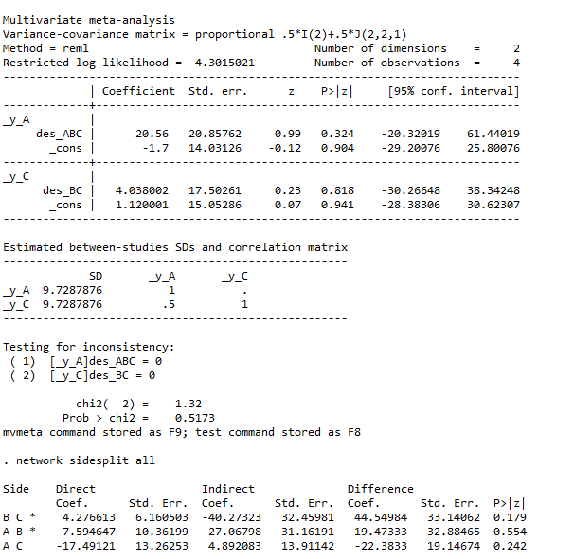
SBP
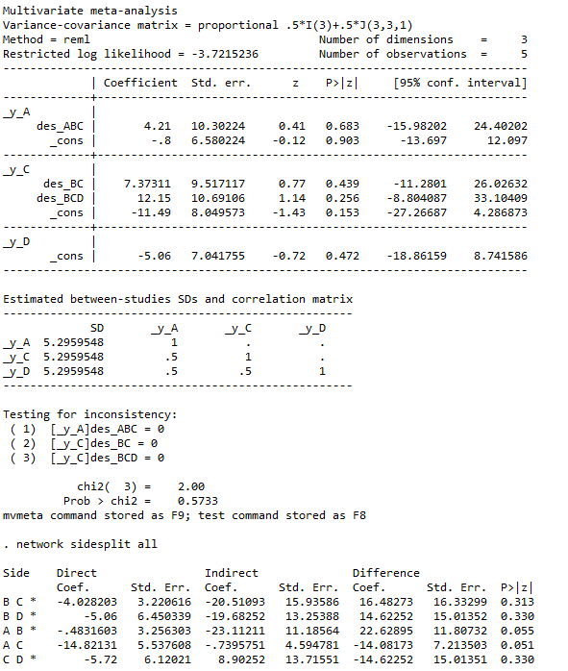
DBP
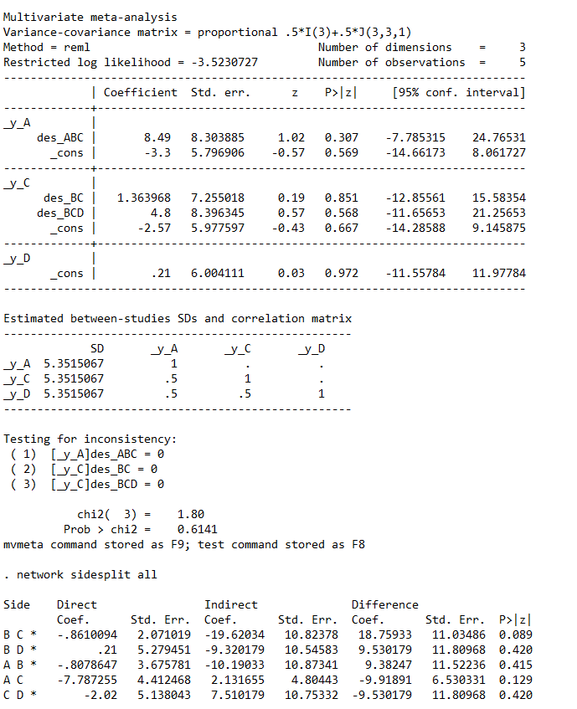

Effect sizes
Figure 1. Remission of T2DM
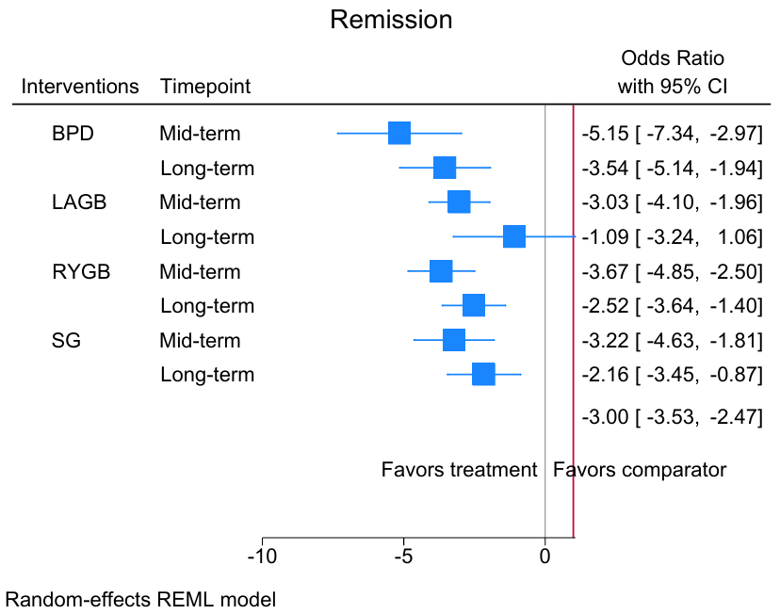

Figure 2. Forest plot of HbA1C levels
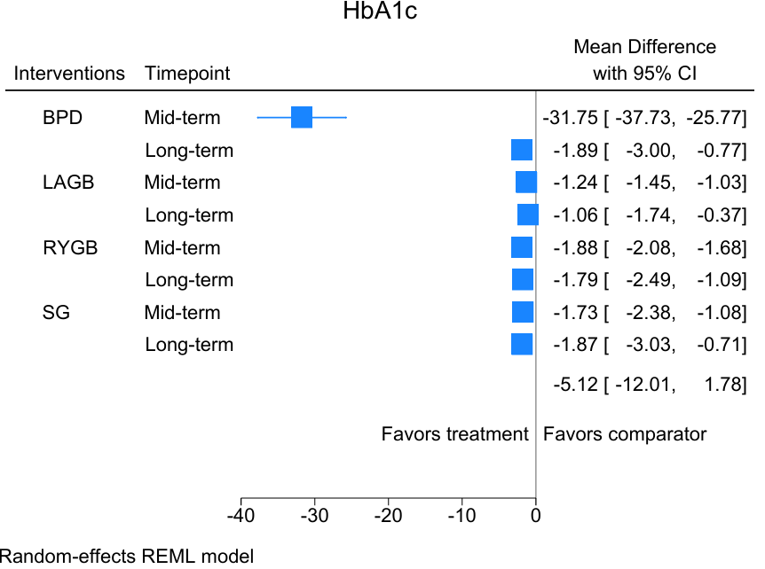

Figure 3. Forest plot of BMI
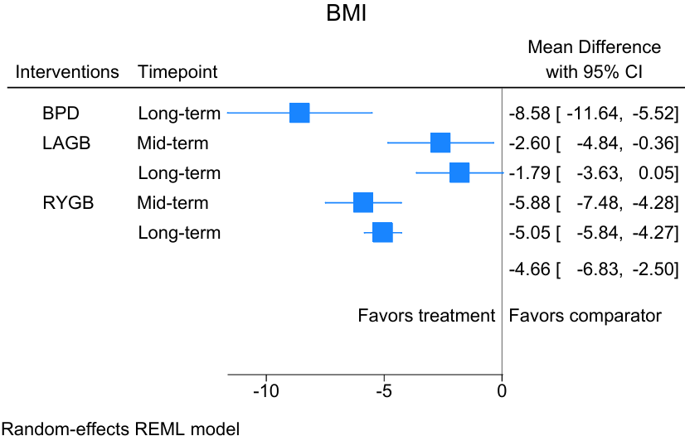

Figure 4. Forest plot of triglyceride
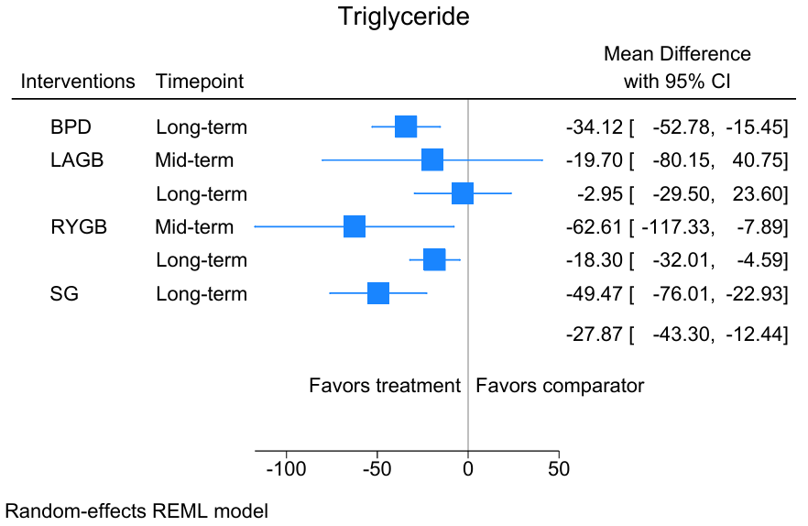

Figure 5. Forest plot of total cholesterol
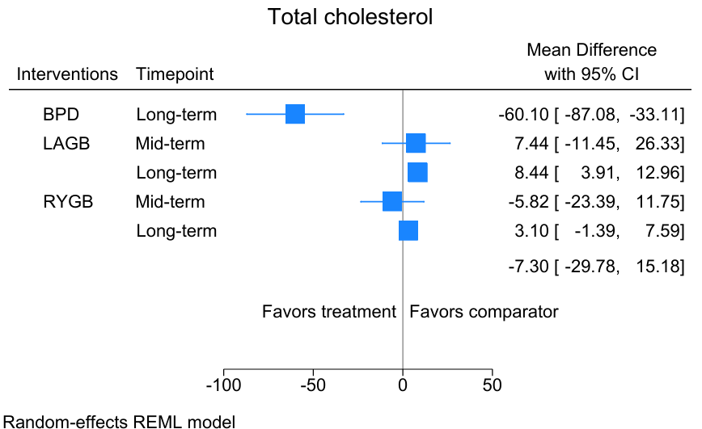

Figure 6. Forest plot of LDL
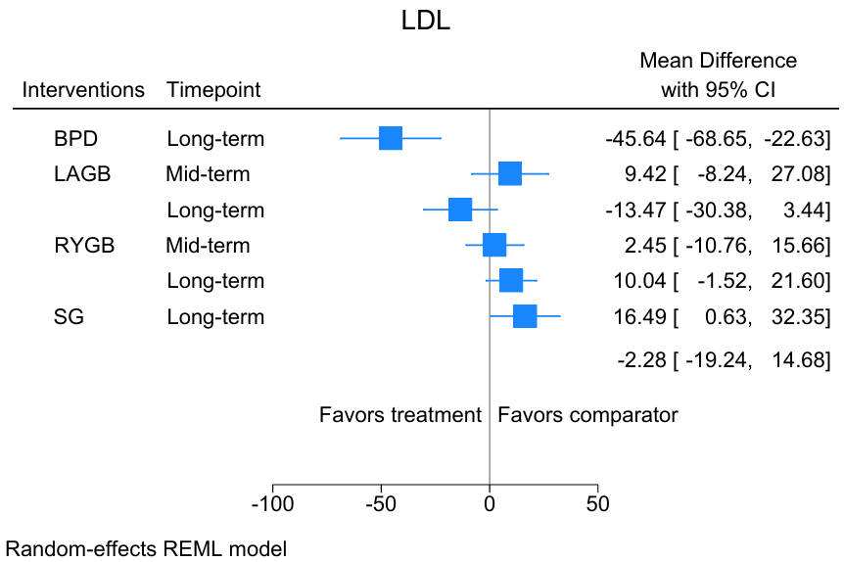

Figure 7. Forest plot of SBP
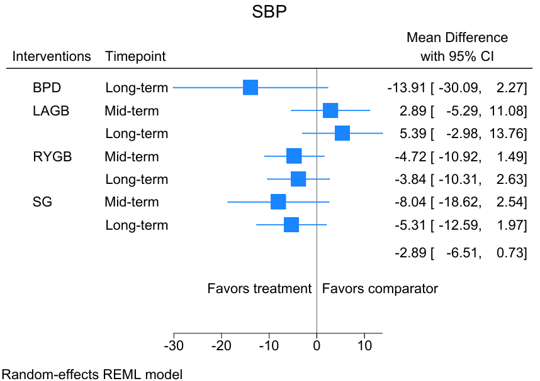

Figure 8. Forest plot of DBP
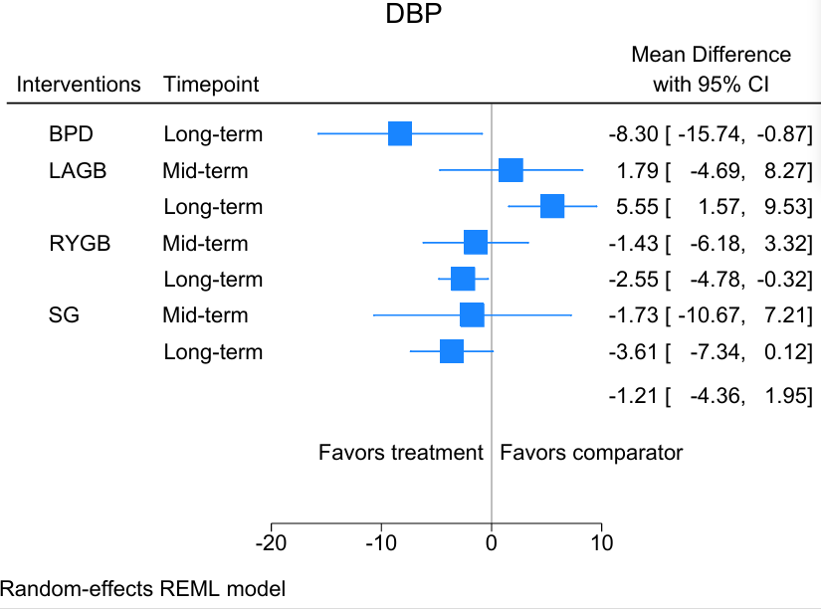

SUCRA values
Table 1. Remission
Intervention | SUCRA
BPD | 1.00
RYGB | 0.62
SG | 0.55
LAGB | 0.30
MT | 0.03

Table 2. HbA1c
Intervention | SUCRA
BPD | 1.00
RYGB | 0.67
SG | 0.56
LAGB | 0.27
MT | 0.00

Table 3. BMI
Intervention | SUCRA
RYGB | 0.99
LAGB | 0.50
MT | 0.00

Table 4. TG
Intervention | SUCRA
RYGB | 0.93
LAGB | 0.44
MT | 0.13

Table 5. TC
Intervention | SUCRA
LAGB | 0.80
MT | 0.51
BPD | 0.19

Table 6. LDL
Intervention | SUCRA
LAGB | 0.75
RYGB | 0.57
MT | 0.18

Table 7. SBP
Intervention | SUCRA
SG | 0.88
RYGB | 0.70
MT | 0.30
LAGB | 0.12

Table 8. DBP
Intervention | SUCRA
RYGB | 0.67
SG | 0.65
MT | 0.45
LAGB | 0.24

