Supporting Information
Convenient Method to Obtain Homoallylic Thioethers from Aromatic Dithioacetal Derivatives
Natalia Buszta, Wojciech J. Depa, Agata Bajek, Grażyna Groszek*

Faculty of Chemistry, Rzeszów University of Technology, 6 Powstańców Warszawy Ave., 35-959 Rzeszów, Poland
*Corresponding author, ggroszek@prz.edu.pl

Table of contents

1. | General Information | S2
2. | Materials | S2
3. | General procedure | S2
4. | Analysis Data of Products | S2-S3
5. | Copies of ¹H and ¹³CNMR spectra for all new compounds | S4-S10

General Information: Reactions were monitored by TLC on Merck silica gel 60 F₂₅₄ plates visualized by UV lamp at 254 nm. Column chromatography was performed on Merck silica gel 60. NMR spectra were measured on a Bruker AVANCE^{II} 500 NMR spectrometer (500 MHz for ¹H spectra and 125 MHz for ¹³C spectra), CDCl₃ or CD₂Cl₂ served as an internal standard. Chemical shifts (δ values) were quoted in parts per million (ppm), the following abbreviations were used to describe resonance splitting patterns when appropriate: s = singlet, d = doublet, t = triplet, m = multiplet. Coupling constants (J values) were reported in hertz unit (Hz). Infrared spectra were measured on a Nicolet 8700 spectrometer (ATR). High-resolution mass spectra (HRMS) and low-resolution mass spectra were measured on an AMD-604 mass spectrometer (EI).
Materials: Substrate, dithioacetal derivatives 1a-g, were prepared according to literature [Ali et al. 2005] from commercial available aldehyde derivatives. Other materials were also commercial.
General procedure: Dithioacetal derivative (1.0 mmol) was dissolved in DCM (5 mL) in a round bottom flask, equipped with a magnetic stirring bar. Then, Sc(OTf)₃ (1.1 mmol) was added and the mixture was stirred for 10 min at room temperature. Next, the allyl-SnBu₃ (1.1 mmol) was added and reaction mixture was stirred at room temperature overnight. The reaction progress was monitored by TLC (hexane:ethyl acetate, 20:1). After 24 hours the reaction mixture was poured into water (30 mL). The organic layer was separated and the aqueous layer was extracted with DCM (3x20 mL). The combined organic layers were dried over anhydrous Na₂SO₄. After solvent evaporation, product was purified or isolated by flash chromatography on silica gel (hexane:ethyl acetate).
1-(Ethylthio)-1-phenyl-3-butene (2a). Colorless oil; Yield: 57% (110 mg); ¹H NMR and ¹³C data consistent with the literature description [Ando et al. 1972]: IR (ATR, cm⁻¹) ν 3078, 2971, 1640, 1452, 1260. HRMS (EI+) m/z calcd for C₁₂H₁₆S [M]⁺ 192.0972; found 192.0976. LRMS (EI+), m/z (%): 151(100), 131(34), 115(16), 90(50), 77(18).
4-(Ethylthio)-4-(2-methoxyphenyl)-1-butene (o-2b). Yellow oil. Yield: 65% (144 mg). ¹H NMR (500 MHz, CDCl₃) δ 7.44 (d, J 7.6, 1H, ArH), 7.20 (d, J 7.6, 1H, ArH), 6.96 (d, J 7.5, 1H, ArH), 6.86 (d, J 8.2, 1H, ArH), 5.80-5.72 (m, 1H, -CH=CH₂), 5.05-4.96 (m, 2H, -CH=CH₂), 4.49 (t, J 7.5, 1H, -S-CH-CH₂-), 3.83 (s, 3H, -O-CH₃), 2.61 (t, J 7.2, 2H, -CH-CH₂-CH=), 2.42-2.31 (m, 2H, -S-CH₂-CH₃), 1.17 (t, J 7.4, 3H, -S-CH₂-CH₃). ¹³C NMR (125 MHz, CDCl₃) δ 157.1, 136.0, 130.8, 128.4, 127.8, 120.9, 116.6, 110.7, 55.7, 41.0, 40.3, 25.2, 14.7. IR (ATR, cm⁻¹) ν 3075, 2962, 1598, 1490, 1241. HRMS (EI+) m/z calcd for C₁₃H₁₈OS [M]⁺ 222.1078; found 222.1080. LRMS (EI+), m/z (%): 222(6); 181(100); 161(63); 91(46); 75(53).
2-(1-(Ethylthio)but-3-en-1-yl)phenol (o-2c). Purple oil. Yield: 80% (110 mg) from 151 mg (0.66 mmol). ¹H NMR (500 MHz, CDCl₃) δ 7.39 (br s, 1H), 7.19 (t, J 7.7, 1H, ArH), 7.05 (d, J 7.5, 1H, ArH), 6.89 (d, J 7.3, 1H, ArH), 6.85 (t, J 7.4, 1H, ArH), 5.77-5.69 (m, 1H, -CH=CH₂), 5.08-5.01 (m, 2H, -CH=CH₂), 4.07 (t, J 7.7, 1H, -S-CH-CH₂-), 2.73-2.61 (m, 2H, -CH-CH₂-CH=), 2.42-2.32 (m, 2H, -S-CH₂-CH₃), 1.17 (t, J 7.4, 3H, -S-CH₂-CH₃). ¹³C NMR (125 MHz, CD₂Cl₂) δ 155.4, 135.2, 130.1, 129.0, 125.3, 120.4, 117.8, 117.4, 47.6, 38.7, 25.0, 14.3. IR (ATR, cm⁻¹) ν 3269, 3069, 2973, 1581, 1487. HRMS (EI+) m/z calcd for C₁₂H₁₆OS [M]⁺ 208.0922; found 208.0929. LRMS (EI+), m/z (%): 208(6); 167(100); 147(43); 107(24); 91(27).
4-(2-Chlorophenyl)-4-(ethylthio)-1-butene (o-2d). Colorless oil. Yield: 25% (56 mg). ¹H NMR (500 MHz, CDCl₃) δ 7.59 (d, J 7.8, 1H, ArH), 7.33 (d, J 8.0, 1H, ArH), 7.28 (t, J 8.0, 1H, ArH), 7.16 (t, J 7.6, 1H, ArH), 5.79-5.71 (m, 1H, -CH=CH₂), 5.06-4.99 (m, 2H, -CH=CH₂), 4.57 (t, J 7.4, 1H, -S-CH-CH₂-), 2.65-2.54 (m, 2H, -CH-CH₂-CH=), 2.43-2.31 (m, 2H, -S-CH₂-CH₃), 1.18 (t, J 7.4, 3H, -S-CH₂-CH₃). ¹³C NMR (125 MHz, CDCl₃) δ 140.2, 135.0, 133.8, 129.4, 129.3, 128.1, 127.3, 117.3, 44.5, 40.6, 25.3, 14.8. IR (ATR, cm⁻¹) ν 3066; 2968; 2926; 1640; 1441. HRMS (EI+) m/z calcd for C₁₂H₁₅ClS [M]⁺ 226.0583; found 226.0577. LRMS (EI+), m/z (%): 226(7); 187(49); 185(100); 157(18); 129(25); 46(25).
4-(Ethylthio)-4-(4-methoxyphenyl)-1-butene (p-2b). Colorless oil. Yield: 59% (132 mg). ¹H NMR (500 MHz, CDCl₃) δ 7.22 (d, J 8.7, 2H, ArH), 6.84 (d, J 8.7, 2H, ArH); 5.74-5.66 (m, 1H,-CH=CH₂), 5.04-4.96 (m, 2H, -CH=CH₂), 3.81 (t, J 7.6, 1H, -S-CH-CH₂-), 3.79 (s, 3H, -OCH₃), 2.60-2.56 (m, 2H, -CH-CH₂-CH=), 2.30-2.25 (m, 2H, -S-CH₂-CH₃), 1.13 (t, J 7.4, 3H, -S-CH₂-CH₃). ¹³C NMR (125 MHz, CDCl₃) δ 158.5, 135.6, 134.2, 128.8 (2C), 116.8, 113.7 (2C), 55.2, 48.6, 41.0, 24.9, 14.4. IR (ATR, cm⁻¹) ν 2926, 1640, 1509, 1244, 1172, 1034, 830. HRMS (EI+) m/z calcd for C₁₃H₁₈OS [M]⁺ 222.1078; found 222.1082. LRMS (EI+), m/z (%): 161(100); 181(96); 121(22); 77(10).
4-(1-(Ethylthio)but-3-en-1-yl)phenol (p-2c). Yellow oil. Yield: 15% (25 mg) from 174 mg (0.76 mmol). ¹H NMR (500 MHz, CD₂Cl₂) δ 7.17 (d, J 8.6, 2H, ArH), 6.77 (d, J 8.6, 2H, ArH), 5.74-5.66 (m, 1H, -CH=CH₂), 5.04-4.96 (m, 3H, -CH=CH₂ and -OH), 3.81 (t, J 7.6, 1H, -S-CH-CH₂-), 2.63-2.50 (m, 2H, -CH-CH₂-CH=), 2.33-2.25 (m, 2H, -S-CH₂-CH₃), 1.13 (t, J 7.4, 3H, -S-CH₂-CH₃). ¹³C NMR (125 MHz, CD₂Cl₂) δ 155.0, 135.2, 134.9, 136.2, 129.5 (2C), 116.8, 115.5 (2C), 48.8, 41.3, 25.3, 14.7. IR (ATR, cm⁻¹) ν 3336; 3075; 2925; 1611; 1511; 1219. HRMS (EI+) m/z [M]⁺ calcd for C₁₂H₁₆OS 208.0922; found 208.0919. LRMS (EI+), m/z (%): 167(100); 147(80); 107(34); 95(11); 77(17).
4-(4-Bromophenyl)-4-(ethylthio)-1-butene (p-2d). Colorless oil. Yield: 32% (135 mg). ¹H NMR (500 MHz, CDCl₃) δ 7.43 (d, J 8.4, 2H, ArH), 7.19 (d, J 8.4, 2H, ArH), 5.71-5.63 (m, 1H, -CH=CH₂), 5.03-4.98 (m, 2H, -CH=CH₂), 3.80 (t, J 7.5, 1H, -S-CH-CH₂-), 2.63-2.49 (m, 2H, -CH-CH₂-CH=), 2.34-2.22 (m, 2H, -S-CH₂-CH₃), 1.13 (t, J 7.4, 3H, -S-CH₂-CH₃). ¹³C NMR (125 MHz, CDCl₃) δ 141.6, 135.2, 131.7 (2C), 129.8 (2C), 120.9, 117.5, 48.9, 41.0, 25.2, 14.6. IR (ATR, cm⁻¹) ν 3077, 2926, 1640, 1487, 1260; HRMS (EI+) m/z calcd for C₁₂H₁₅BrS [M]⁺ 270.0078; found 270.0083. LRMS (EI+), m/z (%) 231(100); 229(98); 130(66); 129(50); 128(29).

Copies of ¹H and ¹³CNMR spectra for all new compounds
4-(Ethylthio)-4-(2-methoxyphenyl)-1-butene (o-2b).
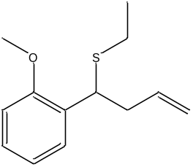
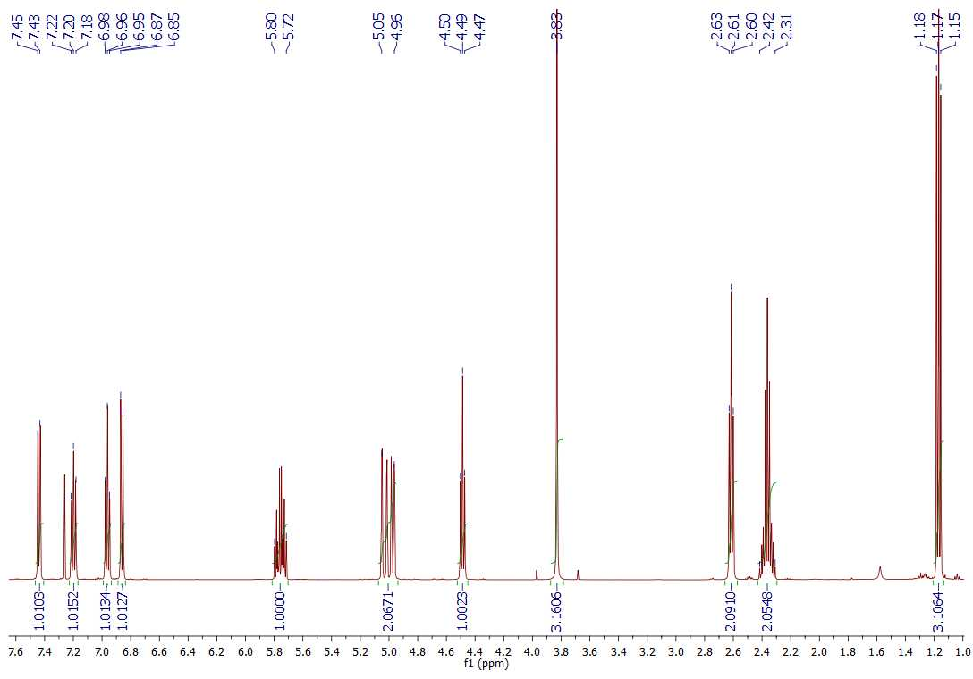
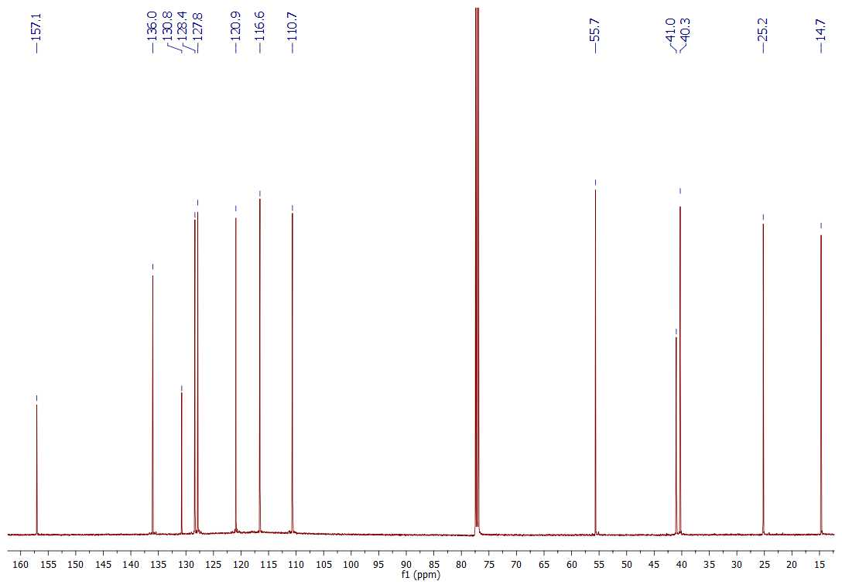

2-(1-(Ethylthio)but-3-en-1-yl)phenol (o-2c).
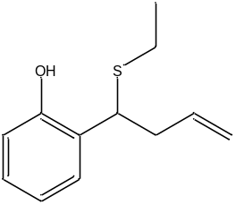
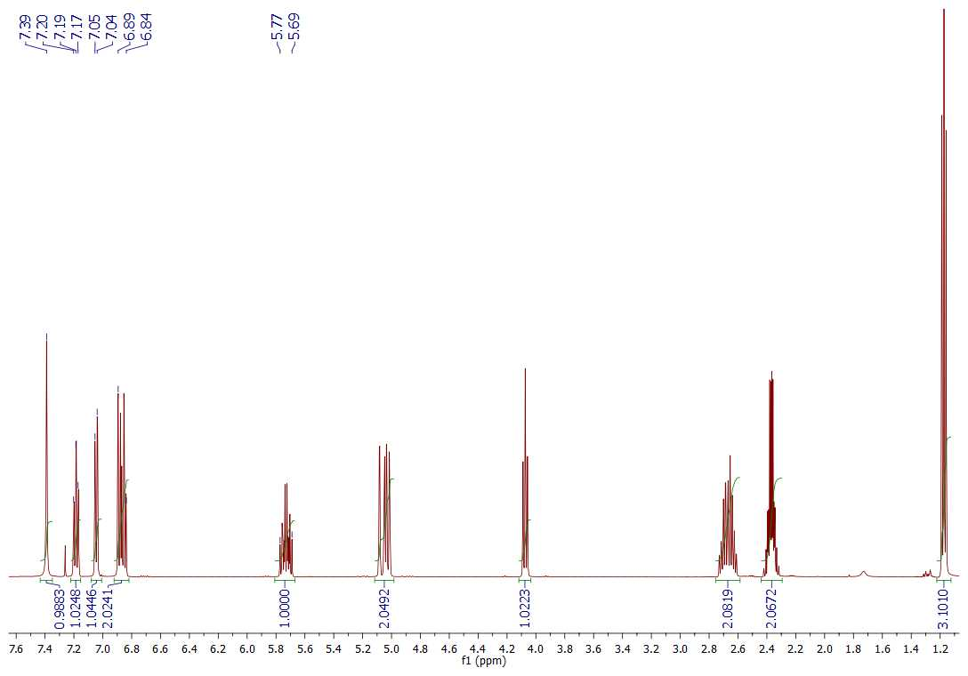
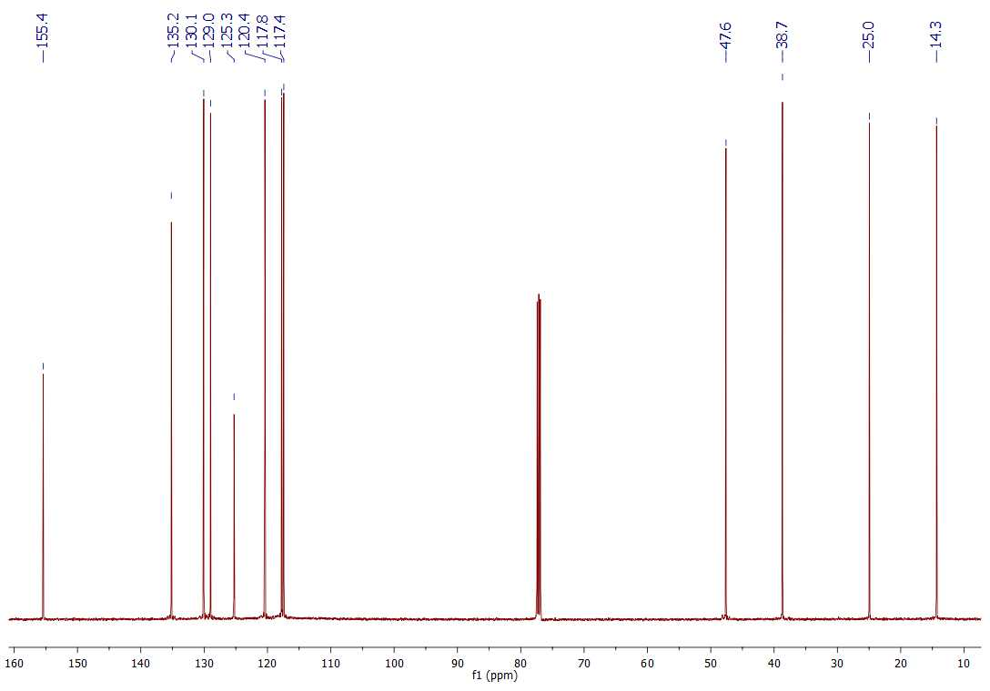

4-(2-Chlorophenyl)-4-(ethylthio)-1-butene (o-2d).
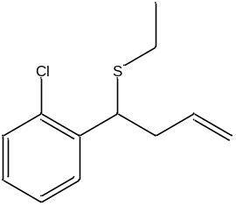
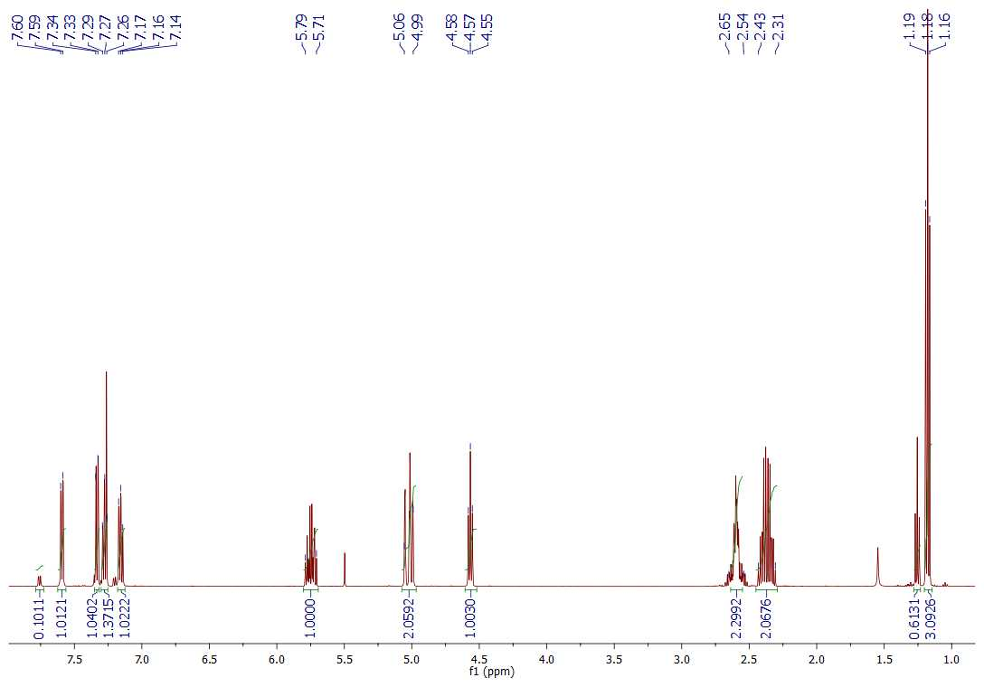
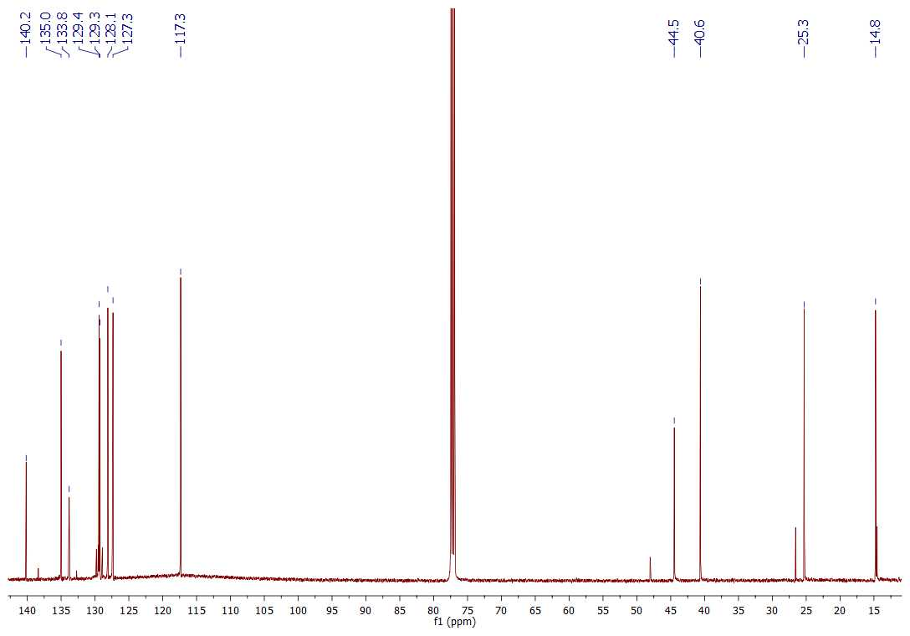
4-(Ethylthio)-4-(4-methoxyphenyl)-1-butene (p-2b).
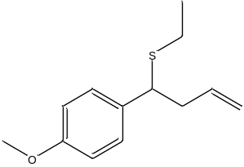

4-(1-(Ethylthio)but-3-en-1-yl)phenol (p-2c).
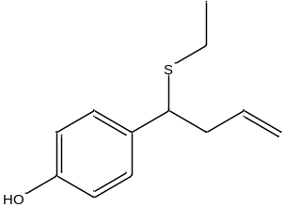
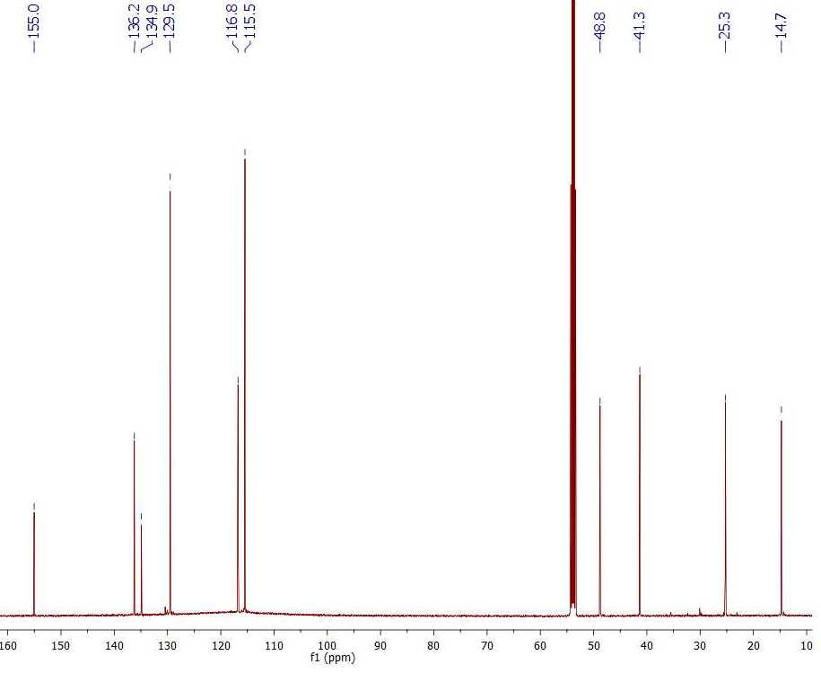
4-(4-Bromophenyl)-4-(ethylthio)-1-butene (p-2d).
