Supplementary Information

Anthracene modified graphene for C₆₀/C₇₀ fullerenes capture and construction of energy storage materials

Agata Fedorczyk, Agnieszka Krogul-Sobczak, Piotr Piotrowski*
Department of Chemistry, University of Warsaw, Pasteura 1, 02-093 Warsaw, Poland

Bis(anthracen-9-ylmethyl) malonate

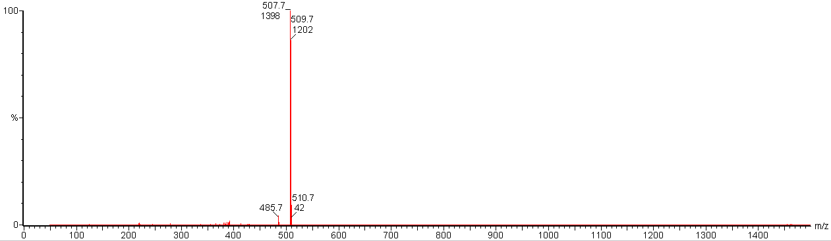
Figure S1. ESI-MS spectrum of of bis(anthracen-9-ylmethyl) malonate.
Figure S2. ¹H NMR spectrum of of bis(anthracen-9-ylmethyl) malonate.

Figure S3. ¹³C NMR spectrum of of bis(anthracen-9-ylmethyl) malonate.

Figure S4. FT-IR spectrum of of bis(anthracen-9-ylmethyl) malonate.

Figure S5. UV-Vis spectrum of of bis(anthracen-9-ylmethyl) malonate.

