Supplementary table 2
Apomorphine IFD Poses
IFD Pose Number | IFD Score | 2D Interaction Diagram
1 | -1466.82 | 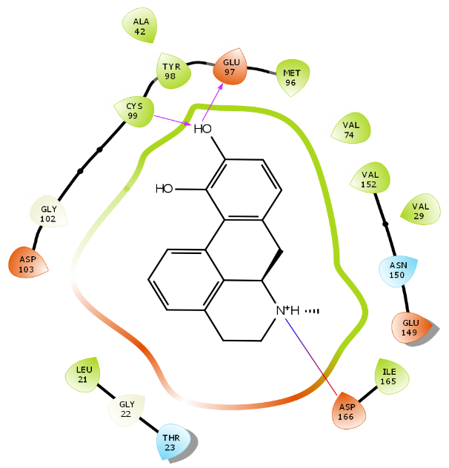
2 | -1466.78 | 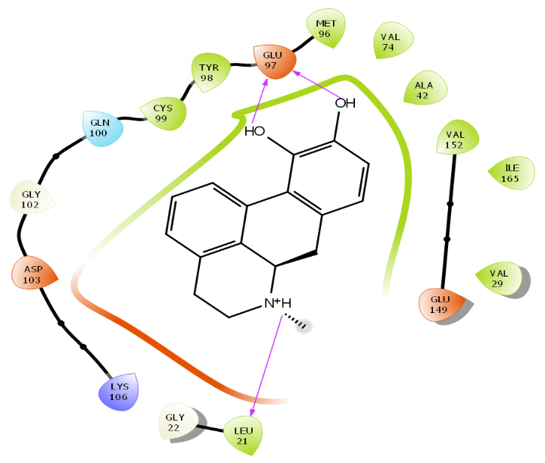
3 | -1466.60 | 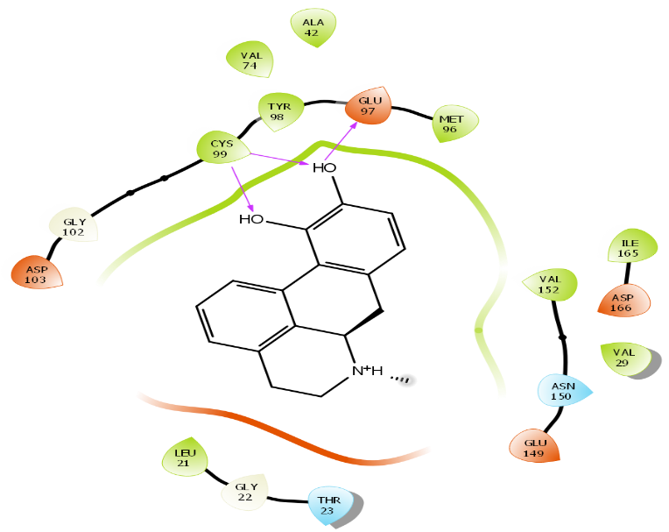
4 | -1466.54 | 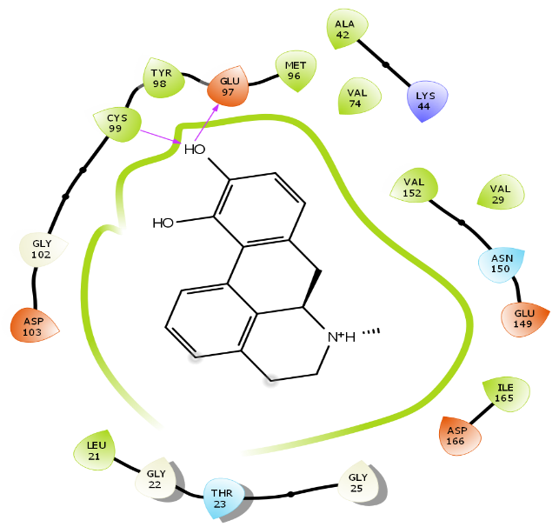
5 | -1466.22 | 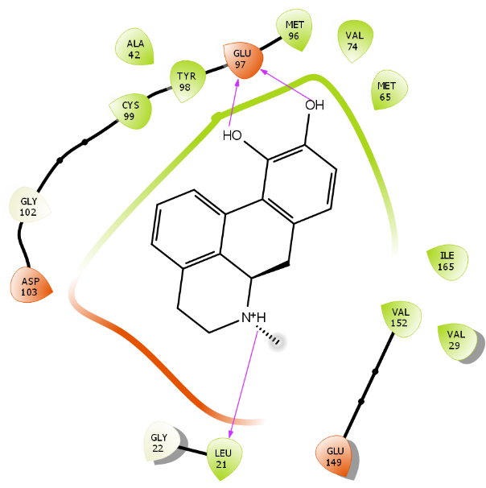
6 | -1466.13 | 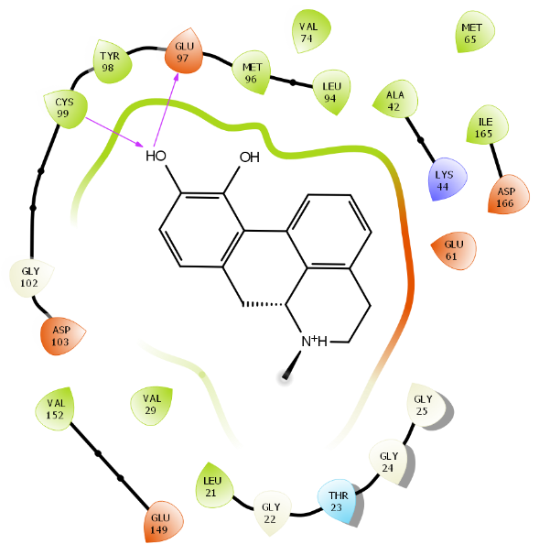
7 | -1465.63 | 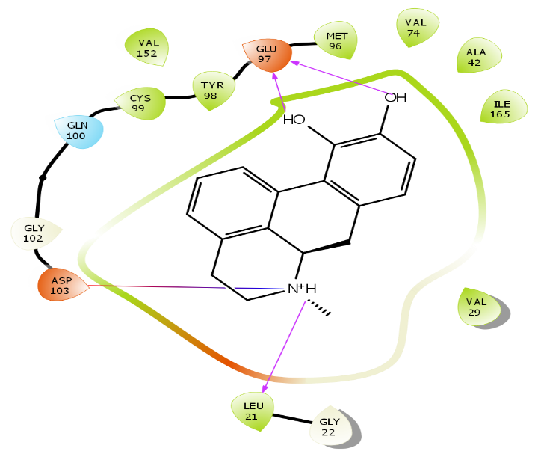
8 | -1464.50 | 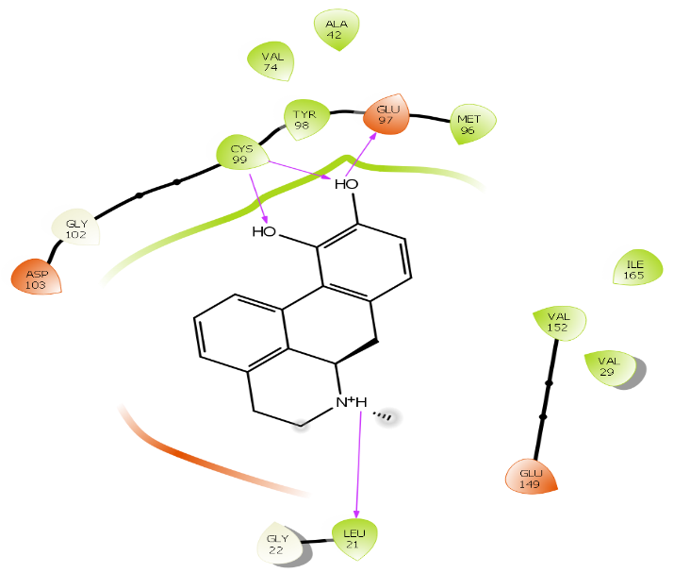
9 | -1464.13 | 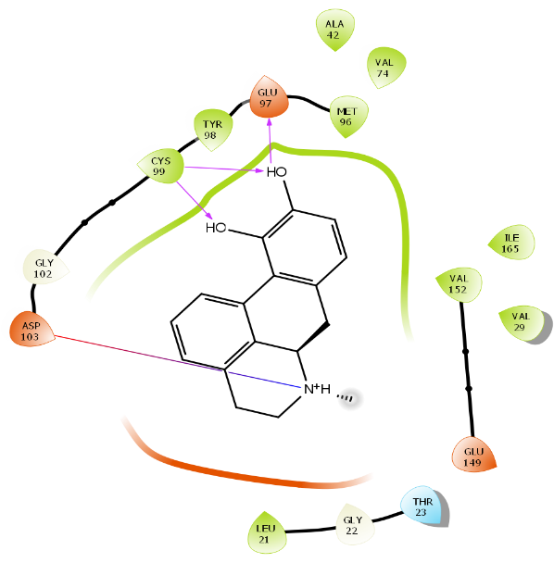
10 | -1463.85 | 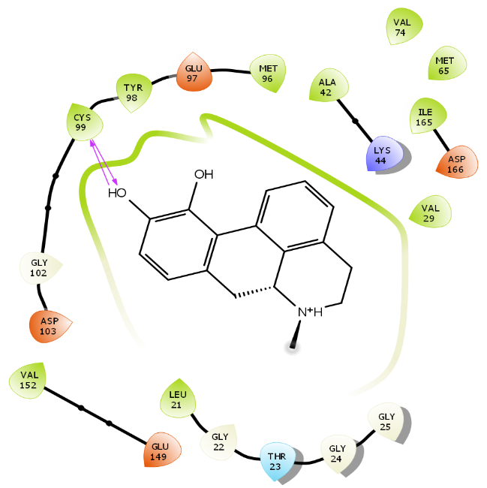
11 | -1462.81 | 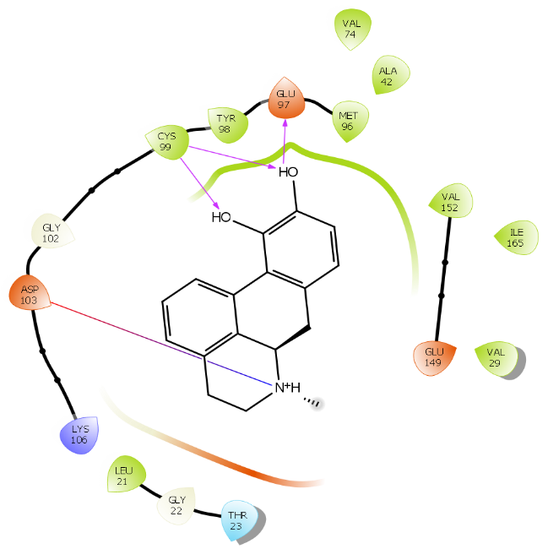
12 | -1462.56 | 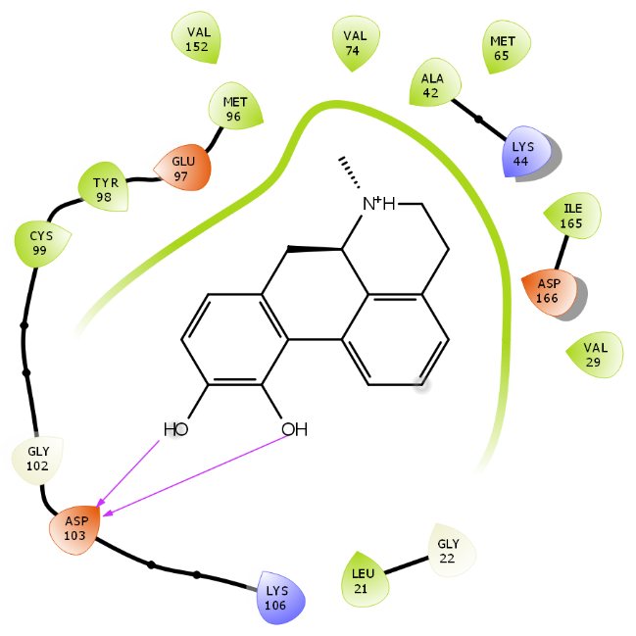
13 | -1462.36 | 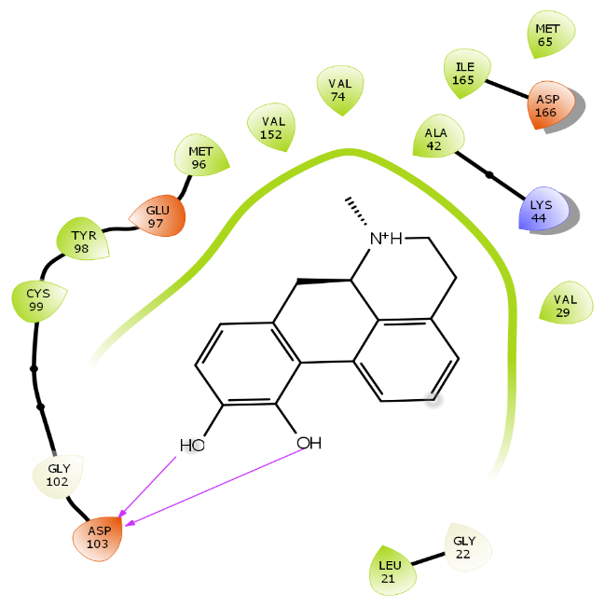
14 | -1462.02 | 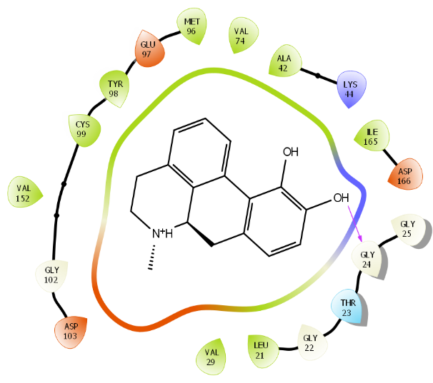
15 | -1461.64 | 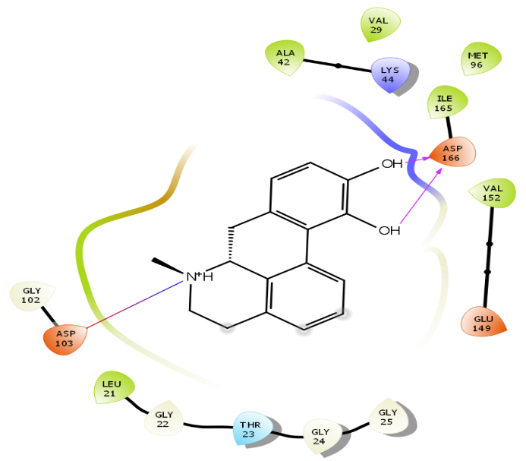
16 | -1459.69 | 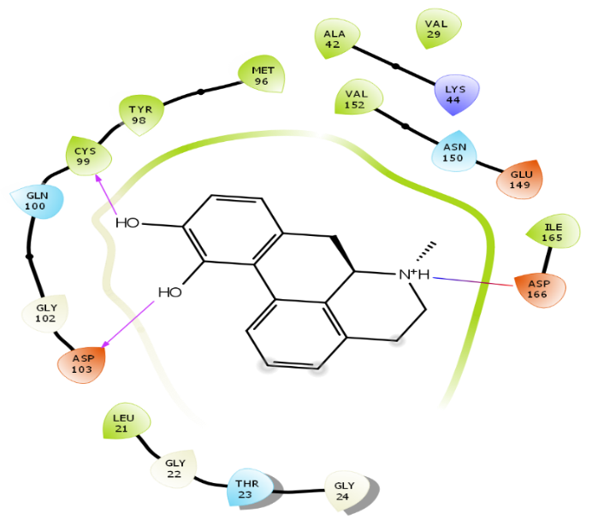

Supplementary table 3
Rotigotine IFD Poses

IFD Pose Number | IFD Score | 2D Interaction Diagram
1 | -1466.49 | 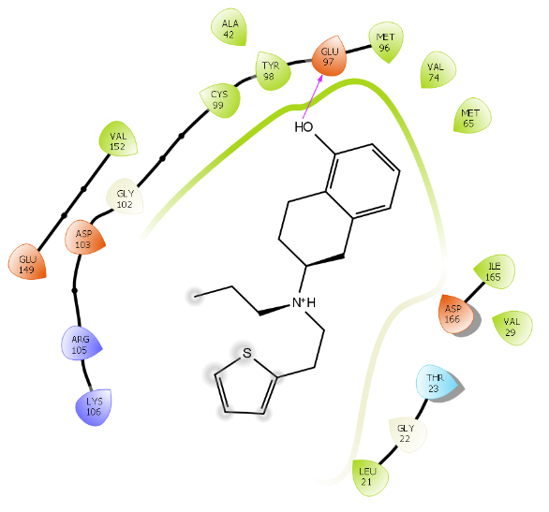
2 | -1466.33 | 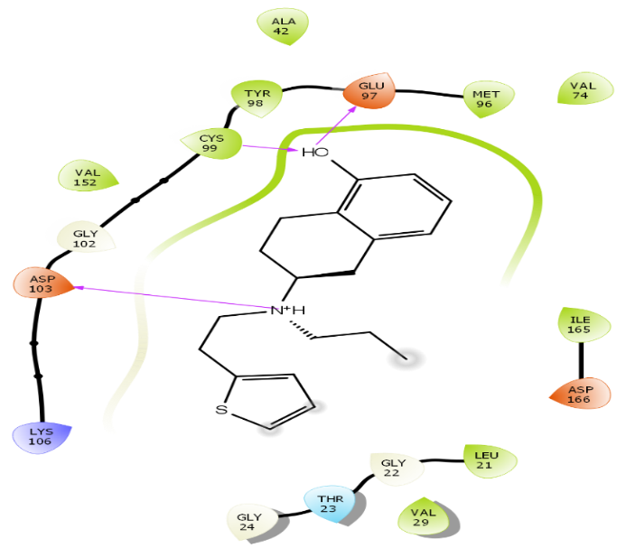
3 | -1466.08 | 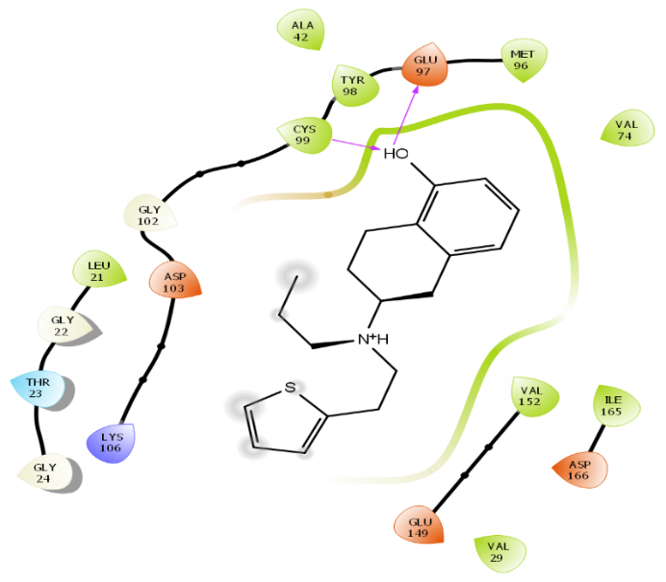
4 | -1465.24 | 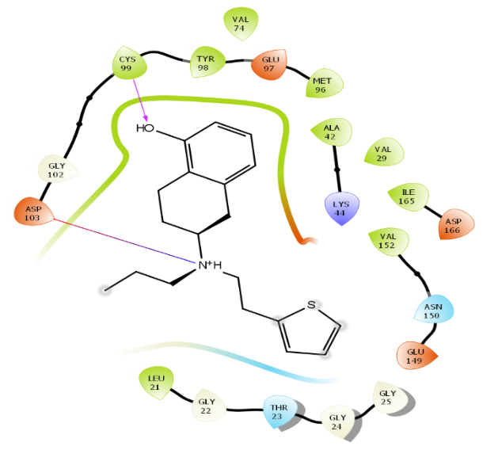
5 | -1465.21 | 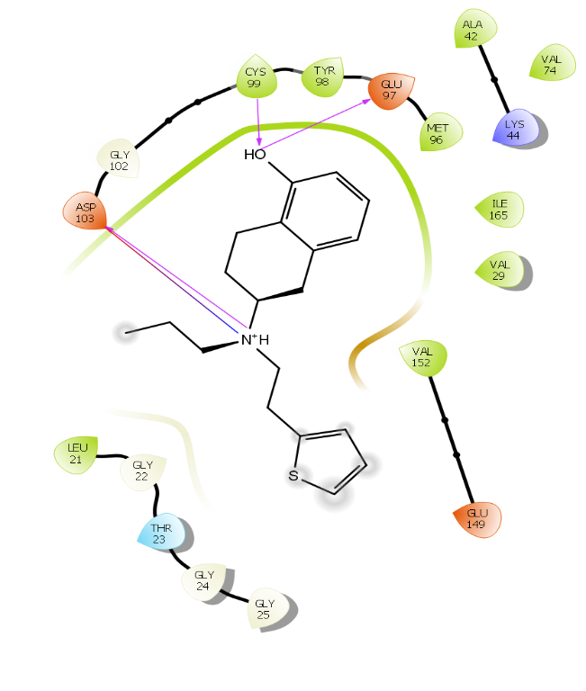
6 | -1463.17 | 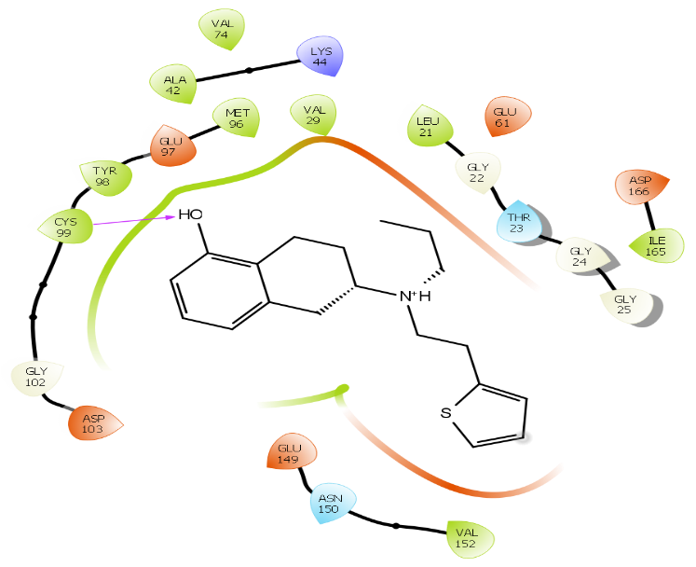
7 | -1462.86 | 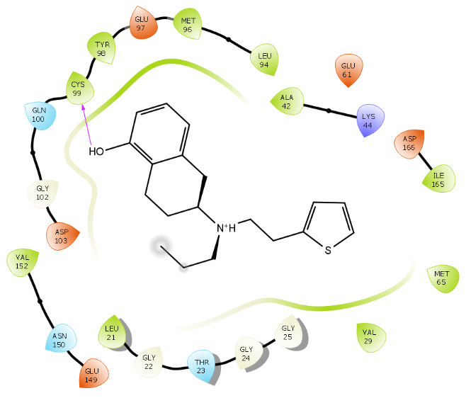
8 | -1462.41 | 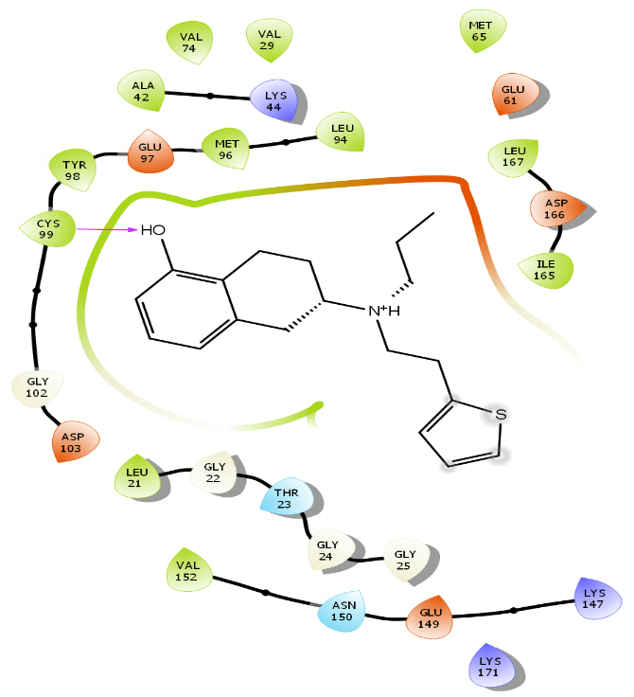
9 | -1462.40 | 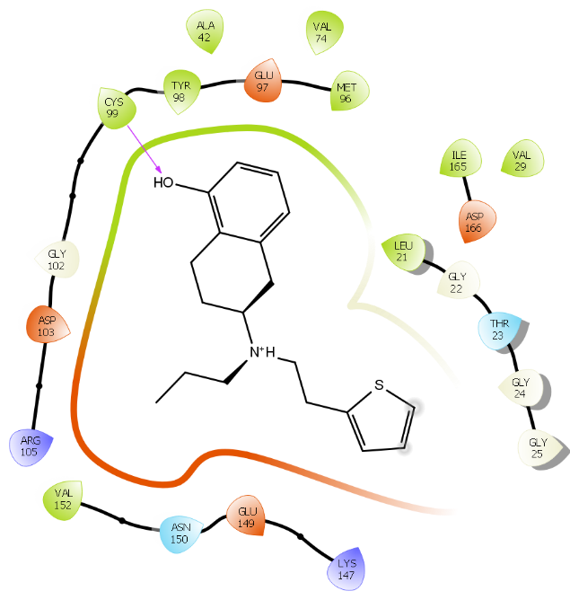
10 | -1459.20 | 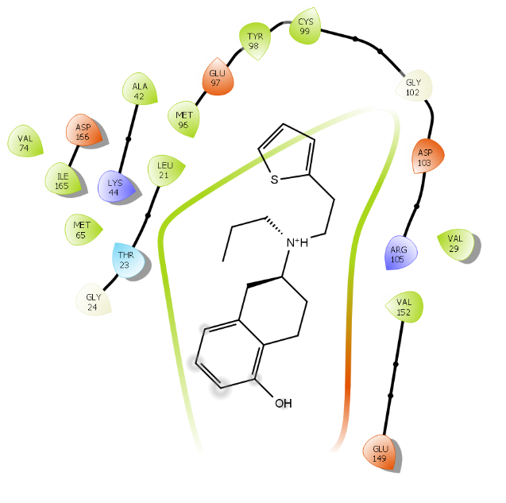

Supplementary table 4
Aripiprazole IFD Poses
IFD Pose Number | IFD Score | 2D Interaction Diagram
1 | -1467.39 | 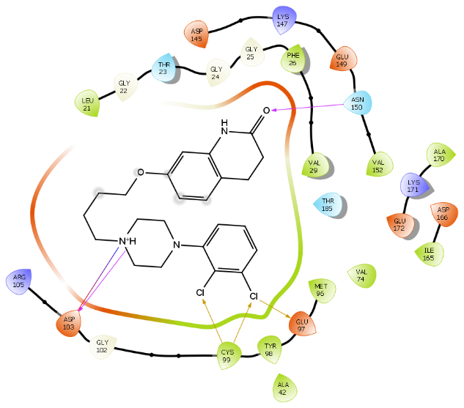
2 | -1466.76 | 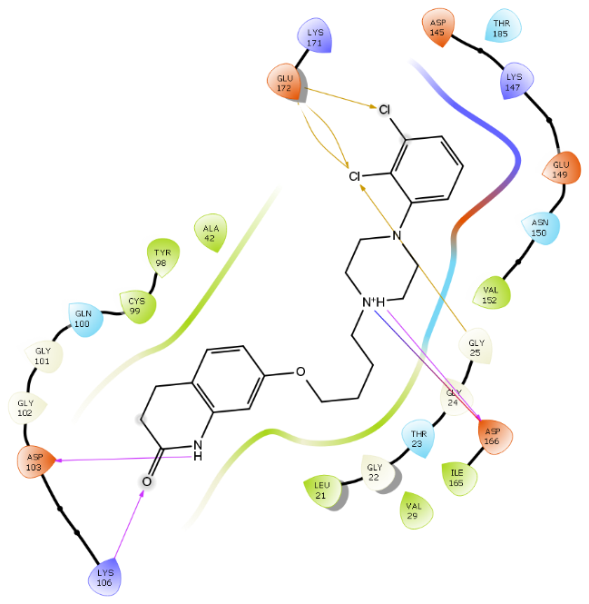
3 | -1466.33 | 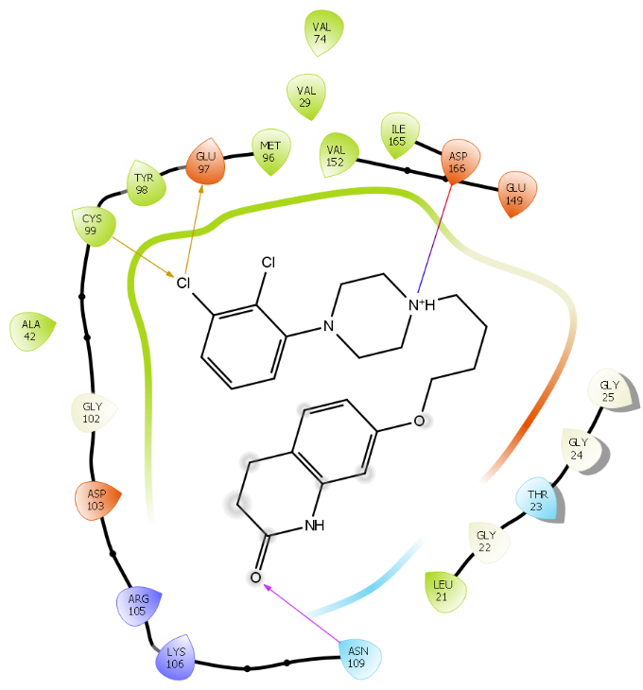
4 | -1466.04 | 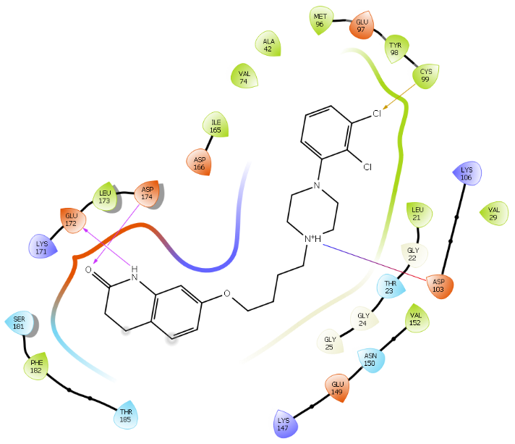
5 | -1465.98 | 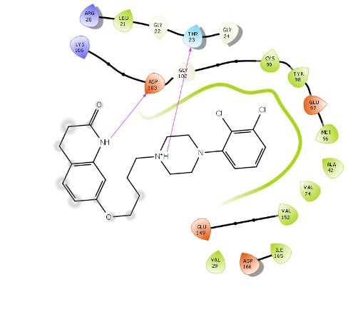
6 | -1465.97 | 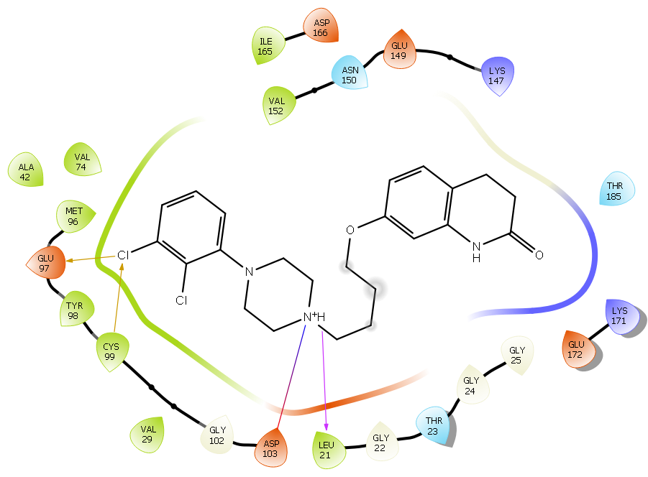
7 | -1465.24 | 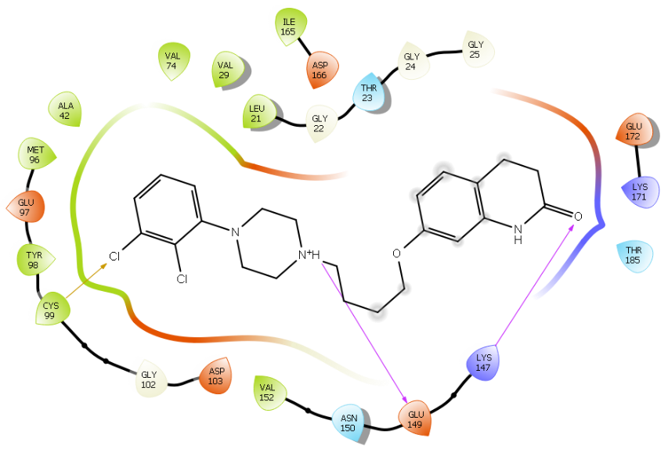
8 | -1464.96 | 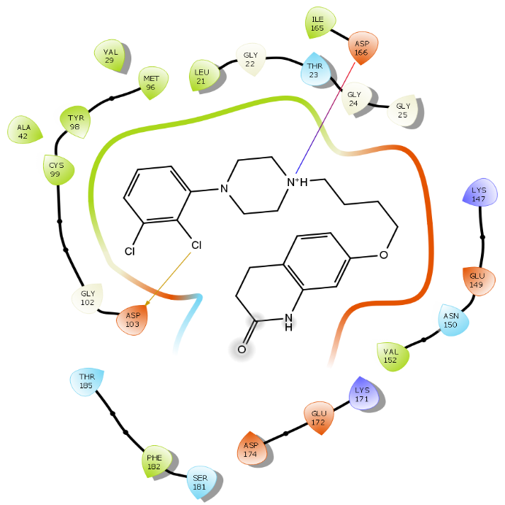
9 | -1464.84 | 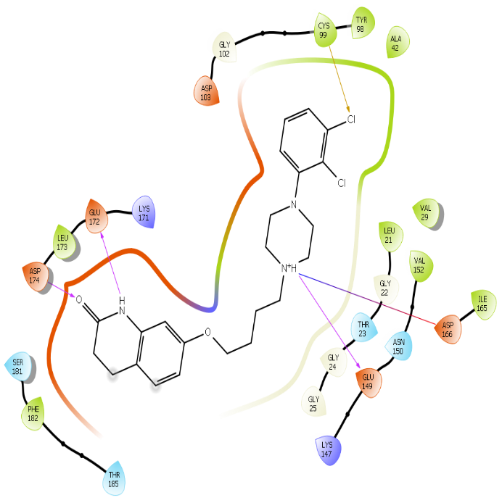
10 | -1464.37 | 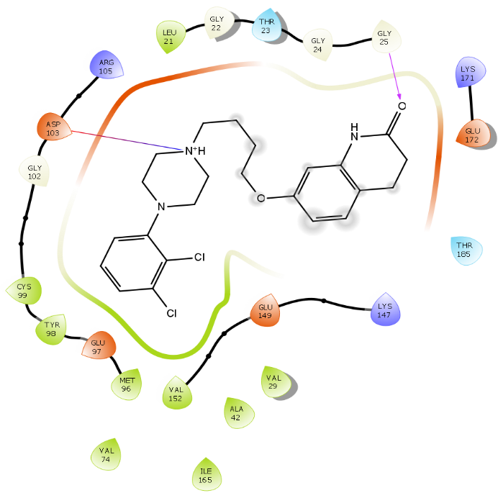
11 | -1464.08 | 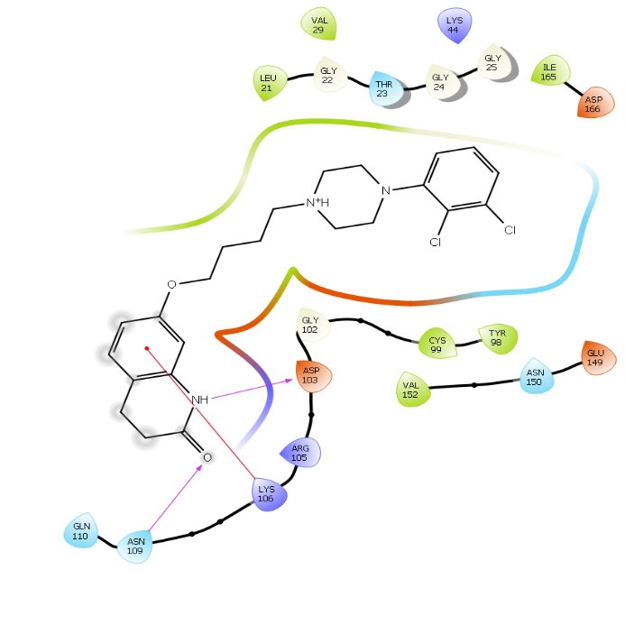
12 | -1464.02 | 