Supplementary materials
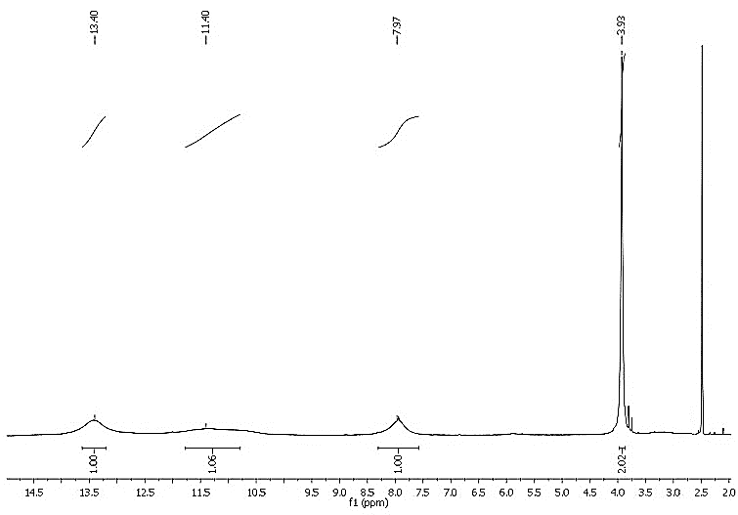
(S1): The ¹H-NMR Spectrum of compound (1).

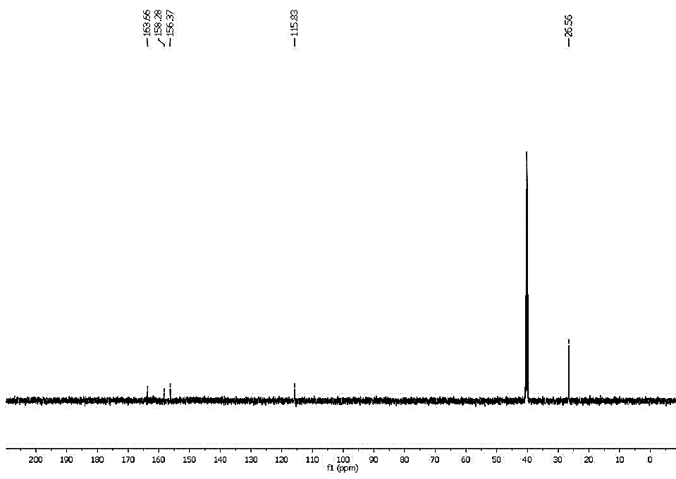
(S2): The ¹³C-NMR Spectrum of compound (1).
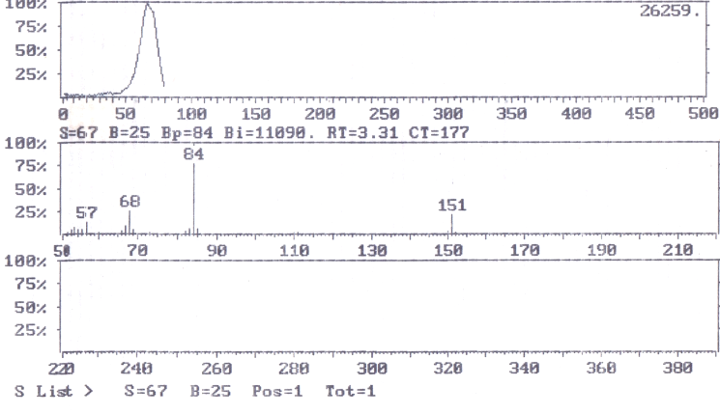
(S3): The mass Spectrum of compound (1).
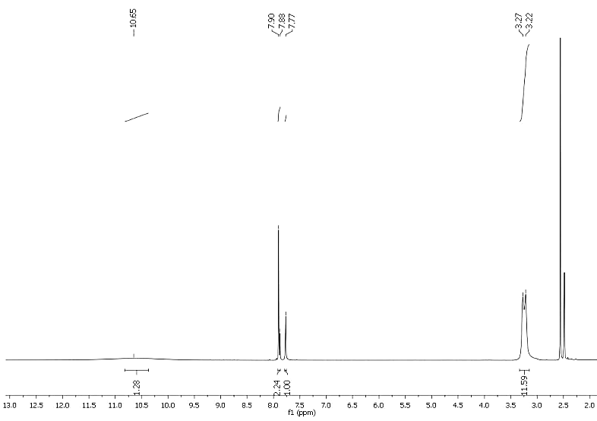
(S4): The ¹H-NMR Spectrum of compound (2).
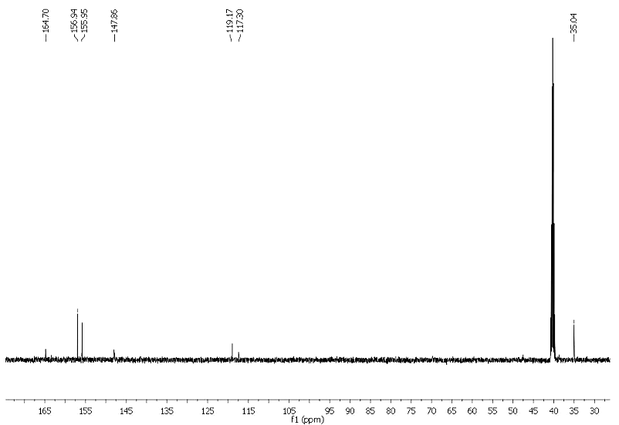
(S5): The ¹³C-NMR Spectrum of compound (2).
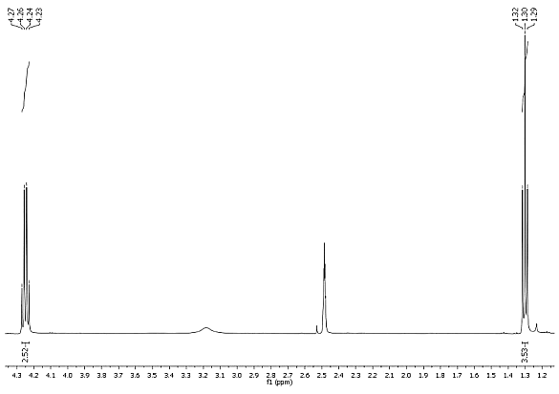
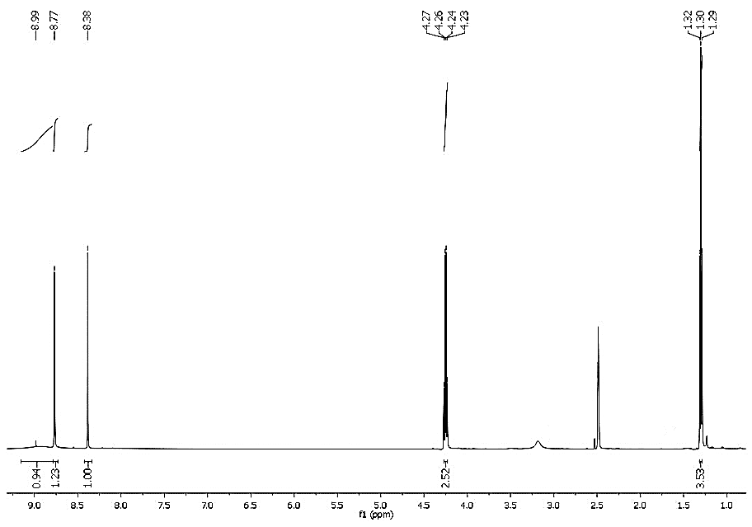
Ethyl group expansion
(S6): The ¹H-NMR Spectrum of compound (3) including the expansion of ethyl group spectrum.
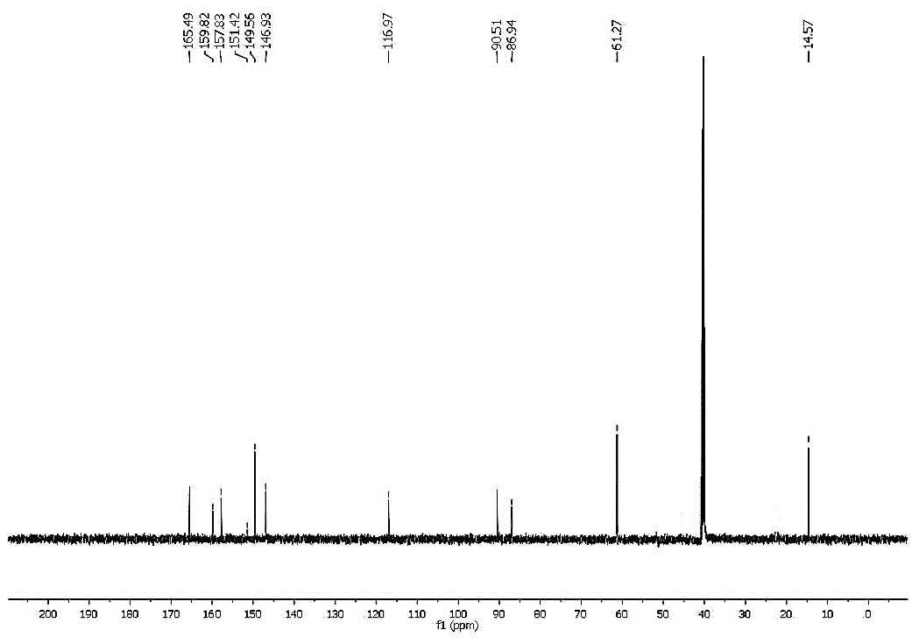
(S7): The ¹³C-NMR Spectrum of compound (3).

