Electronic Supplementary Information (ESI)

Facile microwave-assisted preparation of Fe₃O₄ nanoparticles supported on carbonized cellulose nanocrystals derived from sugarcane bagasse.

Emmanuel Mkumbuzi and Werner E. van Zyl*

School of Chemistry and Physics, University of KwaZulu-Natal, Westville Campus, Durban, 4000, South Africa

* Corresponding author details:
Werner E. van Zyl
School of Chemistry and Physics, University of KwaZulu-Natal, Westville Campus, Durban, 4000, South Africa.
Phone +27 31 260 3199
Email: vanzylw@ukzn.ac.za

Table S1 Peak list of IONP/cCNC nanocomposite

No. | 2θ, ° | d, Å | Height, cps | FWHM, ° | Int. I., cps° | Int. W., ° | Asymmetry
1 | 30.08(2) | 2.969(2) | 913(55) | 0.24(2) | 267(21) | 0.29(4) | 1.0(4)
2 | 35.426(11) | 2.5318(7) | 2810(140) | 0.268(8) | 949(23) | 0.34(3) | 0.88(14)
3 | 43.096(15) | 2.0973(7) | 529(33) | 0.35(5) | 259(24) | 0.49(8) | 1.7(16)
4 | 57.255(9) | 1.6077(2) | 727(48) | 0.42(3) | 391(24) | 0.54(7) | 5(3)

No. | 2θ, ° | Decay(ηL/mL) | Decay(ηH/mH) |  |  | Size, Å |  |  | Phase Name
1 | 30.08(2) | 0.6(4) | 0.1(4) |  |  | 352(29) |  |  | Fe3 O4: 1 0 4
2 | 35.426(11) | 0.40(13) | 0.55(12) |  |  | 325(10) |  |  | Fe3 O4: 0 1 5
3 | 43.096(15) | 0.3(4) | 1.3(3) |  |  | 255(35) |  |  | Fe3 O4: 0 2 4
4 | 57.255(9) | 0.4(2) | 1.0(3) |  |  | 225(17) |  |  | Fe3 O4: 3 0 3
No. | 2θ, ° | Chemical Formula |  | Card No |  | Norm. I. |  | Profile Type
1 | 30.08(2) | Fe3 O4 |  | 1526955 |  | 28.11 |  | Split Pseudo-Voigt
2 | 35.426(11) | Fe3 O4 |  | 1526955 |  | 100.00 |  | Split Pseudo-Voigt
3 | 43.096(15) | Fe3 O4 |  | 1526955 |  | 27.33 |  | Split Pseudo-Voigt
4 | 57.255(9) | Fe3 O4 |  | 1526955 |  | 41.15 |  | Split Pseudo-Voigt
No. | 2θ, ° | Distribution R.S.D. |  | Strain, % |  |  | Degree of Orientation
1 | 30.08(2) | - |  | - |  |  | -
2 | 35.426(11) | - |  | - |  |  | -
3 | 43.096(15) | - |  | - |  |  | -
4 | 57.255(9) | - |  | - |  |  | -
No. | 2θ, ° | Ring Factor |  |  | β Cluster |  | Custom Label
1 | 30.08(2) | - |  |  | -
2 | 35.426(11) | - |  |  | -
3 | 43.096(15) | - |  |  | -
4 | 57.255(9) | - |  |  | -

No. | 2θ, ° | d, Å | h k l | Norm. I.
1 | 18.25211 | 4.85663 | 0 0 3 | 4.20
2 | 18.33039 | 4.83607 | 1 0 1 | 12.47
3 | 21.17397 | 4.19259 | 0 1 2 | 0.00
4 | 30.07104 | 2.96933 | 1 0 4 | 28.38
5 | 30.16895 | 2.95991 | 1 1 0 | 28.13
6 | 35.40351 | 2.53335 | 0 1 5 | 50.35
7 | 35.48823 | 2.52750 | 1 1 3 | 100.00
8 | 35.53052 | 2.52459 | 0 2 1 | 49.83
9 | 36.98907 | 2.42832 | 0 0 6 | 3.89
10 | 37.15209 | 2.41804 | 2 0 2 | 11.54
11 | 43.11763 | 2.09630 | 0 2 4 | 43.06
12 | 47.08396 | 1.92853 | 1 0 7 | 0.32
13 | 47.18451 | 1.92466 | 2 0 5 | 0.32
14 | 47.28490 | 1.92081 | 2 1 1 | 0.64
15 | 48.44815 | 1.87737 | 1 1 6 | 0.00
16 | 48.57933 | 1.87261 | 1 2 2 | 0.00
17 | 53.33953 | 1.71617 | 0 1 8 | 4.71
18 | 53.52306 | 1.71071 | 2 1 4 | 9.32
19 | 53.58414 | 1.70891 | 3 0 0 | 4.64
20 | 56.82568 | 1.61888 | 0 0 9 | 3.12
21 | 56.94300 | 1.61582 | 0 2 7 | 12.44
22 | 57.03089 | 1.61354 | 1 2 5 | 24.75
23 | 57.08943 | 1.61202 | 3 0 3 | 9.21
24 | 57.08943 | 1.61202 | 0 3 3 | 12.33
25 | 62.50837 | 1.48466 | 2 0 8 | 42.52
26 | 62.72969 | 1.47996 | 2 2 0 | 41.96
27 | 65.68610 | 1.42032 | 1 1 9 | 0.51
28 | 65.79389 | 1.41826 | 2 1 7 | 0.51
29 | 65.92849 | 1.41569 | 2 2 3 | 0.51
30 | 65.95539 | 1.41517 | 1 3 1 | 0.51
31 | 66.68274 | 1.40149 | 1 0 10 | 0.00
32 | 66.89658 | 1.39753 | 3 0 6 | 0.00
33 | 66.89658 | 1.39753 | 0 3 6 | 0.00
34 | 67.00337 | 1.39556 | 3 1 2 | 0.00
35 | 70.96375 | 1.32708 | 1 2 8 | 3.36
36 | 71.11960 | 1.32455 | 1 3 4 | 3.34
37 | 73.83368 | 1.28243 | 0 1 11 | 4.29
38 | 74.14038 | 1.27788 | 3 1 5 | 8.46
39 | 74.21698 | 1.27675 | 4 0 1 | 4.22
40 | 74.90802 | 1.26668 | 0 2 10 | 1.80
41 | 75.11147 | 1.26375 | 2 2 6 | 3.58
42 | 75.21313 | 1.26229 | 0 4 2 | 1.78

No. | 2θ, ° | d, Å | h k l | Norm. I.
43 | 78.75521 | 1.21416 | 0 0 12 | 1.44
44 | 79.15569 | 1.20902 | 4 0 4 | 4.23
45 | 81.78004 | 1.17673 | 2 0 11 | 0.21
46 | 81.90413 | 1.17526 | 3 0 9 | 0.21
47 | 81.90413 | 1.17526 | 0 3 9 | 0.05
48 | 82.00337 | 1.17409 | 1 3 7 | 0.11
49 | 82.07779 | 1.17321 | 0 4 5 | 0.05
50 | 82.15219 | 1.17234 | 3 2 1 | 0.41
51 | 82.82406 | 1.16452 | 2 1 10 | 0.00
52 | 83.12109 | 1.16111 | 2 3 2 | 0.00
53 | 86.58610 | 1.12332 | 1 1 12 | 1.85
54 | 86.83217 | 1.12077 | 3 1 8 | 1.83
55 | 86.97979 | 1.11925 | 3 2 4 | 1.82
56 | 87.02899 | 1.11874 | 4 1 0 | 1.82
57 | 89.42167 | 1.09490 | 1 0 13 | 2.69
58 | 89.56908 | 1.09348 | 1 2 11 | 4.18
59 | 89.69191 | 1.09230 | 2 2 9 | 4.17
60 | 89.79018 | 1.09136 | 4 0 7 | 2.66
61 | 89.86388 | 1.09066 | 2 3 5 | 4.15
62 | 89.91301 | 1.09019 | 1 4 3 | 4.14
63 | 89.91301 | 1.09019 | 4 1 3 | 5.30

Table S2 EDX elemental compositions of IONP/cCNC nanocomposite
Element | Peak | Area | k | Abs | Weight% | Weight% | Atomic%
 | Area | Sigma | factor | Corrn. |  | Sigma
C K | 94925 | 559 | 1.431 | 1.000 | 80.47 | 0.20 | 88.99
O K | 12740 | 211 | 1.069 | 1.000 | 8.07 | 0.13 | 6.70
Mg K | 10267 | 180 | 0.608 | 1.000 | 3.70 | 0.07 | 2.02
Al K | 459 | 76 | 0.592 | 1.000 | 0.16 | 0.03 | 0.08
Si K | 6037 | 152 | 0.571 | 1.000 | 2.04 | 0.05 | 0.97
S K | 345 | 87 | 0.548 | 1.000 | 0.11 | 0.03 | 0.05
Cl K | 1069 | 87 | 0.562 | 1.000 | 0.36 | 0.03 | 0.13
Cr K | 749 | 74 | 0.640 | 1.000 | 0.28 | 0.03 | 0.07
Fe K | 5575 | 137 | 0.681 | 1.000 | 2.25 | 0.06 | 0.53
Co K | 939 | 90 | 0.721 | 1.000 | 0.40 | 0.04 | 0.09
Ni K | 2699 | 107 | 0.725 | 1.000 | 1.16 | 0.05 | 0.26
Zn K | 604 | 82 | 0.838 | 1.000 | 0.30 | 0.04 | 0.06
Au L | 749 | 120 | 1.569 | 1.000 | 0.70 | 0.11 | 0.05
Totals |  |  |  |  | 100.00

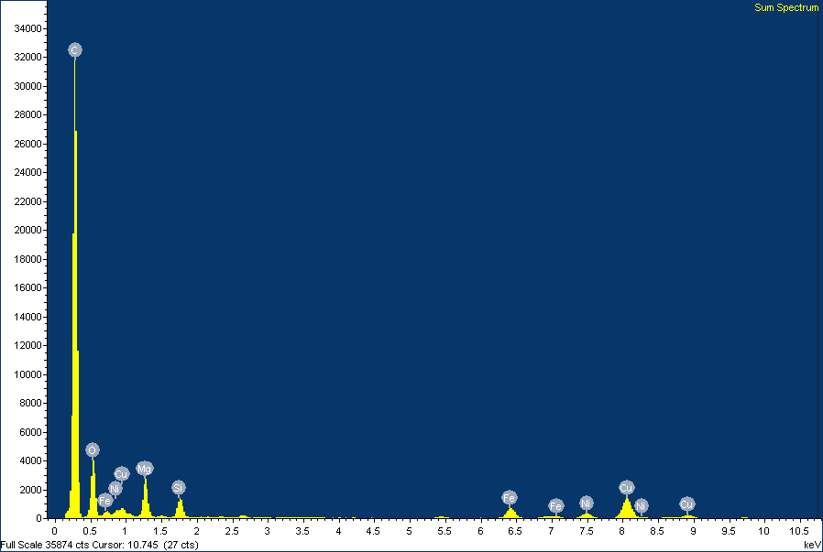
Fig S1 EDX spectrum of IONP/cCNC nanocomposite

