Supporting Information for

Preparation of HOPO-containing lariate ethers based on the diaza-18-crown-6 scaffold
Florian Passler^{a,#}, Linda Belke^{a,#}, Falco Reissig^{a,b}, Klaus Kopka^{a,b}, and Constantin Mamat^{a,b,}*

a Helmholtz-Zentrum Dresden-Rossendorf, Institut für Radiopharmazeutische Krebsforschung, Bautzner Landstraße 400, D-01328 Dresden, Germany
b Technische Universität Dresden, Fakultät Chemie und Lebensmittelchemie, D-01062 Dresden, Germany
# contributed equally
Corresponding author: E-mail address: c.mamat@hzdr.de (C. Mamat)

Table of Contents
Synthesis route to 7,16-di(2-aminoethyl)-1,4,10,13-tetraoxa-7,16-diazacyclooctadecane (1a) and 7,16-di(3-aminopropyl)-1,4,10,13-tetraoxa-7,16-diazacyclooctadecane (1b) …………………………………… 2
Preparation and NMR spectra of compound Phthalimido-1a …………………………………………………………… 3
Preparation and NMR spectra of compound Phthalimido-1b …………………………………………………………… 5
Preparation and NMR spectra of compound 1a ……………………………………………………………………………….. 7
Preparation and NMR spectra of compound 1b ……………………………………………………………………………….. 9
Preparation and ¹H NMR spectrum of compound 2 ……………………………………………………………………….. 11
¹H, ¹³C NMR and ESI MS spectra of compound 3a …………………………………………………………………………… 12
¹H, ¹³C NMR and ESI MS spectra of compound 3b ………………………………………………………………………….. 15
¹H, ¹³C NMR and ESI MS spectra of compound 4a …………………………………………………………………………… 18
¹H, ¹³C NMR and ESI MS spectra of compound 4b ………………………………………………………………………….. 21
Preparation and ¹H NMR spectrum of compound 5 ……………………………………………………………………….. 24
¹H, ¹³C NMR and ESI MS spectra of compound 7a ………………………………………………………………………….. 25
¹H, ¹³C NMR and ESI MS spectra of compound 7b ………………………………………………………………………….. 28
¹H, ¹³C NMR and ESI MS spectra of compound 8a …………………………………………………………………………… 31
¹H, ¹³C NMR and ESI MS spectra of compound 8b ………………………………………………………………………….. 34
Preparation and ¹H NMR spectrum of compound 9 ……………………………………………………………………….. 37
¹H, ¹³C NMR and ESI MS spectra of compound 11 …………………………………………………………………………… 38
¹H, ¹³C NMR and ESI MS spectra of compound 12 …………………………………………………………………………… 41

Synthesis route to 7,16-di(2-aminoethyl)-1,4,10,13-tetraoxa-7,16-diazacyclooctadecane (1a) and 7,16-di(3-aminopropyl)-1,4,10,13-tetraoxa-7,16-diazacyclooctadecane (1b)

Preparation and NMR spectra of N,N'-[(1,4,10,13-tetraoxa-7,16-diazacyclooctadecane-7,16-diyl)bis(ethane-2,1-diyl)]bis[phthalimide] Phthalimido-1a
Diaza-18-crown-6 ether (1.0 g, 3.8 mmol), N-(2-bromoethyl)phthalimide (5.62 g, 22.1 mmol) and Na₂CO₃ (2.35 g, 22.1 mmol) were heated together at 100°C overnight without a solvent. After cooling to rt, chloroform (60 mL) was added and filtered from remaining salts. The organic phase was washed with water (2 x 50 mL) and brine (2 x 50 mL), dried over Na₂SO₄. After removal of the solvent, the crude product was purified using column chromatography (eluent: ethyl acetate) to obtain 7,16-di(2-(N-phthalimido)ethyl)-1,4,10,13-tetraoxa-7,16-diazacyclooctadecane (Phthalimido-1a) as yellow solid (1.82 g, 2.99 mmol, 78%).

Preparation and NMR spectra of N,N'-[(1,4,10,13-tetraoxa-7,16-diazacyclooctadecane-7,16-diyl)bis(propane-3,1-diyl)]bis[phthalimide] Phthalimido-1b
Diaza-18-crown-6 ether (1.5 g, 5.7 mmol), N-(3-bromopropyl)phthalimide (4.6 g, 17.16 mmol) and Na₂CO₃ (1.8 g, 16.98 mmol) were dissolved in acetonitrile (50 mL) and heated at 80°C overnight. After cooling to rt, the solvent was removed, chloroform (60 mL) was added and filtered from remaining salts. The organic phase was washed with water (2 x 50 mL) and brine (2 x 50 mL), dried over Na₂SO₄. After removal of the solvent, the crude product was purified using column chromatography (eluent: ethyl acetate) to obtain 7,16-di(2-(N-phthalimido)propyl)-1,4,10,13-tetraoxa-7,16-diazacyclooctadecane (Phthalimido-1b) as yellow oil (1.53 g, 2.4 mmol, 42%).
Preparation and NMR spectra of 2,2'-(1,4,10,13-tetraoxa-7,16-diazacyclooctadecane-7,16-diyl)bis(ethan-1-amine) (1a)
Compound Phthalimido-1a (1.32 g, 2.18 mmol) and hydrazine (60%, 350 mg, 6.5 mmol) were dissolved in ethanol (20 mL) and the mixture was heated at 80°C overnight. After cooling to rt, the precipitate was removed by filtration and the solution was brought to pH 2 with HCl solution (6 M). The precipitate was removed by filtration and the solvent removed. The crude was dissolved in water (10 mL) and LiOH added until the pH was >12. The aqueous solution was extracted several times with chloroform (>5 x 50 mL). The organic phase was dried over Na₂SO₄ and the solvent was removed to give 7,16-di(2-aminoethyl)-1,4,10,13-tetraoxa-7,16-diazacyclooctadecane (1a) as yellow oil (739 mg, 2.12 mmol, 97%).

Preparation and NMR spectra of 3,3'-(1,4,10,13-tetraoxa-7,16-diazacyclooctadecane-7,16-diyl)bis(propan-1-amine) (1b)
Compound Phthalimido-1b (1.5 g, 2.36 mmol) and hydrazine (60%, 651 mg, 12.1 mmol) were dissolved in ethanol (20 mL) and the mixture was heated at 80°C overnight. After cooling to rt, the precipitate was removed by filtration and the solution was brought to pH 2 with HCl solution (6 M). The precipitate was removed by filtration and the solvent removed. The crude was dissolved in water (10 mL) and LiOH added until the pH was >12. The aqueous solution was extracted with chloroform (>5 x 50 mL). The organic phase was dried over Na₂SO₄ and the solvent was removed to give 7,16-di(3-aminopropyl)-1,4,10,13-tetraoxa-7,16-diazacyclooctadecane (1b) as yellow oil (466 mg, 1.24 mmol, 53%).
Preparation and ¹H NMR spectrum of 1-(benzyloxy)-6-oxo-1,6-dihydropyridine-2-carboxylic acid (2)
1-Hydroxy-6-oxo-1,6-dihydropyridine-2-carboxylic acid (1.78 g, 11.48 mmol) and benzyl chloride (1.75 g, 13.82 mmol) were dissolved in methanol (60 mL) and K₂CO₃ (3.17 g, 22.94 mmol) was added. The mixture was heated under reflux overnight. After cooling to rt, the solvent was removed and the crude product was dissolved in water (10 mL) and brought to pH 2 with HCl (6 M). The solid product was filtered and washed with cold water and dried to obtain compound 2 as colorless solid (2.33 g, 9.5 mmol, 83%).
¹H, ¹³C NMR, and ESI-MS spectra of N,N'-[(1,4,10,13-tetraoxa-7,16-diazacyclooctadecane-7,16-diyl)bis(ethane-2,1-diyl)]bis[1-(benzyloxy)-6-oxo-1,6-dihydropyridine-2-carboxamide] (3a)
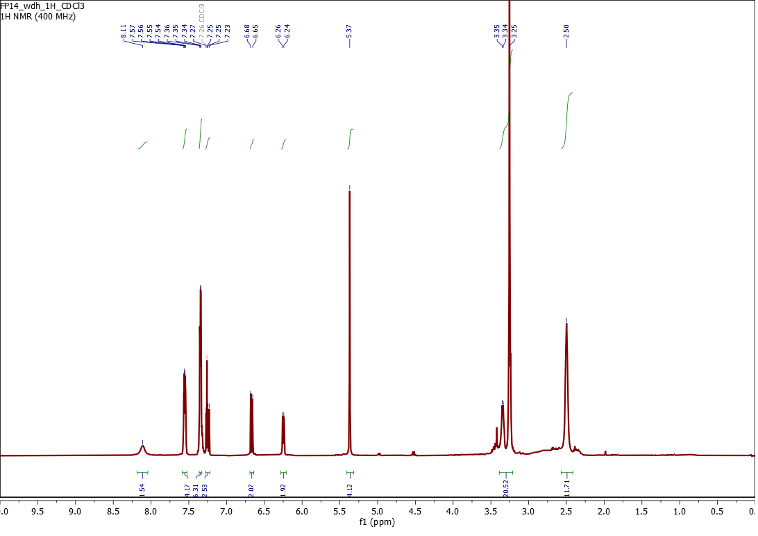
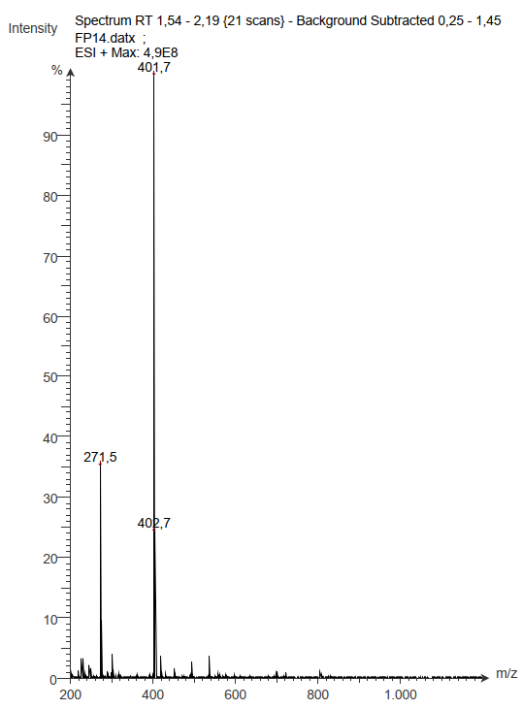

¹H, ¹³C NMR, and ESI-MS spectra of N,N'-[(1,4,10,13-tetraoxa-7,16-diazacyclooctadecane-7,16-diyl)bis(propane-3,1-diyl)]bis[1-(benzyloxy)-6-oxo-1,6-dihydropyridine-2-carboxamide] (3b)
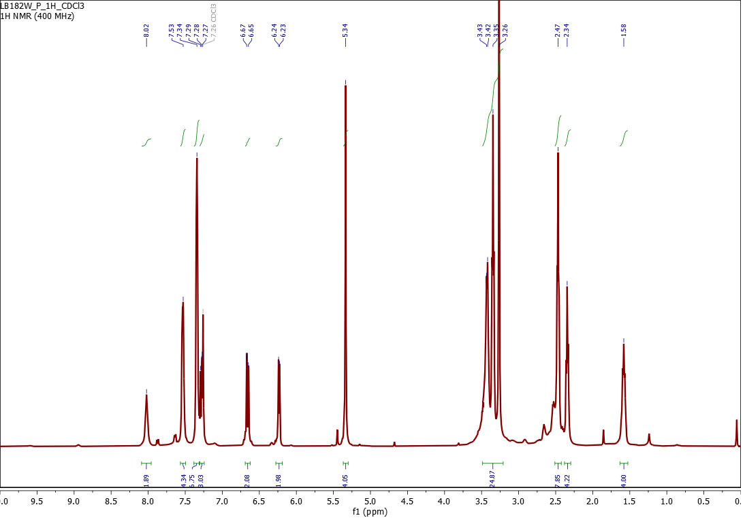

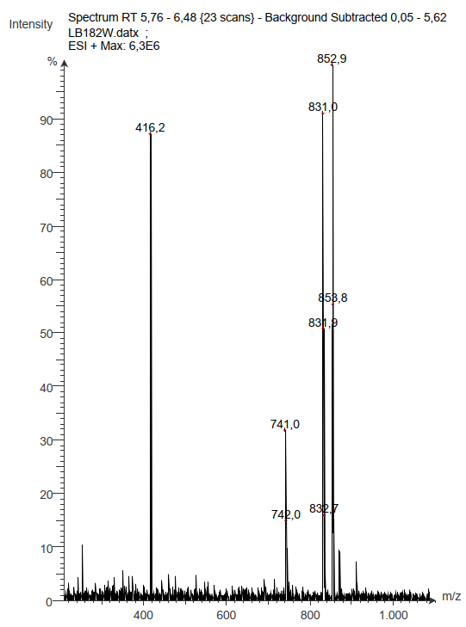
¹H, ¹³C NMR, and ESI-MS spectra of N,N'-[(1,4,10,13-tetraoxa-7,16-diazacyclooctadecane-7,16-diyl)bis(ethane-2,1-diyl)]bis(1-hydroxy-6-oxo-1,6-dihydropyridine-2-carboxamide) (4a)

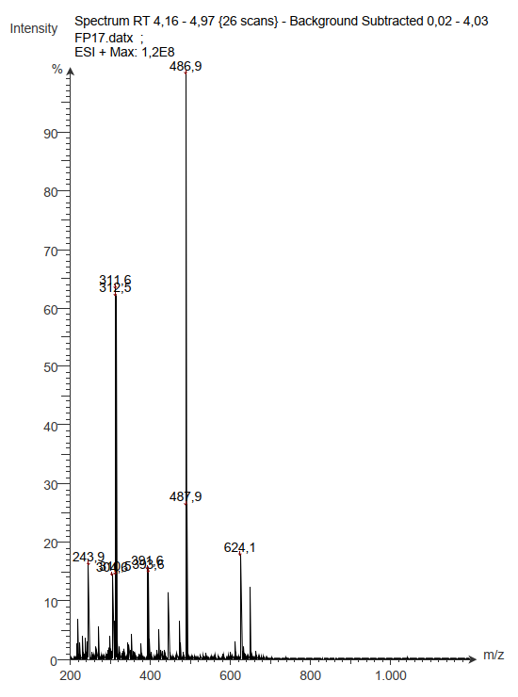

¹H, ¹³C NMR, and ESI-MS spectra of N,N'-[(1,4,10,13-tetraoxa-7,16-diazacyclooctadecane-7,16-diyl)bis(propane-3,1-diyl)]bis(1-hydroxy-6-oxo-1,6-dihydropyridine-2-carboxamide) (4b)

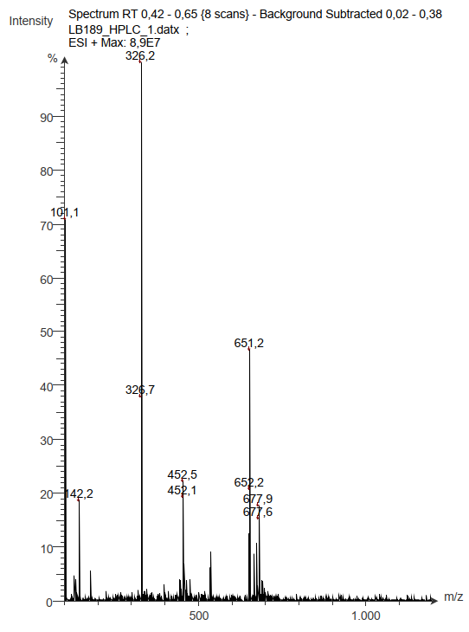
Preparation and ¹H NMR spectrum of 2-oxo-1-phenethoxy-1,2-dihydropyridine-3-carboxylic acid (5)
1-Hydroxy-2-oxo-1,2-dihydropyridine-3-carboxylic acid (1.0 g, 6.45 mmol) and benzyl chloride (852 mg, 6.73 mmol) were dissolved in methanol (45 mL) and K₂CO₃ (1.57 g, 11.36 mmol) was added. The mixture was heated under reflux overnight. After cooling to rt, the solvent was removed and the crude product was dissolved in water (10 mL) and brought to pH 2 with HCl (6 M). The solid product was filtered and washed with cold water and dried to obtain compound 5 as colorless solid (1.05 g, 4.05 mmol, 63%).
¹H, ¹³C NMR, and ESI-MS spectra of N,N'-((1,4,10,13-tetraoxa-7,16-diazacyclooctadecane-7,16-diyl)bis(ethane-2,1-diyl))bis(1-(benzyloxy)-2-oxo-1,2-dihydropyridine-3-carboxamide) (7a)

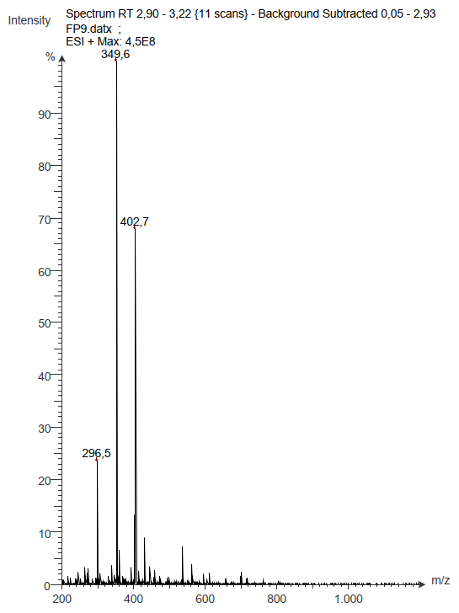
¹H, ¹³C NMR, and ESI-MS spectra of N,N'-((1,4,10,13-tetraoxa-7,16-diazacyclooctadecane-7,16-diyl)bis(propane-3,1-diyl))bis(1-(benzyloxy)-2-oxo-1,2-dihydropyridine-3-carboxamide) (7b)
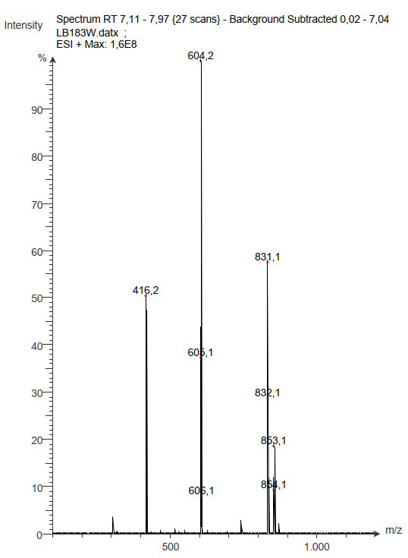
¹H, ¹³C NMR, and ESI-MS spectra of N,N'-[(1,4,10,13-tetraoxa-7,16-diazacyclooctadecane-7,16-diyl)bis(ethane-2,1-diyl)]bis(1-hydroxy-2-oxo-1,2-dihydropyridine-3-carboxamide) (8a)
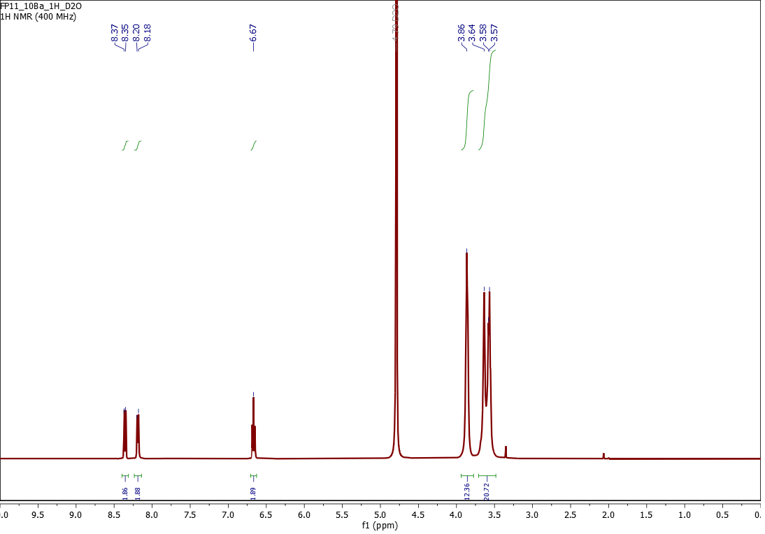

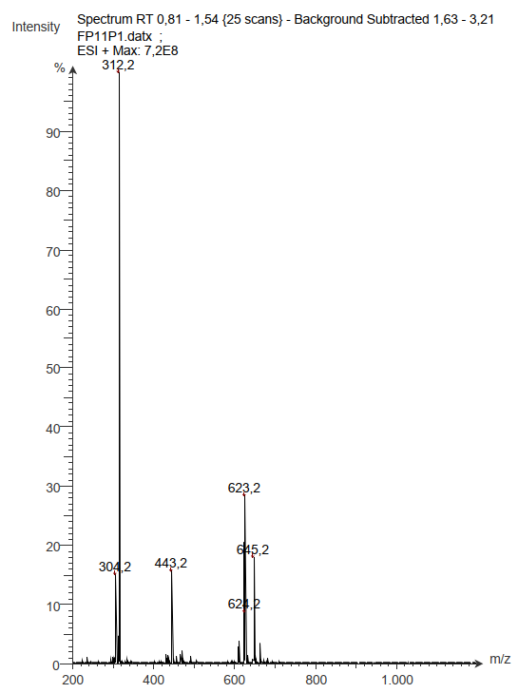

¹H, ¹³C NMR, and ESI-MS spectra of N,N'-[(1,4,10,13-tetraoxa-7,16-diazacyclooctadecane-7,16-diyl)bis(propane-3,1-diyl)]bis(1-hydroxy-2-oxo-1,2-dihydropyridine-3-carboxamide) (8b)

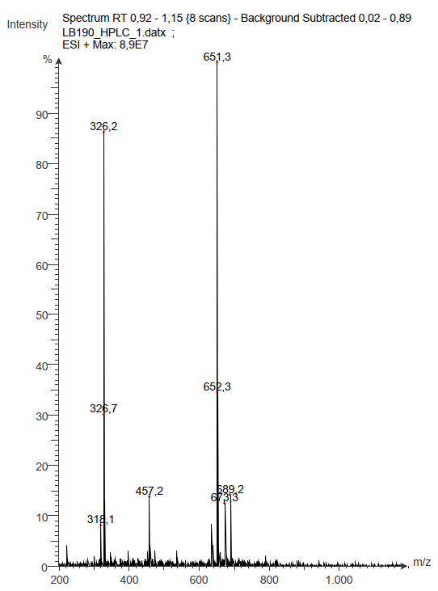
Preparation and ¹H NMR spectrum of 3-Methoxy-1-methyl-2-oxo-1,2-dihydropyridine-4-carboxylic acid (9)
Ethyl 3-methoxy-1-methyl-2-oxo-1,2-dihydropyridine-4-carboxylate (573 mg, 2.71 mmol) and LiOH (79 mg, 3.4 mmol) were dissolved in water (10 mL) and the mixture was stirred at rt overnight. Afterwards, the pH of the solution was brought to 1 with HCl (10% solution). The aqueous phase was extracted with ethyl acetate (3 x 20 mL), the organic phase was dried over Na₂SO₄ and the solvent was removed to obtain compound 9 as colorless solid (269 mg, 1.47 mmol, 54%).
¹H, ¹³C NMR, and ESI-MS spectra of N,N'-[(1,4,10,13-tetraoxa-7,16-diazacyclooctadecane-7,16-diyl)bis(ethane-2,1-diyl)]bis(3-methoxy-1-methyl-2-oxo-1,2-dihydropyridine-4-carboxamide) (11)

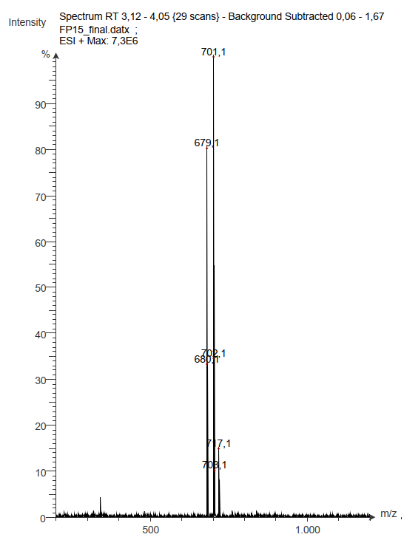

¹H, ¹³C NMR, and ESI-MS spectra of N,N'-((1,4,10,13-tetraoxa-7,16-diazacyclooctadecane-7,16-diyl)bis(ethane-2,1-diyl))bis(3-hydroxy-1-methyl-2-oxo-1,2-dihydropyridine-4-carboxamide) (12)


