Supplementary Information to:
10-[(4-Cyanobenzylidene)]-Anthracen-9(10H)-One: Syntheses, Characterization and Application in UV Light Detection
Gonzalo Valdivieso,ª Neudo Urdaneta,*ª Bruno Pribanic,^{b} Ronald Vargas,^{c,d} and Rafael E. Rodríguez-Lugo^{e}
ªDepartamento de Química, Universidad Simón Bolivar, Caracas 1080-A, AP 89000, Venezuela
^{b}Department of Chemistry and Applied Biosciences, ETH Zurich, Vladimir-Prelog-Weg 1-5/10, 8093 Zurich, Switzerland
^{c}Instituto Tecnológico de Chascomús - Consejo Nacional de Investigaciones Científicas y Técnicas, B7130IWA, Chascomús, Argentina
^{d}Escuela de Bio y Nanotecnologías, Universidad Nacional de San Martín, B7130IWA, Chascomús, Argentina
^{e}Istituto di Chimica dei Composti Organometallici, Consiglio Nazionale delle Ricerche, Via Madonna del Piano 10, 50019 Sesto Fiorentino, Italy.
Abstract
In this work, the compound 10-[(4-cyanobenzylidene)]-anthracen-9(10H)-one (1) has been synthesized from the corresponding anthrone and 4-cyanobenzaldehyde. It has been characterized by nuclear magnetic resonance (NMR), infrared spectroscopy (IR), high resolution mass spectroscopy (HRMS) and single crystal X-ray diffraction (XRD) analysis. Moreover, square wave voltammetry (SWV) was performed to determine the HOMO and LUMO potential levels of the anthrone derivative 1, which indicates that sensitization of TiO₂-based electrodes is thermodynamically feasible. Therefore, this characteristic of compound 1 allowed its incorporation in a Grätzel-type solar cell. Photocurrent density measurements under UV irradiation are proportional to the light source intensity and the operational parameters of the photoelectrochemical cell are relatively stable over time. In fact, the sensitivity of the generated photocurrent normalized by the supplied irradiance for TiO₂-1 (7.73 µA/mW) as a photoanode is higher than that of TiO₂ alone (5.14 µA/mW), indicating the improvement that 1 provides to TiO₂ with respect to UV light detection. The higher photocurrent due to a modification that maintains stability is very promising for possible applications of 1 as a sensitizer to improve the performance of UV light intensity sensors in dye-sensitized solar cells (DSSC).
Keywords Anthrone ・ X-ray diffraction analysis ・ Dye-sensitized solar cell ・ UV Light quantification

General information. All organic solvents were appropriately dried or purified prior to use. Pyridine, methanol, ethyl acetate, hexane and toluene were distilled and stored over 4 Å molecular sieves. Piperidine and dichloromethane were dried over CaH₂ and freshly distilled prior to use. The reagents for synthesis were obtained from Aldrich and used as received. Analytical TLC was done on Merck silica 60 F₂₅₄ aluminum coated plates, using hexane/ethyl acetate 3:1 as eluent. Column chromatography was performed using 230-400 mesh silica gel from Merck. Melting point was determined with a Fischer-Johns Scientific melting point apparatus. NMR spectra were recorded with a Bruker Avance 300 Spectrometer. The chemical shifts (δ) are measured according to IUPAC (Harris et al. 2002, 2008) and expressed in parts per million (ppm) relative to TMS for ¹H, and ¹³C. Coupling constants J are given in Hertz (Hz) as absolute values. The multiplicity of the signals is indicated as d, t, or m for doublets, triplets, or multiplets, respectively. Fourier-transform IR spectra were recorded on a Thermo model Nicolet iS5, with iD3 ATR adapter. Elemental analyses were performed by the microanalytical laboratory of ETH Zürich. High resolution MALDI-MS was recorded using a Varian HiResMALDI by ETH Zürich DCHAB/LOC MS-Service. Values are given as m/z. UV-Vis measurements were performed on an Agilent 8453 UV-Vis spectrophotometer with a diode array system as detector. Single X-ray diffraction analysis was conducted on a Bruker SMART Apex II diffractometer with CCD area detector; MoKα radiation (0.71073 Å) at T = 100 K. The refinement against full matrix (versus F2) was done with SHELXTL (ver. 6.12) and SHELXL-97. Empirical absorption correction was done with SADABS (ver. 2.03). All non-hydrogen atoms were refined anisotropically where not noted otherwise. The contribution of the hydrogen atoms, in their calculated positions, was included in the refinement using a riding model. Electrochemical measurements were performed using a PAR 273 potentiostat-galvanostat. For the construction of the Grätzel-type solar cell, a methodology widely reported in the literature was followed (Madriz et al. 2014; Yum et al. 2011).
Synthesis, purification, and crystallization of 10-[(4-cyanobenzylidene)]-anthracen-9(10H)-one (1). The entitled compound was synthesized according to the literature method by Hu and Zhou (2004). The preparation of such substance was also recently described by He et al. (2023). Pyridine (8.0 mL) and piperidine (0.3 mL) were added to a mixture of anthrone (202.1 mg, 1.04mmol, 1.0 equiv.), 4-cyanobenzaldehyde (172.0 mg, 1.31 mmol, 1.3 equiv.) and p -methoxyphenol (106.0 mg, 0.85 mmol, 0.8 equiv.). Here, p-methoxyphenol was included to avoid the oxidation of the anthrone to anthraquinone. The mixture pyridine/piperidine provided both a basic and dehydrating reaction media. When piperidine was added, the yellow solution became dark red. The reaction mixture was refluxed for 6.0 h under inert argon atmosphere until the anthrone was completely consumed, as indicated by TLC analysis. The mixture was cooled down to room temperature and 5.0 mL of methanol were added. All solvents were evaporated to dryness, yielding a dark solid that was dissolved in dichloromethane and washed with water (liquid-liquid extraction). The organic phase was dried with anhydrous sodium sulfate and the solid was purified by column chromatography using a mixture of hexane/ethyl acetate 4:1. The product was recrystallized using toluene, affording yellow crystals (249.0 mg, 78%), mp: 198-200°C.
One-step synthesis of the 10-[(4-cyanobenzylidene)]-anthracen-9(10H)-one, 1
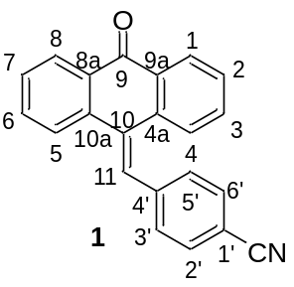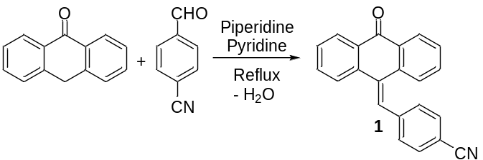
Spectroscopic data. ¹H NMR (300.2 MHz, CDCl₃): δ [ppm] = 8.27-8.22 (H-1,8, 2H, m), 7.96 (H-4, 1H, d, J = 7.9 Hz), 7.64 (H-2, 1H, td, J = 7.6, 1.5 Hz), 7.57 (H-2’,6’, 2H, d, J = 8.2 Hz), 7.53-7.48 (H-3, 1H, m), 7.46-7.41 (H-7, H-11, 2H, m), 7.38 (H-3’, 5’, 2H, d, J = 8.2 Hz), 7.34-7.31 (H-5, 1H, m), 7.26-7.21 (H-6, 1H, m). ¹³C NMR (75.5 MHz, CDCl₃): δ [ppm] = 184.5 (C-9), 142.5 (C-4’), 140.0*, 135.5 *, 134.3*, 133.1 (C-2), 132.7*, 132.5 (C-2’,6’), 131.3 (C-6), 130.9 (C-9), 130.3 (C-11), 130.1 (C-3’, 5’), 129.2 (C-7), 129.1 (C-5), 128.6 (C-3), 127.5 (C-1)#, 127.4 (C-8)#, 123.2 (C-4), 118.7 (-CN), 111.5*. *Not possible to assign with the available data. #Signals are interchangeable. FT-IR (KBr disk, ν_{max}/cm⁻¹): 2225, 1651, 1598. UV-Vis (CH₂Cl₂, λ_{max}/nm, ε/L.mol⁻¹.cm⁻¹): 365, 9862. HRMS (MALDI-TOF, m/z): calculated for C₂₂H₁₄NO 308.1075 (M+H)⁺; found 308.1070. Elemental analysis (C₂₂H₁₃NO), C, H, N calculated (%): 85.97, 4.26, 4.56; found (%): 85.73, 4.27, 4.57.
Figure S1. ¹H NMR (300.2 MHz, CDCl₃) spectrum of compound 1. Residual solvents, dichloromethane and methanol, come from the purification steps.
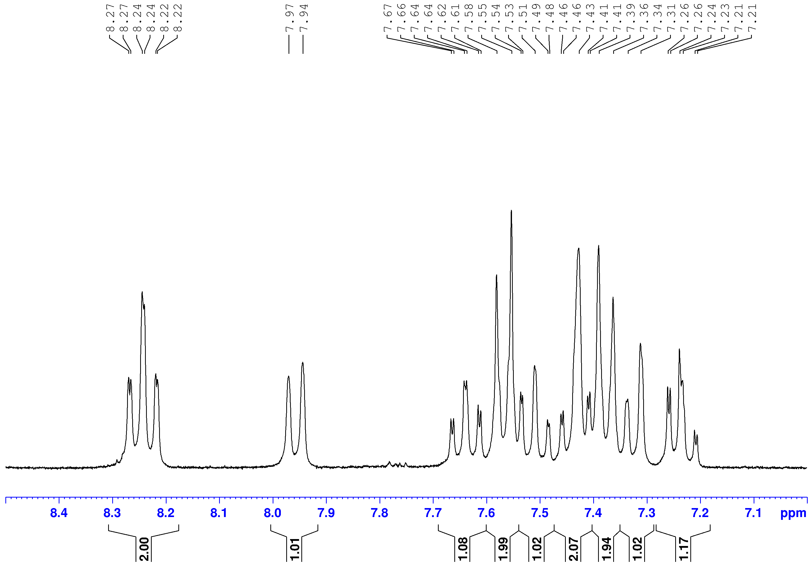
Figure S2. Partial enlarged view (8.5 to 7.0 ppm) of the ¹H NMR (300.2 MHz, CDCl₃) spectrum of compound 1.
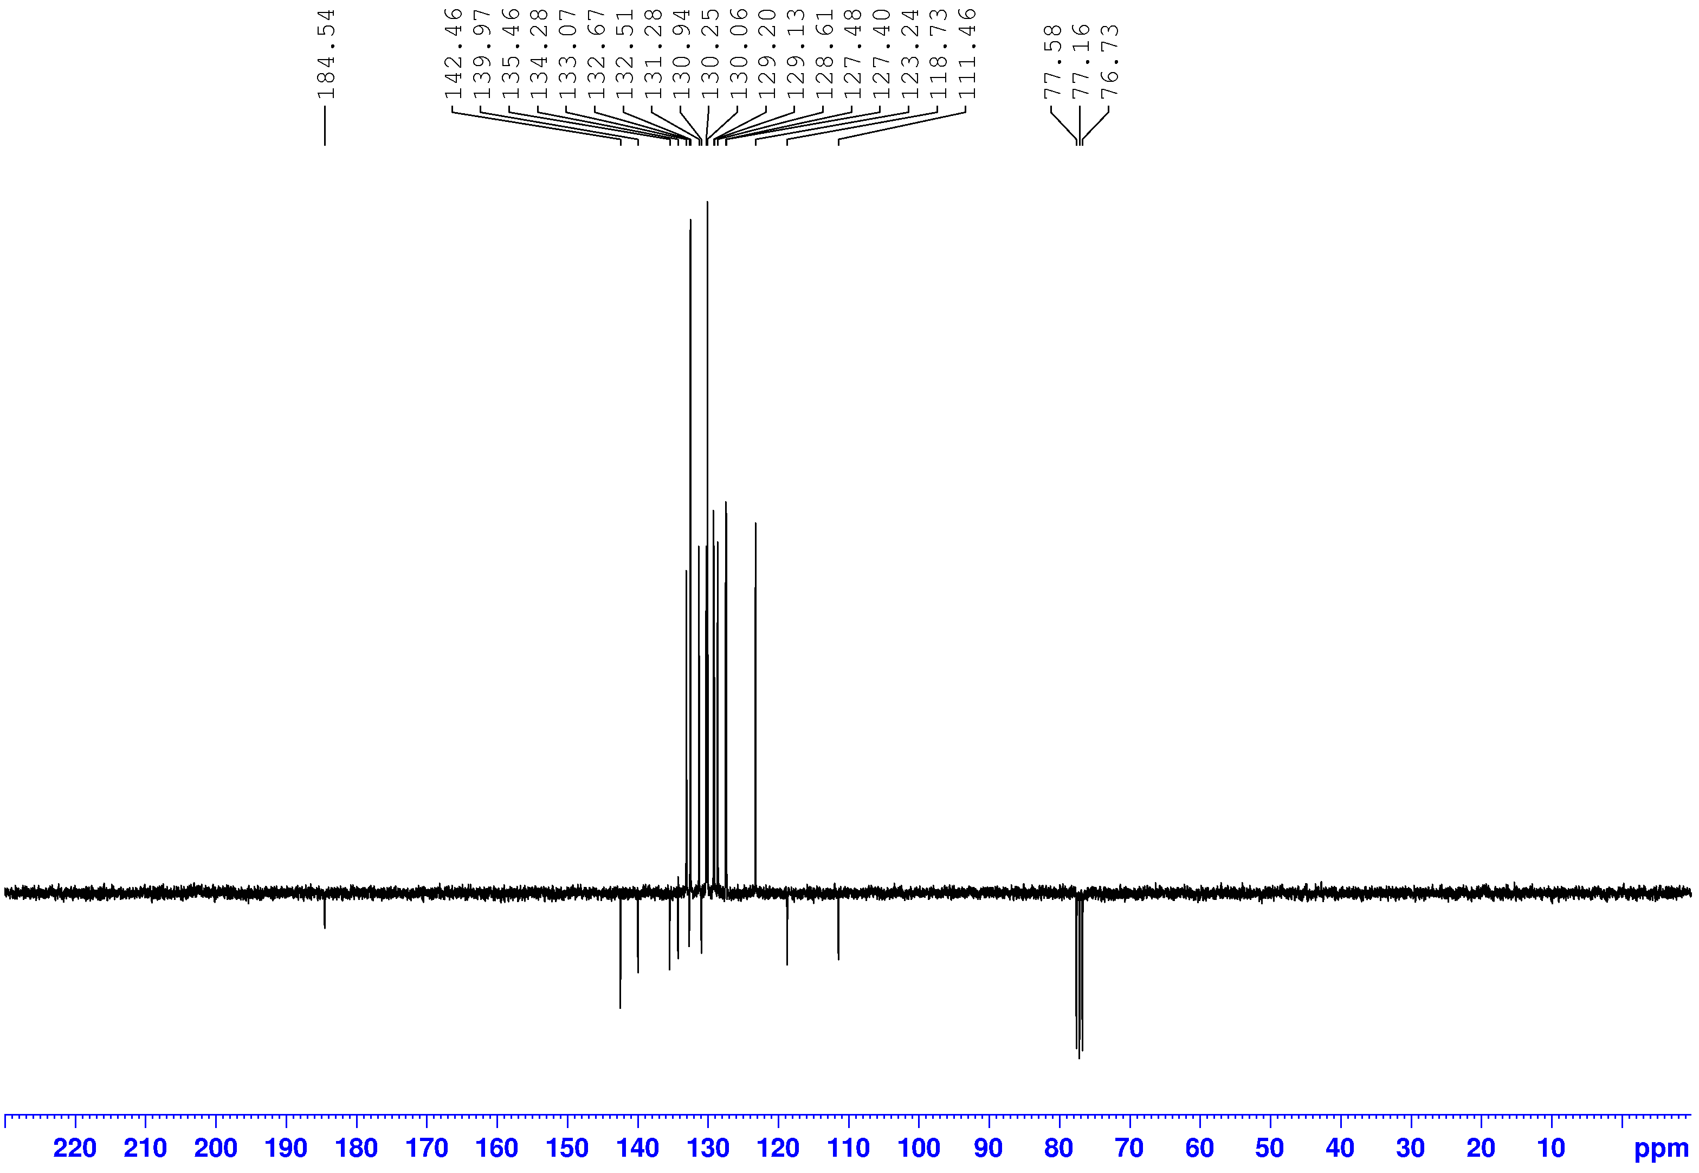
Figure S3. ¹³C{APT} NMR (75.5 MHz, CDCl₃) spectrum of compound 1.
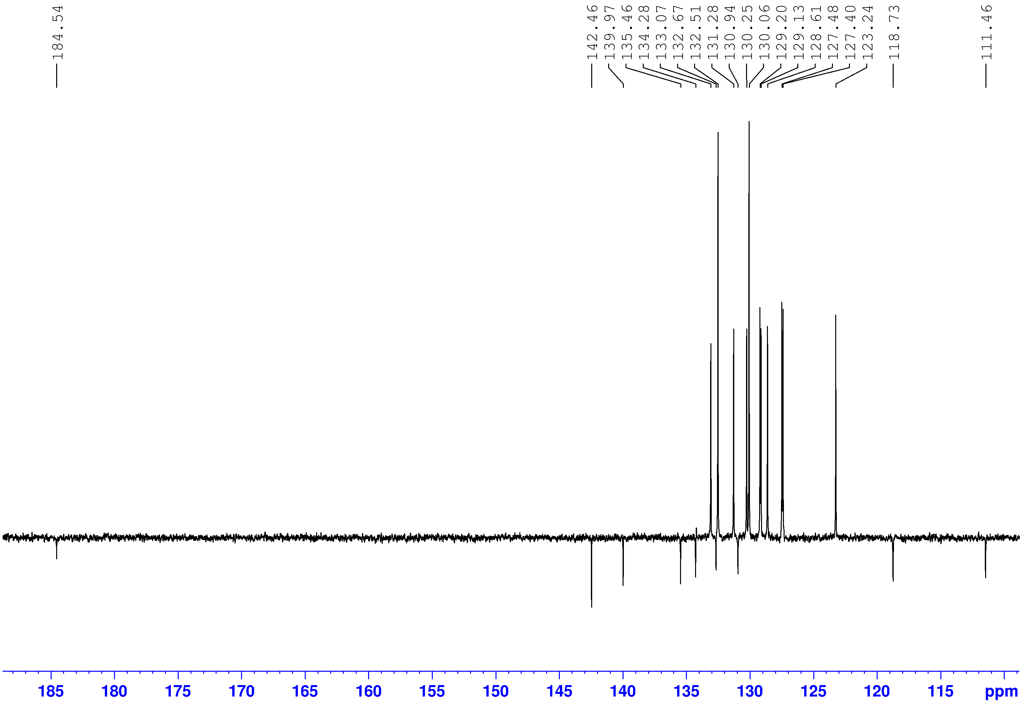
Figure S4. Partial enlarged view (189 to 109 ppm) of the ¹³C{APT} NMR (75.5 MHz, CDCl₃) spectrum of compound 1.
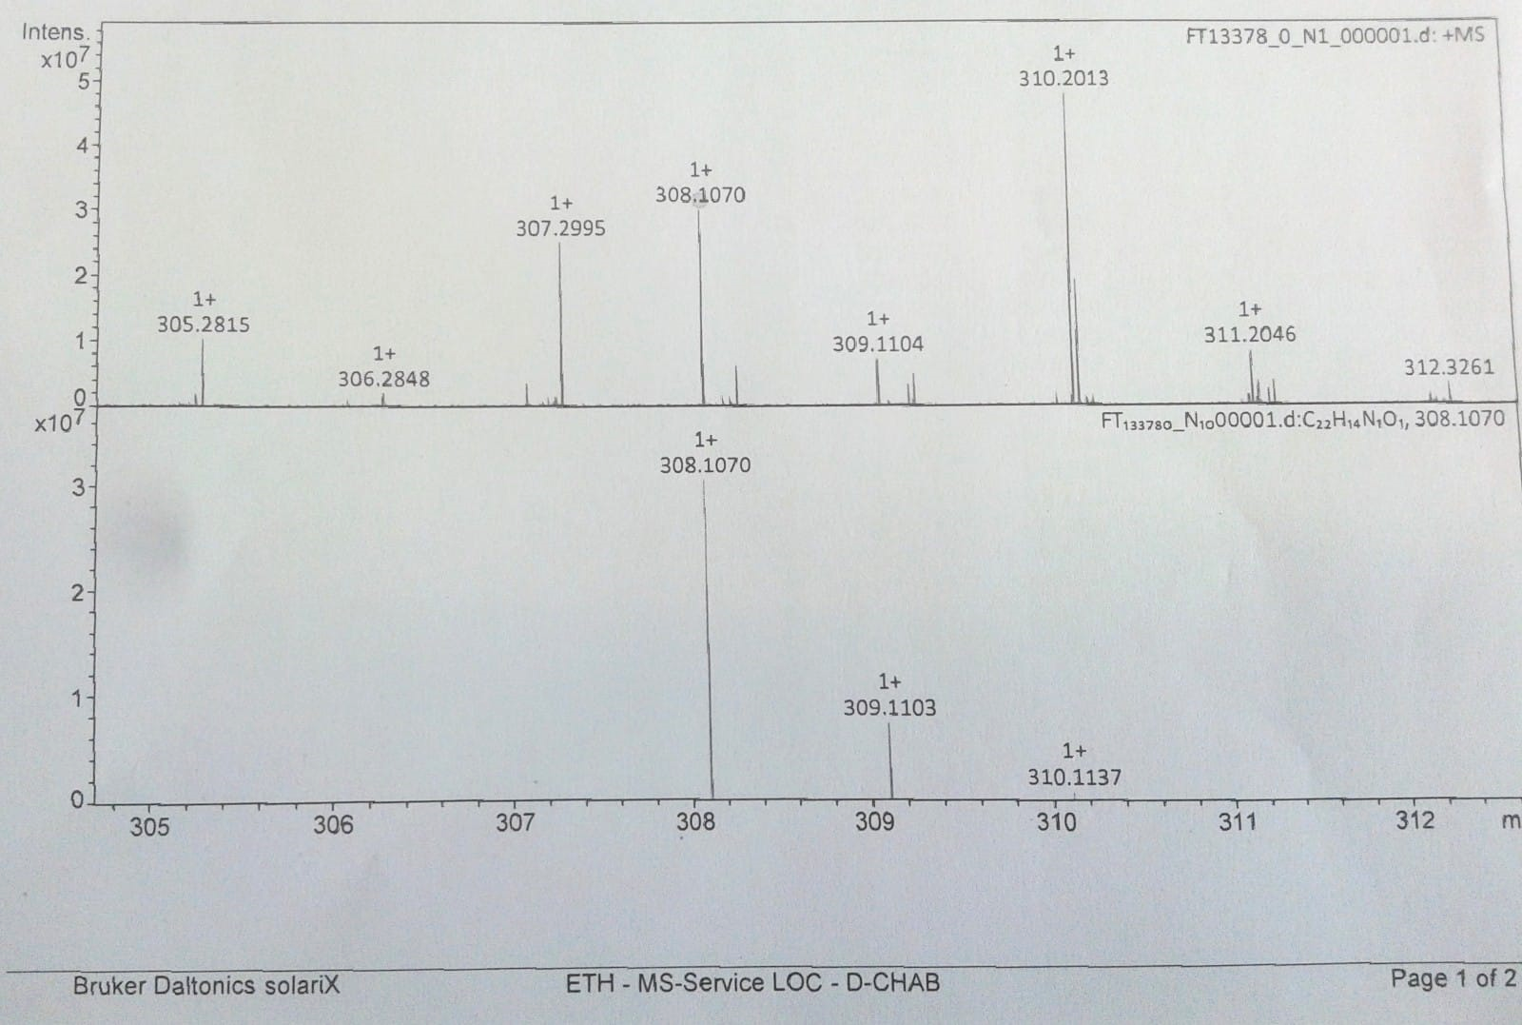
Figure S5. HRMS (MALDI-TOF, m/z) of compound 1.
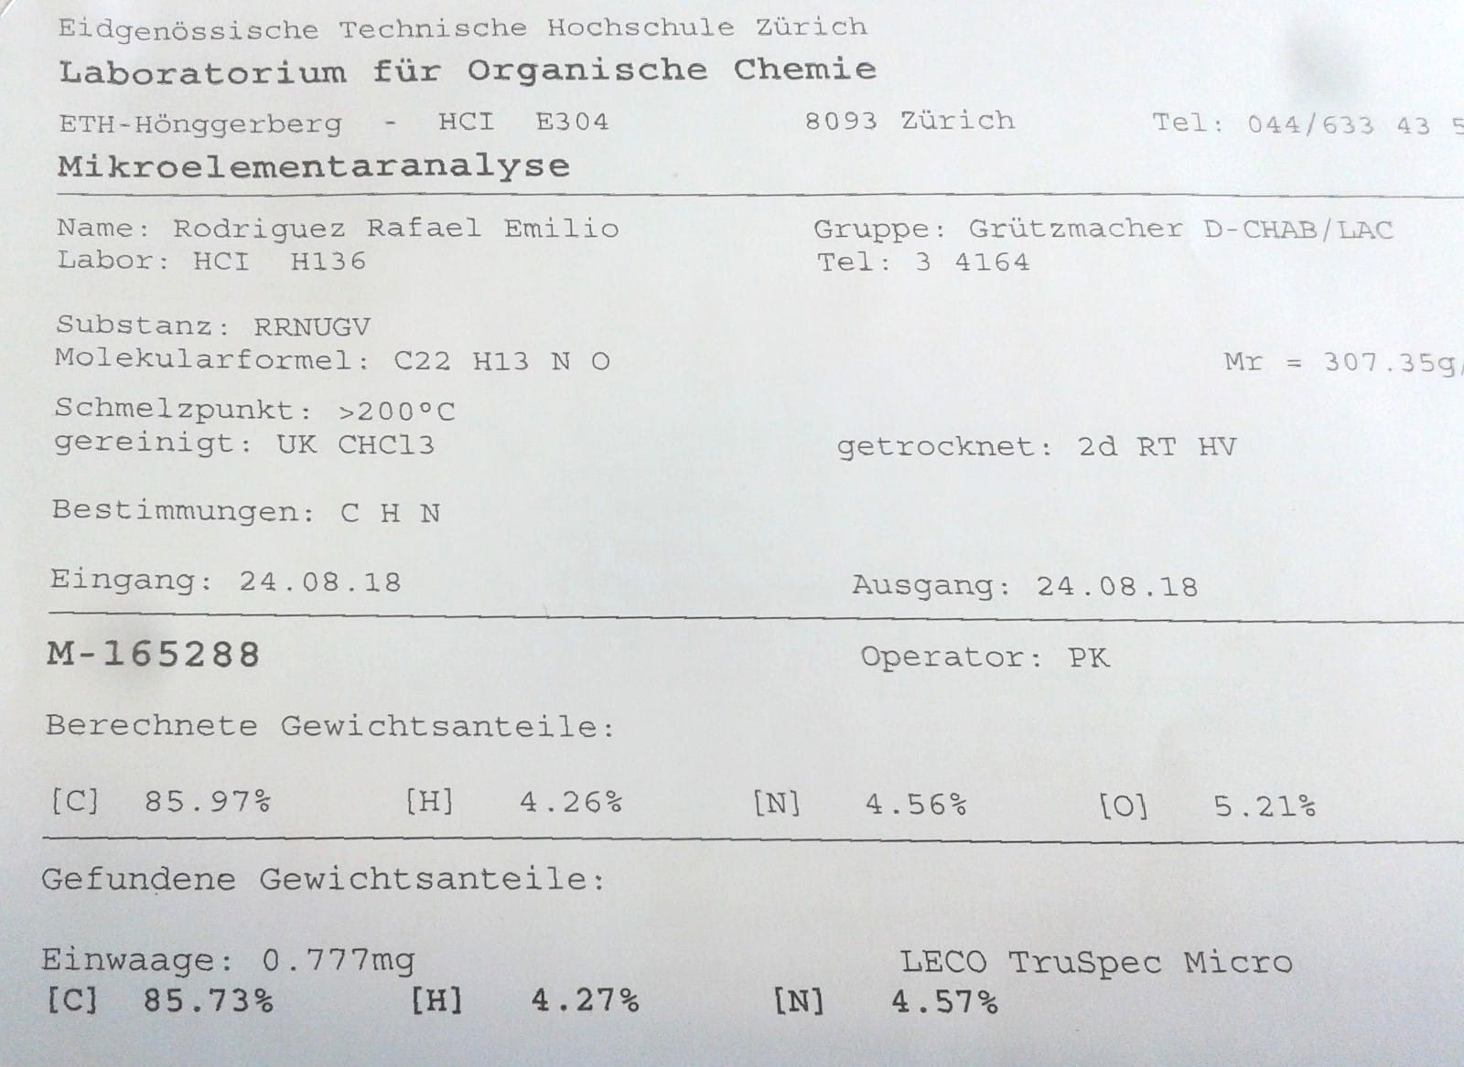
Figure S6. Elemental analysis of compound 1.
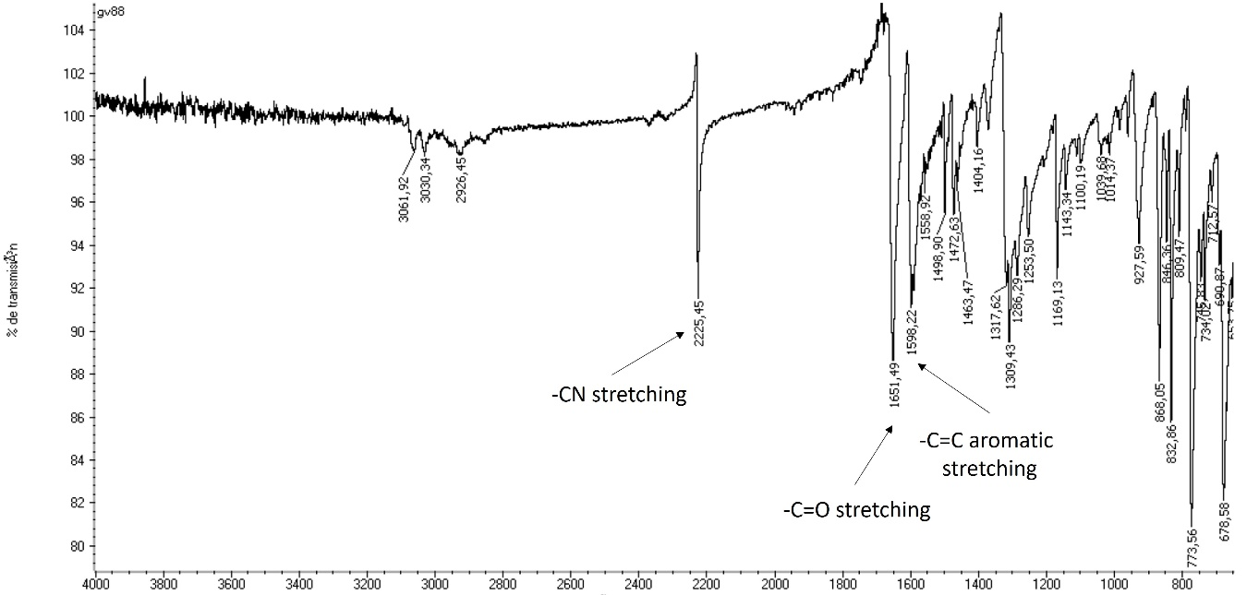
Figure S7. FT-IR (KBr disk) spectrum of compound 1.
Figure S8. The molecular structure of compound 1, showing the boat conformation adopted by the central six-membered ring within the anthracenone ring. Hydrogen atoms and the carbon atoms adjacent to the central anthracenone moiety have been removed for clarity. Ellipsoids are depicted at 30% probability displacement.
Figure S9. The molecular structure of compound 1, showing the dihedral angle between the central anthracenone scaffold (C1–C6) and the pendant 4-benzonitrile ring (C16–C21). Hydrogen atoms have been removed for clarity. Ellipsoids are depicted at 30% probability displacement.

References
Harris RK, Becker ED, de Menezes SMC, Goodfellow R, Granger P (2002) NMR nomenclature: nuclear spin properties and conventions for chemical shifts. IUPAC recommendations 2001. Solid State Nucl Magn Reson 22:458−483. https://doi.org/10.1006/snmr.2002.0063
Harris RK, Becker ED, de Menezes SMC, Granger P, Hoffman RE, Zilm KW (2008) Further conventions for NMR shielding and chemical shifts. Pure Appl Chem 80:59−84. https://doi.org/10.1351/pac200880010059
He S-J, Zhu S, Qiu S-Q, Ding W-Y, Cheng JK, Xiang S-H, Tan B (2023) Phosphoric acid-catalyzed enantioselective synthesis of axially chiral anthrone-based compounds. Angew Chem Int Ed 62:e202213914. https://doi.org/10.1002/anie.202213914
Hu W, Zhou W (2004) Synthesis and antitumor activity of 10-substituted benzylidene anthrone. Bioorg Med Chem Lett 14:621−622. https://doi.org/10.1016/j.bmcl.2003.11.053

