Supplementary:

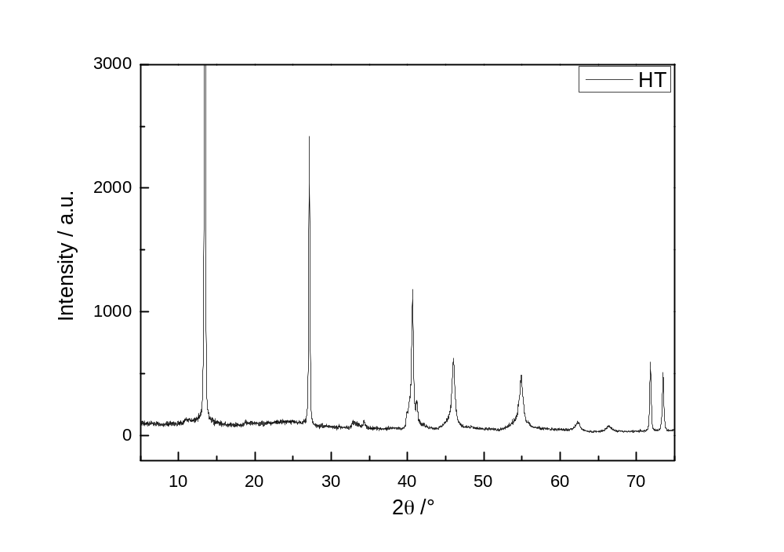
Fig. S1. XRD pattern of Mg₆Al₂(CO₃)(OH)₁₆·4H₂O (HT) powder.

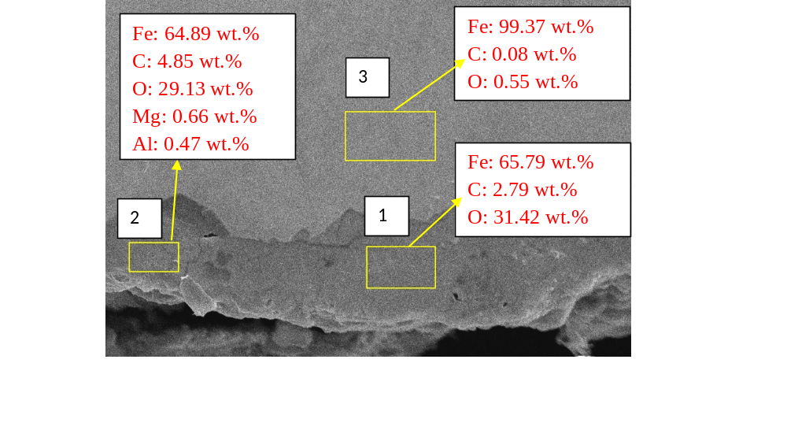
Fig. S2. Cross section morphology of sample T+1 g HT (magnification 5000x).

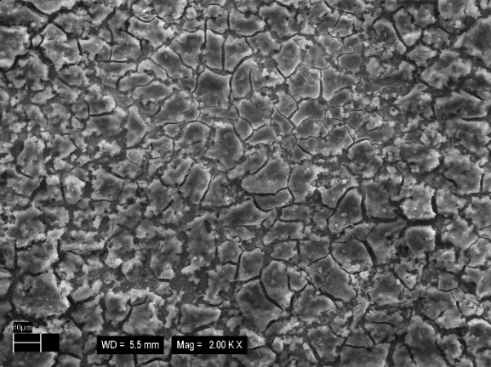  T + 0 g HT – 2 layers | 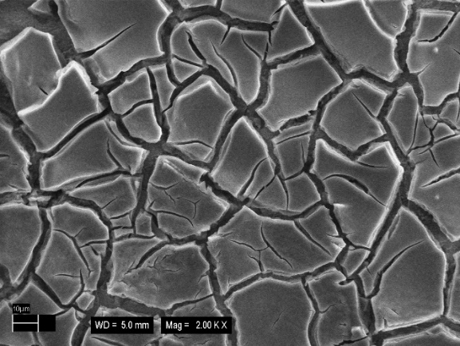  T + 0 g HT – 3 layers
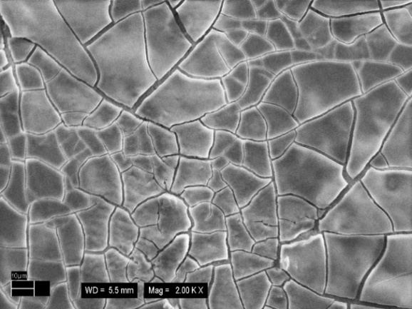  T + 1 g HT – 2 layers | 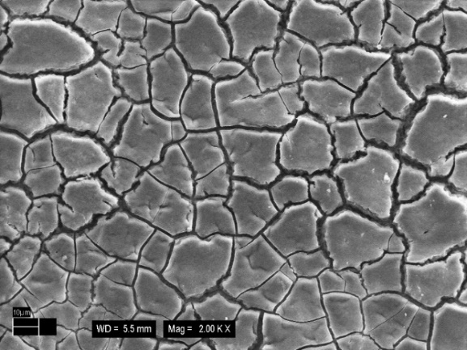  T + 1 g HT – 3 layers
Fig. S3. SEM images of 2-3 layers of conversion coating for T + 0 g HT and T + 1 g HT (magnification 2000X).

T + 0 g HT, 0 min | 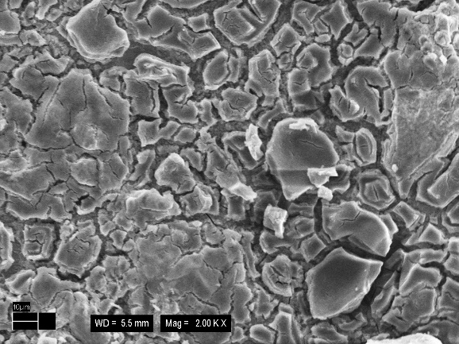  T + 0 g HT, 10 min
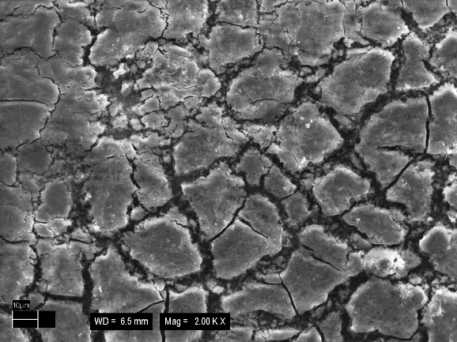  T + 1 g HT, 0 min | 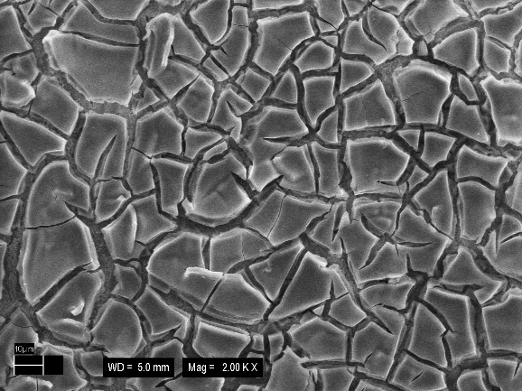  T + 1 g HT, 10 min
Fig. S4. SEM images of conversion coating for T + 0 g HT and T + 1 g HT with different immersion time (magnification 5000X).

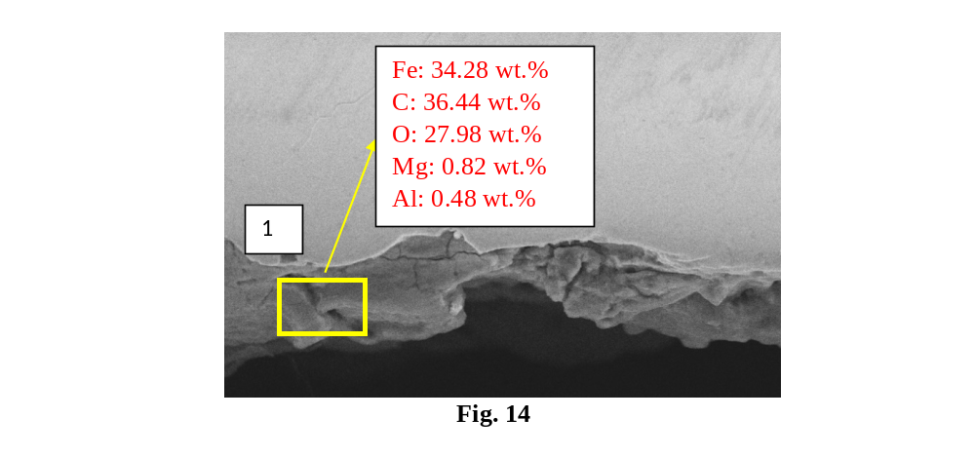
Fig. S5. Cross section morphology of sample T+1 g HT, 10 min (magnification 5000x).

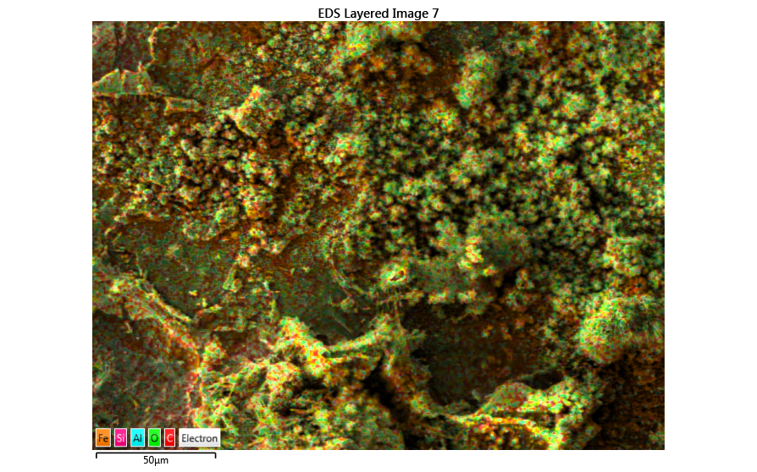 | 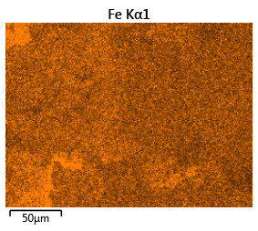
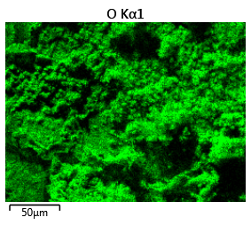 | 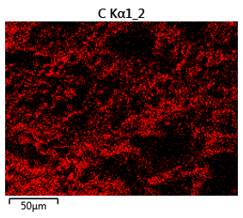
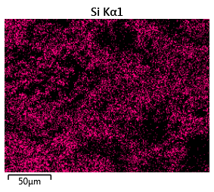 | 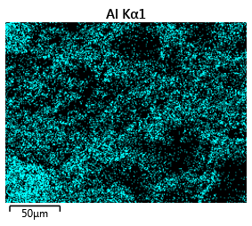
Fig. S6. Elemental distribution mapping of coating T+ 1g HT, after exposure in QUV chamber for 3 weeks.

