Structure-based virtual screening for assessing the efficacy of NLRP3 small molecule compounds on sepsis
Yuexiang Ma^{1#}, Qi Zhang^{1#}, Zheng Dai¹, Jiawei Xu², Meng Zhang¹, Peiyu Zhang¹, Qianmei Wang¹, Junjie Li^{1*}, Wen Yin^{1*}
¹Department of Emergency, Xijing Hospital, Fourth Military Medical University, Xi’an, Shaanxi Province, China 710000
²Physical and Theoretical Chemistry Laboratory, Department of Chemistry, University of Oxford, Oxford OX1 3QZ, United Kingdom
^{1#} These authors contributed equally to this work.
*Corresponding authors: Junjie Li, Department of Emergency, Xijing Hospital, Fourth Military Medical University, Xi’an, 710032, People’s Republic of China, Email: lijunjie@fmmu.edu.cn; Wen Yin, Department of Emergency, Xijing Hospital, Fourth Military Medical University, Xi’an, 710032, People’s Republic of China. Email: xjyyyw@fmmu.edu.cn.

Table S1. Molecular docking interaction of NLRP3 small molecule compounds.
Rank | Ligands | Structure | Docking scores (kcal/mol) | H-bonds |  | Amino Acid Residual interactions |  |  |  | Ref
 |  |  |  |  | π-Stacking |  | Hydrophobic Interactions | Metal Complexes | Halogen bonds | Ref
1 | ZYIL1 |  | -7.23 | TYR_202B  GLU_228B  SER_234B | / |  | ILE_123B  LYS_124B  LYS_163B  TYR_201B  TYR_202B  GLN_233B  TYR_237B | / | / | [34]
2 | MCC950 |  | -6.76 | GLU_228B  ARG_578A  GLU_629A | / |  | ALA_227A  PRO_352  THR_659 | / | / | [35]
3 | Selnoflast |  | -6.67 | PRO_283A  HIS_393A | TYR_252A |  | TYR_39A  ILE_105A  PHE_244A  PRO_283A  TRP_289A  ILE_392A | / | / | [11]
4 | RRx-001 |  | -6.67 | LYS_164A | / |  | LYS_160A  LYS_164A | / | / | [36]
5 | 4b |  | -6.38 | ARG_38A  THR_40A  TYR_252A | / |  | TYR_39A  PHE_244A  TYR_252A  LEU_284A | / | / | [37]
6 | NT-0249 |  | -6.25 | GLU_638A  GLY_696A  ARG_697A | / |  | GLU_135B | / | / | [12]
7 | Parthenolide |  | -6.16 | THR_167A  GLY_227A  GLY_229A  LYS_230A  THR_231A  ILE_232A | LYS_230A  HIS_520A |  | / | / | / | [38]
8 | EmlenoflastIZD-174 |  | -6.14 | SER_120B  ALA_165B  GLU_228B | / |  | ILE_123B  LYS_124B  LYS_163B  PRO_200B  TYR_201B  TYR_201B  TYR_237B | / | / | [11]
9 | GDC-2394 |  | -6.05 | GLN_636A  GLU_638A  ARG_697A | / |  | / | / | / | [39]
10 | Glyburide |  | -6.04 | TYR_201B  TYR_202B  GLU_228B | / |  | ILE_123B  LYS_124B  LYS_127B  TYR_201B  PHE_1030A | / | / | [40]
11 | C77 |  | -5.85 | YHR_167A  GLY_227A  GLY_229A  LYS_230A  THR_231A  ILE_232A | LYS_230A  HIS_520A |  | / | / | / | [41]
12 | Oridonin |  | -5.83 | THR_167A  GLY_227A  GLY_229A  LYS_230A  THR_231A  ILE_232A | LYS_230A  HIS_520A |  | / | / | / | [42]
13 | MNS |  | -5.81 | THR_167A  GLY_227A  GLY_229A  LYS_230A  THR_231A  ILE_232A | LYS_230A  HIS_520A |  | / | / | / | [43]
14 | Iguratimod |  | -5.76 | THR_167A  GLY_227A  GLY_229A  LYS_230A  THR_231A  ILE_232A | LYS_230A  HIS_520A |  | / | / | / | [44]
15 | DFV-890 |  | -5.7 | SER_120B  ALA_165B  GLU_228B | / |  | ILE_123B  LYS_163B  TYR_201B  TYR_202B  TYR_237B | / | / | [11]
16 | Ibuprofen |  | -5.62 | TYR_58A  ILE_59A  ILE_61A  GLU_86A  LYS_87A  VAL_88A  ASN_92A  ARG_111A | LYS_87A  ARG_111A  LYS_307A  ARG_309A |  | / | ATP_501A  HOH_514A  HOH_520A  HOH_528A  HOH_530A | / | [45]
17 | VX-740 |  | -5.60 | THR_167A  GLY_227A  GLY_229A  LYS_230A  THR_231A  ILE_232A | LYS_230A  HIS_520A |  | / | / | / | [46]
18 | NP3-146 |  | -5.50 | THR_167A  GLY_227A  GLU_228B  GLY_229A  LYS_230A  ARG_578A | LYS_230A  HIS_520A |  | / | / | / | [47]
19 | Isoliquiritigenin |  | -5.44 | THR_167A  GLY_227A  GLY_229A  LYS_230A  THR_231A  ILE_232A | LYS_230A  HIS_520A |  | / | / | / | [48]
20 | Licochalcone B |  | -5.34 | THR_167A  GLY_227A  GLY_229A  LYS_230A  THR_231A  ILE_232A | LYS_230A  HIS_520A |  | / | / | / | [49]
21 | BMS-986299 |  | -5.32 | THR_167A  GLY_227A  GLY_229A  LYS_230A  THR_231A  ILE_232A | LYS_230A  HIS_520A |  | / | / | / | [50]
22 | Tranilast |  | -5.26 | THR_167A  GLY_227A  GLY_229A  LYS_230A  THR_231A  ILE_232A | LYS_23A  HIS_520A |  | / | / | / | [51]
23 | 32 |  | -5.21 | GLU_135B  ARG_136B  GLU_638A  HIS_698A | GLU_135B |  | GLU_638A  HIS_698A | / | HIS_698A | [52]
24 | Rapamycin |  | -5.17 | THR_167A  GLY_227A  GLY_229A  LYS_230A  THR_231A  ILE_232A | LYS_230A  HIS_520A |  | / | // | / | [53]
25 | CY-09 |  | -5.16 | / | LYS_565A |  | GLN_642A  TYR_647A  VAL_702A | / | ASP_700A | [54]
26 | Curcumin |  | -5.0 | THR_167A  GLY_227A  GLY_229A  LYS_230A  THR_231A  ILE_232A | LYS_230A  HIS_520A |  | / | / | / | [55]
27 | NT-0796 |  | -4.96 | THR_167A  GLY_227A  GLY_229A  LYS_230A  THR_231A  ILE_232A | LYS_230A  HIS_520A |  | / | / | / | [56]
28 | BAY-II-7082 |  | -4.95 | / | / |  | VAL_544A  LEU_551A  GLU_567A | / | / | [54]
29 | Cardamonin |  | -4.89 | THR_167A  GLY_227A  GLY_229A  LYS_230A  THR_231A  ILE_232A | LYS_230A  HIS_520A |  | / | / | / | [57]
30 | Amentoflavone |  | -4.88 | THR_167A  GLY_227A  GLY_229A  LYS_230A  THR_231A  ILE_232A | LYS_230A  HIS_520A |  | / | / | / | [58]
31 | JC121 |  | -4.31 | LEU_132B  GLU_135B  ASN_720A | / |  | / | / | / | [54]
32 | OLT-1177 |  | -3.69 | GLN_703A  CYS_704A | / |  | PHE_727A | / | / | [40]
33 | β-hydroxybutyrate |  | -3.39 | THR_167A  GLY_227A  GLY_229A  LYS_230A | LYS_230A  HIS_520A |  | / | / | / | [59]
34 | Disulfiram |  | -2.82 | THR_167A  THR_231A  GLY_227A  ILE_232A  GLY_229A  LYS_230A | LYS_230A  HIS_520A |  | / | / | / | [60]

Table S2. ADME values of selected NLRP3 small molecule compounds.
No. | Compound | Caco-2  Permeability | F_{30%}¹ | PPB², % | Vd³,L/kg | Metabolism | T_{1/2},⁴ (h)
1 | C77 | -4.905 | 0.188 | 61.90 | 1.554 | CYP2C9  substrate | 0.870
2 | Oridonin | -5.296 | 0.028 | 52.04 | 0.970 | CYP2C9  substrate | 0.375
3 | MNS | -4.599 | 0.008 | 87.81 | 0.698 | CYP2C9  substrate | 0.773
4 | Iguratimod | -5.312 | 0.047 | 94.22 | 0.630 | CYP2C9  substrate | 0.353
5 | DFV-890 | -5.181 | 0.055 | 89.08 | 0.685 | CYP2C9  substrate | 0.387
6 | Ibuprofen | -4.359 | 0.001 | 94.64 | 0.199 | CYP2C9  substrate | 0.676
7 | VX-740 | -5.952 | 0.654 | 60.55 | 1.259 | CYP2C9  substrate | 0.756
8 | NP3-146 | -5.411 | 0.007 | 100.30 | 0.789 | CYP2C9  substrate | 0.218
9 | Isoliquiritigenin | -4.779 | 0.784 | 98.86 | 0.495 | CYP2C9  substrate | 0.898
10 | Licochalcone B | -4.694 | 0.572 | 98.92 | 0.410 | CYP2C9  substrate | 0.927
11 | BMS-986299 | -5.627 | 0.987 | 21.92 | 1.066 | CYP2C9  substrate | 0.588
12 | Tranilast | -4.754 | 0.599 | 91.17 | 0.218 | CYP2C9  substrate | 0.895
13 | 32 | -5.237 | 0.003 | 86.44 | 0.540 | CYP2C9  substrate | 0.109
14 | Rapamycin | -5.081 | 0.810 | 85.53 | 0.678 | CYP2C9  substrat | 0.246
15 | CY-09 | -5.139 | 0.001 | 97.44 | 0.158 | CYP2C9  substrate | 0.231
16 | Curcumin | -4.852 | 0.963 | 89.71 | 0.321 | CYP2C9  substrate | 0.942
17 | NT-0796 | -5.124 | 0.008 | 52.62 | 1.283 | CYP2C9  substrate | 0.423
18 | BAY-II-7082 | -4.501 | 0.001 | 74.45 | 0.244 | CYP2C9  substrate | 0.427
19 | Cardamonin | -4.842 | 0.989 | 98.92 | 0.466 | CYP2C9  substrate | 0.863
20 | Amentoflavone | -5.263 | 1.000 | 96.91 | 0.479 | CYP2C9  substrate | 0.638
21 | JC121 | -4.758 | 0.002 | 94.47 | 0.541 | CYP2C9  substrate | 0.124
22 | OLT-1177 | -5.591 | 0.002 | 11.54 | 0.668 | CYP2C9  substrate | 0.886
23 | β-hydroxybutyrate | -5.551 | 0.341 | 9.208 | 0.261 | CYP2C9  substrate | 0.833
24 | Disulfiram | -4.512 | 0.003 | 33.30 | 0.92 | CYP2C9  substrate | 0.775
¹F30%—30% bioavailability; ²PPB—plasma protein binding; ³Vd—volume of distribution; ⁴T_{1/2}—half-life.
Table S3. Toxicity profile of other NLRP3 small molecule compounds.
Compound | hERG  Blockers | H-HT¹ | DILI² | AMES  Toxicity | MRDD³
NT-0249 | 0.020 | 0.956 | 0.995 | 0.030 | 0.959
Parthenolide | 0.031 | 0.531 | 0.330 | 0.109 | 0.662
EmlenoflastIZD-174 | 0.009 | 0.461 | 0.978 | 0.008 | 0.937
GDC-2394 | 0.389 | 0.638 | 0.945 | 0.081 | 0.950
Glyburide | 0.218 | 0.442 | 0.975 | 0.008 | 0.906
C77 | 0.536 | 0.852 | 0.806 | 0.036 | 0.924
Oridonin | 0.062 | 0.502 | 0.036 | 0.123 | 0.608
MNS | 0.043 | 0.634 | 0.769 | 0.900 | 0.694
Iguratimod | 0.157 | 0.312 | 0.958 | 0.106 | 0.902
DFV-890 | 0.002 | 0.069 | 0.958 | 0.081 | 0.929
Ibuprofen | 0.021 | 0.299 | 0.944 | 0.004 | 0.014
VX-740 | 0.015 | 0.991 | 0.834 | 0.955 | 0.955
NP3-146 | 0.007 | 0.253 | 0.980 | 0.005 | 0.704
Isoliquiritigenin | 0.092 | 0.048 | 0.517 | 0.668 | 0.159
Licochalcone B | 0.166 | 0.022 | 0.545 | 0.383 | 0.033
BMS-986299 | 0.019 | 0.997 | 0.881 | 0.809 | 0.998
Tranilast | 0.015 | 0.914 | 0.994 | 0.030 | 0.179
Rapamycin | 0.987 | 0.965 | 0.916 | 0.641 | 0.960
CY-09 | 0.137 | 0.831 | 0.989 | 0.217 | 0.106
Curcumin | 0.368 | 0.019 | 0.845 | 0.143 | 0.057
NT-0796 | 0.133 | 0.922 | 0.320 | 0.167 | 0.981
BAY-II-7082 | 0.010 | 0.569 | 0.980 | 0.251 | 0.101
Cardamonin | 0.108 | 0.032 | 0.723 | 0.470 | 0.433
Amentoflavone | 0.096 | 0.146 | 0.988 | 0.258 | 0.836
JC121 | 0.794 | 0.390 | 0.986 | 0.073 | 0.936
OLT-1177 | 0.006 | 0.918 | 0.875 | 0.028 | 0.031
β-hydroxybutyrate | 0.013 | 0.114 | 0.033 | 0.020 | 0.161
Disulfiram | 0.005 | 0.897 | 0.973 | 0.817 | 0.043
¹H-HT: Human hepatotoxicity; ²DILI: Drug induced liver injury; ³MRDD: Maximum recommended daily dose.
Fig. S1 Ramachandran plots of the protein structure. (A) Prior to water removal and hydrogen addition; (B) Following water removal and hydrogen addition.
Fig. S2 The docked images of the five NLRP3 small-molecule compounds. (A) ZYIL1; (B) MCC950; (C) Selnoflast; (D) RRx-001; (E) 4b.
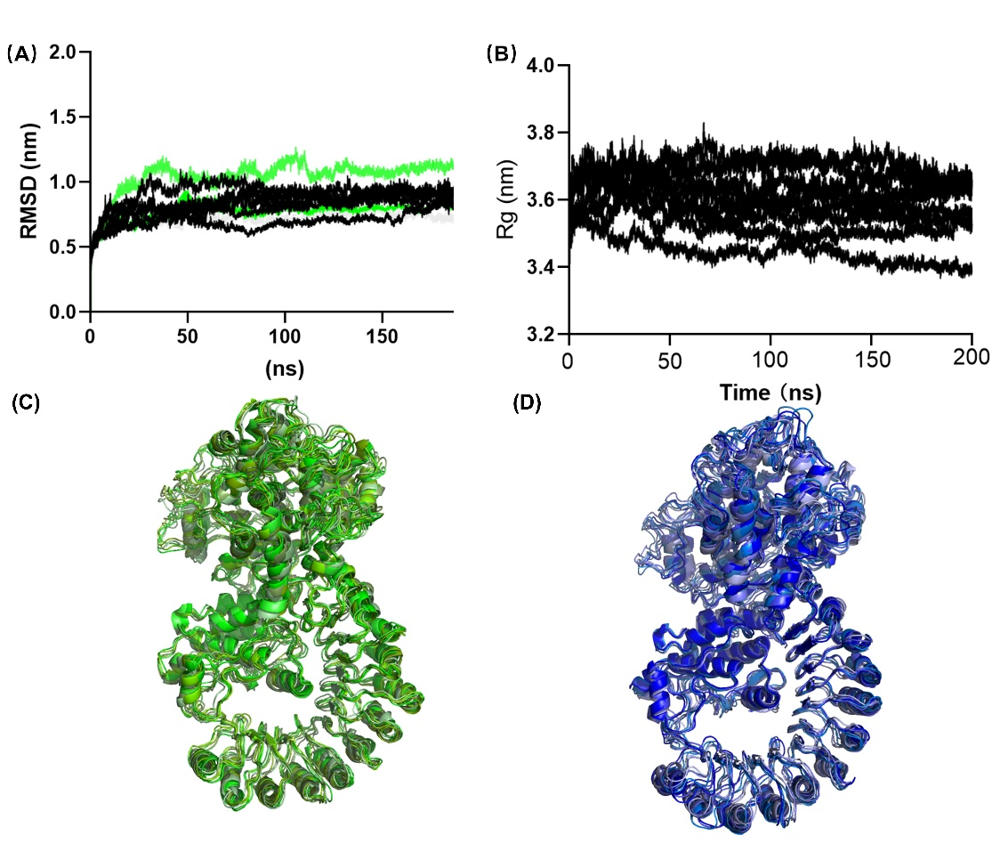
Fig. S3 Characterization of protein stability during molecular dynamics simulation. (A) Root Mean Square Deviation (RMSD) of the protein in protein-MCC950 complex, protein in protein-ZYIL1 complex, and apo protein over 200 ns; (B) Radius of Gyration (Rg) – Displays the Rg of the same systems over 200 ns; (C) and (D) Superimposed Structures – Overlay of representative structures at 50 ns, 80ns, 110ns, 140ns, 170ns, 200 ns, with light blue to dark blue for the ZYIL1 complex protein and light green to dark green for the MCC950 complex protein,

