Synthesis, enzyme inhibition, in silico molecular docking and DFT analysis
of novel multi-functionalized thiourea and thiazolidinone benzenesulfonamides

Mehtap Tugrak Sakarya^{1*}, Cem Yamali², Adem Erturk³, Yusuf Sert⁴, Halise Inci Gul⁵, Mustafa Gul⁶, Ilhami Gulcin³

¹Department of Pharmaceutical Chemistry, Faculty of Pharmacy, Tokat Gaziosmanpasa University, Tokat, Turkey
²Department of Basic Pharmaceutical Sciences, Faculty of Pharmacy, Cukurova University, Adana, Turkey
³Department of Chemistry, Faculty of Science, Ataturk University, Erzurum, Turkey
⁴Department of Motor Vehicles and Transportation Technologies, Sorgun Vocational High School, Yozgat Bozok University, Yozgat, Turkey
⁵Department of Pharmaceutical Chemistry, Faculty of Pharmacy, Ataturk University, Erzurum, Turkey
⁶Department of Physiology, Faculty of Medicine, Ataturk University, Erzurum, Turkey

* Assoc. Prof. Dr. Mehtap Tugrak Sakarya, Department of Pharmaceutical Chemistry, Faculty of Pharmacy, Tokat Gaziosmanpasa University, Tokat, Turkey
Email: mehtaptugrak@hotmail.com, mehtap.tugrak@gop.edu.tr, mehtaptugrak@gmail.com

Mehtap Tugrak Sakarya ORCID: https://orcid.org/0000-0002-6535-6580
Cem Yamali ORCID: https://orcid.org/0000-0002-4833-7900
Adem Erturk ORCID: https://orcid.org/0000-0002-1750-1966
Yusuf Sert ORCID: https://orcid.org/0000-0001-8836-8667
Halise Inci Gul ORCID: https://orcid.org/0000-0001-6164-9602
Mustafa Gul ORCID: https://orcid.org/0000-0002-0042-890X
Ilhami Gulcin ORCID: https://orcid.org/0000-0001-5993-1668

Carbonic anhydrase enzyme assay
Human CA isoforms (hCAI and hCAII) were isolated using the sepharose - 4B - L - tyrosine sulfanilamide affinity segregation process, as previously reported. Protein concentrations were measured using the Bradford method at 595 nm. The compounds' inhibitory effects were studied by measuring esterase activity in accordance with Verpoorte et al., as described in prior investigations. The hCA activity was evaluated by monitoring the conversion of the p-nitrophenyl acetate substrate to p-nitro phenolate at 348 nm using a spectrophotometer (UV-VIS Spectrophotometer, UV mini-1240, Shimadzu Corporation). Acetazolamide (AZA) was utilized as the control medication. The Lineweaver-Burk plot was used to determine the drugs' inhibition constants (Ki). Lineweaver–Burk graphics are presented as a supplementary file [1, 5].
2.4. Acetylcholinesterase enzyme assay
The effects of compounds on AChE enzyme were investigated. Two substrates which are 5,5- dithiobis(2-nitrobenzoic acid) (DTNB) and acetylcholiniodate (AChI) were used in the inhibition tests. In addition, Tris / HCl (100 ml, 1M, pH=8) buffer was used in this method for AChE enzyme. The final volume was completed to 100 µL and changes in the absorption were followed at 412 nm. The IC₅₀ values of the compounds were calculated via activity (%) versus compounds concentration plots [6, 7].
α-Glycosidase inhibition studies
α-Glycosidase inhibition effect of the compounds was made according to the method of Tao et al. [8]. p Nitrophenyl-D-glucopyranoside (p-NPG) was used as substrate. First, 75 μL of phosphate buffer solution (5 mM, pH 7.4) was added to 20 μL of α-glycosidase solution (0.15EU/mL), which was prepared in phosphate buffer (pH 7.4, 5 mM) and 5 μLof different concentrations of the compounds. Then, it was preincubated at 35°C for 10 min before adding p-NPG to initiate the reaction. Also, 20 μL of p-NPG was transferred in phosphate buffer (pH 7.4, 5 mM) after a short incubation period at 35°C. The absorbances were measured at 405 nm. One α-glycosidase unit is the quantity of enzyme that catalyzes the hydrolysis of 1.0 mol p-NPG per minute at pH 7.4 [9]. 2.4.3.
α-Amylase inhibition studies
α-Amylase inhibitory effects of the compounds were realized according to the procedure of Xiao [10] using starch as substrate. For starch preparation, 0.4 M starch mixture was prepared in 80 mL NaOH solution at 80°C for 30 min. Then, 35 μL of starch solution, 35 μL of phosphate buffer (pH 6.9), and 10 μL of different concentrations of the compounds were mixed and incubated at 35°C for 25 min. Lastly, 20 μL of the α-amylase solution was added to the final mixture and reincubated for 25 min. The reactions were finished by adding 50 μL of HCl (0.1 M) to each tube. The absorbance was measured at 580 nm. One α-amylase unit is defined as the quantity of α amylase required to release 1 μmol of reducing sugar estimated as glucose per min (pH 6.9, 40°C) [9].

1. Kocyigit UM, Budak Y, Gurdere MB, et al. Synthesis, characterization, anticancer, antimicrobial and carbonic anhydrase inhibition profiles of novel (3aR,4S,7R,7aS)-2-(4-((E)-3-(3-aryl)acryloyl) phenyl)-3a,4,7,7a-tetrahydro-1H-4,7-methanoisoindole-1,3(2H)-dione derivatives. Bioorganic chemistry. Feb 2017;70:118-125.
2. Bradford MM. A rapid and sensitive method for the quantitation of microgram quantities of protein utilizing the principle of protein-dye binding. Analytical biochemistry. May 7 1976;72:248-254.
3. Verpoorte JA, Mehta S, Edsall JT. Esterase activities of human carbonic anhydrases B and C. The Journal of biological chemistry. Sep 25 1967;242(18):4221-4229.
4. Guney M, Coskun A, Topal F, Dastan A, Gulcin I, Supuran CT. Oxidation of cyanobenzocycloheptatrienes: Synthesis, photooxygenation reaction and carbonic anhydrase isoenzymes inhibition properties of some new benzotropone derivatives. Bioorganic & medicinal chemistry. Jul 1 2014;22(13):3537-3543.
5. Tugrak M, Gul HI, Demir Y, Levent S, Gulcin I. Synthesis and in vitro carbonic anhydrases and acetylcholinesterase inhibitory activities of novel imidazolinone-based benzenesulfonamides. Archiv der Pharmazie. Apr 2021;354(4):e2000375.
6. Tugrak M, Gul HI, Demir Y, Gulcin I. Synthesis of benzamide derivatives with thiourea-substituted benzenesulfonamides as carbonic anhydrase inhibitors. Archiv der Pharmazie. Feb 2021;354(2):e2000230.
7. El-Sayed NA, Farag AE, Ezzat MAF, Akincioglu H, Gulcin I, Abou-Seri SM. Design, synthesis, in vitro and in vivo evaluation of novel pyrrolizine-based compounds with potential activity as cholinesterase inhibitors and anti-Alzheimer's agents. Bioorganic chemistry. Dec 2019;93:103312.
8. Tao Y, Zhang Y, Cheng Y, Wang Y. Rapid screening and identification of α -glucosidase inhibitors from mulberry leaves using enzyme immobilized magnetic beads coupled with HPLC/MS and NMR. Biomed Chromatogr [Internet]. 2013 Feb;27(2):148–55
9. Bal S, Demirci Ö, Şen B, Taşkın Tok T, Taslimi P, Aktaş A, et al. Silver N ‐heterocyclic carbene complexes bearing fluorinated benzyl group: Synthesis, characterization, crystal structure, computational studies, and inhibitory properties against some metabolic enzymes. Appl Organomet Chem [Internet]. 2021 Sep 20;35(9):e6312.
10. Xiao Z, Storms R, Tsang A. A quantitative starch iodine method for measuring alpha-amylase and glucoamylase activities. Anal Biochem [Internet]. 2006 Apr 1;351(1):146–8.

CA I Graps
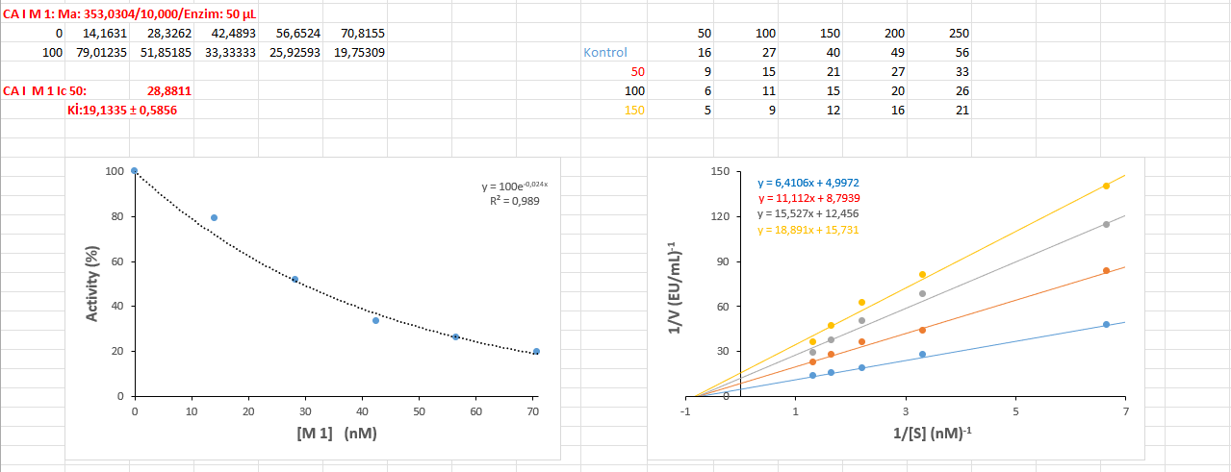
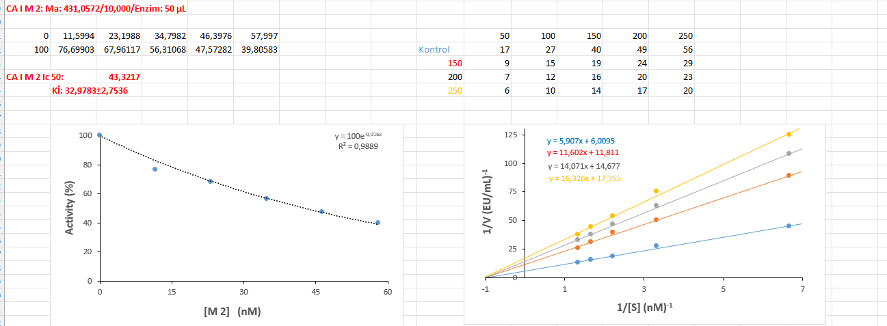
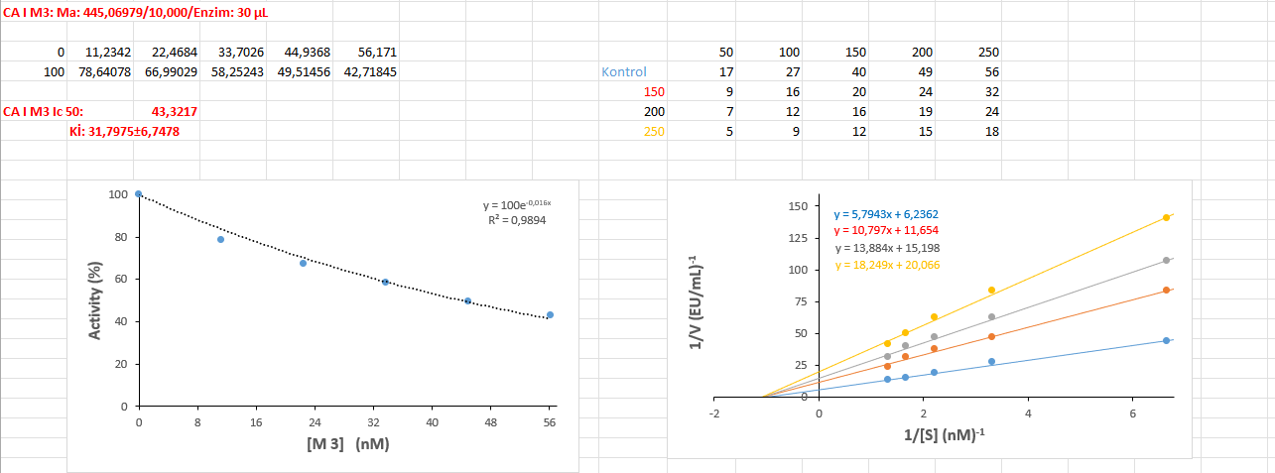

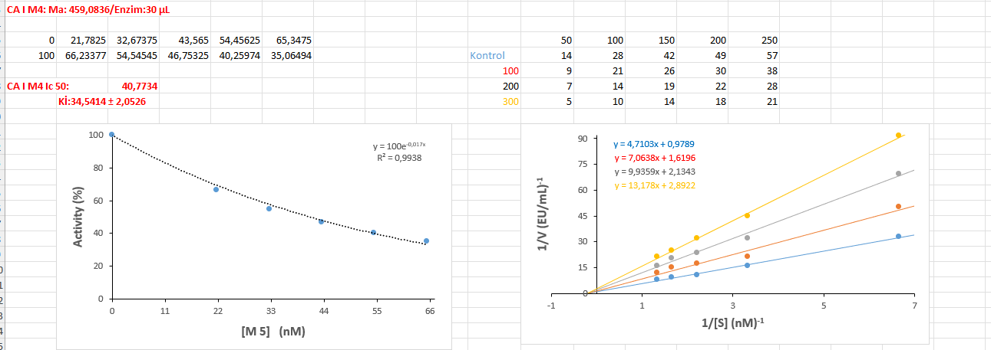
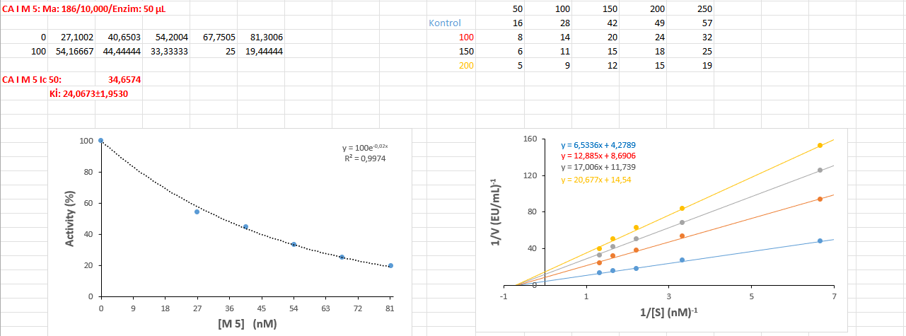

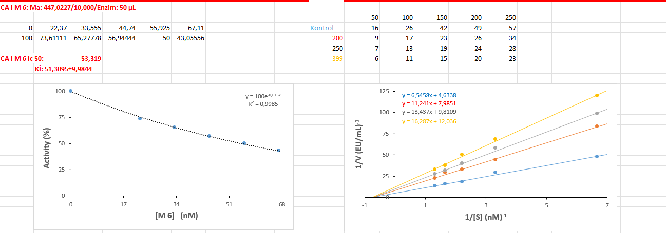

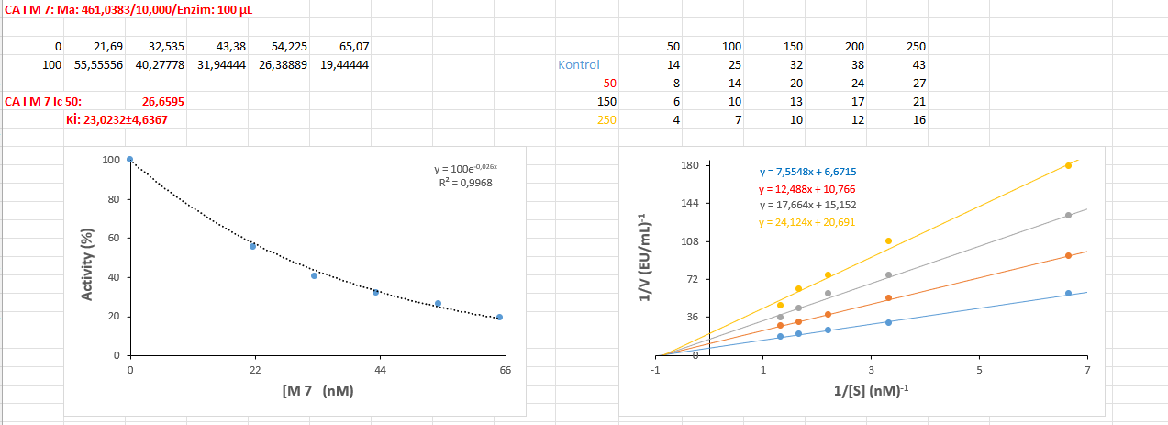
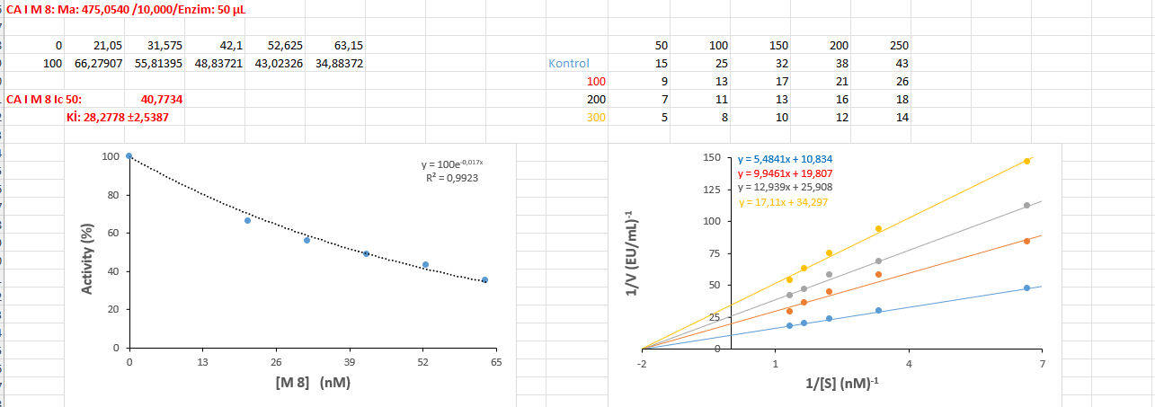

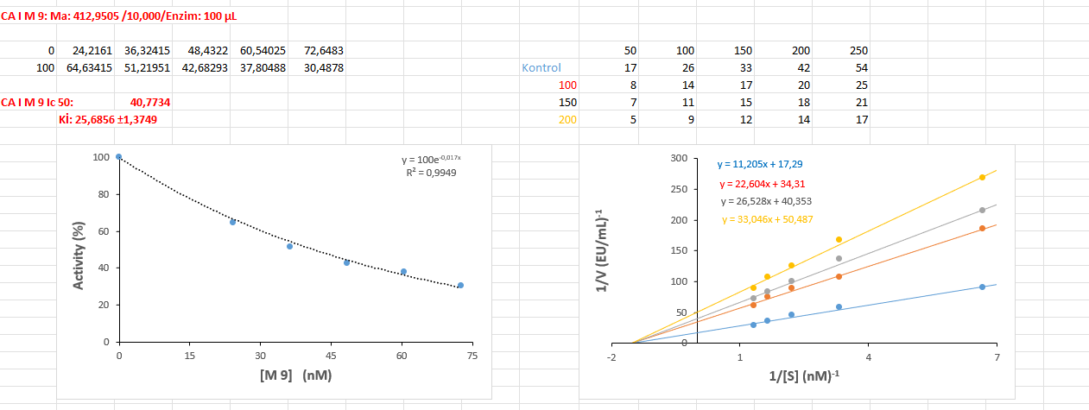

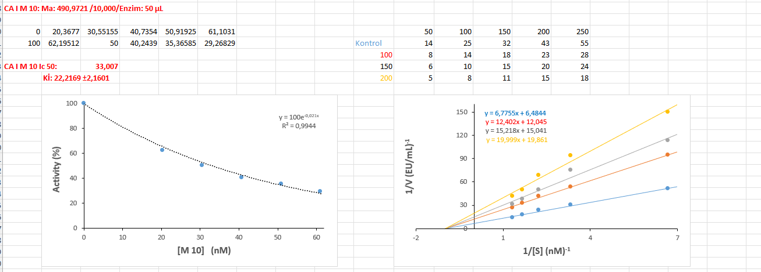
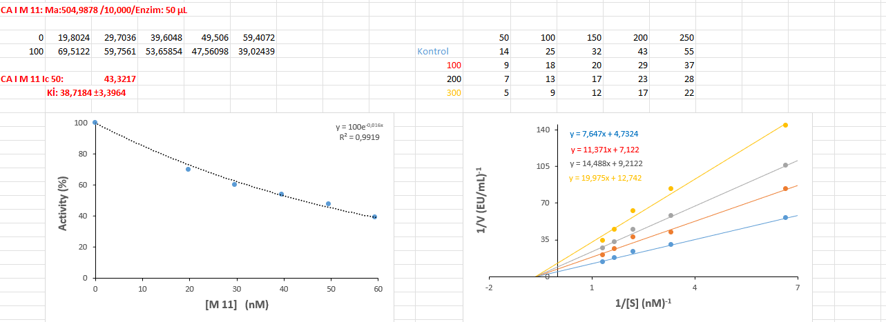
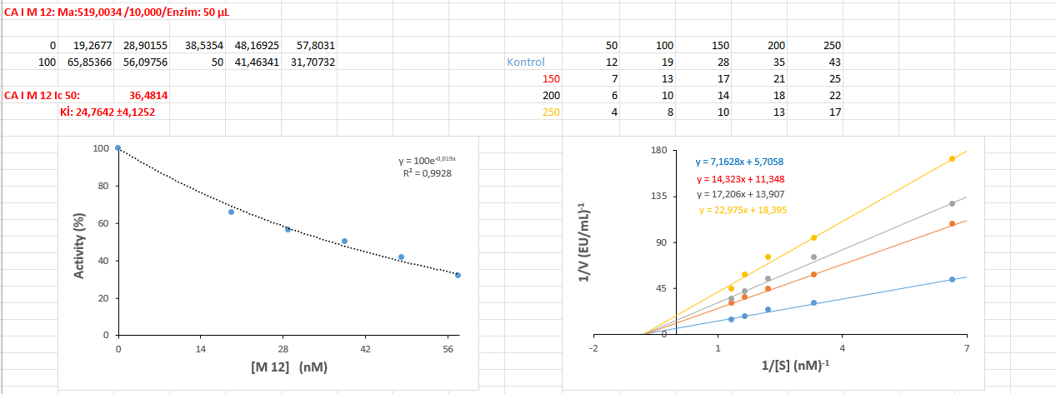

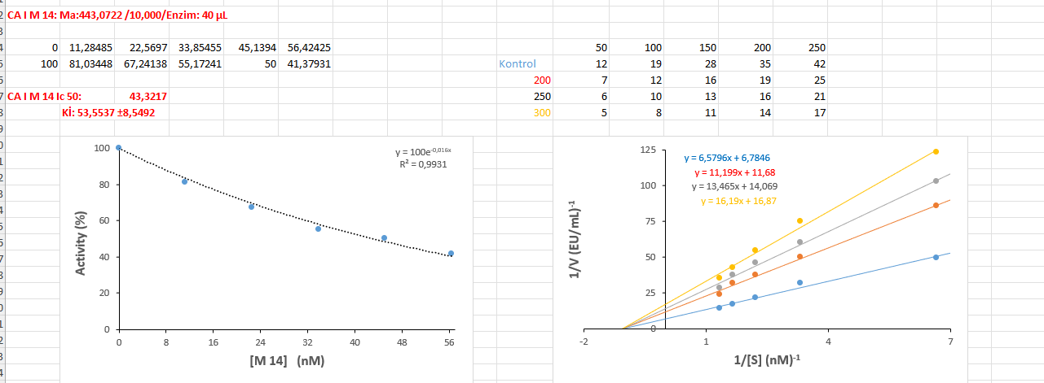
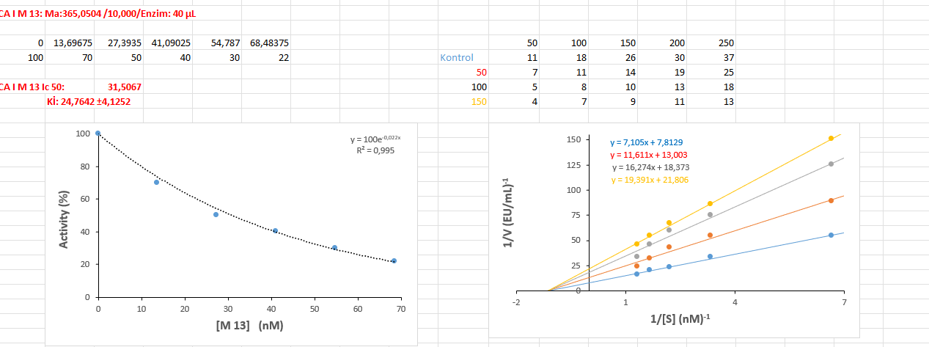

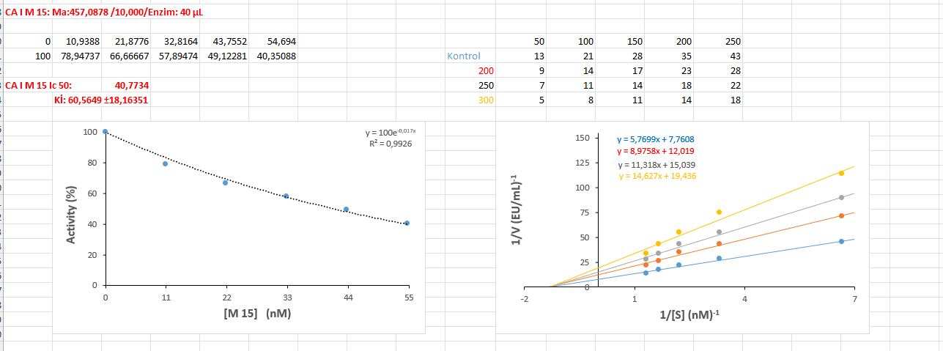

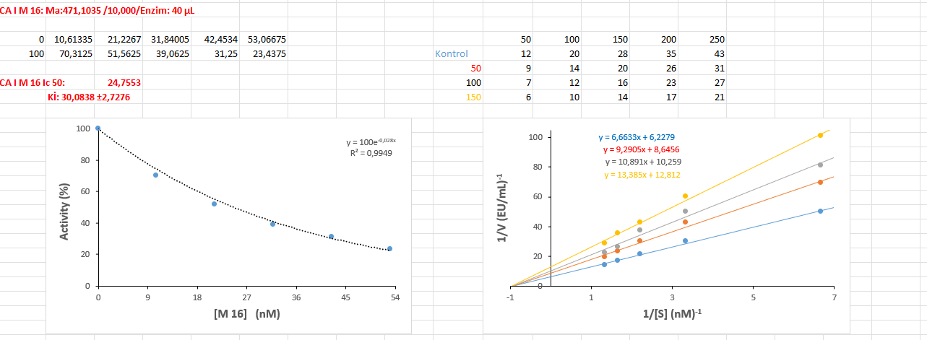
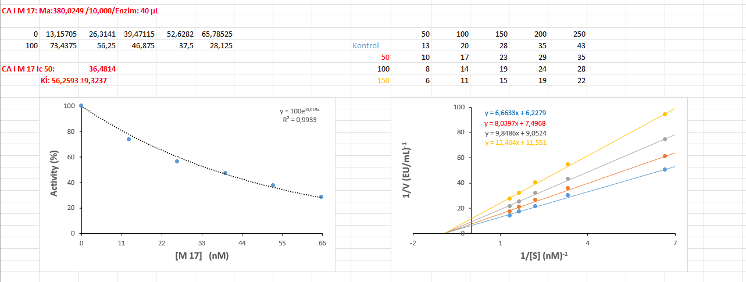

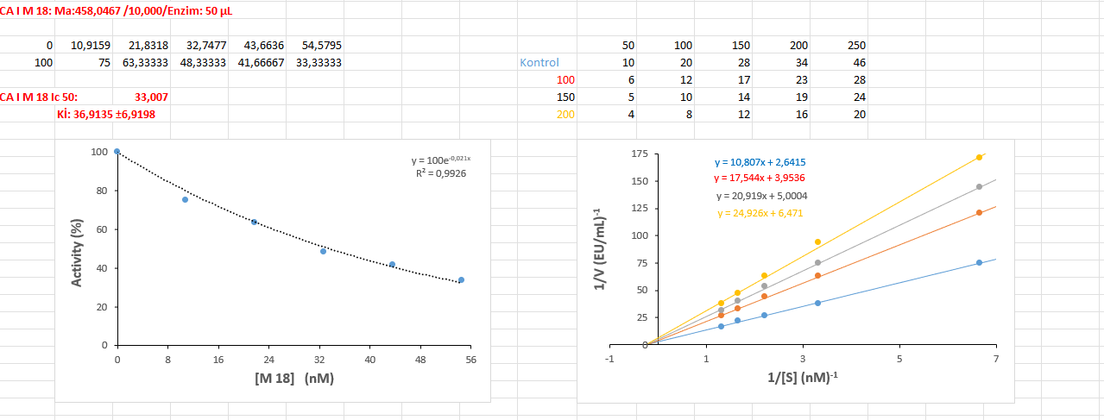

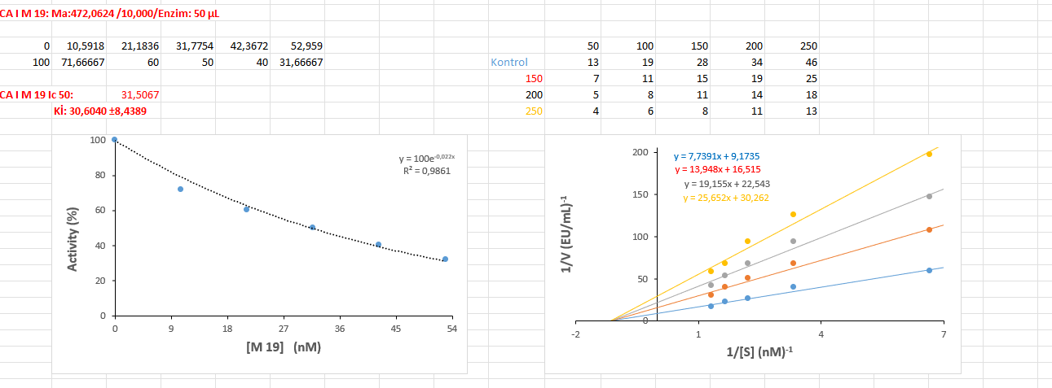
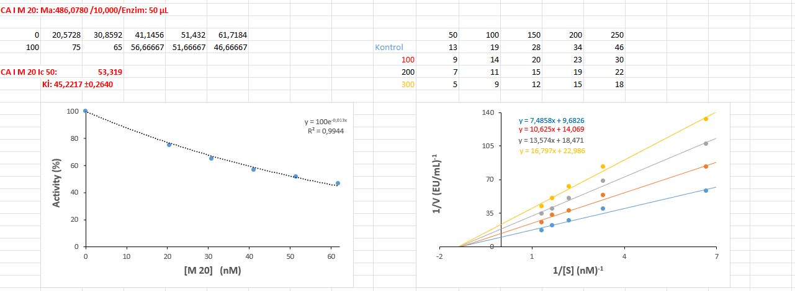

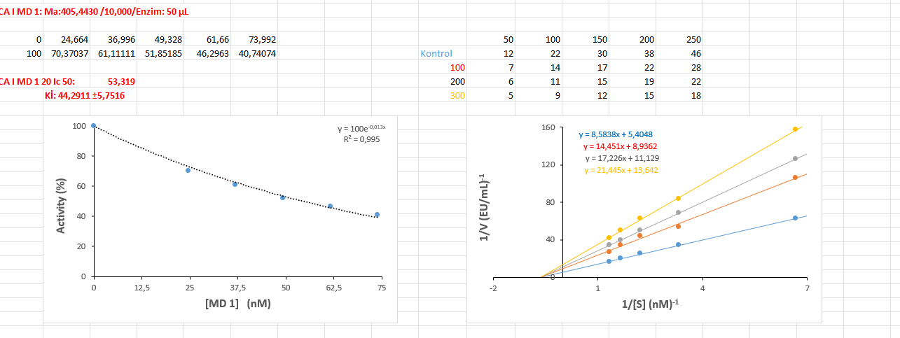

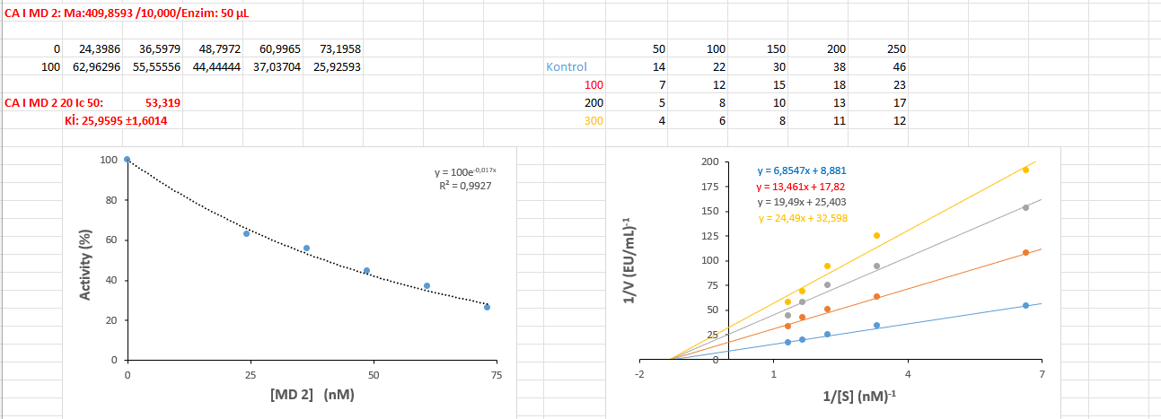
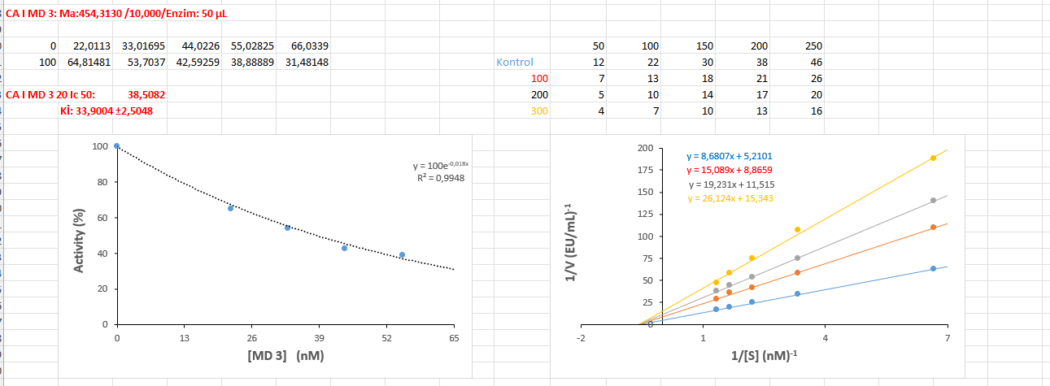

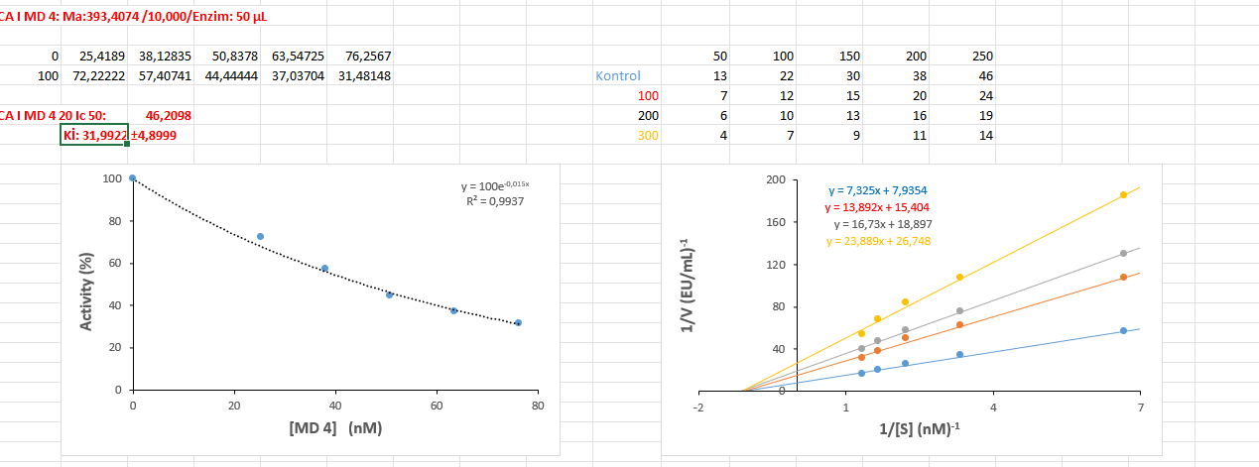

CA II Graps
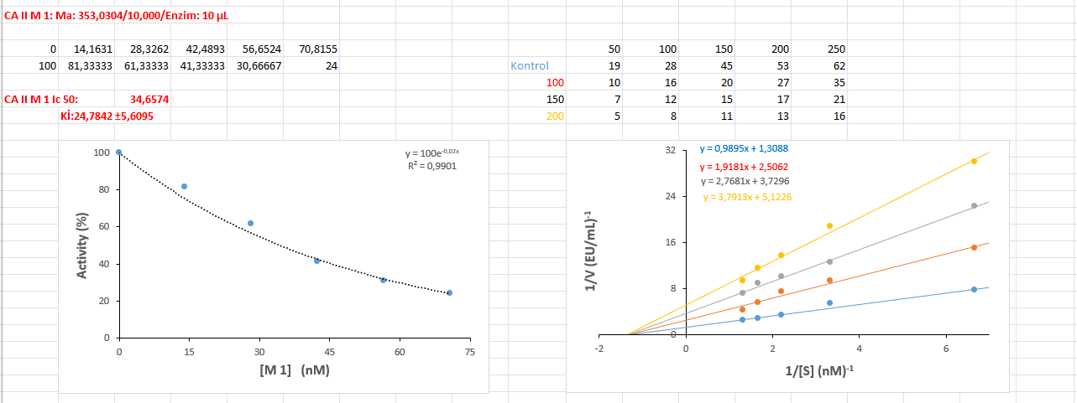
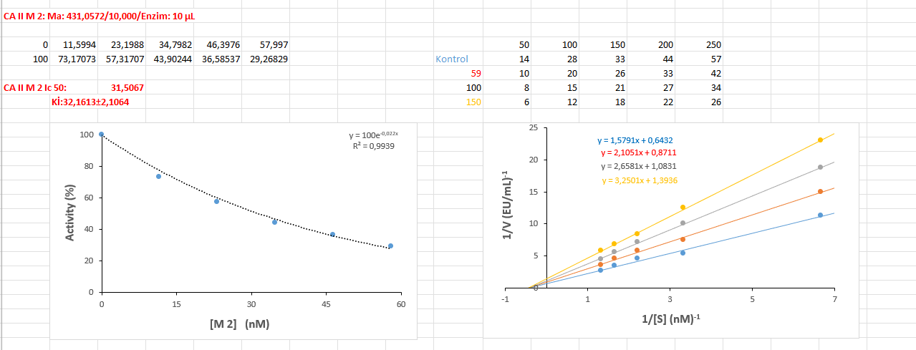

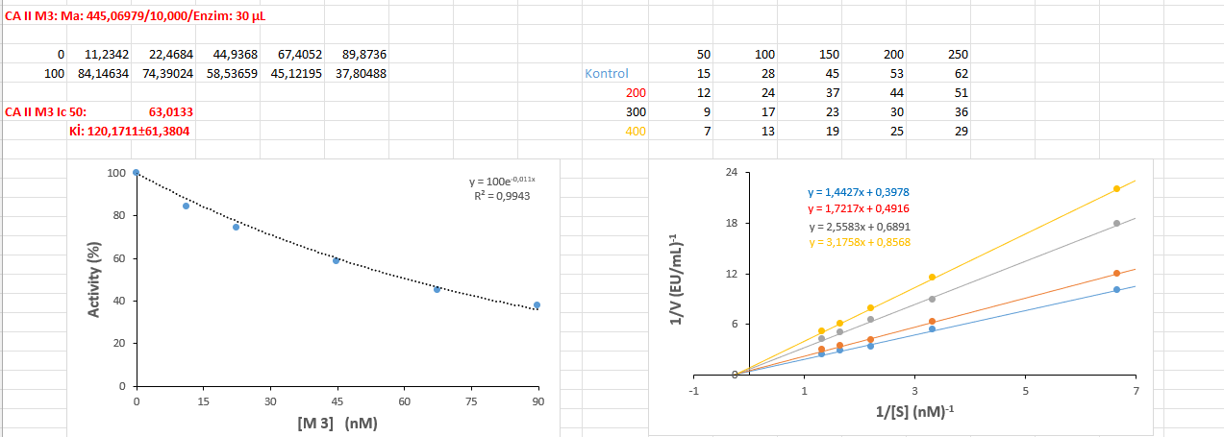

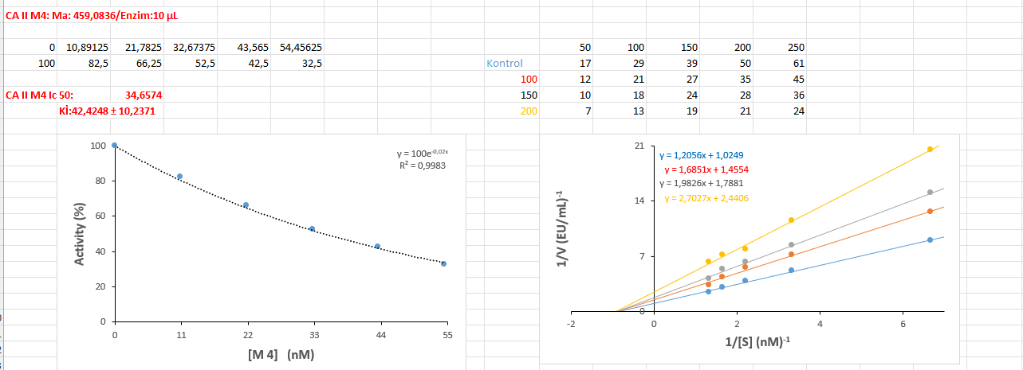
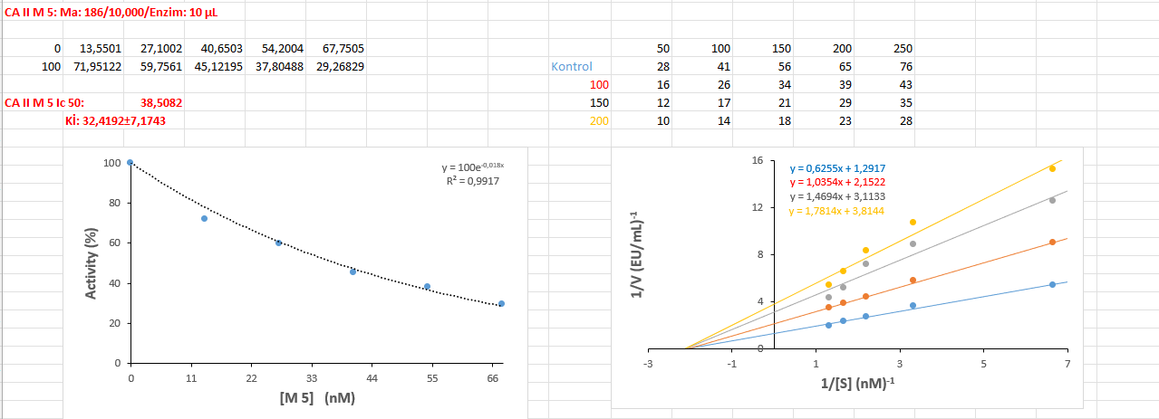

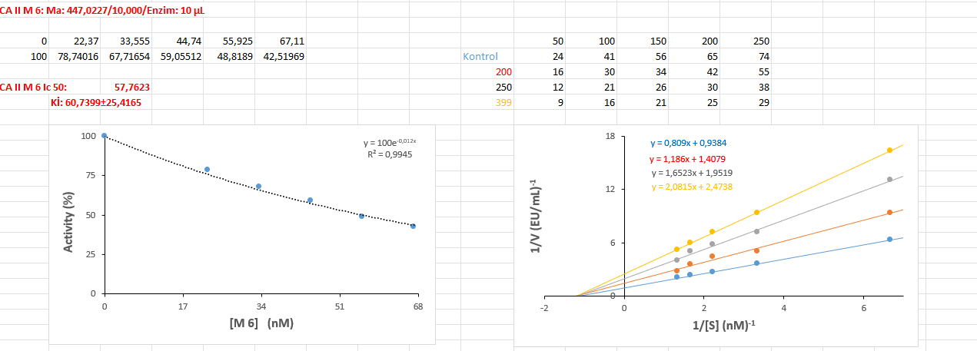

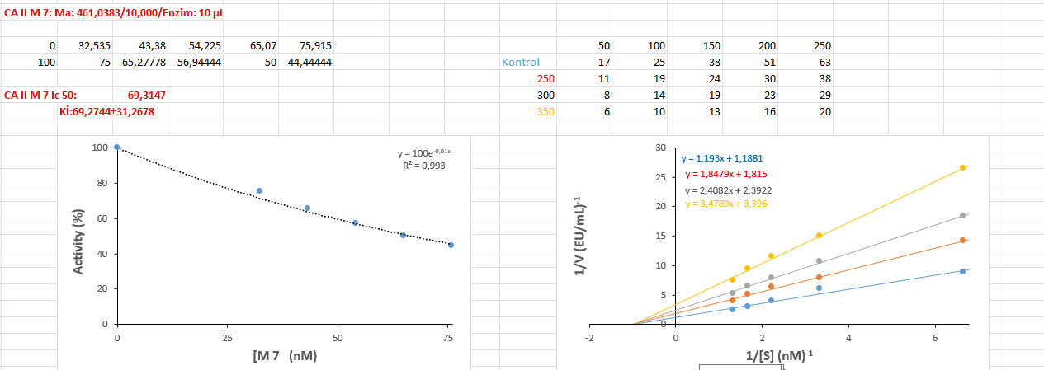
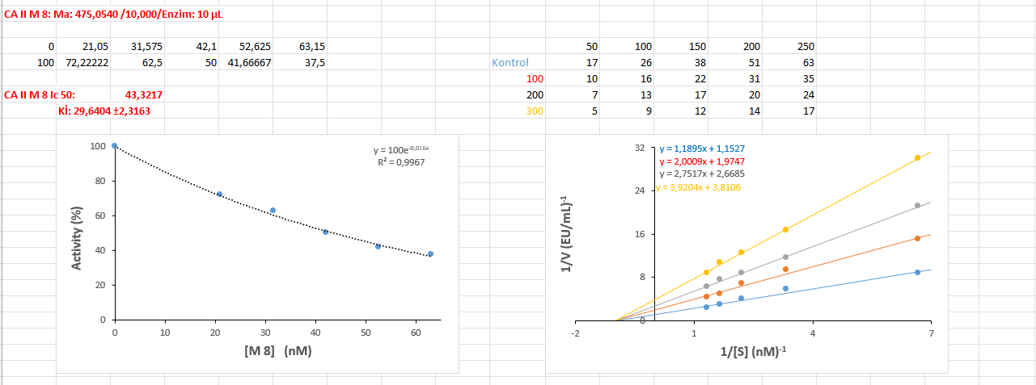

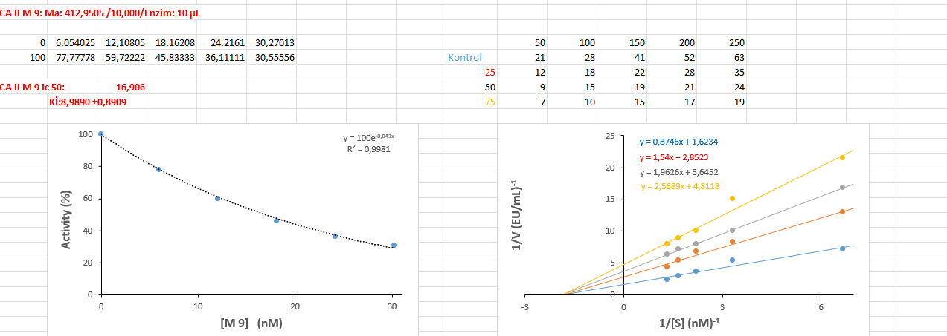

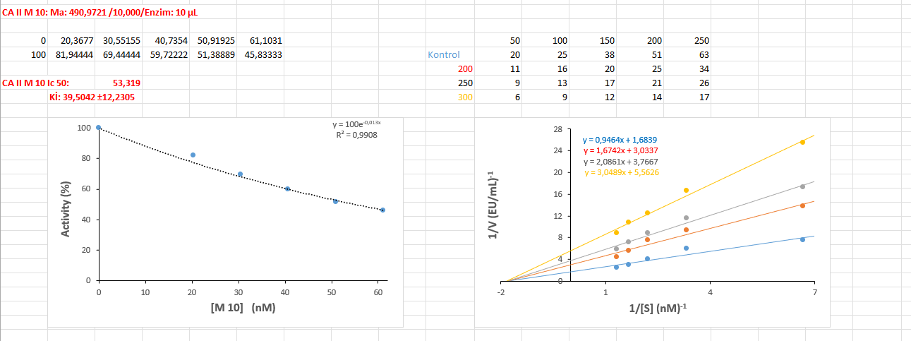
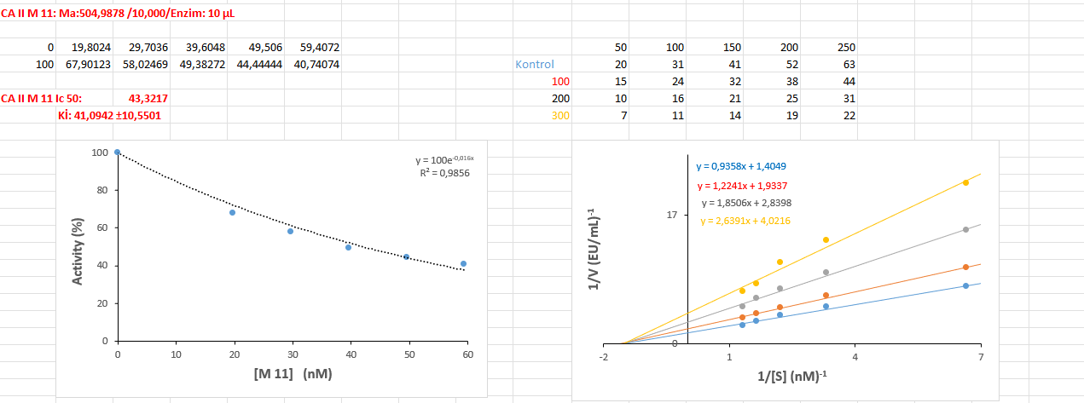

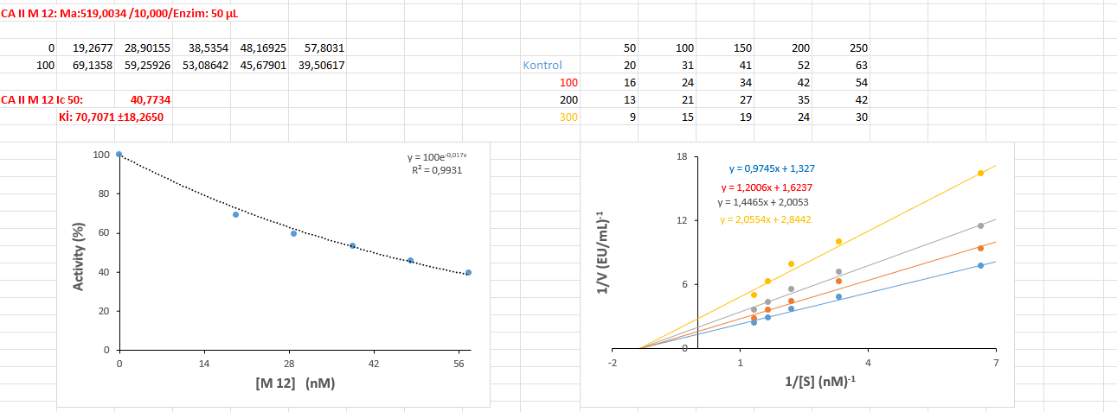

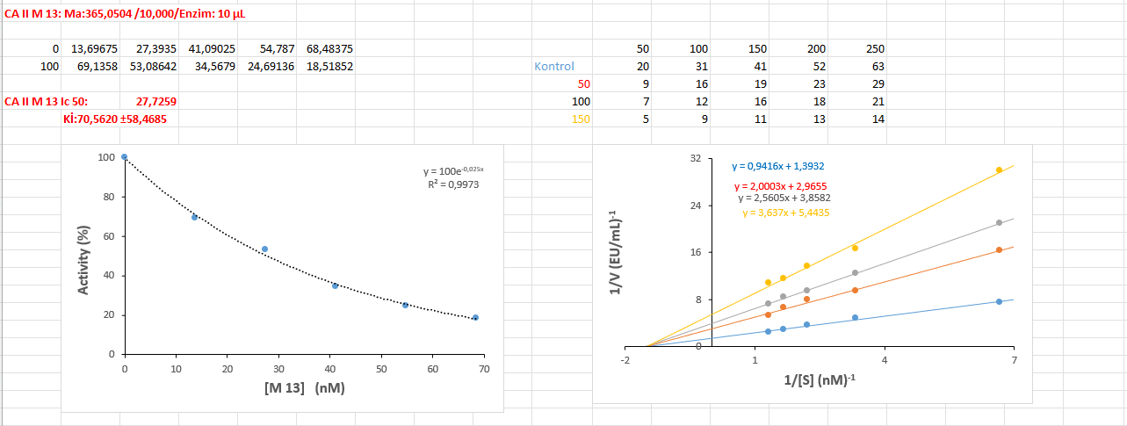
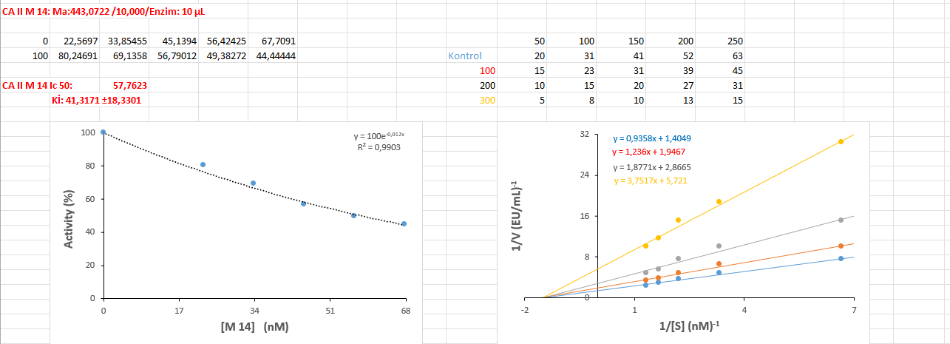

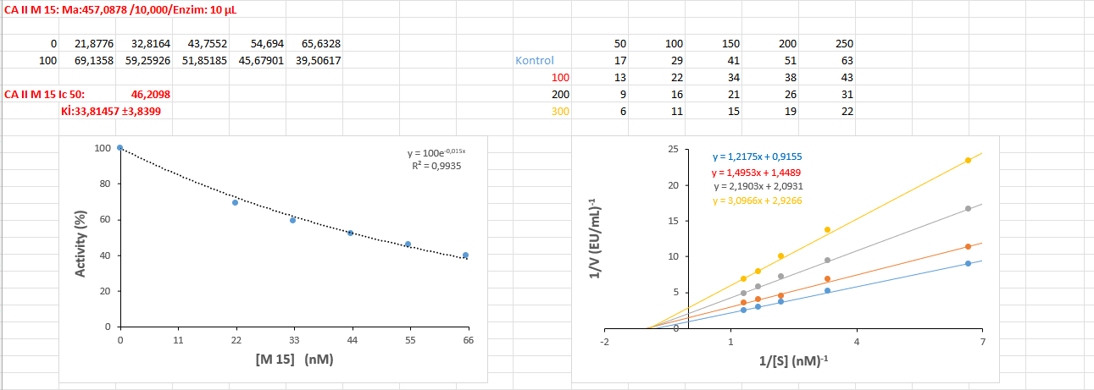

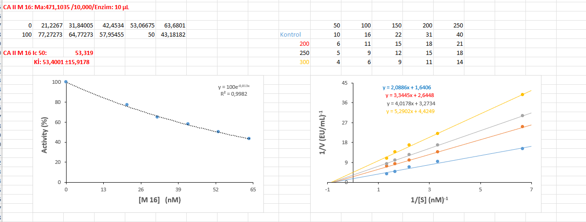
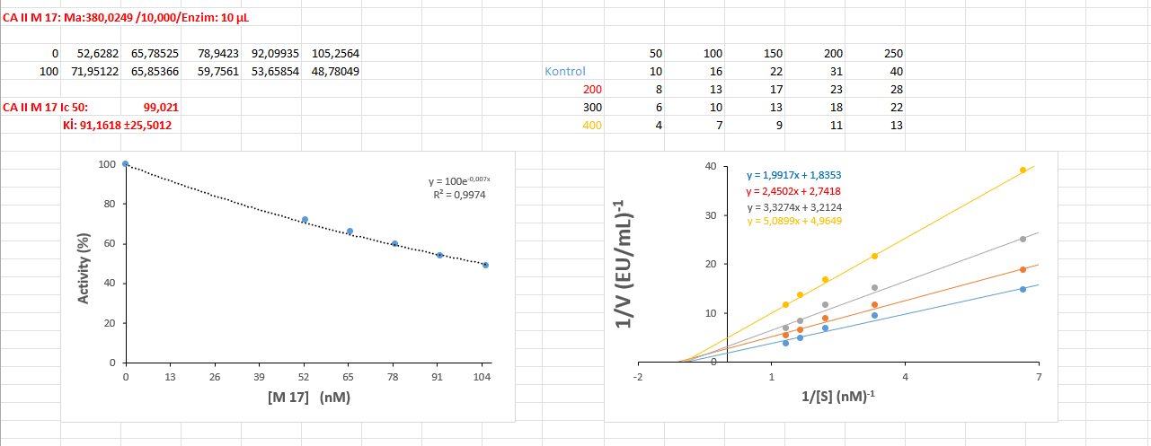

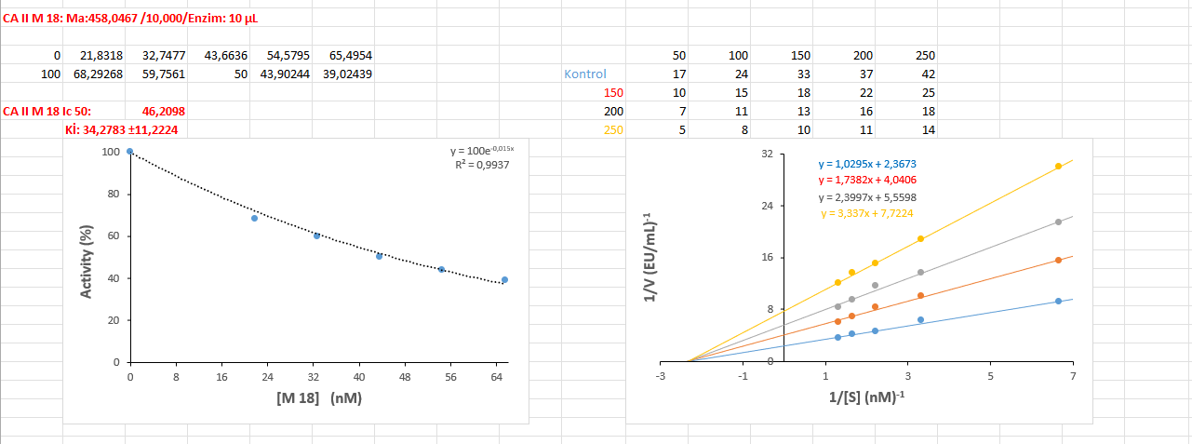

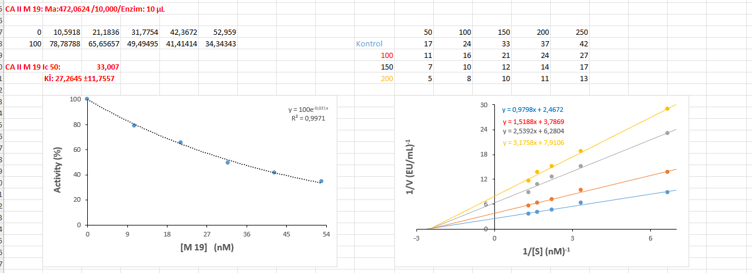
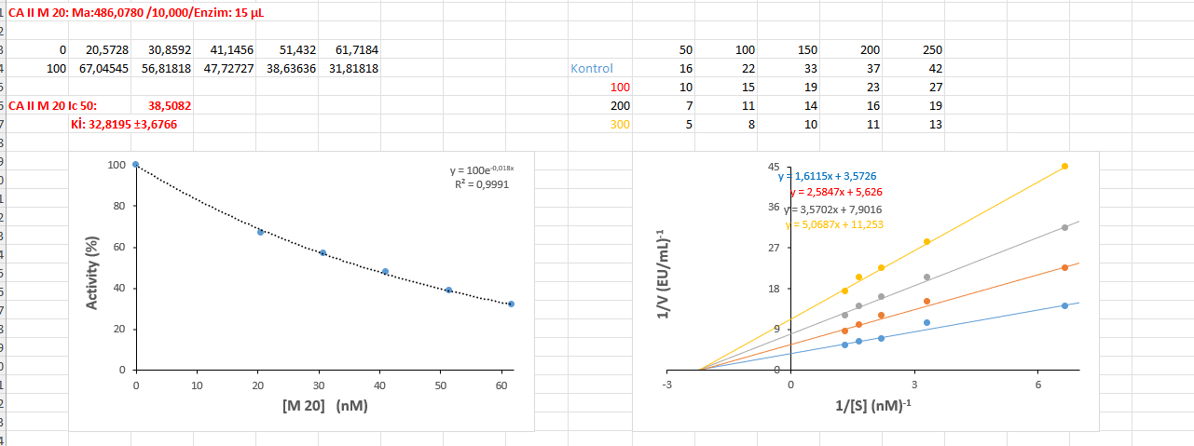

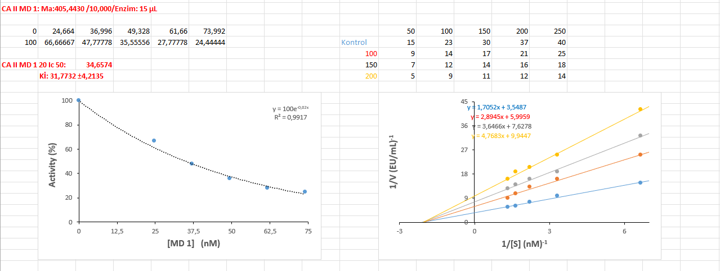

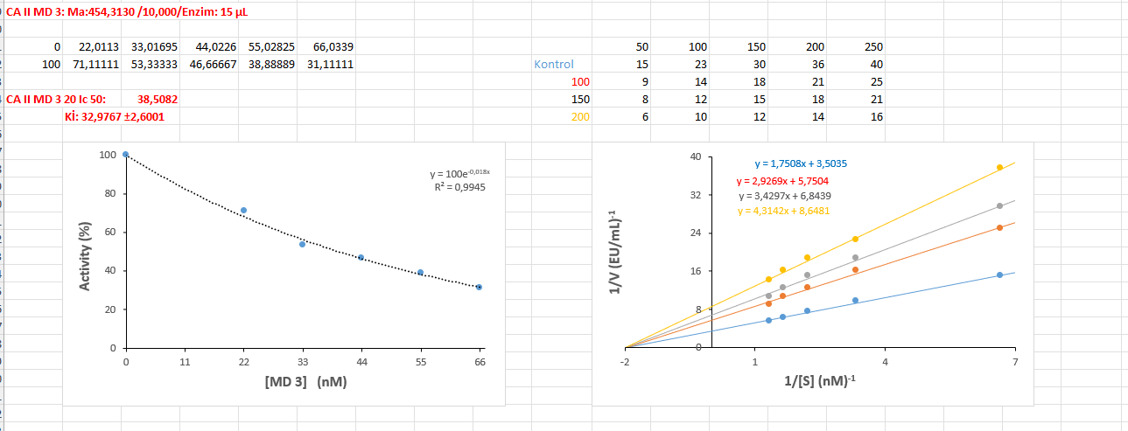
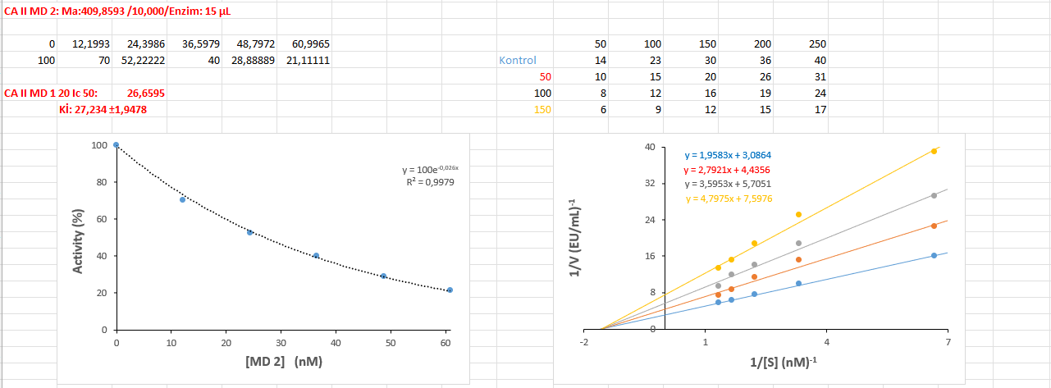

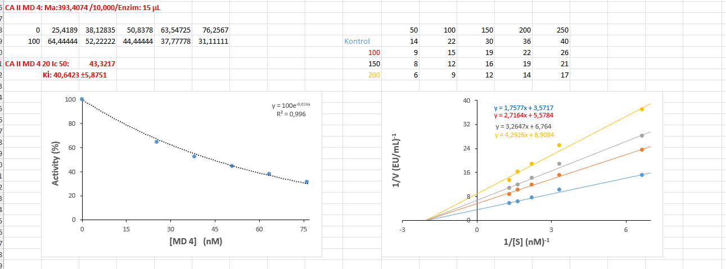

AChE Graps
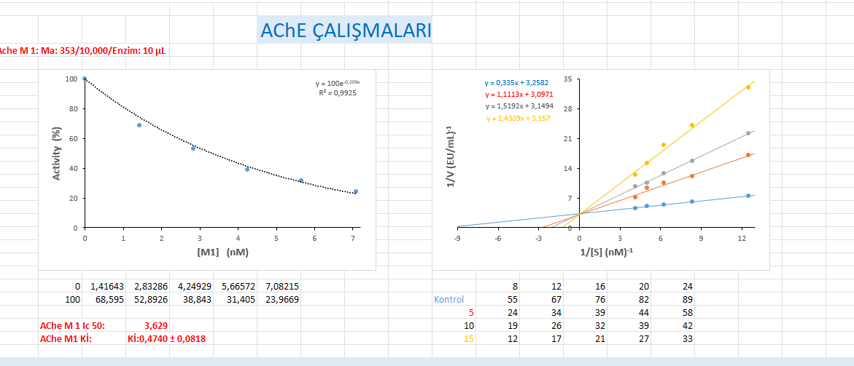

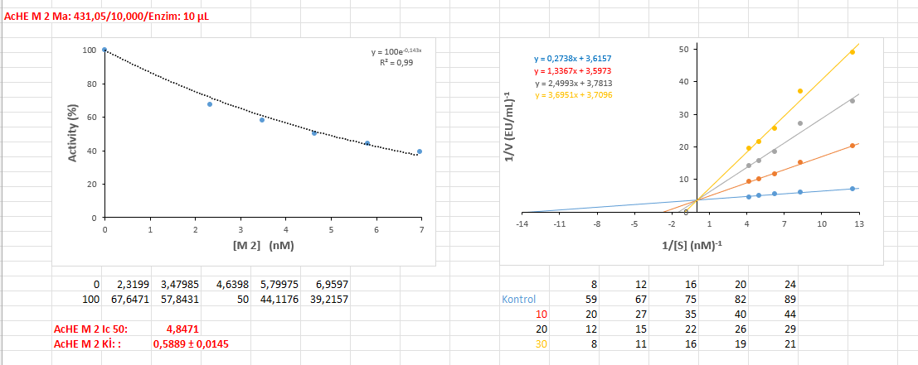

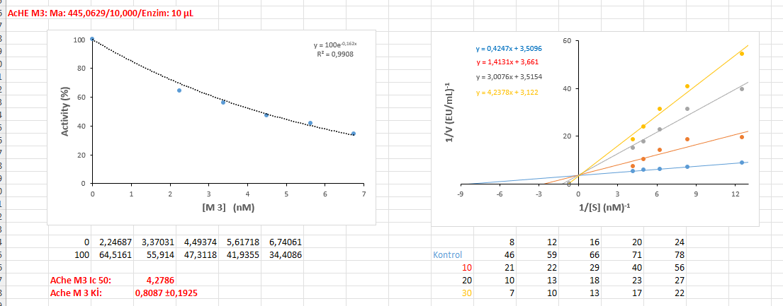
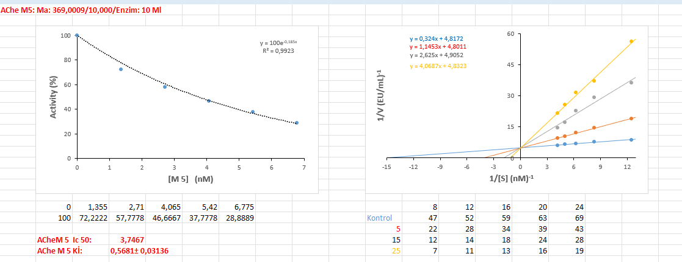
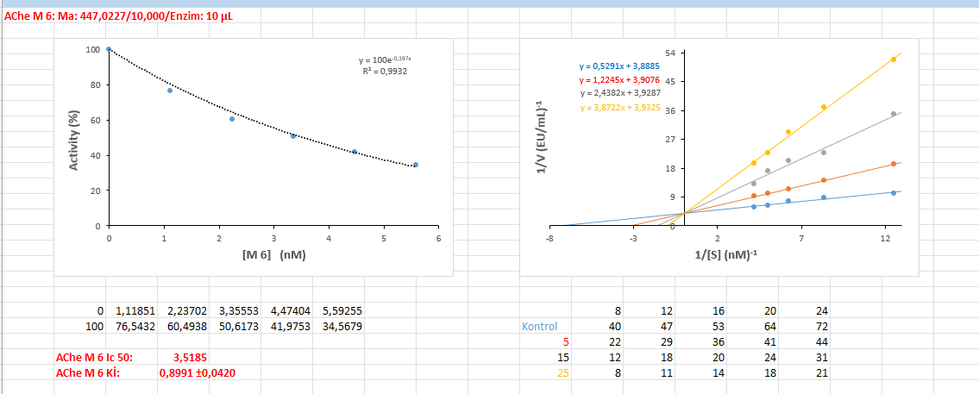

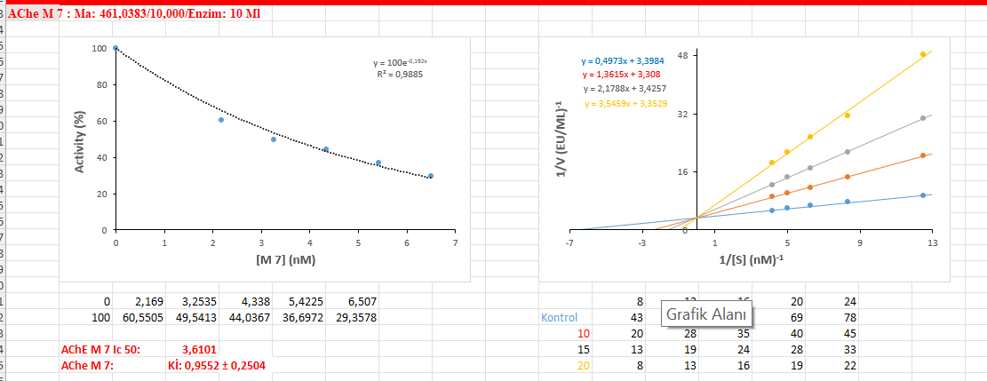

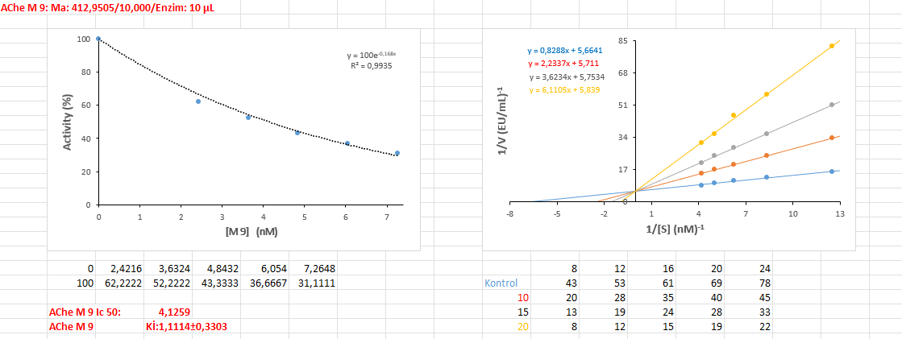
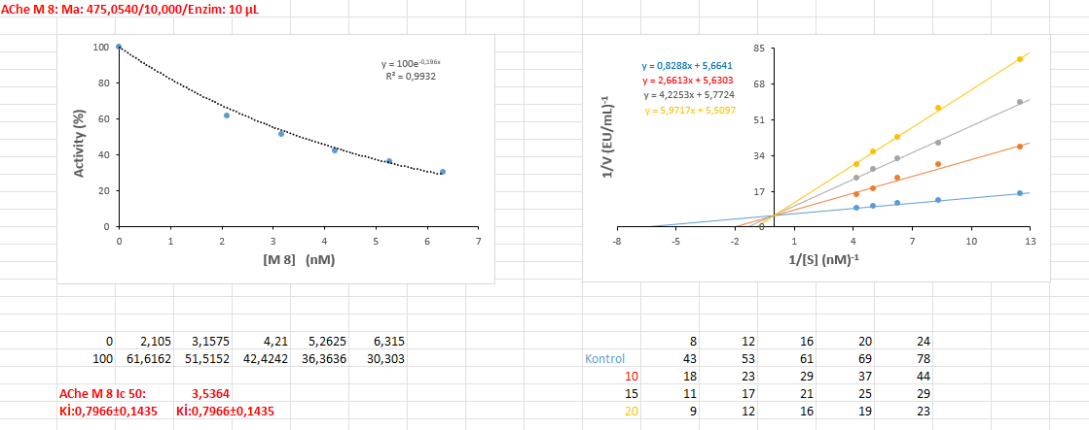

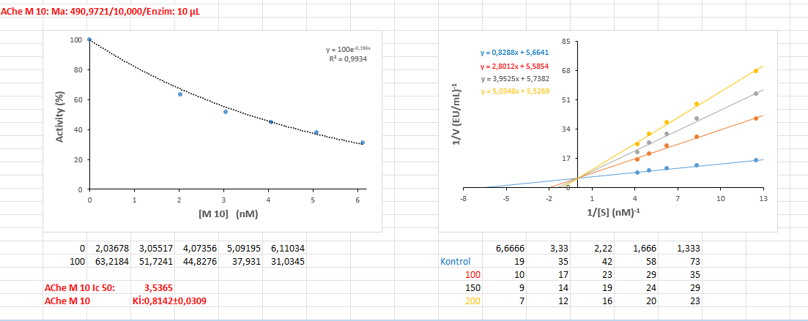

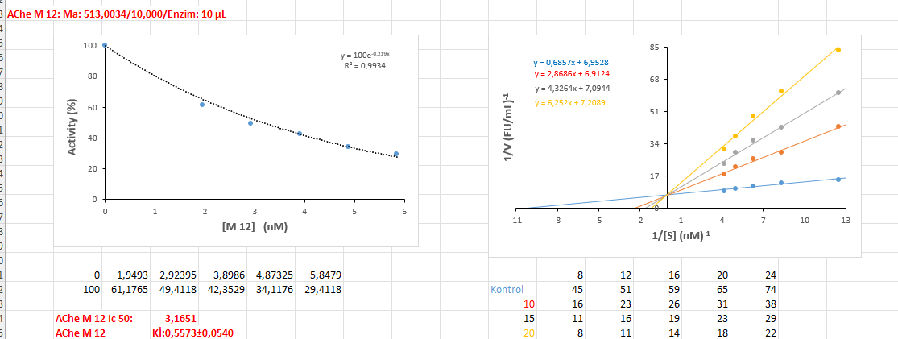
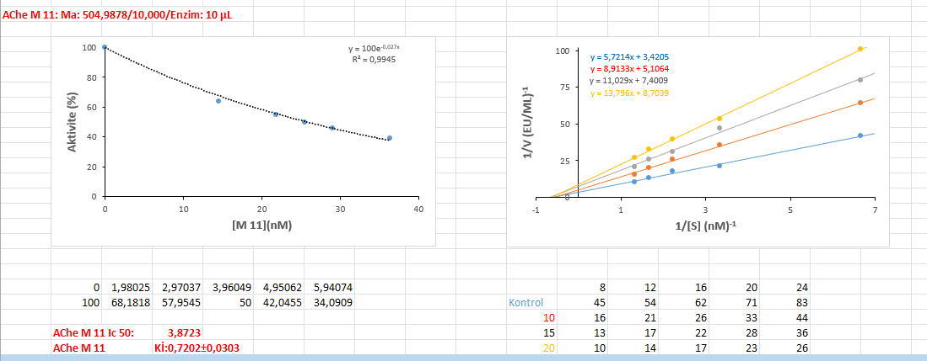
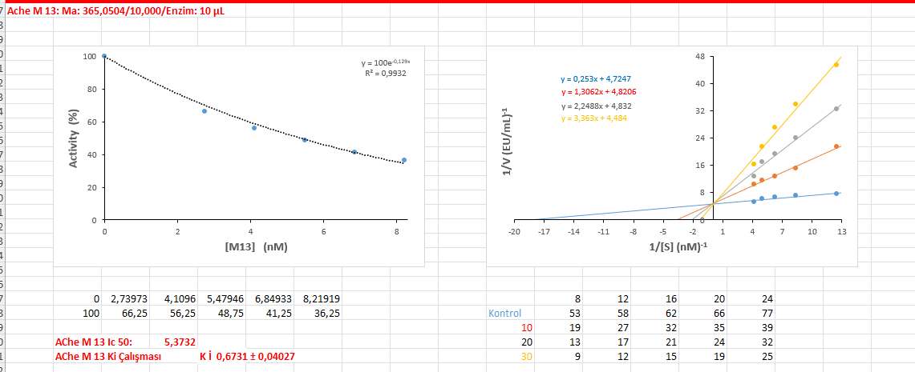

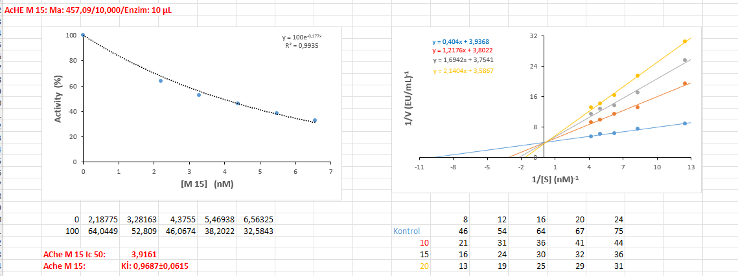
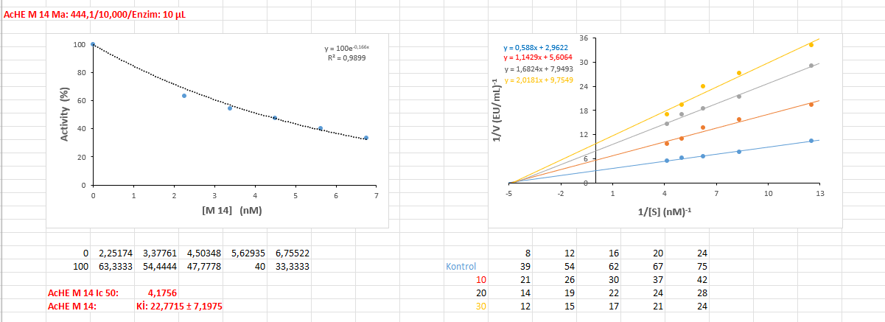

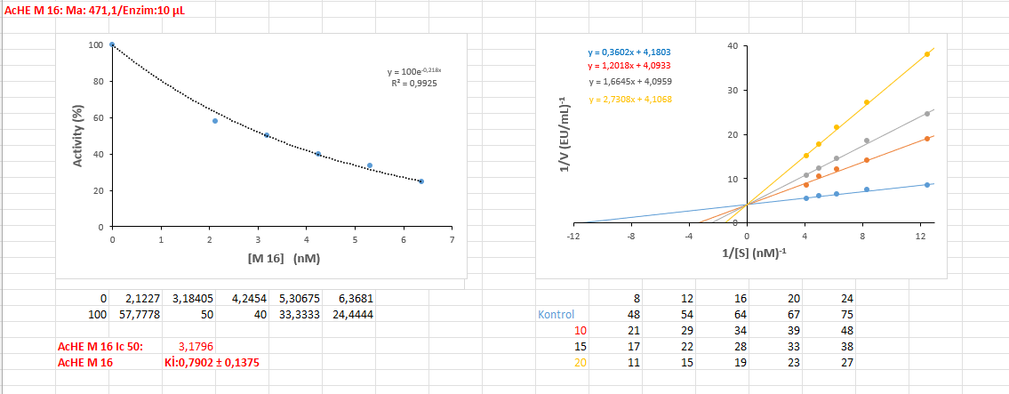

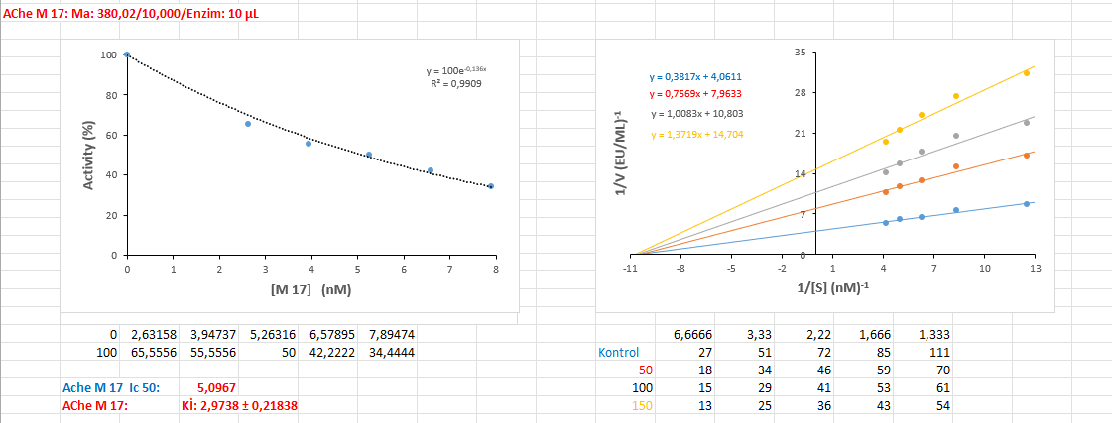
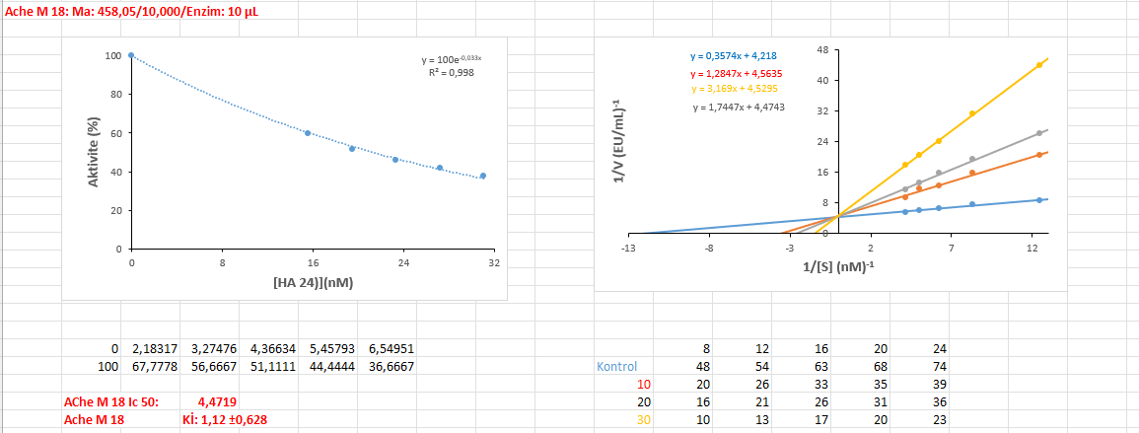

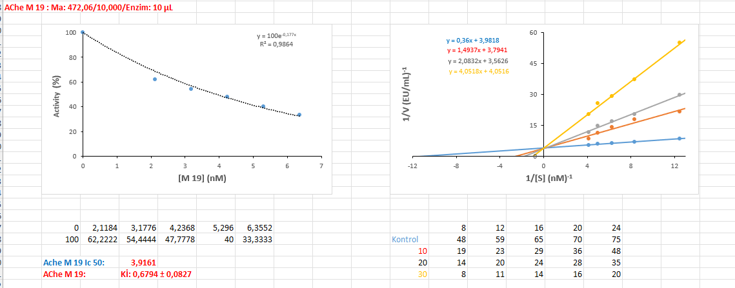

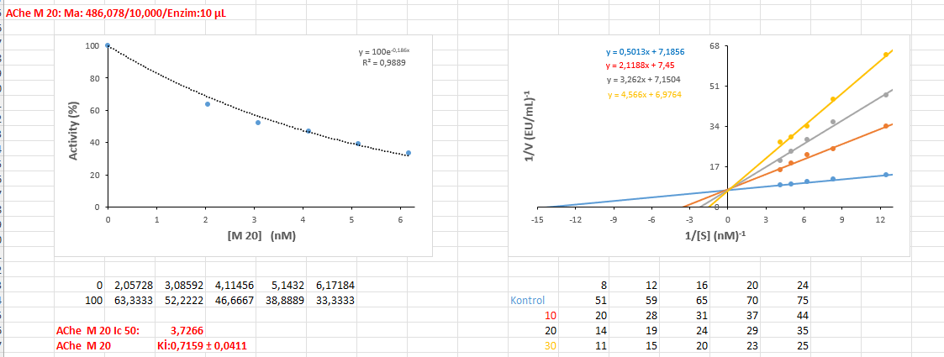
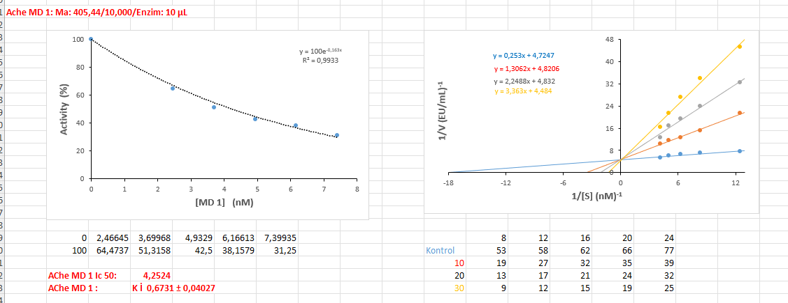

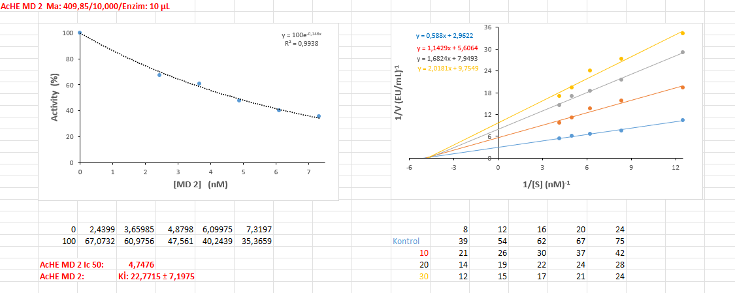

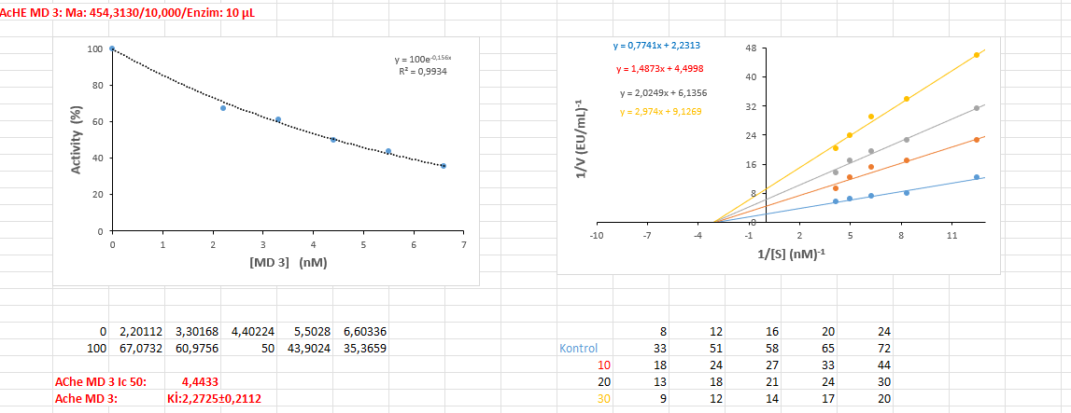
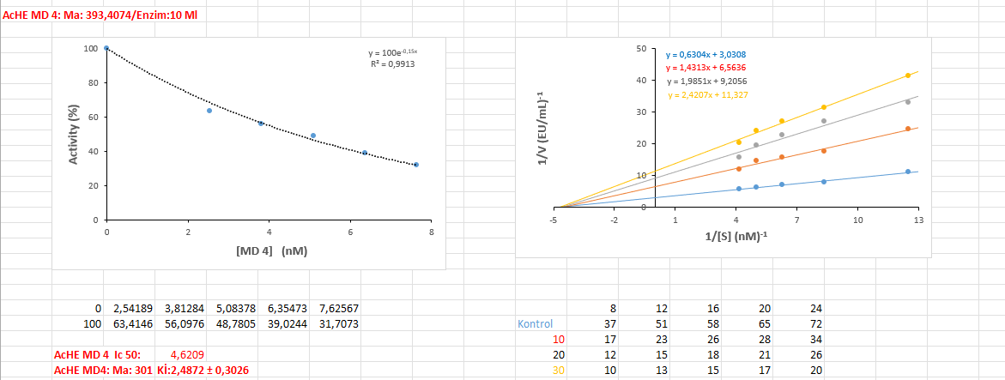

α-Glycosidase Graps
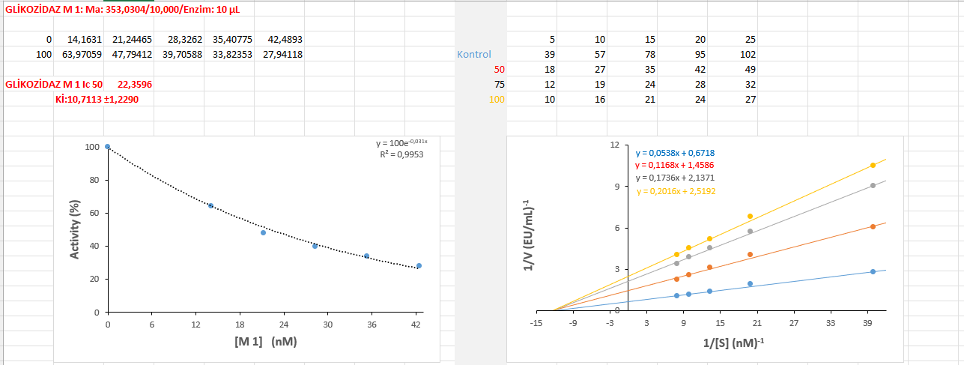
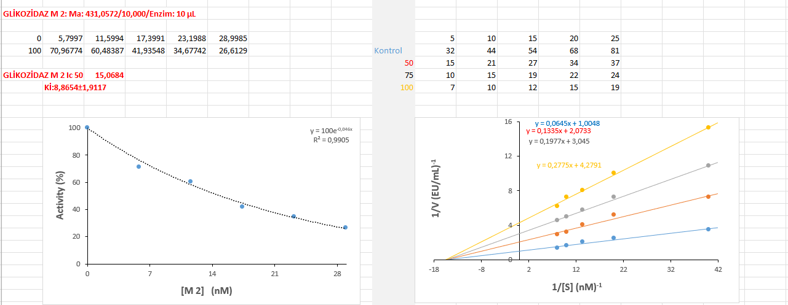

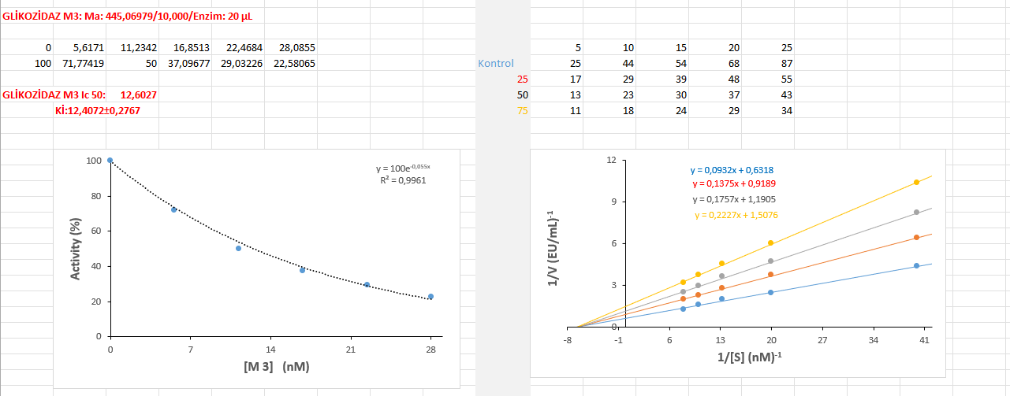

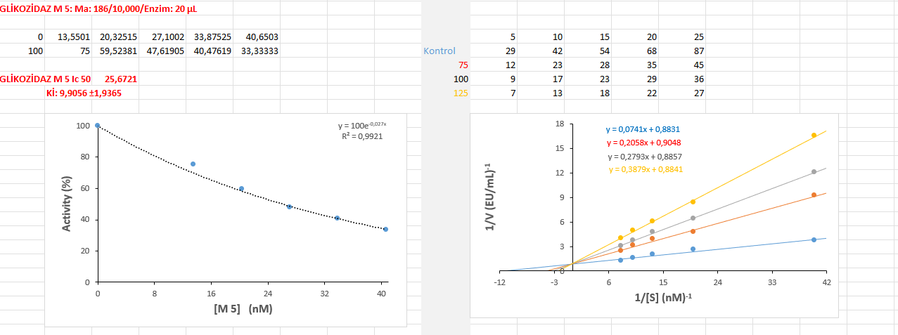
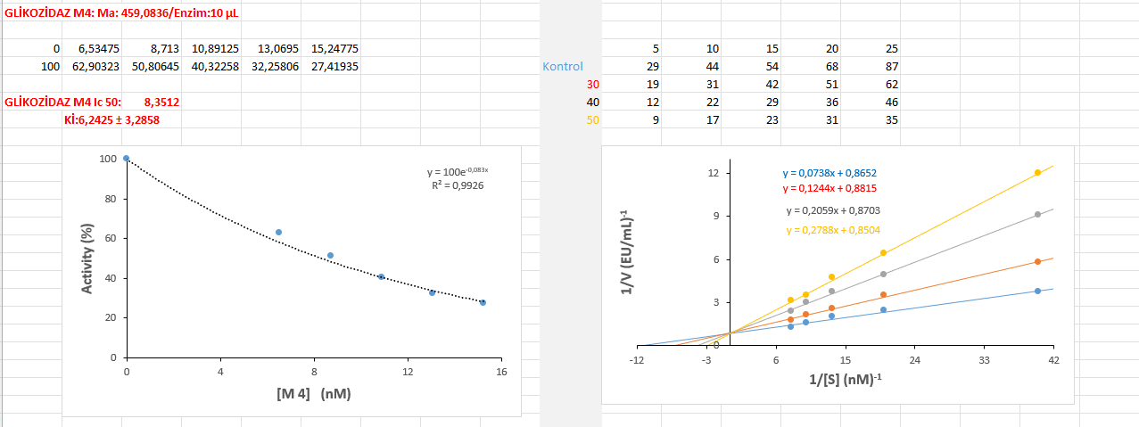

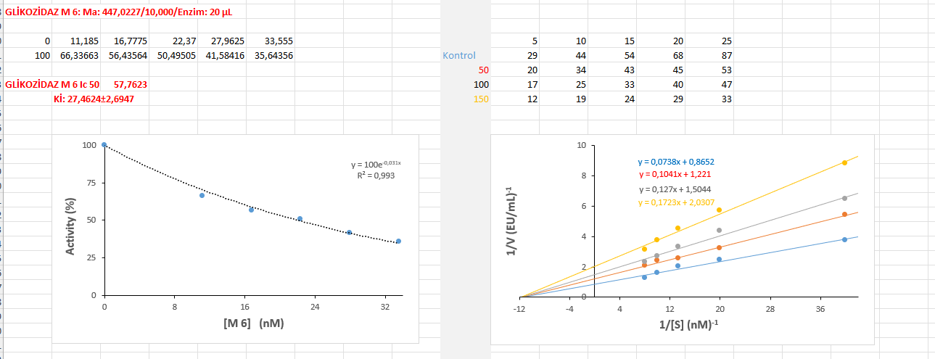

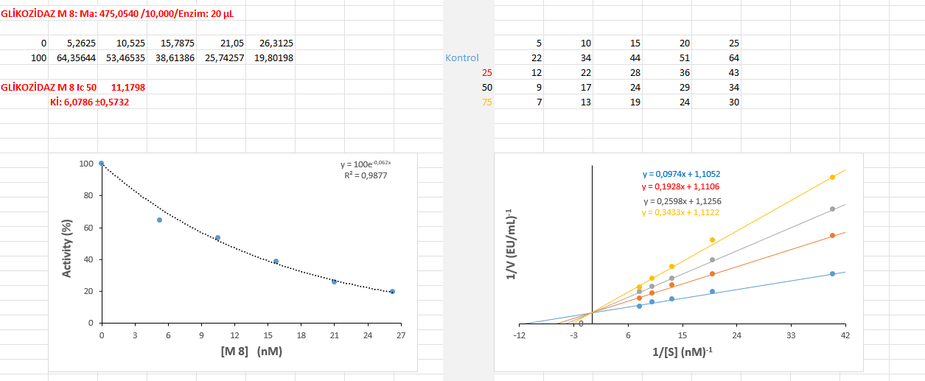
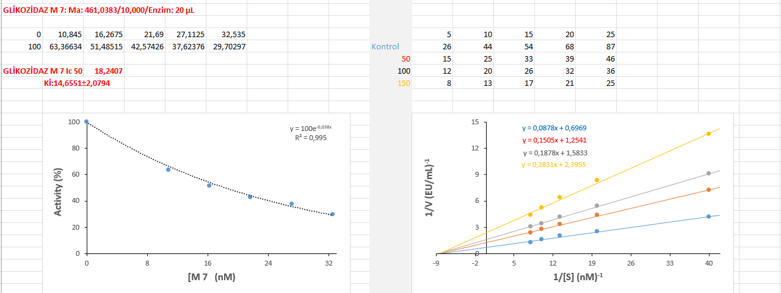

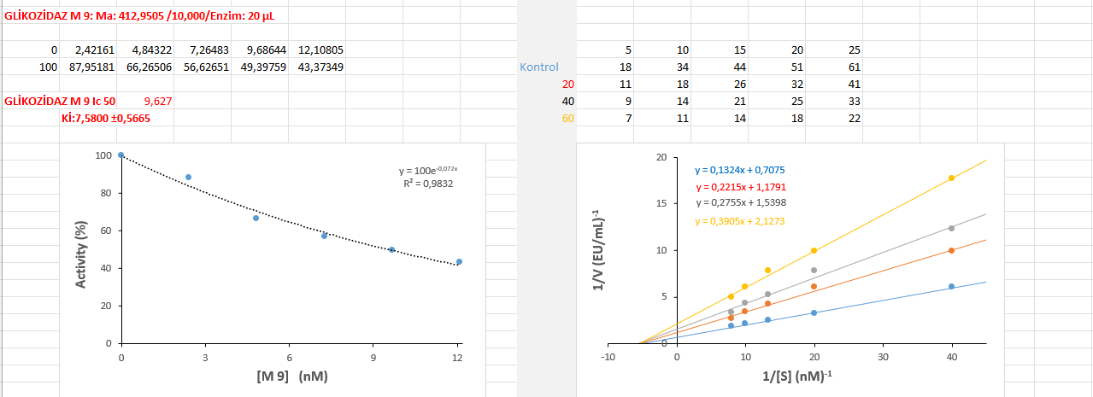

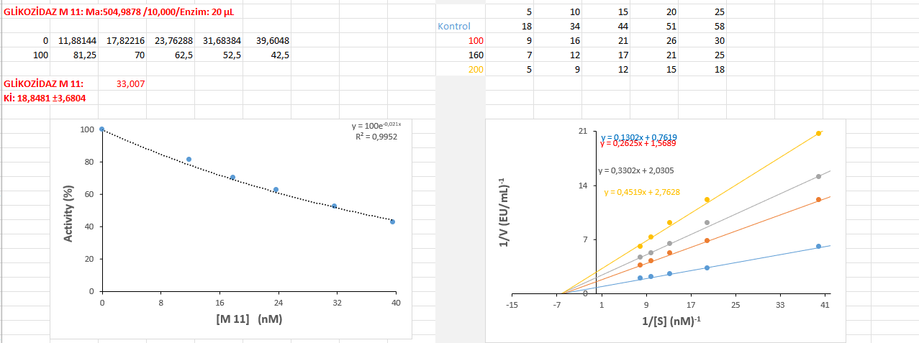
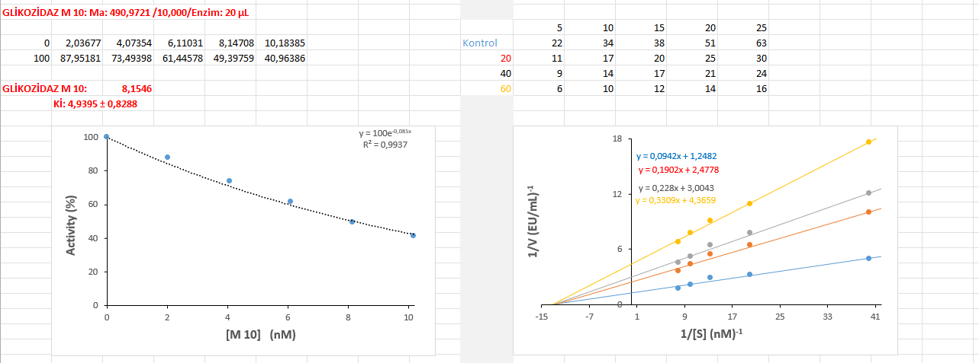

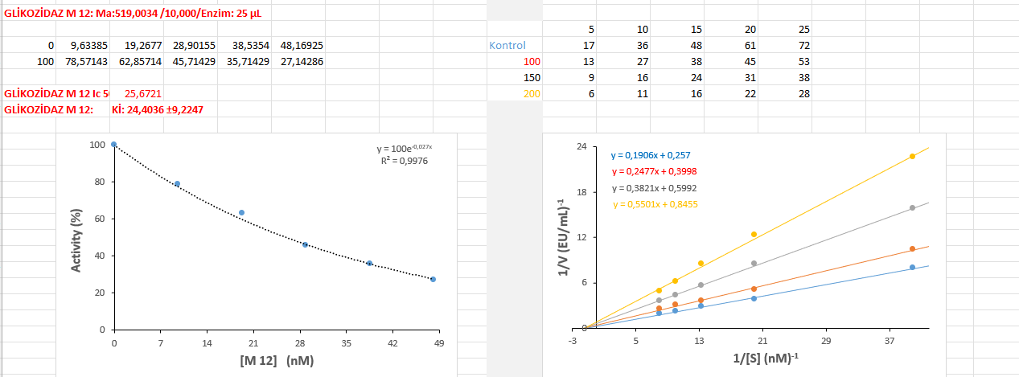

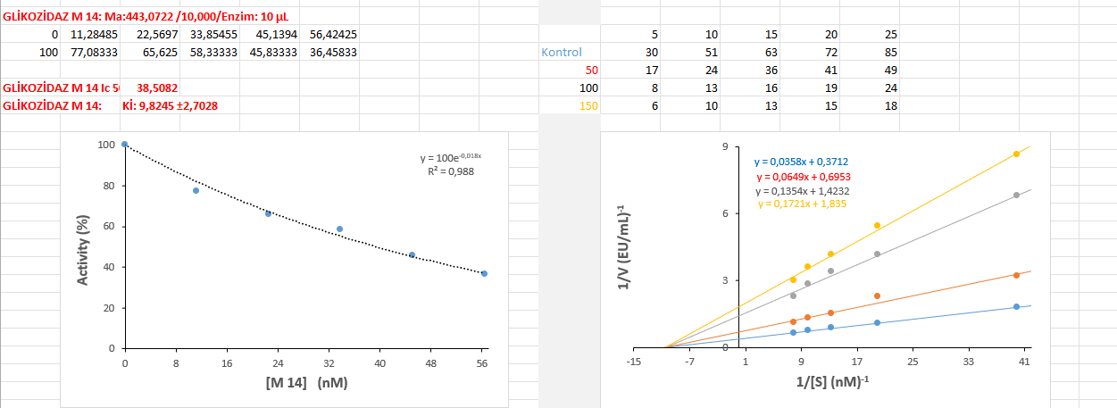
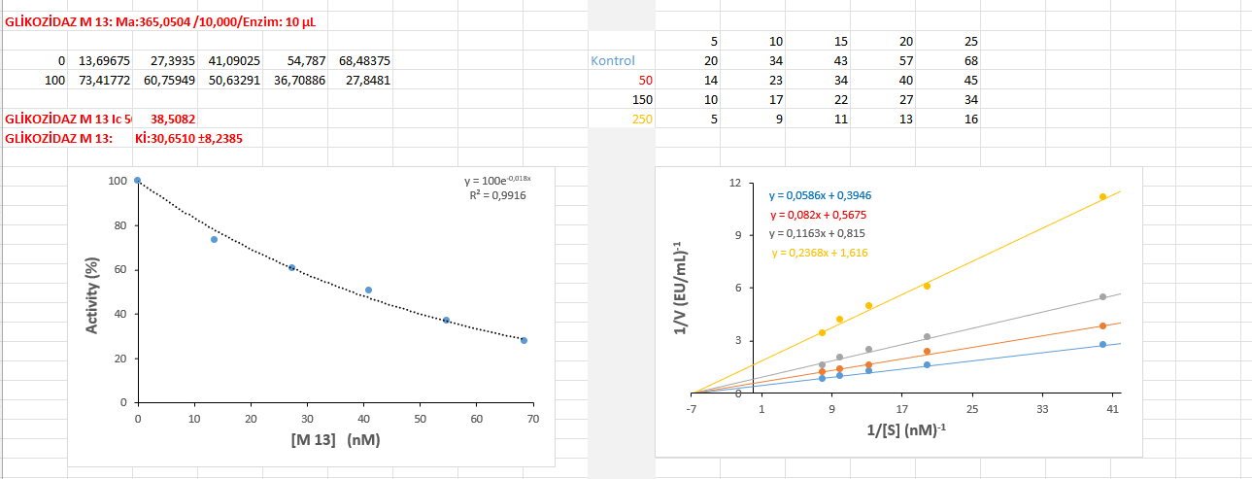

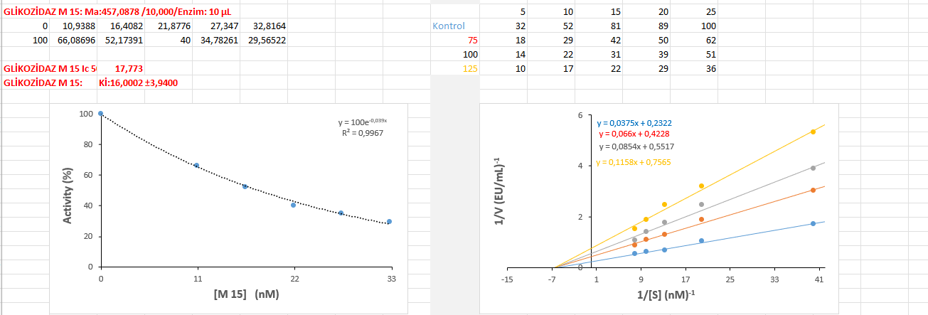

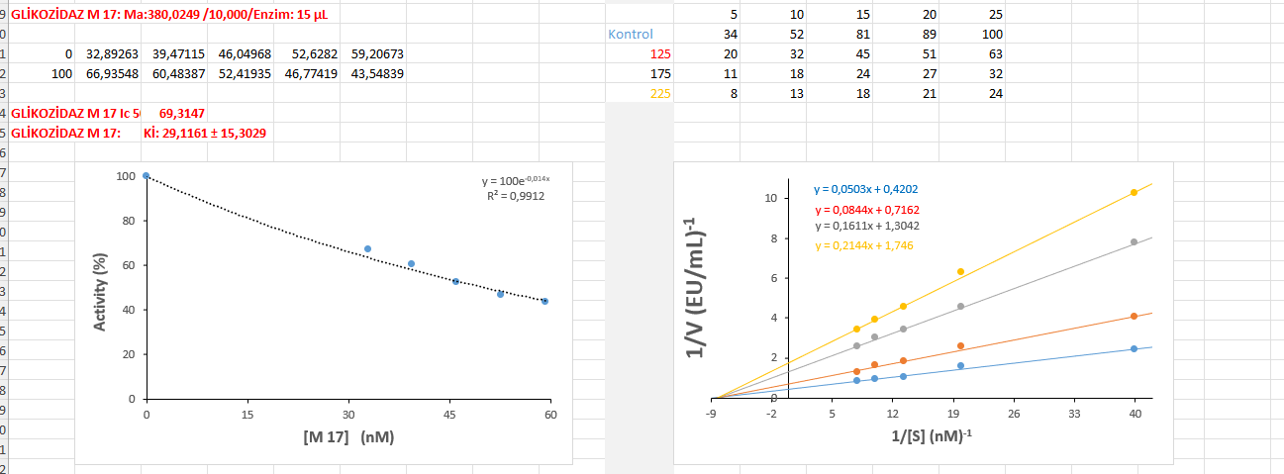
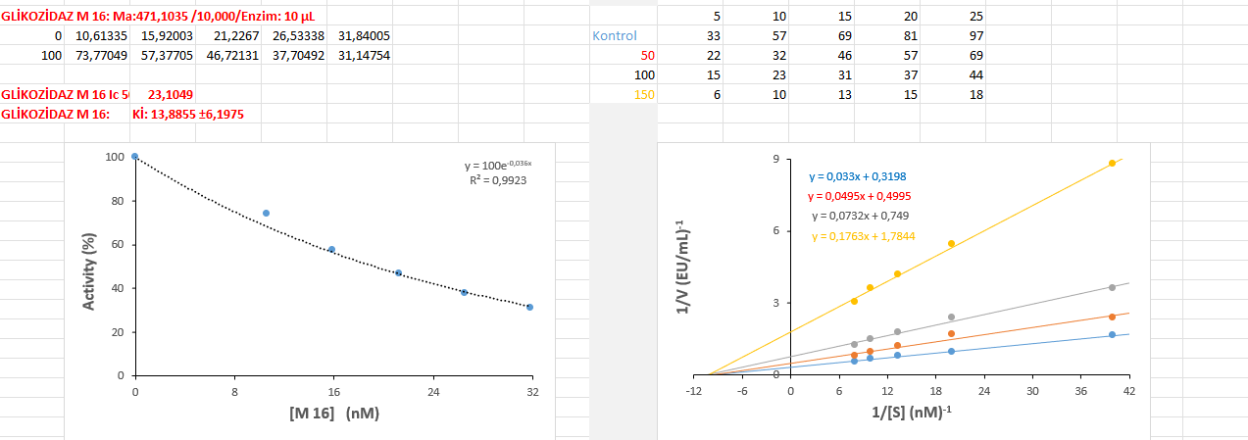

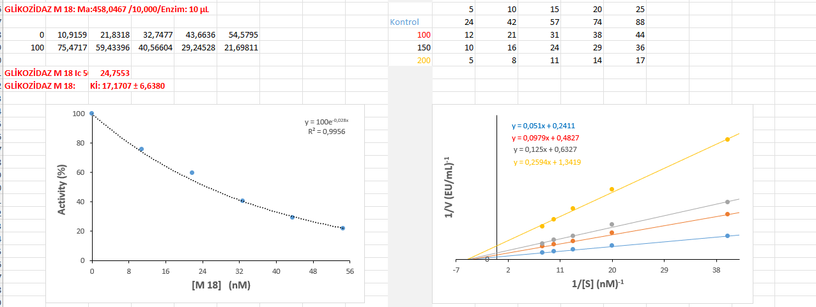

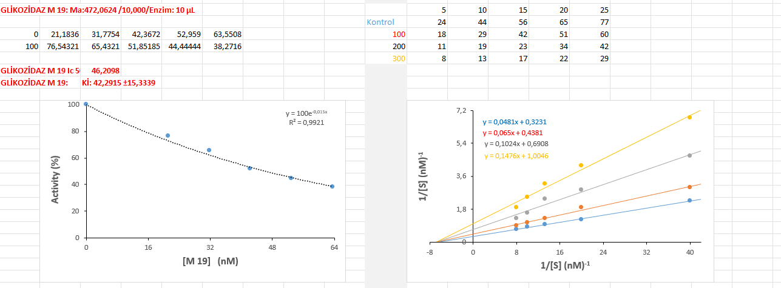
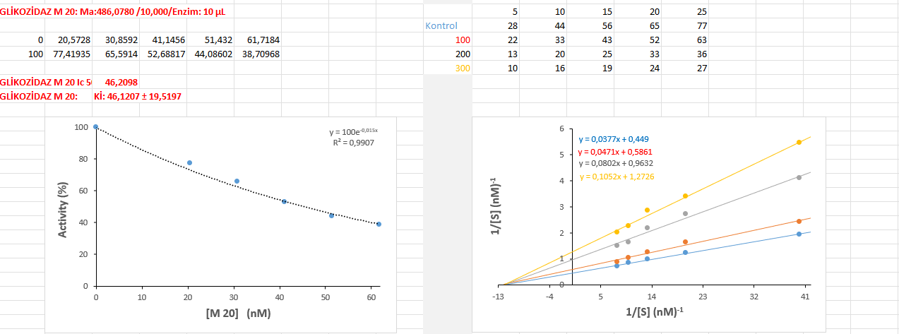

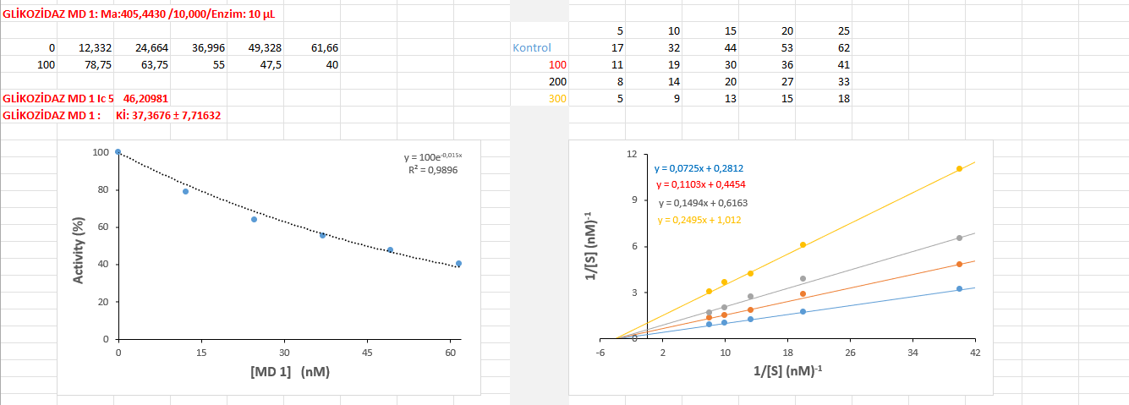

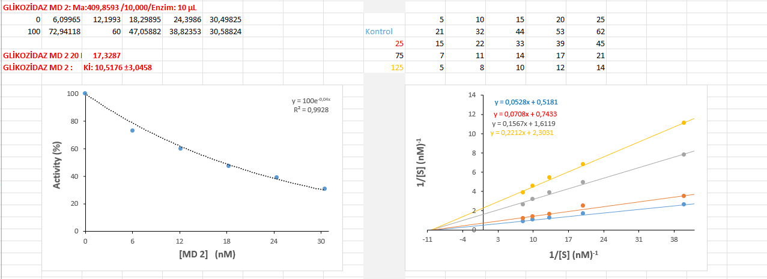
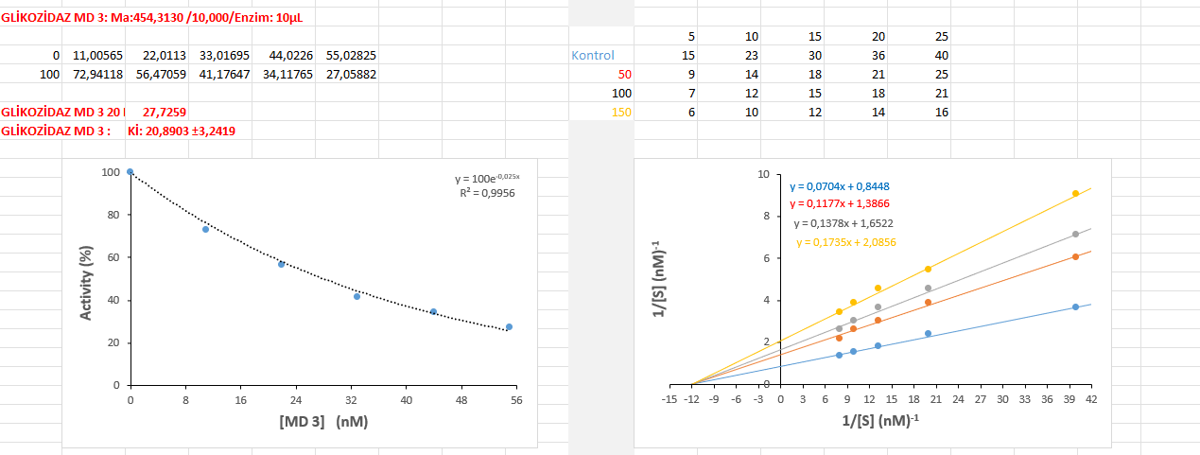

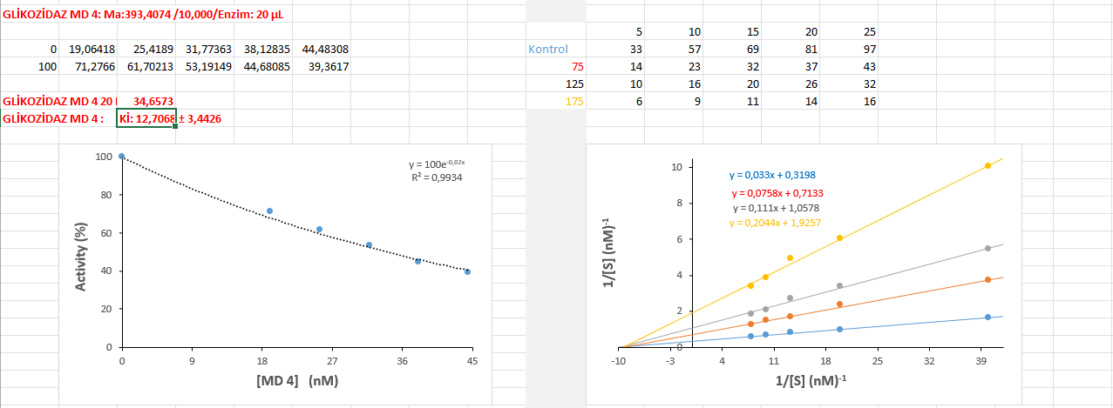

α-Amylase Graps

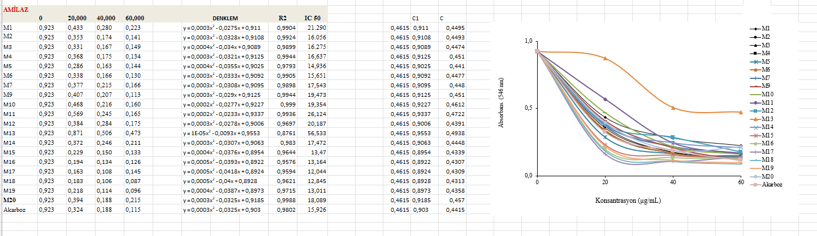
Compound M1-M20

Compound MD1-MD4
