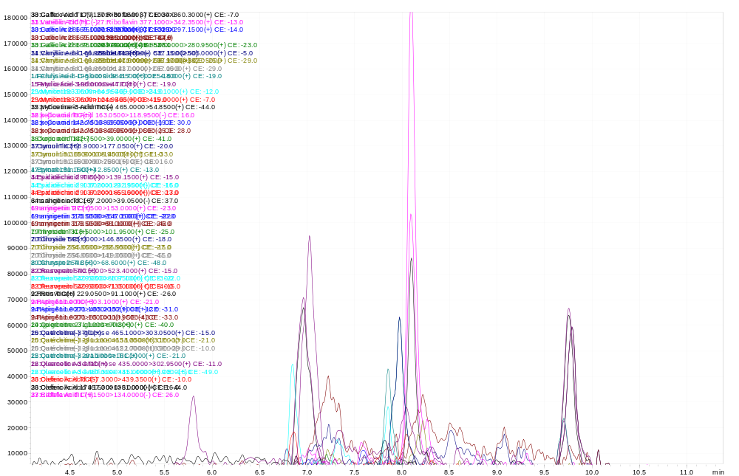
Figure S1. LC–ESI–MS/MS chromatogram of the reference-standard mixture.
Figure S2. Representative concentration–response curves used to determine the DPPH and ABTS IC₅₀ values, and BSA protein anti-denaturation IC₅₀ value of the Opuntia ficus-indica aqueous extract. Data are presented as mean ± SD of three independent determinations.

