The Burden of Performing Minimal Access Surgery: Ergonomics Survey Results from 462 Surgeons across Germany, the UK and the USA

Jonathan Morton, FRCS,¹ Grant D. Stewart, FRCS^{1,2}
¹Cambridge University Hospitals NHS Foundation Trust, Cambridge, UK
²Department of Surgery, University of Cambridge, Cambridge, UK
Corresponding author: Jonathan Morton (jonathan.morton@addenbrookes.nhs.uk); Department of Colorectal Surgery, Addenbrookes Hospital, Cambridge University Hospitals NHS Foundation Trust, Cambridge, UK
SUPPLEMENTARY MATERIALS

Supplementary Table S1: Ergonomics survey questions
Demographic questions
Q1 | How old are you? (Free text)
Q2 | How many years have you been practising as a surgeon? (Free text)
Q3 | Which gender do you identify with? (Free text)
Q4 | Which of the following, if any, best describes your current medical specialty?
Q4 | Gynaecology / colorectal / general (performing hernia repair)
Q5 | Which of the following types of surgery do you routinely conduct?
Q5 | Laparoscopic/MAS surgery / open surgery / robot-assisted surgery
Q6 | How tall are you? (Free text)
Q7 | What is your surgical glove size? (Multiple choice)
Q7 | XS / S / M / L / XL
Study questions
Q1 | How often do you experience muscular or back pain as a result of practicing surgery? (Multiple choice)
Q1 | Never / rarely / sometimes / frequently / every time I operate
Q2 | How physically comfortable or uncomfortable are you during surgery? (Multiple choice)
Q2 | Very comfortable / comfortable / neither comfortable nor uncomfortable / uncomfortable / very uncomfortable
Q3 | If you feel discomfort, where are you mostly affected? (Multiple choice)
Q3 | Back / neck / shoulders / feet / legs / hands / knees / arms / hips / elbows
Q4 | Why do you think this happens? (Free text)
Q5 | How frequently do you experience physical discomfort during surgery? (Multiple choice)
Q5 | Never / rarely / sometimes / frequently / every time I operate
Q6 | Do you have any issues using your hands? (Y / N)
Q7 | What issues do you have using your hands? (Free text)
Q8 | How likely do you think it is you may need to retire early due to the physical impact on your own health of operating? (Multiple choice)
Q8 | Not at all likely / not very likely / don’t know / fairly likely / very likely
Q9 | At what stage in your opinion, do surgeons reach their peak professional performance? (Multiple choice)
Q9 | 30–35 / 35–40 / 40–45 / 45–50 / 50–55 / 55–60 / prefer not to say
Q10 | Have you ever personally had to consult a healthcare professional due to musculoskeletal injuries associated with minimal access surgery? (Multiple choice)
Q10 | Yes / no / prefer not to say

Supplementary Table S2: Direct quotes for reasons for discomfort while performing MAS
Why do you think you feel discomfort during surgery?
‘Prolonged standing lasting several hours and working without a break’
‘Standing without much movement for prolonged periods of time’
‘Especially in laparoscopic procedures, a longer-term oblique posture (e.g., when standing sideways-on to the patient) occasionally results in neck tension pains’
‘Length of surgery as standing for a long time. My shoulders hurt when I do long laparoscopic surgeries’
‘Twisting my body into uncomfortable positions’
‘Standing for a long time in concentrated, forced posture under constant tension’
‘Unfavourable position/posture at the table’
‘Prolonged standing with a strained arm position and uneven weight distribution’
‘Positioning during laparoscopic surgery can cause difficult back positioning in gynaecology [procedures]’
‘Gynaecology surgery almost always results in poor ergonomic positioning, especially vaginal surgery. Repetitive movements are tiring and straining’
‘Due to the prolonged standing the body gets tired and you’d often be standing in an unfavourable position, as not all equipment is designed to fit tall surgeons’
‘Performing surgery mandates certain positions for longer periods of time, and certain positions that are unnatural. With a ‘vulnerable’ neck/back, those factors significantly increase discomfort/pain’
‘Due to the long, relatively static standing with minimal opportunity to move around’
‘Occasional pain due to the back being in a twisted position’
‘Tensing up over long periods, especially when operating laparoscopically, uncomfortable posture’
‘In particular during laparoscopic procedures, a crooked posture (e.g., when lateral to the patient) leads to long-term muscle tensions and pain in the neck area’
‘Prolonged standing in one position, in particular during endoscopic procedures’
‘I find myself super-extending my knees while I operate without even realising and, after standing for 2–3 hours, it becomes really painful’
‘I am 6ft 2” and the table is often too low for my height, so I have to bend my neck down far’
‘I especially feel neck and shoulder discomfort during direct view (without a camera) laparoscopy. Sometimes I can see better that way, but it is a very awkward position. Otherwise, I mostly feel discomfort during long procedures’
‘Positioning of patients and instruments are not necessarily ergonomically designed, nor designed with female surgeons in mind’
‘Shoulder and neck positions for vaginal hysterectomy, especially with an assistant, is challenging. Also shoulders from reaching to use laparoscopic ports. Although I do not use a microscope frequently, when I do it can cause neck pain if not meticulously positioned’
What issues do you have using your hands?
‘After back-to-back surgeries my thumb and index finger get very swollen and lose their complete range of motion’
‘Bilateral carpal tunnel syndrome’
‘Joint issues’
‘Occasional pain and stiffness’
‘I get some pain at sites of tendons in my wrist’

Supplementary Figure S1: Frequency of discomfort by surgeon height
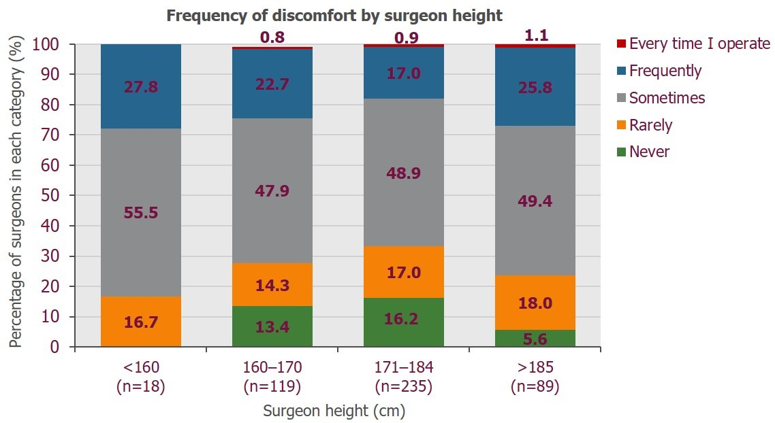
Frequency of discomfort while performing surgery stratified by surgeon height category.

