Development and Evaluation of a Societal Core Robotic Surgery Accreditation Curriculum for the UK
Authors: Matthew WE Boal (MBChB)^{1,2,3}, Asma Afzal (MD)^{3,4}, Jack Gorard (MBChB)⁵, Aishwarya Shah (iBSc)⁵, Freweini Tesfai (MD/MSc)^{1,2,3}, Walaa Ghamrawi (MD)^{1,2}, Matthew Tutton (FRCS)^{3,6}, Jawad Ahmad (FRCS)^{3,7}, Chelliah Selvasekar (PhD, FRCS)^{3,8}, Jim Khan (PhD, FRCS)^{3,9}, Nader K Francis (PhD, FRCS)^{1,3,10,11}
Affiliations:
- The Griffin Institute, Northwick Park & St Marks’ Hospital, London, UK
- Wellcome/ESPRC Centre for Interventional Surgical Sciences (WEISS), University College London (UCL), UK
- The Association of Laparoscopic Surgeons of Great Britain and Ireland, UK
- The Royal Devon and Exeter NHS Foundation Trust
- University College London, UK
- East Suffolk and North Essex NHS Foundation Trust, UK
- University Hospitals Coventry and Warwickshire NHS Trust, UK
- The Christie NHS Foundation Trust, UK
- Portsmouth Hospitals University NHS Trust, UK
- Division of Surgery and Interventional Science, Research Department of Targeted Intervention, UCL, UK
- Yeovil District Hospital, Somerset Foundation NHS Trust, UK
Conflict of interest and Source of Funding:
No funding sources
Matt Boal’s PhD is funded by Digital Surgery Ltd, Medtronic
Category: Original article
Word count: 2741
Author correspondence: Professor Nader Francis, The Griffin Institute, Northwick Park and St Marks Hospital, London, UK. N.francis@griffininstitute.org.uk. 02039580500.
Keywords: Robotic, Surgery, Curriculum, Development, Evaluation, Proficiency
Acknowledgements:
Thank you to Digital Surgery Inc, a Medtronic Company, for funding Matthew Boal’s PhD.
Thank you to all participants of the curriculum.
Thank you to Dr C. Suarez-Rivera, UCL Associate Lecturer, for providing statistical consulting support.
Data access: Data can be reproduced on reasonable request

Supplementary Figures:
Supplementary Figure 1: Modifiable-GEARS assessment tool
Supplementary Figure_2: Example feedback capturing participants’ reaction
Supplementary Figure_3: Scatter plot demonstrating the correlation between attempt 2 dry task sum M-GEARS scores and the summative cyst removal final score

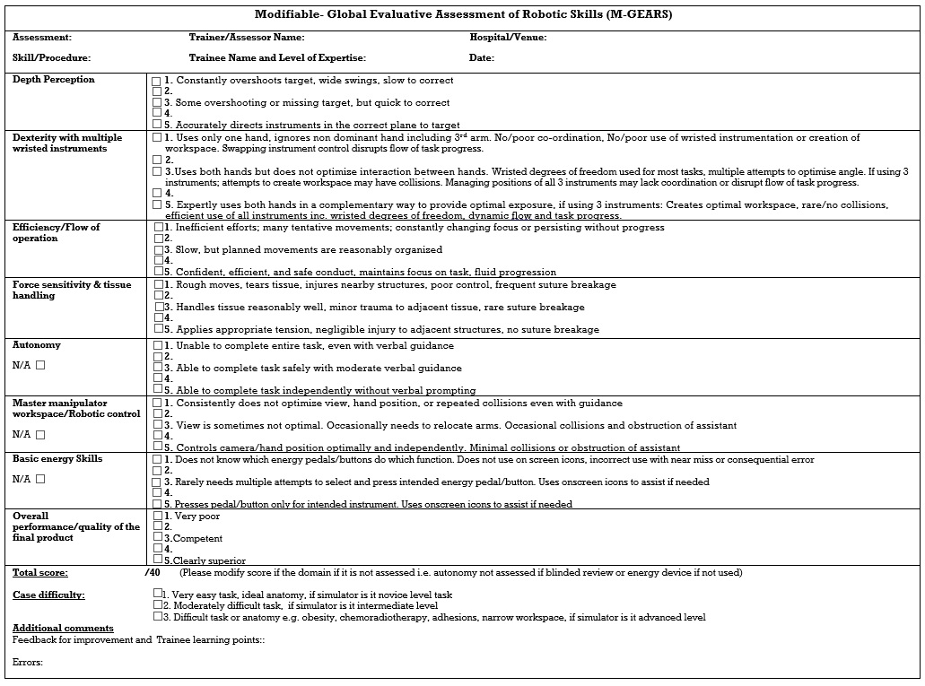
Supplementary Figure 1: Modifiable-Global Evaluative Assessment of Robotic Skills (M-GEARS) assessment tool

Supplementary Figure_2: Example feedback capturing participants’ reaction

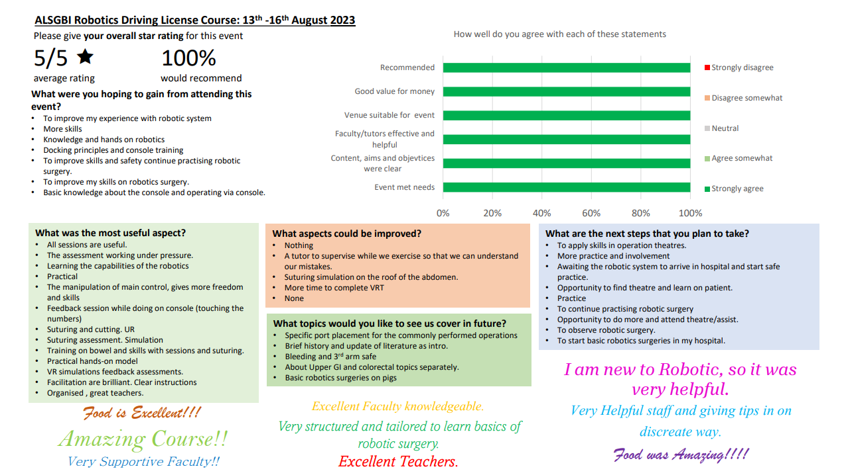

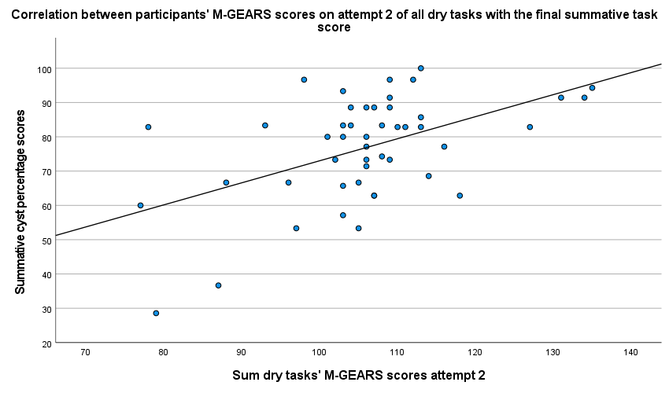
Supplementary Figure_3: Scatter plot demonstrating the correlation between attempt 2 dry task sum M-GEARS scores and the summative cyst removal final scores

Top of Form

