Supplementary files
Supplementary Figure 1: Study flow diagram
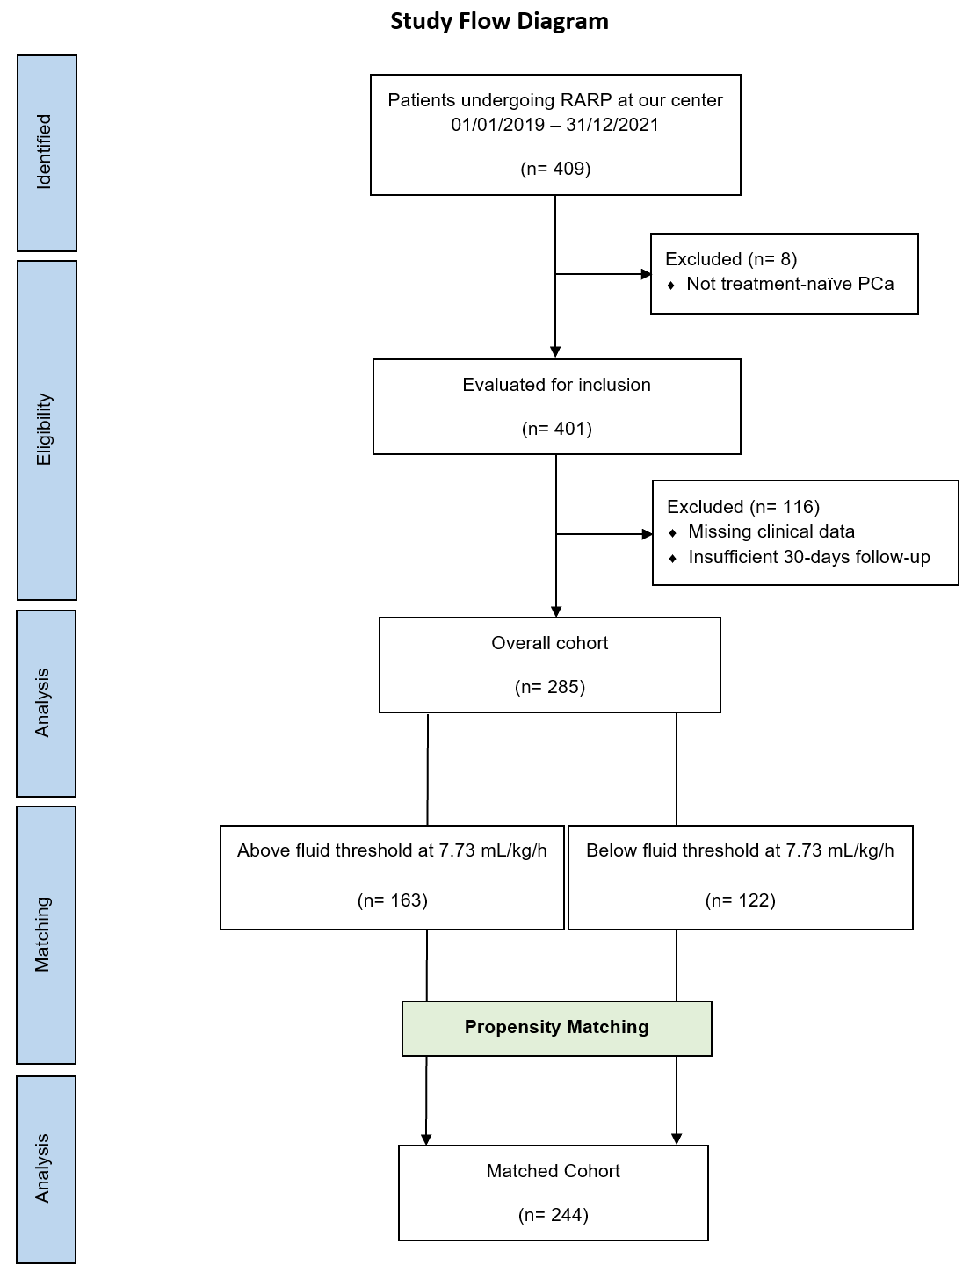
Supplementary Figure 2: Distribution of Propensity scores
