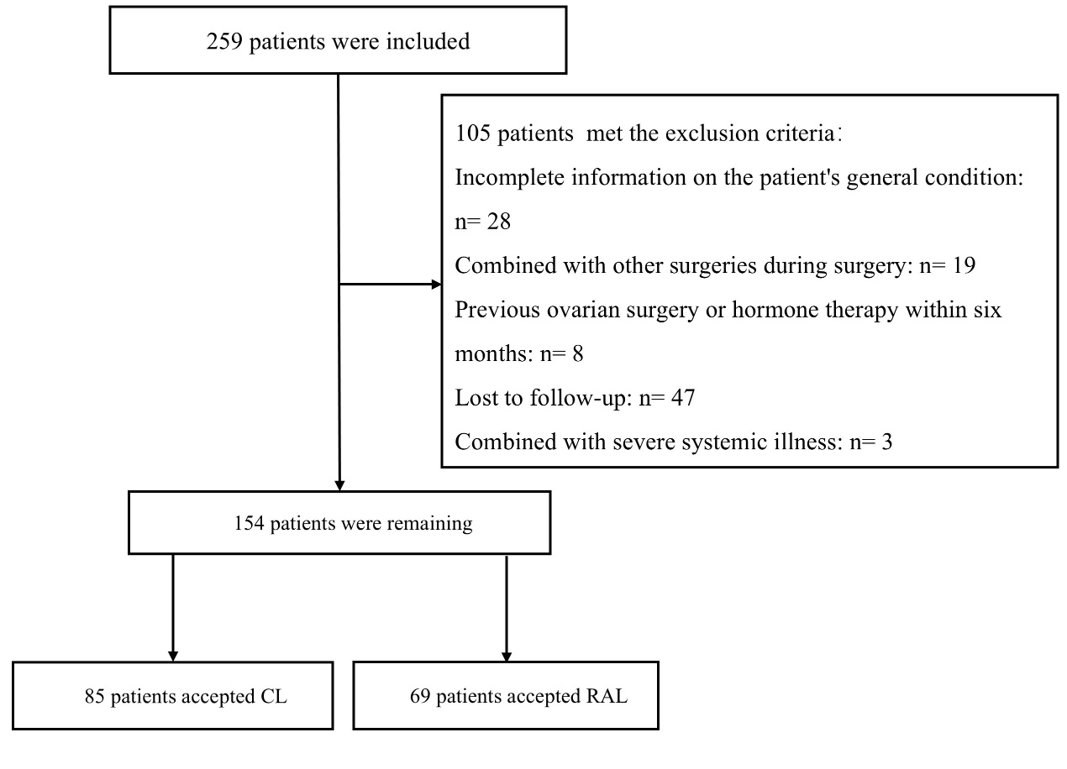
Supplemental Fig 1. Flowchart of the participant selection

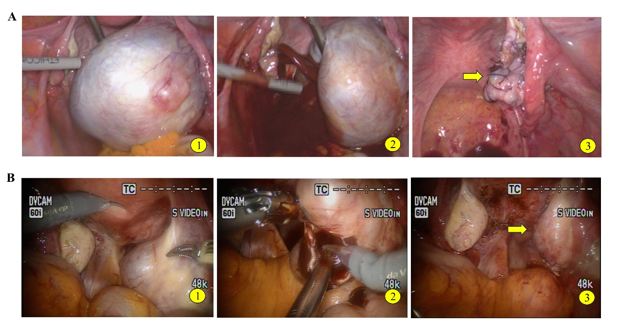
Supplemental Fig2. Representative photographic images showing the surgical outcomes of ROS-RAL OMA surgery and conventional OMA CL surgery. 2A is CL findings, and 4B is ROS-RAL surgery findings. 2A1 and 2B1 show OMA of the right ovary before surgery. 2A2 and 2B2 shows the chocolate-colored liquid flowing out after the cyst has been ruptured. 2A3 and 2B3 show the postoperative findings.

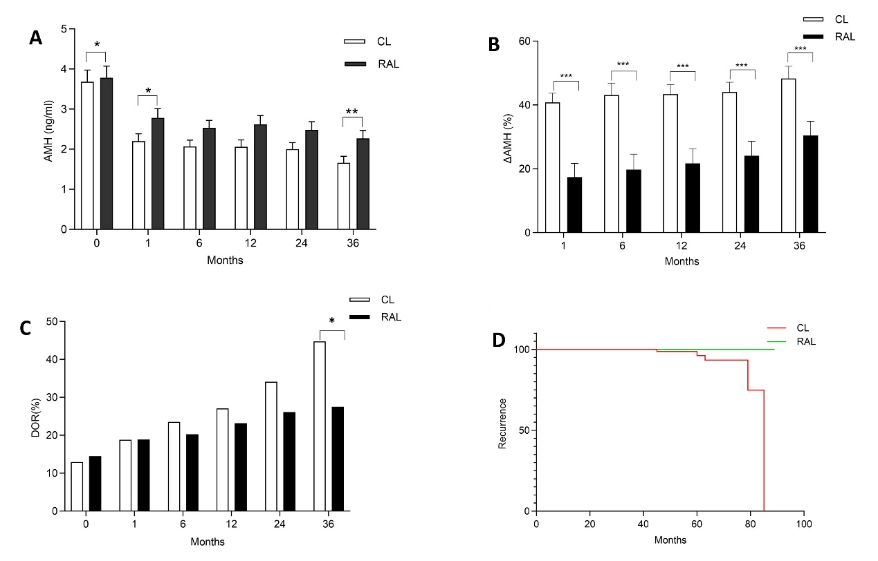
Supplemental Fig3. Effects of CL and RAL on ovarian function and postoperative recurrence. A. AMH levels at different postoperative time points (0, 1, 6, 12, 24, and 36 months). B. ΔAMH decline rate at different postoperative time points (1, 6, 12, 24, and 36 months). C. Incidence of DOR at different postoperative time points (0, 1, 6, 12, 24, and 36 months). D. Kaplan-Meier curve showing the recurrence rate of OMA post-surgery, with no recurrence observed in the RAL group. *p <0.05, **p <0.01, ***p<0.001

