Journal of Robotic Surgery
Real-World Performance of the SSI Mantra™ Robotic System: A Multi-Centric Multi-Specialty Study Evaluating its Safety and Surgical Applications
Running head: SSI Mantra™ Robotic System Study
Somashekhar SP¹, Medha Sugara¹, Kushal Agrawal¹, Sudhir Kumar Rawal², Amitabh Singh², Magan Mehrotra³, Raj Gajbhiye⁴, Chandramohan Vaddi⁵, Srikarthik Voleti¹, Leena Mehrotra ⁶, Ganesh Gorthi⁷, Manjiri Somashekhar⁸, Nitin Kumar Rajput⁹
¹Department of Surgical Oncology, Aster International Institute of Oncology, Bangalore, India.
²Department of Genito-Uro-Oncology, Rajiv Gandhi Cancer Institute, New Delhi, India.
³Department of Minimal Access and Bariatric Surgery, Apex Hospital, Moradabad, India.
⁴Department of General Surgery, Government Medical College, Nagpur, India.
⁵Department of Urology, Preeti Urology and Kidney Hospital, Hyderabad, India.
⁶Department of Gynecology, Apex Hospital, Moradabad, India.
⁷Department of Surgical Gastroenterology, Continental Hospital, Hyderabad, India.
⁸Department of Pediatric Surgery, Aster International Institute of Oncology, Bangalore, India.
⁹Department of Cardiothoracic Surgery Narayana Institute of Cardiac Sciences, Narayana Health, Bengaluru, India.
Corresponding author: Dr. (Prof) Somashekhar SP
Aster International Institute of Oncology, Aster Hospital, Aster CMI Hospital, No. 43/2, New Airport Road, NH44, Sahakar Nagar, Hebbal, Bengaluru, India 560092.
Contact number: +919845712012
Email ID: drspsomashekhar@gmail.com

Supplementary Table S1. Distribution of robot-assisted surgeries performed with the SSI Mantra™ system by region and hospital. The table shows the top hospitals by procedure volume in each region (North, South, East, West).
Region | Sl. No. | Hospital | Surgery Count
North | 1 | Rajiv Gandhi Cancer Institute and  Research Center, Delhi NCR | 454
 | 2 | Apex Hospital, Moradabad | 404
 | 3 | Aadhar Health Institute, Hisar | 159
 | 4 | Medanta Hospital, Gurgaon | 59
 | 5 | Meenakshi Hospital, Ghaziabad | 49
 | 6 | Marengo, Gurgaon | 38
 | 7 | Medanta Hospital, Gurgaon | 38
 | 8 | Apex Hospital, Moradabad | 26
 | 9 | Metro Hospital, Faridabad | 26
 | 10 | SRMS, Bareilly | 26
South | 1 | Aster-CMI Hospital, Bangalore | 235
 | 2 | Continental Hospital, Hyderabad | 129
 | 3 | Preeti Hospital, Hyderabad | 119
 | 4 | NH, Bangalore | 117
 | 5 | Hindusthan Hospital, Coimbatore | 74
 | 6 | KIIMS Hospital, Hyderabad | 47
 | 7 | Yenepoya Hospital, Mangalore | 31
 | 8 | KLE Hospital, Belgaum | 29
 | 9 | Silverline Hospital | 19
 | 10 | Prakriya Hospital, Bangalore | 17
East | 1 | Shanti Memorial Hospital, Cuttack | 53
 | 2 | Ruban Memorial Hospital, Bihar | 30
 | 3 | Healthworld Hospital, Asansol | 16
 | 4 | Fortis Hospital & Kidney Institute, Kolkata | 13
 | 5 | Agile Hospital, Guwahati | 5
West | 1 | GMC, Nagpur | 167
 | 2 | Kaizen Hospital, Ahmedabad | 98
 | 3 | Conwest Jain Hospital, Mumbai | 76
 | 4 | Sanjeevani Hospital, Raipur | 63
 | 5 | Cytocure Hospital, Mumbai | 61
 | 6 | Marengo, Ahmedabad | 29
 | 7 | Dhamelia Hospital, Surat | 26
 | 8 | ICON Hospital, Surat | 25
 | 9 | GBL Hospital, Indore | 23
 | 10 | Noble Hospital, Pune | 18

Supplementary Table S2. Experience and conversion-wise length of stay.
Experience Group | Conversion Status | n | % of Group | Median LOS (IQR) | Mean LOS (SD) | Min–Max
Q1–Q3 | Not Converted | 485 | 92.9% | 3 (2–4) | 2.99 (2.04) | 1–38
Q1–Q3 | Converted | 37 | 7.1% | 3 (2–4) | 5.00 (9.48) | 1–60
Q4 | Not Converted | 1997 | 96.3% | 3 (2–4) | 2.96 (1.40) | 1–16
Q4 | Converted | 77 | 3.7% | 3 (2–3) | 3.29 (2.22) | 1–15
Q: quartile; IQR: interquartile range; SD: standard deviation; LOS: length of stay; Min: minimum; Max: maximum

Supplementary Table S3. Multivariable linear regression of console time (minutes).
Variable | β (minutes) | 95% Confidence Interval | p-value
Conversion to open surgery (Yes vs No) | −36.7 | −52.1 to −21.3 | <0.001
Surgeon experience (More vs Less experienced) | −28.4 | −35.8 to −20.9 | <0.001
Cardiac | −73.5 | −161.0 to 13.8 | 0.099
Colorectal | 11.0 | −76.4 to 98.4 | 0.806
Gastrointestinal | 8.5 | −79.7 to 96.7 | 0.850
General | −98.7 | −185.0 to −12.2 | 0.025
Gynecology | −46.0 | −133.0 to 40.7 | 0.298
Head and neck | −49.1 | −139.0 to 40.9 | 0.285
Thoracic | −60.6 | −153.0 to 32.2 | 0.200
Urology | 3.4 | −83.2 to 89.9 | 0.939

Supplementary Table S4. Log-transformed multivariable regression of console time (Sensitivity analysis; relative effects).
Variable | β (log scale) | 95% Confidence Interval | p-value | Approx. % Change
Conversion to open surgery (Yes vs No) | −0.235 | −0.353 to −0.117 | <0.001 | −21%
Surgeon experience (More vs Less experienced) | −0.364 | −0.421 to −0.306 | <0.001 | −30%
Cardiac | −0.705 | −1.37 to −0.038 | 0.038 | −50%
Colorectal | −0.048 | −0.715 to 0.619 | 0.887 | −5%
Gastrointestinal surgery | −0.222 | −0.895 to 0.451 | 0.518 | −20%
General surgery | −0.967 | −1.63 to −0.307 | 0.004 | −62%
Gynecology | −0.409 | −1.07 to 0.253 | 0.226 | −34%
Head and neck | −0.451 | −1.14 to 0.236 | 0.198 | −36%
Thoracic | −0.450 | −1.16 to 0.258 | 0.213 | −36%
Urology | −0.065 | −0.726 to 0.595 | 0.846 | −6%

Supplementary Figure S1. Residual plots to inspect deviations from linearity or homoscedasticity
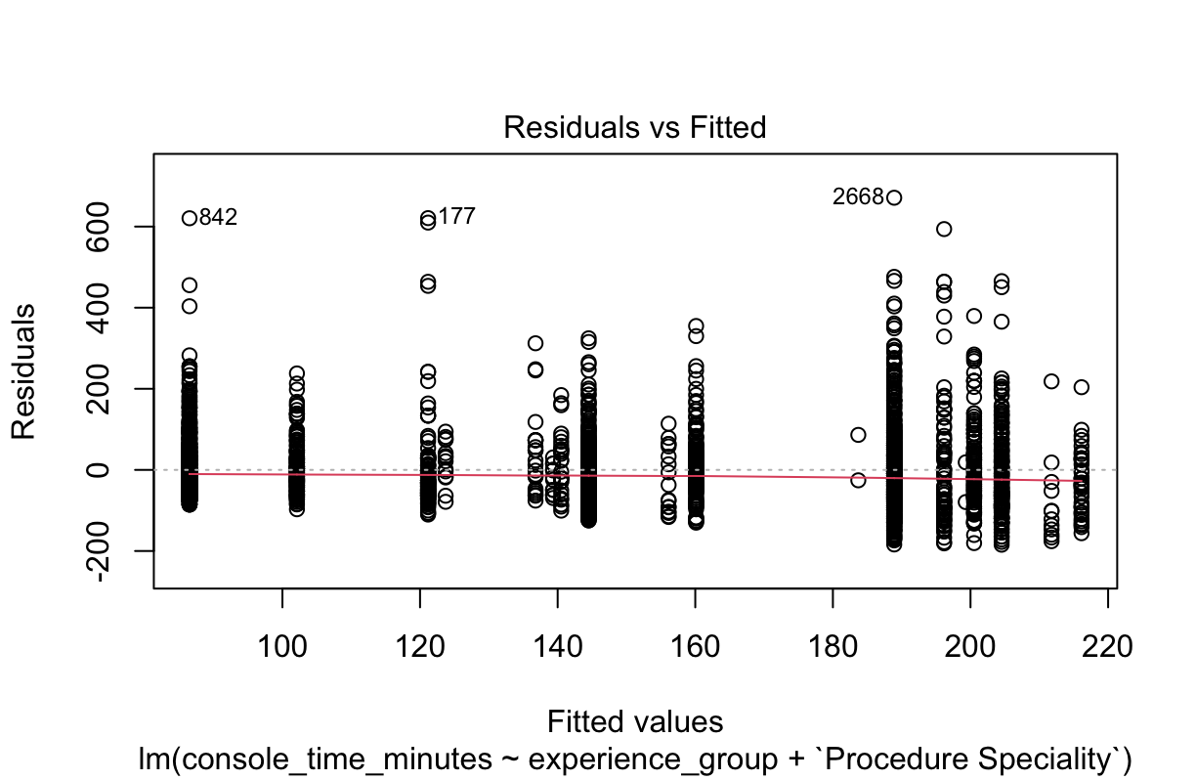

Supplementary Figure S2. Conversion rate (%) by surgical procedure with ≥20 cases and ≥5 conversions

Supplementary Figure S3. Continuous CUSUM charts for lower-volume procedures. a Internal mammary artery (IMA) harvest (cardiac), b Lower anterior resection (colorectal), c Hysterectomy (gynecology), d Gastrectomy/gastrojejunostomy (gastrointestinal)

Supplementary Figure S4. a & b Radar plots comparing surgeon experience groups on raw and normalized values for console time, conversion rate, and length of stay, respectively

