Supplementary Materials
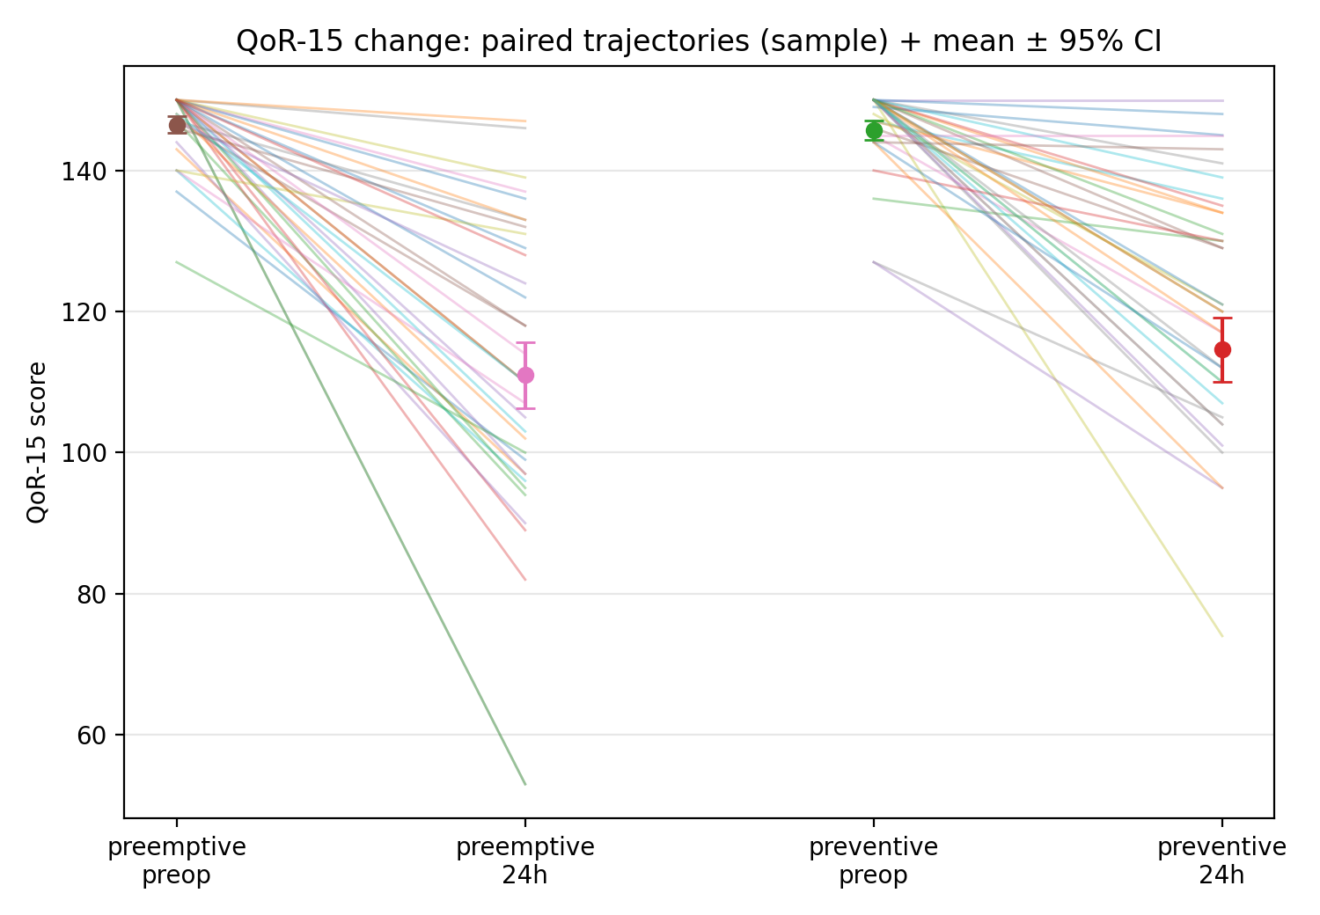

Supplementary Figure S1. Quality of Recovery Trajectories
Paired slope plot showing individual QoR-15K trajectories from preoperative to 24 hours for a random sample, with group means and 95% confidence intervals. Baseline scores clustered near the ceiling (~146–150) in both groups. At 24 hours, scores declined to approximately 111 (preemptive, pink marker) and 115 (preventive, red marker). Individual trajectories show heterogeneous decline patterns, with similar distributions between groups.
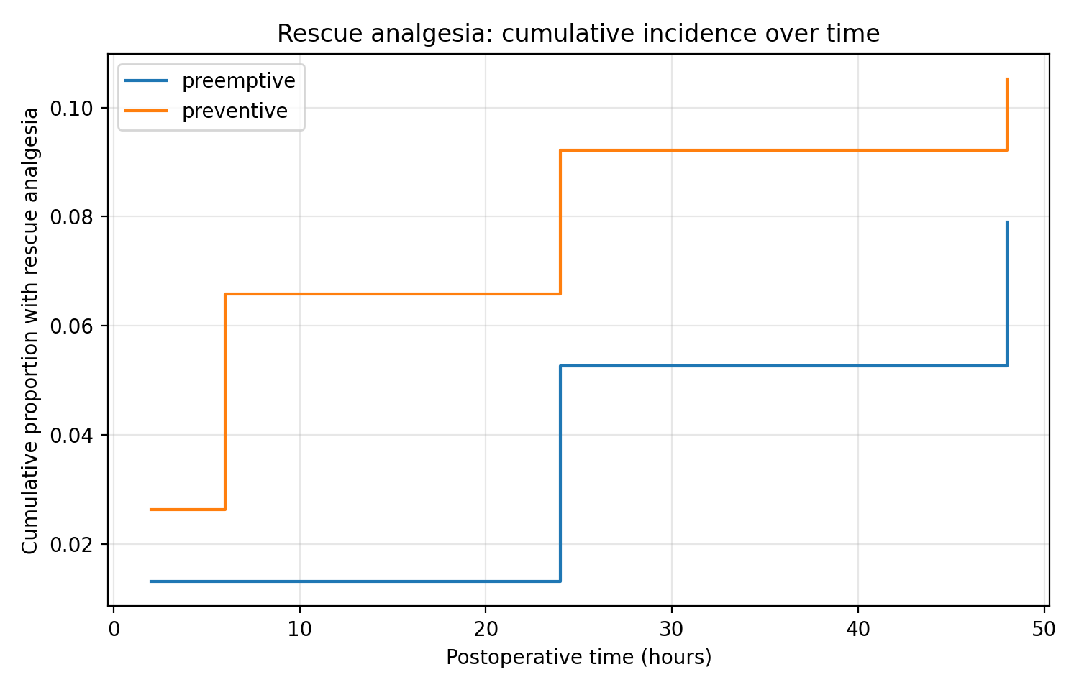

Supplementary Figure S2. Cumulative Incidence of Rescue Analgesia
Step functions showing the cumulative proportion of participants receiving rescue analgesia by postoperative time. The preventive group (orange) shows earlier and higher rescue use, reaching approximately 2.6% at two h, 6.6% at six h, 9.2% at 24 h, and 10.5% at 48 h. The preemptive group (blue) shows lower cumulative rescue use: 1.3% at two h, 1.3% at six h, 5.3% at 24 h, and 7.9% at 48 h.
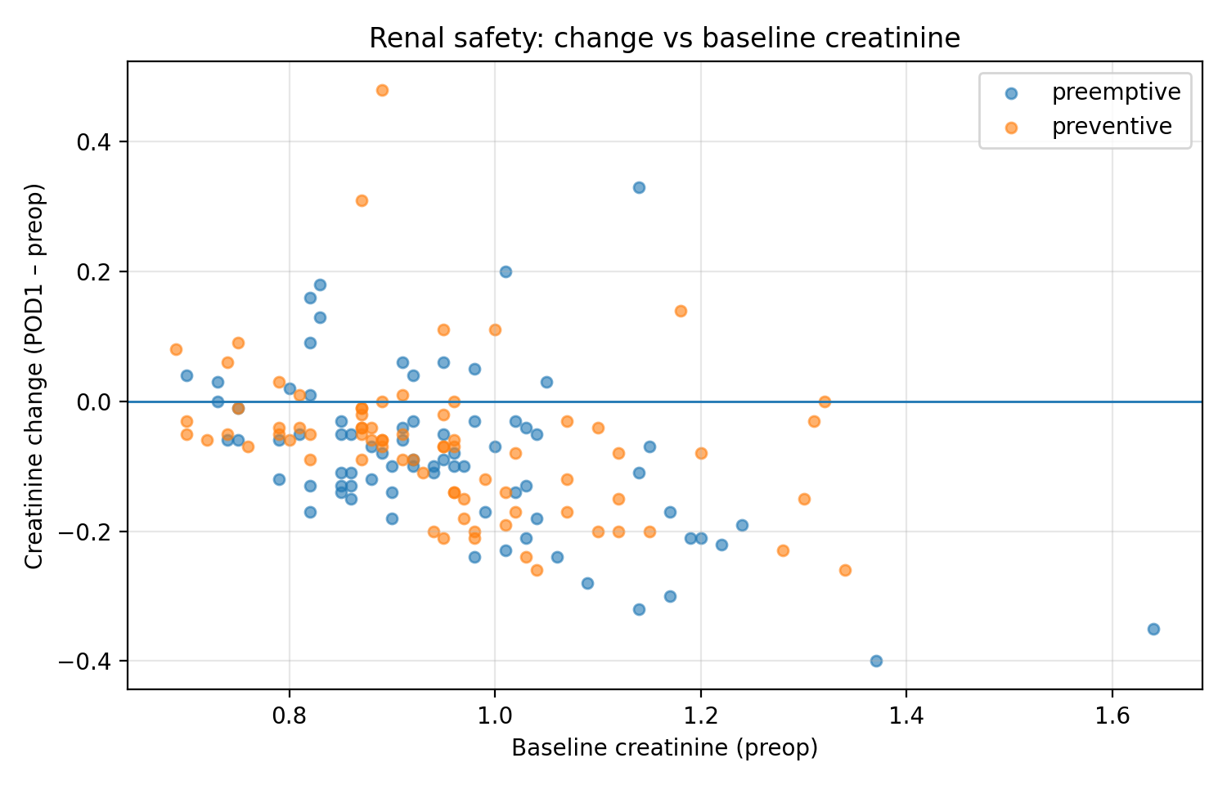

Supplementary Figure S3. Renal Safety: Creatinine Change Versus Baseline
Scatter plot of creatinine change (postoperative day 1 minus preoperative) versus baseline creatinine by group (preemptive: blue; preventive: orange). Points are intermixed with no systematic separation. Most participants showed small decreases in creatinine (below the zero reference line). No baseline-dependent differential effects were observed across the range of baseline creatinine (0.65–1.65 mg/dL).

Supplementary Table S1. Mixed-Effects Model for Cumulative Fentanyl Over Time (Log Scale)
Term | Coefficient | SE | z | P | 95% CI
Intercept | 4.34 | 0.09 | 49.46 | <0.001 | 4.16, 4.51
Preventive group | -0.01 | 0.12 | -0.10 | 0.920 | -0.26, 0.23
Time 6 h | 0.66 | 0.06 | 10.44 | <0.001 | 0.54, 0.78
Time 24 h | 1.21 | 0.06 | 19.20 | <0.001 | 1.09, 1.34
Time 48 h | 1.51 | 0.06 | 23.99 | <0.001 | 1.39, 1.64
Preventive × 6 h | 0.01 | 0.09 | 0.13 | 0.897 | -0.16, 0.19
Preventive × 24 h | 0.12 | 0.09 | 1.33 | 0.185 | -0.06, 0.29
Preventive × 48 h | 0.27 | 0.09 | 3.02 | 0.003 | 0.10, 0.44
Random intercept variance | 0.43 | 0.16 | — | — | —
Linear mixed-effects model for log(1+fentanyl) with random intercept for participant.

Supplementary Table S2. Model-Estimated Marginal Means
Rest Pain (NRS)
Time | Preemptive | Preventive
2 h | 4.61 | 4.84
6 h | 4.30 | 4.17
24 h | 2.32 | 2.43
48 h | 1.30 | 1.72
Cumulative Fentanyl (µg, back-transformed from log scale)
Time | Preemptive | Preventive
2 h | 75 | 74
6 h | 146 | 146
24 h | 255 | 284
48 h | 345 | 447

