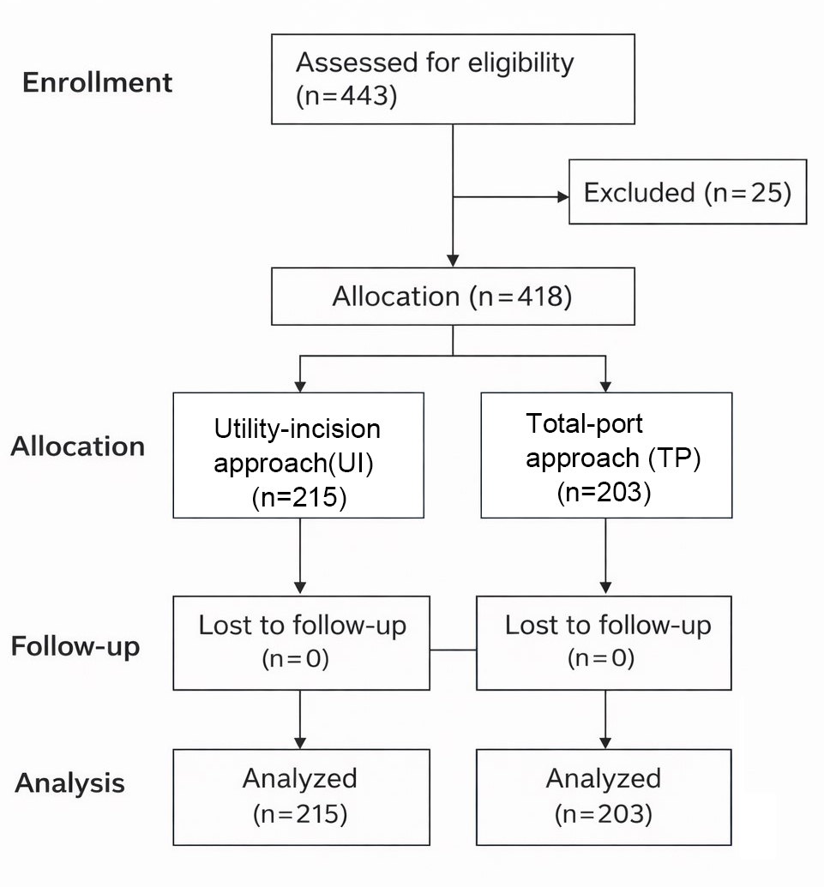 Figure S1: Flowchart of the study participants
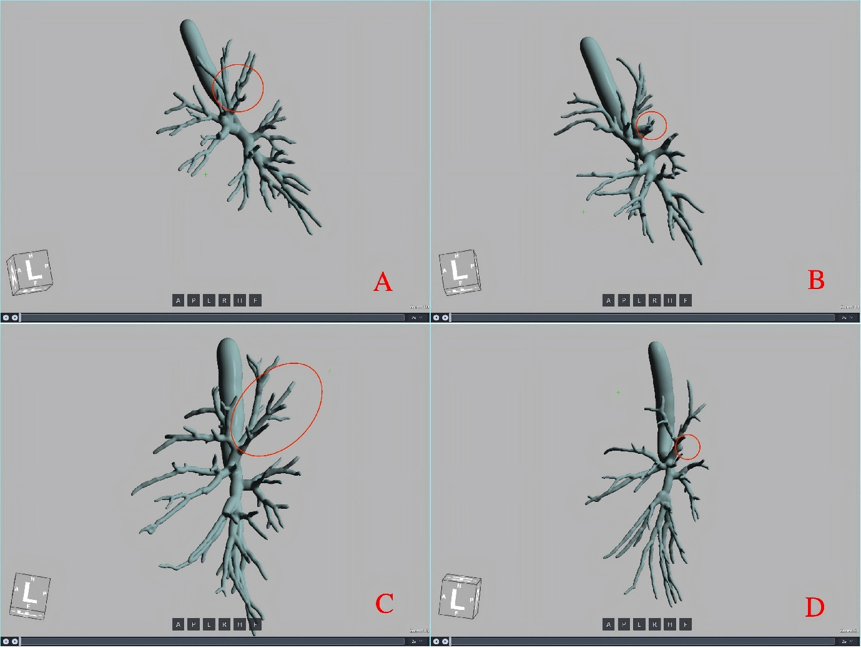
Figure S2: Assessment of surgical completeness using postoperative 3D-CT airwayreconstruction (left upper lobe apicoposterior segmentectomy). (A, C) Preoperative reconstruction. (B) Residual bronchial stump (low completeness). (D) Complete bronchial transection (high completeness). Images were independently reviewed by two blinded thoracic radiologists.
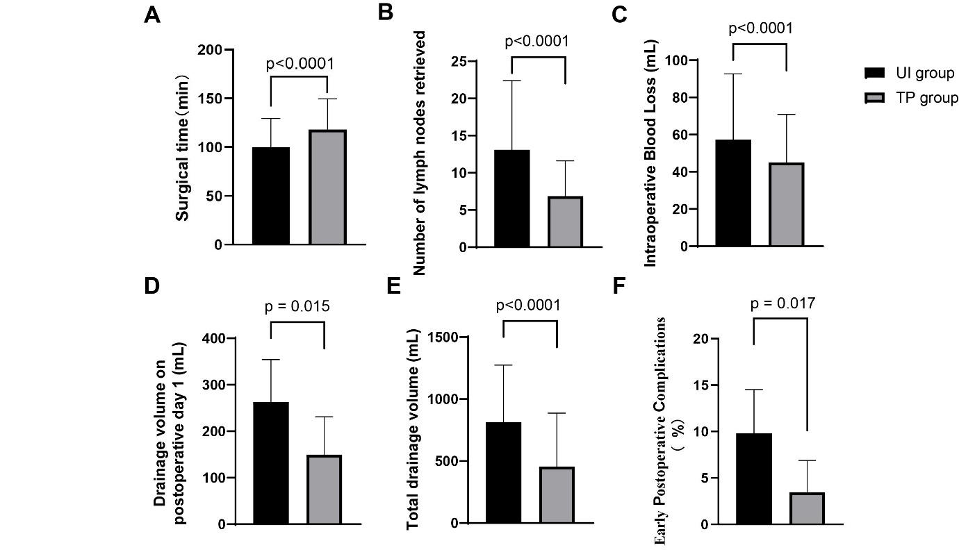 Figure S3: Perioperative outcomes and safety comparison between TP and UI approaches. UI (n=215) vs TP (n=203): (A) Operative time: 99.7 vs 118.3 min (P<0.0001) (B) Lymph nodes retrieved: 13.10 vs 6.87 (P<0.0001) (C) Blood loss: 57.4 vs 45.0 mL (P<0.0001) (D) Drainage (day 1): 262.4 vs 149.4 mL (P<0.05) (E) Total drainage: 812.8 vs 455.8 mL (P<0.0001)(F) Complications: 9.77% vs 3.45% (P<0.05). Error bars: mean (SD) for A-E; 95% CI (Wilson) for F.Early complications included prolonged air leak, chylothorax, pulmonary infection, and arrhythmiawithin 30 days.

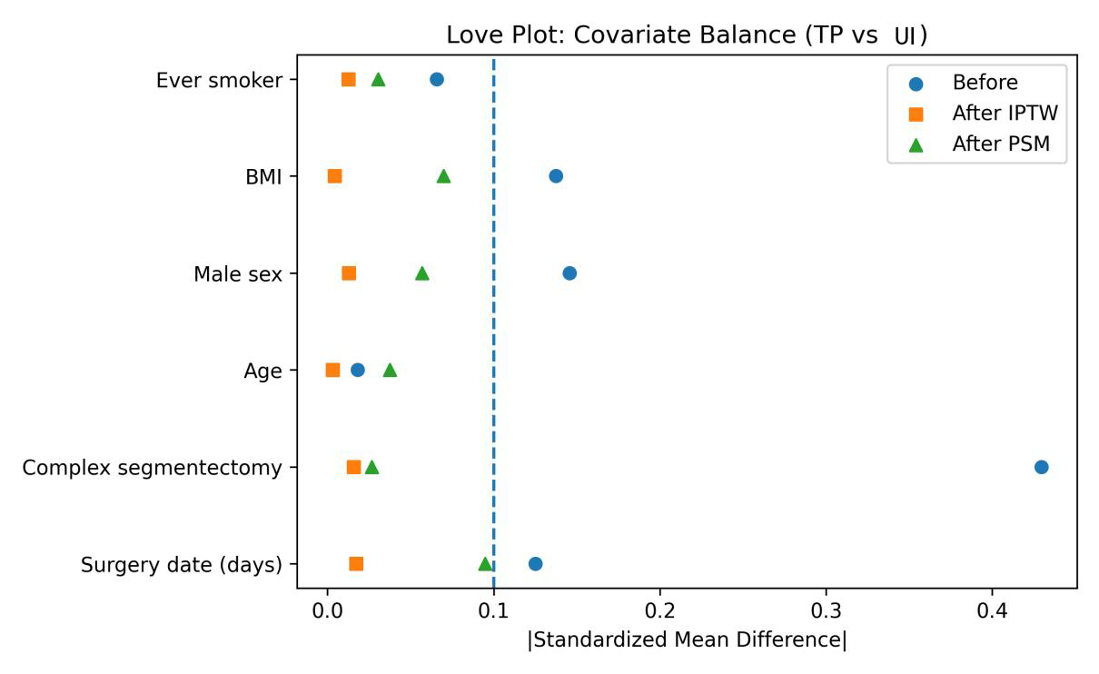
Figure S4: Covariate Balance Before and After Propensity Score–Based Balancing
Love plot showing standardized mean differences (SMDs) for baseline covariates before weighting/matching (Before), after inverse probability of treatment weighting (IPTW), and after propensity score matching (PSM). The dashed vertical line indicates the prespecified balance threshold of |SMD| = 0.10. Adequate balance was achieved for all covariates after IPTW and PSM.
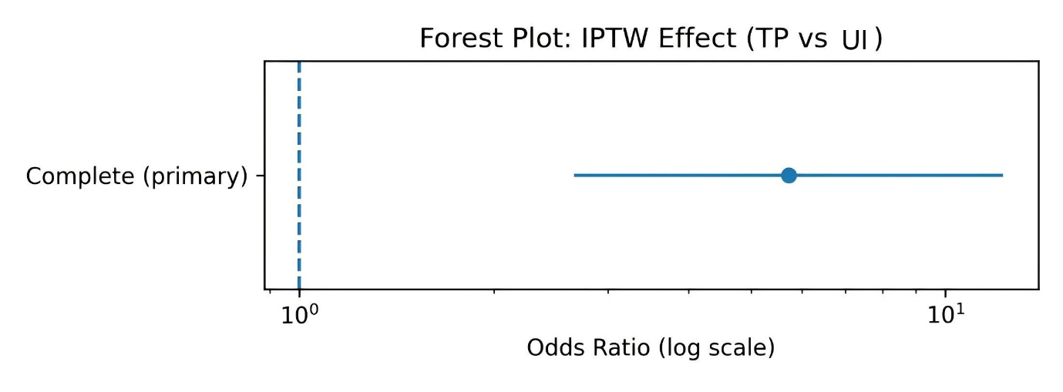 Figure S5 : IPTW-Adjusted Treatment Effect on Surgical Completeness
Forest plot of the IPTW-adjusted treatment effect comparing total-port (TP) versus utility-incision (UI) segmentectomy for the primary outcome of surgical completeness. Effect estimates are presented as odds ratios (ORs) with 95% confidence intervals (CIs) on a logarithmic scale. The vertical dashed line indicates the null effect (OR = 1.0).

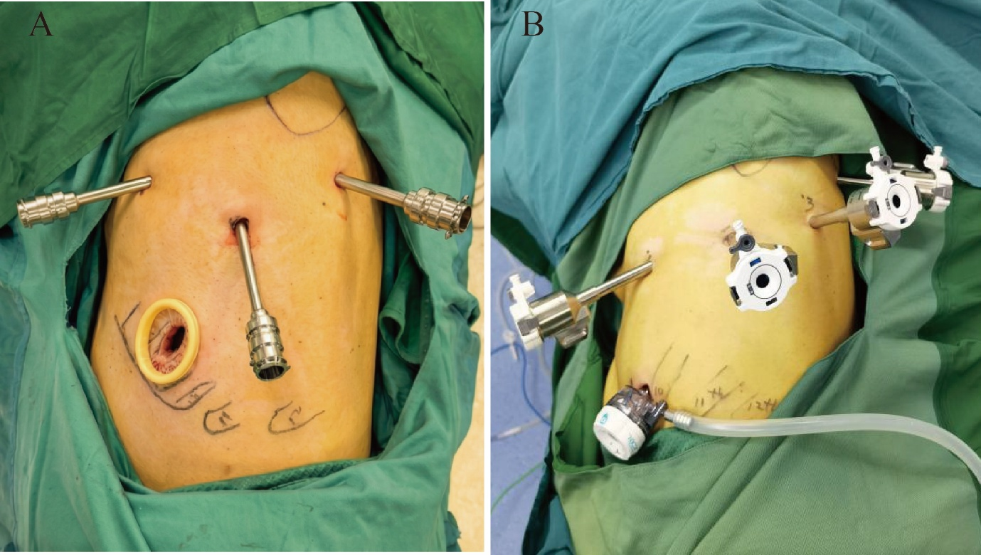
Figure S6: Port placement for robotic pulmonary segmentectomy using the fourth-generation da Vinci Xi Surgical System. (A) utility-incision (UI) approach with a 3–4 cm utility incision (mini-thoracotomy) in the 4th or 5th intercostal space. (B) Total-port (TP) approach using four robotic ports with continuous CO₂ insufflation and no utility incision during the main procedure. Both approaches were performed using the same fourth-generation da Vinci Xi Surgical System; the difference between the two groups was the surgical approach and port configuration rather than the robotic platform
Figure S7 :Blinded assessment and adjudication workflow for surgical completeness based on 3D-CT reconstruction

