Electronic Supplementary Material

Non-thermal plasma driven dry reforming of methane: electron energy-input power coupling mechanism and catalyst design criteria
Minghai Shen^{1,3}, Wei Guo¹, Lige Tong ()¹, Li Wang¹, Paul K. Chu ()², Sibudjing Kawi ()³, Yulong Ding ()⁴
1 School of Energy and Environmental Engineering, University of Science and Technology Beijing, Beijing 100083, China
2 Department of Physics, Department of Materials Science and Engineering, and Department of Biomedical Engineering, City University of Hong Kong, Hong Kong, China
3 Department of Chemical and Biomolecular Engineering, National University of Singapore, Singapore 119260, Singapore
4 Birmingham Centre for Energy Storage & School of Chemical Engineering, University of Birmingham, B15 2TT, UK

E-mails: tonglige@me.ustb.edu.cn (Tong L); paul.chu@cityu.edu.hk (Chu P K); chekawis@nus.edu.sg (Kawi S); Y.Ding@bham.ac.uk (Ding Y)

Table of Contents
Supplementary Fig.1. Schematic diagram of the cylindrical DBD reactor system. 3
Supplementary Fig. 2. Typical DBD Lissajous figures. 4
Supplementary Fig. 3. Comparison of CO and H₂ production performance at different CO₂/CH₄ feed molar ratios (total gas flow = 30 mL/min). (a) Selectivity of H₂ and CO. (b) Yields of H₂ and CO. (c) Conversion of CH₄ and CO₂ feedstocks. (d) Product CO/H₂ molar ratio. 5
Supplementary Fig. 4. Schematic diagram of the infrared thermal imaging temperature of small reactors with different input powers: (a and b) 40 W; (c and d) are 60 W; (e and f) 100 W. 6
Supplementary Fig. 5. Selectivity of Ni-based catalysts at different input powers: (a) H₂ and CO; (b) C₂H₄, C₂H₆ and C3H₈. 7

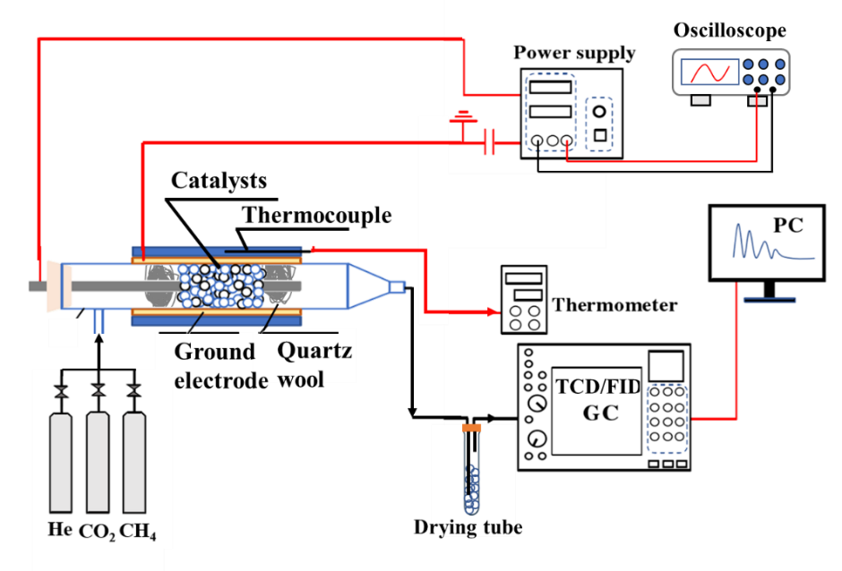

Supplementary Fig.1. Schematic diagram of the cylindrical DBD reactor system.
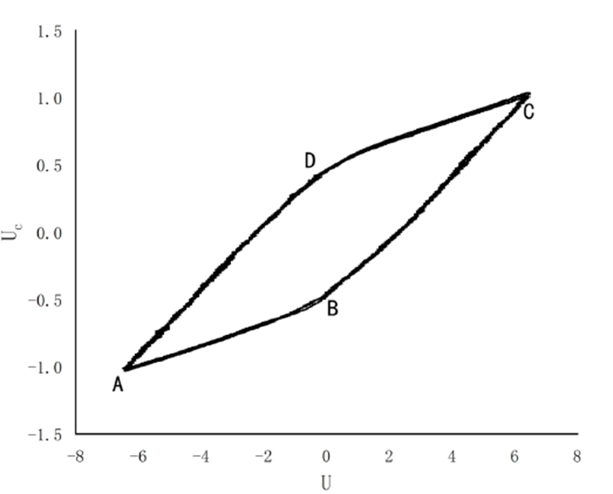

Supplementary Fig. 2. Typical DBD Lissajous figures.
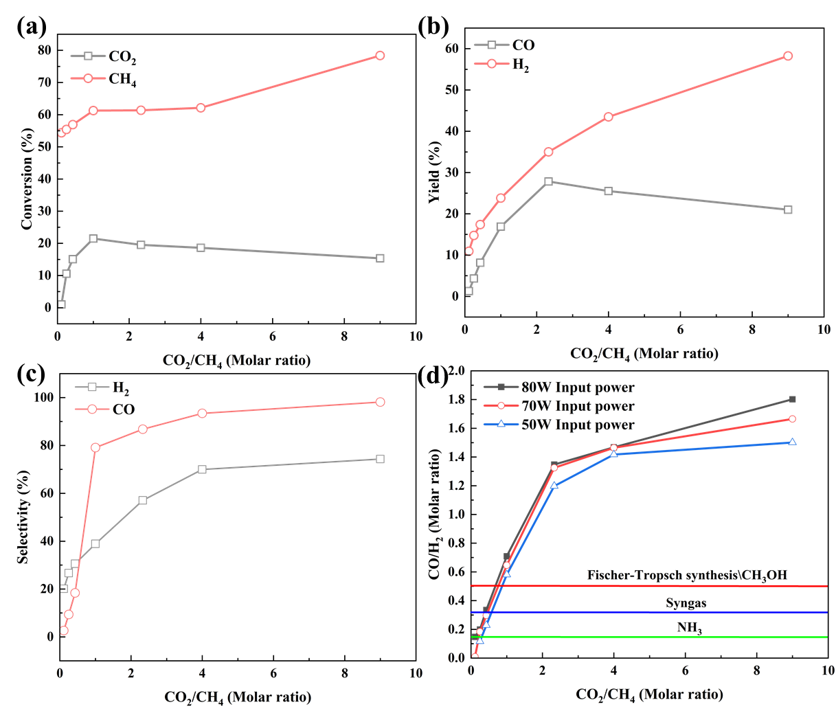

Supplementary Fig. 3. Comparison of CO and H₂ production performance at different CO₂/CH₄ feed molar ratios (total gas flow = 30 mL/min). (a) Selectivity of H₂ and CO. (b) Yields of H₂ and CO. (c) Conversion of CH₄ and CO₂ feedstocks. (d) Product CO/H₂ molar ratio.

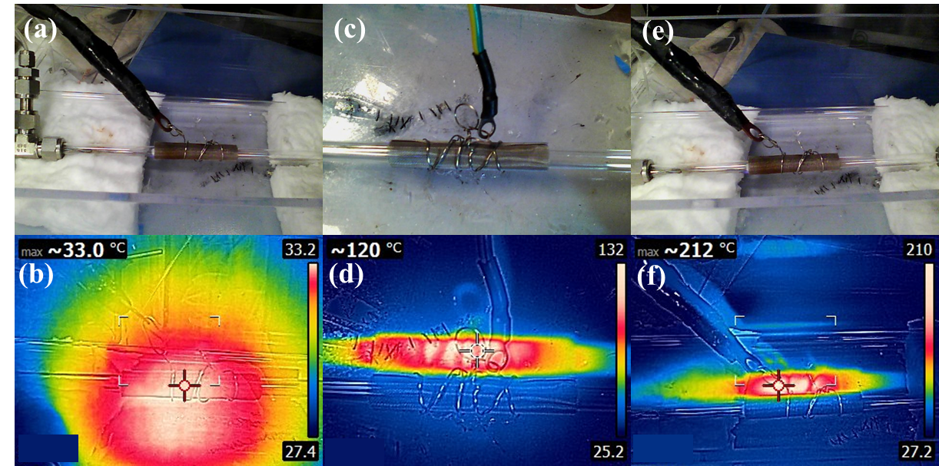

Supplementary Fig. 4. Schematic diagram of the infrared thermal imaging temperature of small reactors with different input powers: (a and b) 40 W; (c and d) are 60 W; (e and f) 100 W.
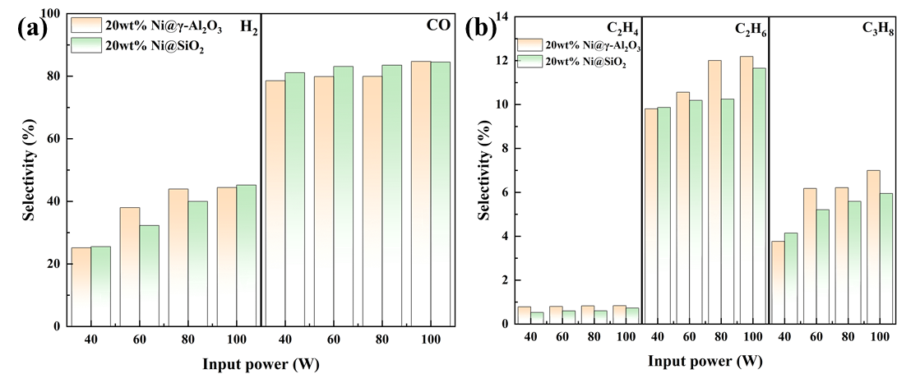

Supplementary Fig. 5. Selectivity of Ni-based catalysts at different input powers: (a) H₂ and CO; (b) C₂H₄, C₂H₆ and C3H₈.

