Supplementary figure 1. Flow cytometry histograms of oat plants; (A) control 2n, (B) haploid 1n and (C) doubled haploid 2n.
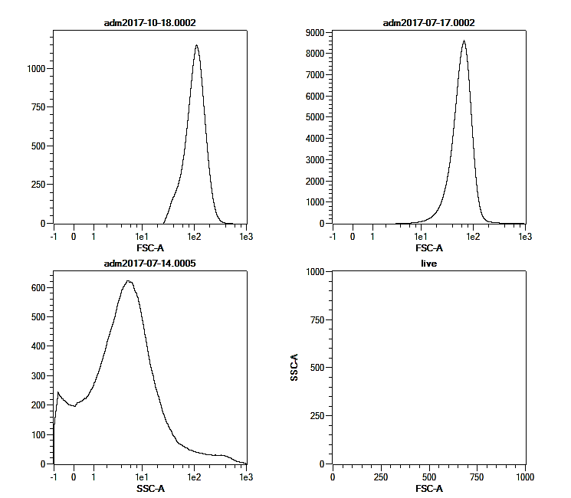
Relative DNA content

A
BA
CA
Number of nuclei
2C
1C
2C

