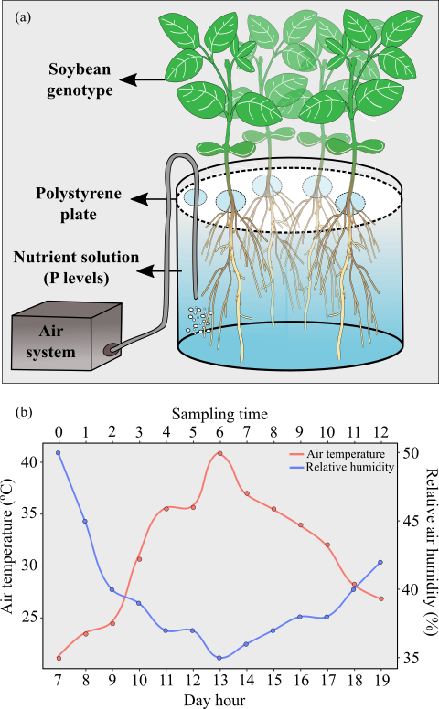
Online Resource 1. Illustrative representation of the hydroponic system used for soybean cultivation (a). Air temperature and relative humidity inside the greenhouse during the solution sampling time (b). The values represent the mean of measurements from three Thermo hygrometers.

