Antithrombotic management and outcomes of patients with atrial fibrillation treated with NOACs early at the time of market introduction:
Main results from the PREFER in AF Prolongation Registry

ONLINE SUPPLEMENTAL MATERIAL

OS TABLES

OS Table 1. Distribution of NOACs in the 9 European Countries
COUNTRY | Total | Apixaban | Dabigatran | Rivaroxaban
 | n | % | % | %
AUSTRIA | 4 | 0.0 | 25.0 | 75.0
BELGIUM | 95 | 39.0 | 15.8 | 45.2
SWITZERLAND | 9 | 0.0 | 0.0 | 100.0
GERMANY | 1014 | 27.1 | 14.0 | 58.9
SPAIN | 290 | 37.9 | 25.9 | 36.2
FRANCE | 732 | 16.4 | 21.0 | 62.6
UK | 306 | 32.7 | 24.2 | 43.1
ITALY | 536 | 24.1 | 41.6 | 34.3
NETHERLANDS | 227 | 29.5 | 31.7 | 38.8
TOTAL | 3213* | 26.0 | 24.0 | 50.0
* for 10 patients type of NOAC was not given

OS Table 2. Main clinical events in 12 months between baseline and follow-up
EVENTS | Patients* N (%)
Stroke | 24 (0.8)
Acute coronary syndrome | 28 (0.9)
Arterial embolism | 2 (0.1)
TIA | 27 (0.9)
Any major bleeding | 62 (2.0)
Intracranial hemorrhage | 3 (0.1)
Bleeding in critical organ other than brain | 24 (0.8)
Any other Bleedings | 37 (1.2)
Hospitalization due to Clinical Events | 224 (7.0)
Hospitalization due to Bleeding Events | 80 (2.5)
Hospitalization due to Clinical or Bleeding Events | 271 (8.4)
*patients with at least 1 event

OS Table 3. Causes of death in 12 months between baseline and follow-up
EVENTS | n (%)
Total | 69 (2.1)
Cardiovascular | 40 (1.2)
Cardiavascular unspecified | 20 (0.6)
Heart failure | 10 (0.3)
Reduced left ventricular ejection fraction | 3 (0.09)
Myocardial infarction | 2 (0.06)
Stroke | 0 (0.0)
Arterial embolism | 1 (0.03)
Pulmonar & Venous embolism | 1 (0.03)
Sudden death | 3 (0.09)
Non cardiovascular | 29 (0.9)
Cancer | 8 (0.2)
Infection | 6 (0.2)
Major bleeding | 2 (0.06)
Neurological | 2 (0.06)
Injury/accident | 2 (0.06)
Other/unspecified non cardiovascular | 9 (0.3)

OS Table 4. Incidence of MACCE by CHA₂DS₂-VASc score
CHA₂DS₂-VASc
MACCE |  | 0 | 1 | 2 | 3 | 4 | 5 | 6 | 7 | 8 | 9 | Total
No | Number | 46 | 283 | 556 | 740 | 619 | 349 | 174 | 63 | 17 | 3 | 2850
 | % | 100 | 98.95 | 97.72 | 98.01 | 97.17 | 97.49 | 96.13 | 95.45 | 100 | 100 | 2850
Yes | Number | 0 | 3 | 13 | 15 | 18 | 9 | 7 | 3 | 0 | 0 | 68
 | % | 0 | 1.05 | 2.28 | 1.99 | 2.83 | 2.51 | 3.87 | 4.55 | 0 | 0 | 68
Total | Number | 46 | 286 | 569 | 755 | 637 | 358 | 181 | 66 | 17 | 3 | 2918
Frequency Missing = 305

OS Table 5. Procedures of cardioversion and ablation
PROCEDURES | Baseline (n=3223) | Follow-up (n=3149*) | Follow-up vs baseline
 | n (%) | n (%) | P
Pharmacological Cardioversion | 372 (11.54%) | 90 (2.85%) | <0.0001
Electrical Cardioversion | 575 (17.84%) | 204 (6.47%) | <0.0001
Ablation | 169 (5.24%) | 119 (3.78%) | 0.0049
*for 69 patients which died and for other 5 this info in missing at follow-up
Statistically significant P values are in bold

OS FIGURES

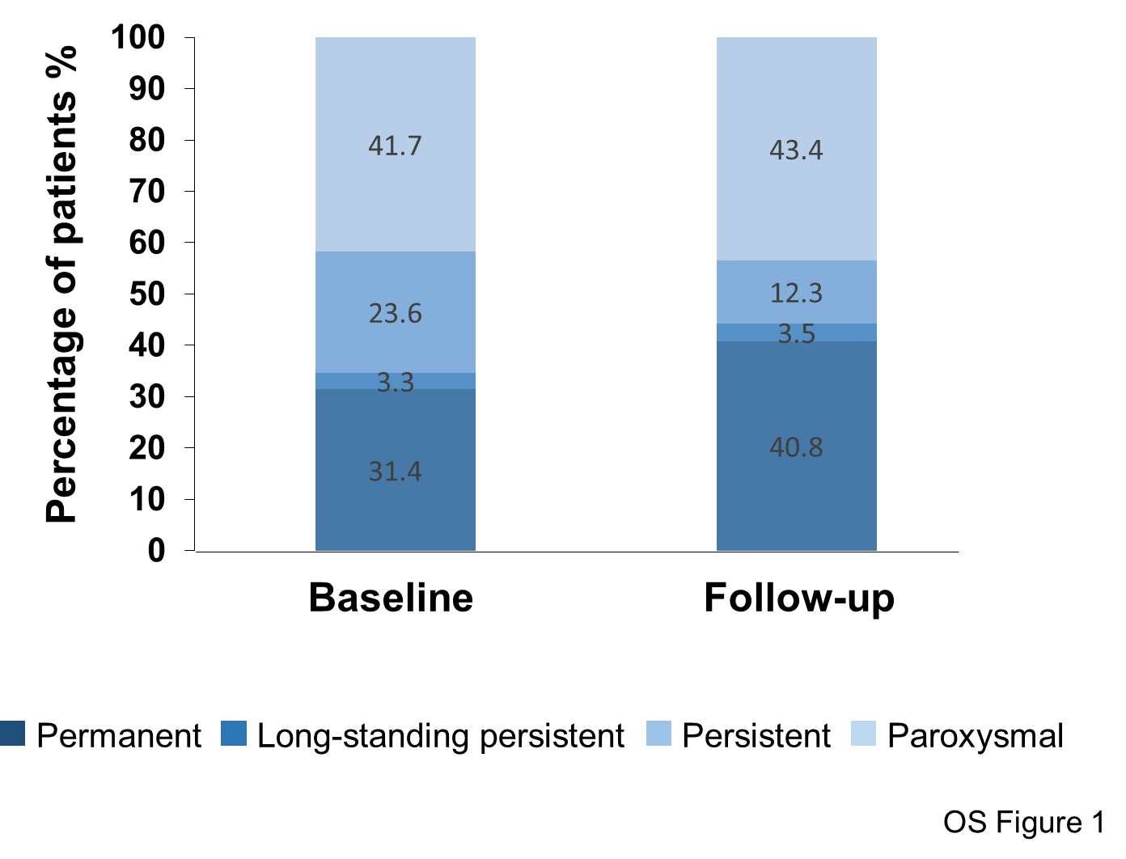
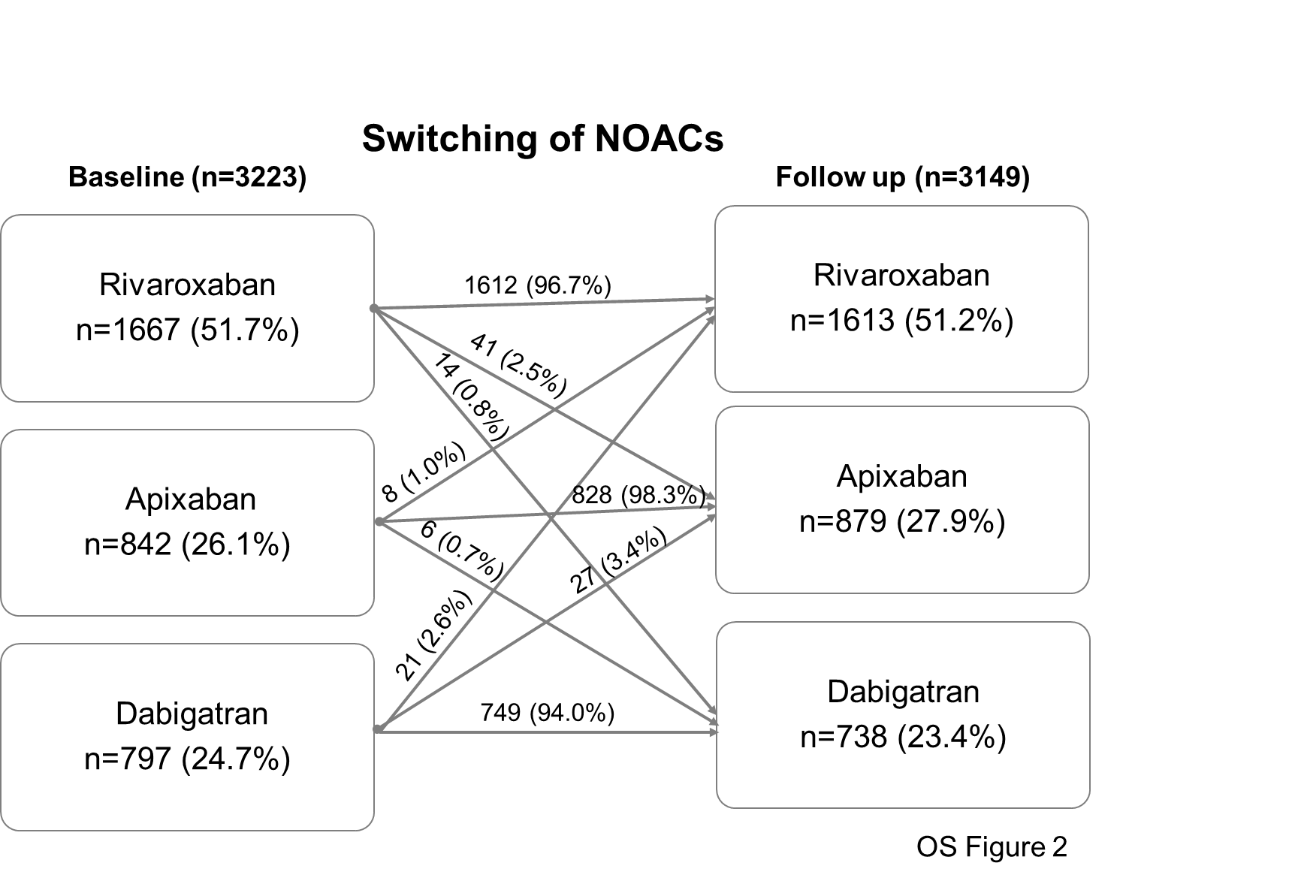
LEGENDS TO OS FIGURES

OS Figure 1. Clinical presentation of AF at baseline and follow-up. The darker blue represents permanent AF, the lighter paroxysmal AF.

OS Figure 2. Switching of NOACs from baseline to follow up. Percentages of patients switching from a NOAC to another were reported above the arrows. 5 patients who were withdrawn from NOACs during 1 year follow up were not presented in this figure.

